2017/18 Personal Academic Tutoring Student and Staff Survey Report

Gergana Georgieva
Business Intelligence and Management Information Unit
June 2018

Contents
Contents 2
1. Introduction 3
1. Key Findings 3
APPENDIX 1: Response Rates 6
APPENDIX 2: I met with my PAT at the very beginning of the year 6
APPENDIX 3: % agreement with statements (Staff) 7
APPENDIX 4: % agreement with statements (Students) 7
APPENDIX 5: Frequency of meetings with their PATs 8
APPENDIX 6: PAT meetings were initiated and arranged by 8
APPENDIX 7: Student % agreement by gender 8
APPENDIX 8: Student % agreement by domicile 9
APPENDIX 9: Student % agreement by mode 9
APPENDIX 10: Student % agreement by level 9
APPENDIX 11: Student % agreement by Faculty 10
APPENDIX 12: % student agreement with statements by faculty 10
APPENDIX 13: University of Northampton Three Year Trend Data 12
APPENDIX 14: Faculty Tables by Key Questions 14
APPENDIX 15: Examples of open-ended responces 16

Introduction

The Personal Academic Tutoring (PAT) scheme at the University of Northampton is a core component of the University’s approach to supporting student success. The annual PAT survey, currently in its 5th year, is conducted during April of each year to provide a sense of how the scheme is working and being received from both staff and student perspectives. The findings from the online surveys provide a mandate for action-oriented approaches to quality enhancement of the PAT scheme.

Student survey coverage: 7,219 students studying on campus and by distance learning were included in the survey. Final year undergraduate and PhD students are not included as their opportunity to provide feedback on the support received while at University is via the National Student Survey and the PRES survey respectively.

Staff survey coverage: 865 staff members on academic contracts were surveyed.

Response Rates
- Student – 19.3% (1395 responses) up from 7% in 2016/17 and 6% in 2015/2016.
- Staff – 30.3% (263 responses, 219 have worked as a PAT) up from 16% in 2016/17 and 12% in 2015/16.
- The highest response rates were found in FEH (38% for staff and 28% for students) whilst the lowest were found for staff in FAST (23%) and for students in FBL (14%). See Appendix 1 for full details.

Key Findings

- PATs do make a difference to the lives of their students, but there is a discrepancy between the extent to which staff and students believe this is the case. While 91.4% of staff agreed that their work as a PAT has made a difference to the lives of their tutees (Appendix 3) and 85.4% of students thought that it was really important to have a personal academic tutor, only 51.2% of students agreed that the sessions with their PAT have made a difference to their university experience. (Appendix 4)

- Similarly, there is a discrepancy between staff’s confidence in providing support and the students’ assessment of its effectiveness. While over 80% of staff indicated that they felt confident in providing both personal/pastoral and academic support to students as part of their PAT role (Appendix 3), just around 50% of students agreed that they had been effectively supported in personal/ pastoral and academic matters by their PAT (Appendix 4). Open-ended questions echo similar results with many students reporting they are able to confide in their PAT (Appendix 15, Example 1).

- More students are meeting with their PAT at the beginning of the academic year. 67.6% of students had met with their tutor at the beginning of this year, an increase of 10% points for 2016/17 and 4% points for 2015/16. (Appendix 2)

- Students are requesting more sessions. Although the number of initial contact sessions is increasing (58.7% in 2017/18, 50.6% in 2016/17 and 42.5% in 2015/16), there is a decrease in the frequency of sessions overall (Appendix 5). This is one of the main themes identified in the open-ended question with students generally requesting more sessions (Appendix 15, Example 2 )

- Students are seeking support from other staff as well as their PAT. 92.8% of staff report that they support students who are not their personal tutees (Appendix 3) and likewise 70.9% of students agreed that they actively engaged with other members of University staff for support. (Appendix 4)

- Staff are increasingly feeling that they don’t have enough time. The majority of staff (60.8%) feel that they don’t have enough time to perform the role (an increase from 53.2% in 2016/17 and 53.3% in 2015/16) (Appendix 3). This is also a main theme in the staff open-ended comments. (Appendix 15, Example. 3)

- Students are calling for staff to be more proactive in initiating and arranging the meetings. This is one of the main themes identified by the students in the open ended comments (Appendix 15, Ex. 4). 48.4% of students stated that PAT meetings were initiated and arranged by both student and PAT, only 29.0% of meeting were initiated by the PAT and 22.7% by the student. (Appendix 6).

- Post graduate students are generally more satisfied with the PAT system than undergraduates (Appendix 10). Other Student Survey Respondent Characteristics analysis shows that UK students are more likely to engage with other members of staff than EU and Overseas students, but are less likely to have group meetings (Appendix 8), and although distance learning students are the least likely to know who their PAT is and to have met them (reflected in the open ended comments), those that did are most likely to declare that the session has made a difference to their university experience. Open ended questions also indicate that BME students are the most likely to confide in their PAT.

- On a Faculty level, FEH is performing better overall with both staff and students most likely to be satisfied with the PAT system:

  - Better initial contact with students (Appendix 2).
  - Most proactive staff (Appendix 6)
  - Best overall student satisfaction (Appendix 11)
  - Highest proportion of staff that: considered they had sufficient time to perform the PAT role; feel they are qualified to perform the PAT role; feel they have the appropriate resources for the PAT role and are most likely to work closely with others in their team to facilitate Personal Academic Tutoring (Appendix 14)

- Staff are reporting a growing number of students with more complex needs (including mental health), who cannot be supported by the already overwhelmed student support services. A theme not covered by the questions, but identified in the open-ended comments. (Appendix 15, Example 5)

- Staff are concerned with the proposed changes to the PAT system. The need for consistency in the provision of the PAT system on a university level clashes with the need for flexibility (individual and personalized approaches) (Appendix 15, Example 6)

APPENDIX 1: Response Rates
Staff Survey Response Rates
Faculty | Staff  Population | No of responses | PAT staff 2018 | PAT staff 2017 | PAT staff 2016
Faculty of Arts Science & Technology | 207 | 47 | 22.7% | 18.3%
Faculty of Business & Law | 215 | 60 | 27.9% | 22.2%
Faculty of Education & Humanities | 143 | 54 | 37.8% | 19.0%
Faculty of Health & Society | 285 | 99 | 34.7% | 40.5%
Non-Faculty | 18 | 3 | 20.0% | 0%
UoN | 868 | 263 | 30.3% | 16.0%

Student Survey Response Rates
Faculty | Student  Population | No of responses | PAT student 2018 | PAT student 2017 | PAT student 2016
Faculty of Arts Science & Technology | 1429 | 208 | 14.6% | 12.3%
Faculty of Business & Law | 1912 | 258 | 13.5% | 20.0%
Faculty of Education & Humanities | 865 | 238 | 27.5% | 19.1%
Faculty of Health & Society | 2430 | 594 | 24.4% | 40.1%
Joint Honours | 583 | 97 | 16.6% | 6.9%
The Graduate School | n/a | n/a | n/a | 1.6%
UoN only | 7219 | 1395 | 19.3% | 7.0% | 6.0%

APPENDIX 2: I met with my PAT at the very beginning of the year

 | No | Yes | overall | % met with PAT | 2017 | 2016
Faculty Of Arts, Science & Technology | 62 | 146 | 208 | 70.2%
Faculty Of Business & Law | 111 | 147 | 258 | 57.0%
Faculty Of Education & Humanities | 43 | 195 | 238 | 81.9%
Faculty Of Health & Society | 190 | 404 | 594 | 68.0%
Joint Honours | 46 | 51 | 97 | 52.6%
Overall UoN | 452 | 943 | 1395 | 67.6% | 57.6% | 63.6%

APPENDIX 3: % agreement with statements (Staff)
Question | % Agree | % Neither Agree nor Disagree | % Disagree
I feel that I am qualified to perform the PAT role (e.g. through experience, training etc) | 89.4% | 4.8% | 5.8%
I have appropriate resources to help me perform the PAT role (e.g. PAT web area, peer support) | 54.1% | 16.6% | 29.3%
I have enough time to perform the PAT role | 28.6% | 10.6% | 60.8%
I am familiar with the PAT web area on the ILT website | 34.5% | 12.2% | 53.3%
In my role as a PAT I refer (have referred) to the PAT web area | 21.1% | 8.9% | 70.0%
I am aware of the PAT development opportunities within the University's C@N-DO professional development scheme | 52.8% | 11.3% | 35.9%
I have engaged with one of the C@N-DO PAT Development Opportunities this academic year | 16.9% | 6.3% | 76.8%
I work closely with others in my team to support high-quality PAT provision for students | 86.1% | 3.8% | 10.1%
As a PAT, I am happy to support students via group tutorials | 71.0% | 9.0% | 20.0%
As a PAT, I prefer to work with students on a one-to-one basis | 78.7% | 19.1% | 2.2%
Students who are not assigned to me (as a PAT) still come to me for support | 92.8% | 2.4% | 4.8%
I prefer to facilitate personal tutoring as scheduled, timetabled sessions | 60.5% | 14.4% | 25.1%
I prefer to facilitate personal tutoring using an 'open-door' policy (it is OK to prefer scheduled and 'open-door') | 74.1% | 7.8% | 18.1%
In my work as a PAT, I know I have made a positive impact on the lives of my tutees | 91.4% | 8.1% | 0.5%
I feel confident in the pastoral/personal aspect of the PAT role | 85.5% | 6.5% | 8.0%
I feel confident in the academic support aspect of the PAT role | 87.3% | 5.6% | 7.1%

APPENDIX 4: % agreement with statements (Students)

University of Northampton | % agreement | % disagreement | % neither agree or disagree | % agreement 2017 | % agreement 2016
My sessions with my PAT have made a difference to my University experience | 51.2% | 32.4% | 16.4% | 60.7% | 36.2%
During the sessions with my PAT, we review my progress toward my own goals | 51.1% | 33.2% | 15.7% | 62.7% | 43.2%
It is really important for me to have a personal development plan | 76.1% | 8.5% | 15.3% | 69.1% | 54.0%
I actively engage with other members of University staff (e.g. my module tutor) for support | 70.9% | 15.5% | 13.6% | 73.1% | 55.2%
I think it is really important for students to have a Personal Academic Tutor | 86.7% | 4.0% | 9.3% | 85.4% | 72.0%
I have been effectively supported in personal/pastoral issues by my Personal Academic Tutor | 48.4% | 33.3% | 18.4% | 60.1% | 35.8%
I have been effectively supported in academic matters by my Personal Academic Tutor | 54.4% | 31.8% | 13.8% | 65.7% | 38.4%
I have had some group meetings with my PAT and other students | 29.8% | 55.9% | 14.3% | 40.3% | 25.8%

APPENDIX 5: Frequency of meetings with their PATs

 | FAST | % FAST | FBL | % FBL | FEH | % FEH | FHS | % FHS | JH | % JH | UoN | % UoN | %UoN 2017 | %UoN 2016
at least once in the first term | 103 | 49.5% | 163 | 63.2% | 102 | 42.9% | 382 | 64.3% | 69 | 71.1% | 819 | 58.7% | 50.6% | 42.5%
at least once per term | 46 | 22.1% | 43 | 16.7% | 75 | 31.5% | 115 | 19.4% | 14 | 14.4% | 293 | 21.0% | 24.2% | 32.4%
I met with my PAT more than three times | 59 | 28.4% | 52 | 20.2% | 61 | 25.6% | 97 | 16.3% | 14 | 14.4% | 283 | 20.3% | 25.3% | 25.0%
Overall Total | 208 |  | 258 |  | 238 |  | 594 |  | 97 |  | 1395

APPENDIX 6: PAT meetings were initiated and arranged by

PAT meetings were initiated and arranged by: | UoN | FAST | FBL | FEH | FHS | JH | UoN 2017 | UoN 2016
Both of us | 48.4% | 49.7% | 50.9% | 47.9% | 46.8% | 51.9% | 48.2% | 51.1%
My PAT | 29.0% | 31.5% | 21.0% | 41.0% | 26.4% | 20.4% | 37.4% | 26.4%
Myself | 22.7% | 18.8% | 28.1% | 11.1% | 26.8% | 27.8% | 14.3% | 22.3%

APPENDIX 7: Student % agreement by gender

% agreement | % agreement female | % agreement male | diff
My sessions with my PAT have made a difference to my University experience | 50.5% | 53.7% | -3.2%
During the sessions with my PAT, we review my progress toward my own goals | 50.4% | 53.2% | -2.8%
It is really important for me to have a personal development plan | 77.0% | 73.3% | 3.7%
I actively engage with other members of University staff (e.g. my module tutor) for support | 71.0% | 70.5% | 0.5%
I think it is really important for students to have a Personal Academic Tutor | 86.8% | 86.5% | 0.4%
I have been effectively supported in personal/pastoral issues by my Personal Academic Tutor | 47.9% | 50.2% | -2.3%
I have been effectively supported in academic matters by my Personal Academic Tutor | 53.0% | 59.0% | -6.1%
I have had some group meetings with my PAT and other students | 28.8% | 33.1% | -4.3%

APPENDIX 8: Student % agreement by domicile

 | % agree EU | % agreement Overseas | % agree EU and Overseas |  | % agree Uk | difference
My sessions with my PAT have made a difference to my University experience | 38.5% | 61.3% | 57.3% | 50.9% |  | 6.5%
During the sessions with my PAT, we review my progress toward my own goals | 54.5% | 50.0% | 50.7% | 51.1% |  | -0.4%
It is really important for me to have a personal development plan | 80.0% | 76.6% | 77.0% | 76.1% |  | 0.9%
I actively engage with other members of University staff (e.g. my module tutor) for support | 50.0% | 61.3% | 59.2% | 71.6% |  | -12.4%
I think it is really important for students to have a Personal Academic Tutor | 86.7% | 86.2% | 86.3% | 86.8% |  | -0.5%
I have been effectively supported in personal/pastoral issues by my Personal Academic Tutor | 46.7% | 51.6% | 50.6% | 48.2% |  | 2.4%
I have been effectively supported in academic matters by my Personal Academic Tutor | 57.1% | 58.7% | 58.4% | 54.1% |  | 4.3%
I have had some group meetings with my PAT and other students | 21.4% | 44.1% | 39.7% | 29.2% |  | 10.6%

APPENDIX 9: Student % agreement by mode

% agreement | FT | PT | DL | at least 10% difference
My sessions with my PAT have made a difference to my University experience | 50% | 54% | 60% | FT / DL (10%)
During the sessions with my PAT, we review my progress toward my own goals | 50% | 60% | 50% | FT and DL / PT 10%
It is really important for me to have a personal development plan | 76% | 75% | 76% | n/a
I actively engage with other members of University staff (e.g. my module tutor) for support | 48% | 53% | 48% | n/a
I think it is really important for students to have a Personal Academic Tutor | 86% | 93% | 91% | n/a
I have been effectively supported in personal/pastoral issues by my Personal Academic Tutor | 48% | 53% | 48% | n/a
I have been effectively supported in academic matters by my Personal Academic Tutor | 54% | 63% | 54% | n/a
I have had some group meetings with my PAT and other students | 30% | 33% | 21% | PT and DL (12%)

APPENDIX 10: Student % agreement by level

%Agreement | PG | UG | % Difference
My sessions with my PAT have made a difference to my University experience | 63.9% | 48.0% | -15.9%
During the sessions with my PAT, we review my progress toward my own goals | 60.1% | 48.9% | -11.2%
It is really important for me to have a personal development plan | 82.5% | 74.5% | -8.0%
I actively engage with other members of University staff (e.g. my module tutor) for support | 70.4% | 71.0% | 0.6%
I think it is really important for students to have a Personal Academic Tutor | 93.3% | 85.1% | -8.2%
I have been effectively supported in personal/pastoral issues by my Personal Academic Tutor | 57.1% | 46.2% | -10.9%
I have been effectively supported in academic matters by my Personal Academic Tutor | 63.6% | 52.1% | -11.6%
I have had some group meetings with my PAT and other students | 32.4% | 29.1% | -3.3%

APPENDIX 11: Student % agreement by Faculty

% agreement | UoN | FAST | FBL | FEH | FHS | JH
My sessions with my PAT have made a difference to my University experience | 51.2% | 49.5% | 47.1% | 68.7% | 48.8% | 37.2%
During the sessions with my PAT, we review my progress toward my own goals | 51.1% | 50.5% | 40.3% | 75.0% | 48.7% | 34.8%
It is really important for me to have a personal development plan | 76.1% | 71.9% | 78.0% | 76.2% | 77.7% | 71.0%
I actively engage with other members of University staff (e.g. my module tutor) for support | 70.9% | 71.8% | 70.5% | 72.7% | 71.8% | 60.4%
I think it is really important for students to have a Personal Academic Tutor | 86.7% | 84.8% | 87.0% | 90.8% | 86.3% | 82.8%
I have been effectively supported in personal/pastoral issues by my Personal Academic Tutor | 48.4% | 52.4% | 39.3% | 61.8% | 48.5% | 30.1%
I have been effectively supported in academic matters by my Personal Academic Tutor | 54.4% | 59.2% | 47.4% | 71.9% | 50.9% | 38.4%
I have had some group meetings with my PAT and other students | 29.8% | 35.4% | 33.2% | 26.0% | 30.6% | 12.5%

APPENDIX 12: % student agreement with statements by faculty

APPENDIX 13: University of Northampton Three Year Trend Data

The following graphs show trend data since 2015/16 for each question in the PAT staff survey.
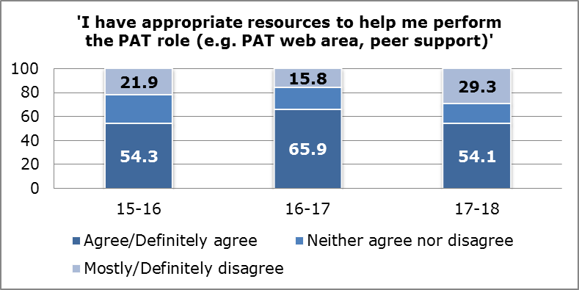
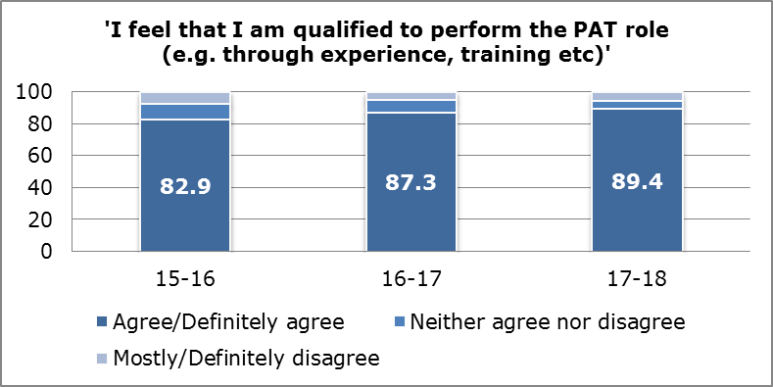

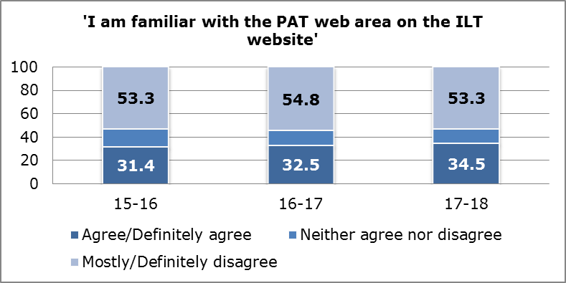
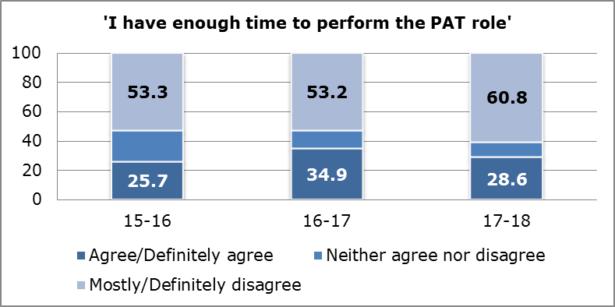

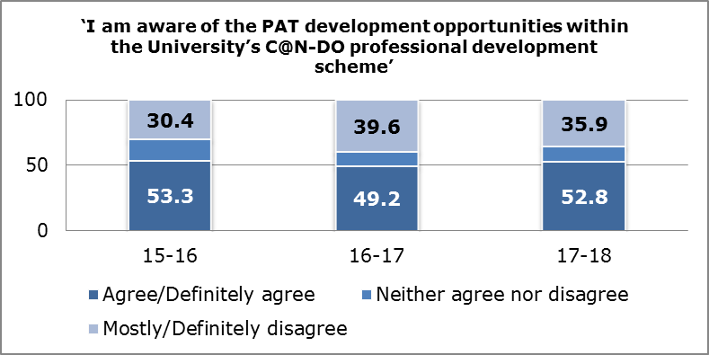
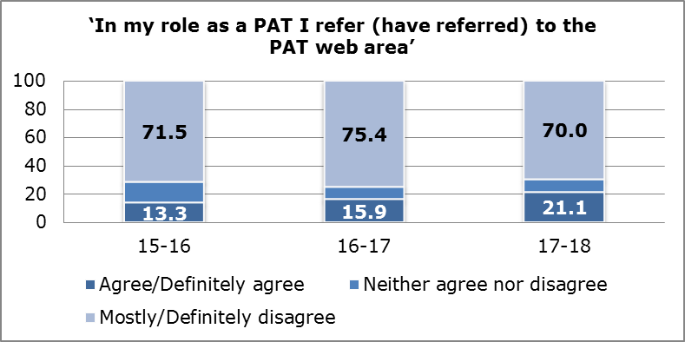

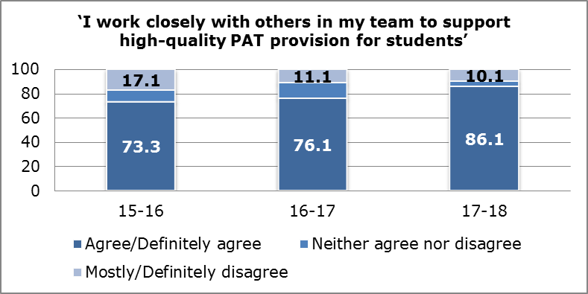
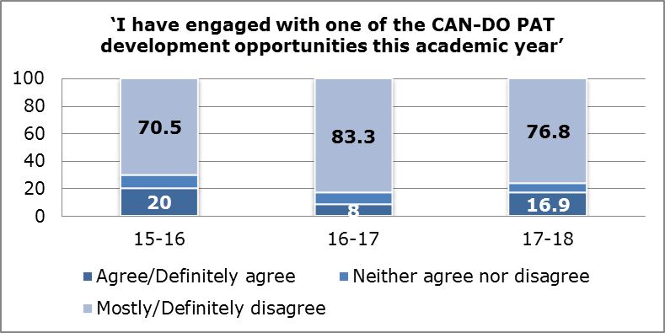

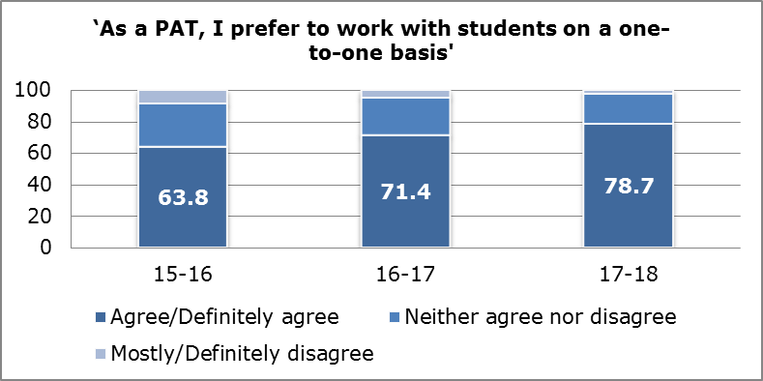
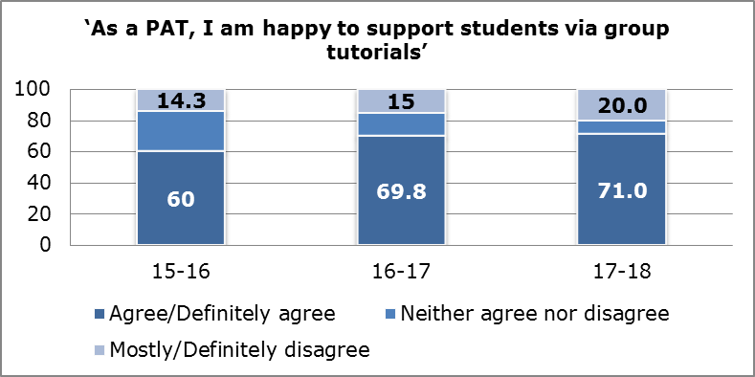

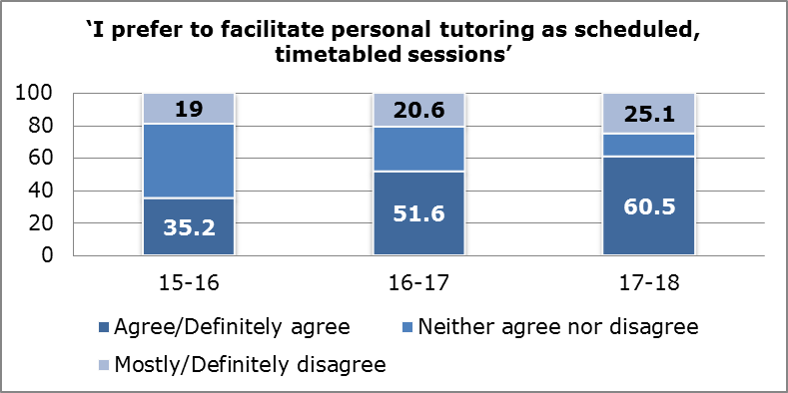
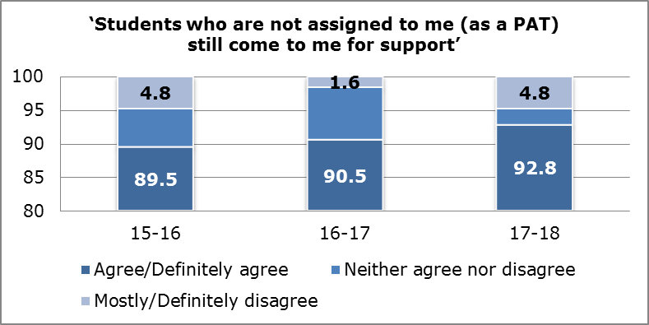

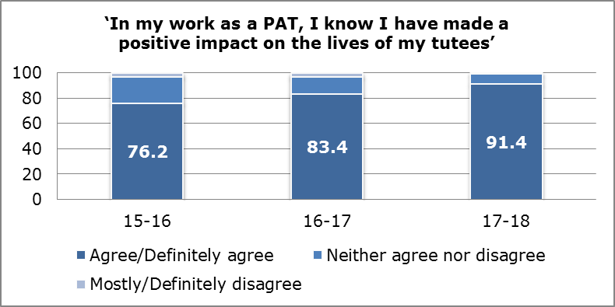
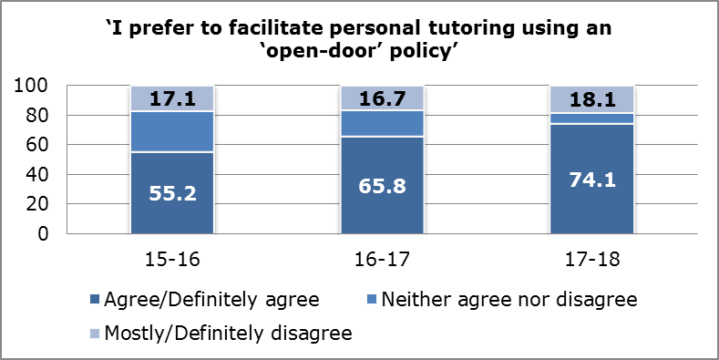

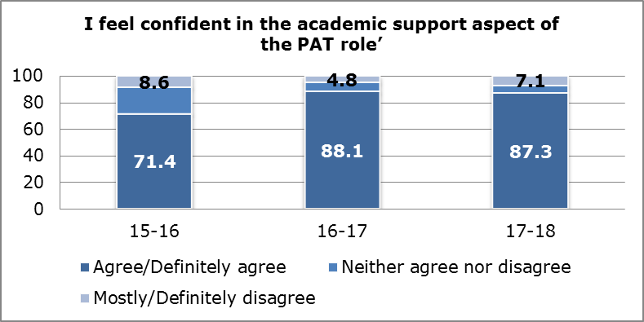
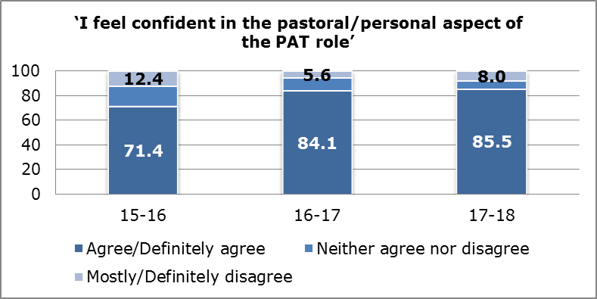

APPENDIX 14: Faculty Tables by Key Questions
I feel that I am qualified to perform the PAT role (e.g. through experience, training etc)
 | FAST | FBL | FEH | FHS
Agree | 82.9% | 91.1% | 95.5% | 87.7%
Neither Agree or Disagree | 2.9% | 4.4% | 4.5% | 6.2%
Disagree | 14.3% | 4.4% | 0.0% | 6.2%

I have appropriate resources to help me perform the PAT role (e.g. PAT web area, peer support)
 | FAST | FBL | FEH | FHS
Agree | 40.5% | 51.2% | 80.5% | 53.8%
Neither Agree or Disagree | 21.6% | 17.1% | 17.1% | 15.4%
Disagree | 37.8% | 39.0% | 12.2% | 29.5%

I have enough time to perform the PAT role
 | FAST | FBL | FEH | FHS
Agree | 18.9% | 31.7% | 41.5% | 25.6%
Neither Agree or Disagree | 13.5% | 0.0% | 22.0% | 9.0%
Disagree | 67.6% | 68.3% | 36.6% | 65.4%

I work closely with others in my team to support high-quality PAT provision for students
 | FAST | FBL | FEH | FHS
Agree | 87.2% | 76.2% | 97.6% | 84.3%
Neither Agree or Disagree | 5.1% | 7.1% | 2.4% | 2.4%
Disagree | 7.7% | 16.7% | 0.0% | 13.3%

Students who are not assigned to me (as a PAT) still come to me for support
 | FAST | FBL | FEH | FHS
Agree | 94.7% | 93.5% | 91.1% | 92.3%
Neither Agree or Disagree | 5.3% | 0.0% | 4.4% | 1.3%
Disagree | 0.0% | 6.5% | 4.4% | 6.4%

In my work as a PAT, I know I have made a positive impact on the lives of my tutees
 | FAST | FBL | FEH | FHS
Agree | 83.8% | 90.5% | 93.0% | 95.9%
Neither Agree or Disagree | 16.2% | 9.5% | 7.0% | 2.7%
Disagree | 0.0% | 0.0% | 0.0% | 1.4%

I feel confident in the pastoral/personal aspect of the PAT role
 | FAST | FBL | FEH | FHS
Agree | 75.7% | 86.0% | 95.1% | 84.4%
Neither Agree or Disagree | 13.5% | 2.3% | 2.4% | 7.8%
Disagree | 10.8% | 11.6% | 2.4% | 7.8%

I feel confident in the academic support aspect of the PAT role
 | FAST | FBL | FEH | FHS
Agree | 94.1% | 91.1% | 90.0% | 80.3%
Neither Agree or Disagree | 2.9% | 0.0% | 5.0% | 10.5%
Disagree | 2.9% | 8.9% | 5.0% | 9.2%

APPENDIX 15: Examples of open-ended responses

- “I have found having a PAT helps with all aspects of my course, I have someone I can contact when unsure and I know I will always be directed to the right support. I find meeting on a regular basis provides an environment to discuss concerns or issues and provides a support network. It feels more personal knowing I have someone directly responsible for my learning and keeps in touch.”

- “Having a PAT is amazing during time at university however I believe there should be more time spent to see students. Maybe creating timetabled sessions which will give use the opportunity to meet up and discuss any issues etc.”

“I would like to have more frequent PAT meetings in each term to talk about certain issues and how I am able to improve my time at university.”

- “I thoroughly enjoy the role of PAT and feel with our specific team our students (who are extremely dependent) are supported well, yet we as lecturers are not provided adequate time /acknowledged adequate time to spend with students. It is recognised that not ALL students require additional time, yet some (in particular, our students) do require a more supportive system.”

- “I like the thought of having an academic tutor to speak to and it is comforting to know that there is a specific person assigned for everyone. However, I mostly forgot that I had one because there were no meeting arranged throughout the whole year to check on progress or if each student was okay. Therefore, they have not really affected my first year of uni at all.”

- “Whilst as a PAT I understand what pathways to refer students to - the reality is that those pathways are not able to cope with referrals and often students are left feeling unsupported which means in my role as PAT I am often having to take on roles that should be covered by people qualified and allocated the time to deal with that area - such as counselling support, academic writing support, etc.”

“From experience, students value the role academics play in the PAT system but we don't always have sufficient time to devote to the role. One of the biggest concern among academics is the lack of support services to refer students onto with long waiting lists to access mental health services for example.”

- “The PAT role needs to be flexible if the student is to be supported effectively thereby positively raising their perception of the experience. No one method fits all across any University! … All students must have access to a personal tutor for pastoral care and to build on continuity which is important for many students. If a programme moves to continuous assessment of practice, the relationship between the student and her tutor, who should be linked to her site, is even more important. I would be most interested as to the rationale for a 'blanket' decision for a designated PAT role for some staff, particularly in relation to time issues and student satisfaction/support.”

“The PAT system we operate is effective, well evaluated and built into placements and assessments. The changes will be a retrograde step for our programmes.”

