2017/18 Personal Academic Tutoring Staff Survey Report

Emily Fletcher
Business Intelligence and Management Information Unit
June 2018

For Internal Use Only

Contents

1. Introduction 1
2. Key Findings 2
Appendices 5
APPENDIX 1: Response Rates 6
APPENDIX 2: University of Northampton Results 7
APPENDIX 3: University of Northampton Three Year Trend Data 8
APPENDIX 4: Faculty Tables by Key Questions 14

Introduction

The Personal Academic Tutoring scheme at the University of Northampton is a core component of the University’s approach to supporting student success. The annual PAT survey is conducted during April of each year to provide a sense of how the scheme is working and being received from both staff and student perspectives. The findings from the surveys provide a mandate for action-oriented approaches to quality enhancement of the PAT scheme.

This is the 5th year in which the PAT staff and student surveys have been conducted. The results of the 2017-2018 PAT Staff Survey are presented in this report. The results from the PAT Student Survey are presented in a parallel report.

Response Rates
In line with previous surveys, the PAT Staff Survey 2017-2018 was conducted using an online survey tool. The survey was sent via personal email to 868 members of staff on academic contracts. 263 recipients responded to and completed the survey – an overall response rate of 30%, up from 16% in 2016/17 and 12% in 2015/16. Of the 263 responses, 219 have worked as a PAT, therefore analysis is based on these 219 respondents.

Response rates by faculty varies from 37.8% in the Faculty of Education and Humanities to 22.7% in the Faculty of Arts, Science and Technology. See Appendix 1 for full details.

Key Findings

University of Northampton
- The majority of staff completing the survey are either Senior or Principal Lecturers (72.6%) or Lecturers (19.6%).

- 89% of staff felt that they were qualified to perform the PAT role. This is 2% higher than the previous year and a positive three year trend (83% in 2015/16). Less than 6% of staff stated that they did not feel qualified for the role.

- 54.1% of staff felt that they had appropriate resources for the PAT role. This is a decrease of 12% since 2016/17, and a similar percentage to that in 2015/16. Nearly 30% of staff disagreed with this statement, an increase from 15% in 2016/17.

- Just 28.6% of staff considered that they had sufficient time to perform the PAT role, a decrease of 6.3% from 34.9% in 2016/17. The three year trend shows a slight increase from 25.7% in 2015/16. Just over 60% of staff felt that they did not have enough time to perform the role (an increase from 53.2% in 2016/17).

- 34.5% of staff were familiar with the PAT web area on the ILT website, which has increased slightly over 3 years from 31.4% in 2015/16. However the proportion of staff unfamiliar with the PAT web area has remained static at approximately 54%.

- Just over 21% of staff have used the PAT web area in their work to support students. This is a positive 3 year trend from 13.3% in 2015/16 and 15.9% in 2016/17.

- Nearly 53% of staff are aware of the PAT development opportunities contained within C@N-DO. This is an increase of just over 3% since 2016/17, but represents a static three year trend.

- Only 17% of staff have engaged with one of the C@N-DO PAT Development Opportunities this year. This represents a 9% increase from 2016/17, but is still a negative 3 year trend, down from 20% in 2015/16.

- 86% of staff work closely with others in their team to facilitate Personal Academic Tutoring, an increase of 10% since 2016/17 and a positive 3 year trend, from 73% in 2015/16.

- 71% of staff are happy to support students via group tutorials, a similar percentage to 2016/17 (70%) and a 10% increase from 2015/16. 20% of staff were, however, not happy with using group tutorials (an increase from 15% in 2016/17).

- 78.7% of staff preferred to work with students on a one-to-one basis. An increase of 7% since 2016/17, and a positive three year trend from 64% in 2015/16.

- 92.8% of staff reported that they support students who are not their personal tutees. This percentage has increased from 89.5% in 2015/16.

- 60.5% of staff preferred their PAT tutorial times to be scheduled; an increase from 51.6% in 2016/17, and a positive three year trend from 35.2% in 2015/16. 25% of staff did not prefer timetabled sessions, an increase from 20% in 2016/17.

- In addition, 74.1% of staff indicated that they prefer to have an open-door policy for their Personal Academic Tutees. This represents a positive three year trend from 55% in 2015/16 to 66% in 2016/17. It is likely that this reflects the fact that many PATs offer a combination of scheduled and ad hoc sessions for their tutees.

- 91.4% of staff agreed that their work as a PAT has made a difference in the lives of their tutees. This represents a positive three year trend from 76.2% in 2015/16 to 83.4% in 2016/17.

- 85.5% of staff indicated that they felt confident in the pastoral and personal aspects of the PAT role, compared to 84% in 2016/17 and 71% in 2015/16.

- 87.3% of staff indicated that they felt confident in providing academic support to students as part of their PAT role, a broadly similar percentage to 2016/17, and a positive 3 year trend from 2015/16 (71%).

Faculty Detail
- The proportion of staff that felt they were qualified to perform the PAT role varies from 95.5% in FEH to 82.9% in FAST (91.1% in FBL and 87.7% in FHS). 14.3% of staff in FAST did not feel that they were qualified; the highest amongst all faculties (0% in FEH).

- FEH also has the highest proportion of staff that felt that they have the appropriate resources for the PAT role – 80.5% agreed with this, compared to 40.5% in FAST, 51.3% in FBL and 53.8% in FHS. 39% of staff from FBL and 37.8% from FAST felt that they did not have the appropriate resources (12.2% in FEH and 29.5% in FHS).

- FEH has the highest proportion of staff that considered that they had sufficient time to perform the PAT role – 41.5%, compared to 18.9% in FAST (31.7% in FBL and 25.6% in FHS). The proportion of staff that felt that they did NOT have sufficient time to perform the PAT role was 68.3% in FBL, 67.6% in FAST and 65.4% in FHS; compared to 36.6% in FEH.

- FEH staff are more likely to work closely with others in their team to facilitate Personal Academic Tutoring; 97.6% in FEH, compared to 76.2% in FBL, 84.3% in FHS and 87.2% in FAST.

- 96% of staff from FHS felt that their work as a PAT has made a difference in the lives of their tutees. More than 90% of staff from FBL and FEH also agreed with this statement, whereas, just 83.8% of staff from FAST agreed. By contrast, just 1.4% of staff from FHS disagreed with this statement; no staff from the other 3 faculties disagreed (the remaining neither agreed nor disagreed with the statement).

- FEH has the highest proportion of staff that felt confident in the pastoral and personal aspects of the PAT role (95.1%), compared to 75.7% in FAST, 84.4% in FHS and 86% in FBL.

- FAST has the highest proportion of staff that felt confident in the academic support to students as part of their PAT role (94.1%), compared to 80.3% in FHS, 90% in FEH and 91.1% in FBL.

Appendices

APPENDIX 1: Response Rates
Faculty | Population | Respondents | Response Rate
Faculty of Arts, Science & Technology | 207 | 47 | 22.7%
Faculty of Business & Law | 215 | 60 | 27.9%
Faculty of Education & Humanities | 143 | 54 | 37.8%
Faculty of Health & Society | 285 | 99 | 34.7%
Inst. for Creative Leather Technologies | 15 | 3 | 20.0%
Inst. for Public Safety, Crime & Justice | 2 |  | 0.0%
Inst. for Social Innovation & Impact | 1 |  | 0.0%
Total UoN | 868 | 263 | 30.3%

APPENDIX 2: University of Northampton Results
Question | % Agree | % Neither Agree nor Disagree | % Disagree
I feel that I am qualified to perform the PAT role (e.g. through experience, training etc) | 89.4% | 4.8% | 5.8%
I have appropriate resources to help me perform the PAT role (e.g. PAT web area, peer support) | 54.1% | 16.6% | 29.3%
I have enough time to perform the PAT role | 28.6% | 10.6% | 60.8%
I am familiar with the PAT web area on the ILT website | 34.5% | 12.2% | 53.3%
In my role as a PAT I refer (have referred) to the PAT web area | 21.1% | 8.9% | 70.0%
I am aware of the PAT development opportunities within the University's C@N-DO professional development scheme | 52.8% | 11.3% | 35.9%
I have engaged with one of the C@N-DO PAT Development Opportunities this academic year | 16.9% | 6.3% | 76.8%
I work closely with others in my team to support high-quality PAT provision for students | 86.1% | 3.8% | 10.1%
As a PAT, I am happy to support students via group tutorials | 71.0% | 9.0% | 20.0%
As a PAT, I prefer to work with students on a one-to-one basis | 78.7% | 19.1% | 2.2%
Students who are not assigned to me (as a PAT) still come to me for support | 92.8% | 2.4% | 4.8%
I prefer to facilitate personal tutoring as scheduled, timetabled sessions | 60.5% | 14.4% | 25.1%
I prefer to facilitate personal tutoring using an 'open-door' policy (it is OK to prefer scheduled and 'open-door') | 74.1% | 7.8% | 18.1%
In my work as a PAT, I know I have made a positive impact on the lives of my tutees | 91.4% | 8.1% | 0.5%
I feel confident in the pastoral/personal aspect of the PAT role | 85.5% | 6.5% | 8.0%
I feel confident in the academic support aspect of the PAT role | 87.3% | 5.6% | 7.1%

APPENDIX 3: University of Northampton Three Year Trend Data

The following graphs show trend data since 2015/16 for each question in the PAT staff survey.
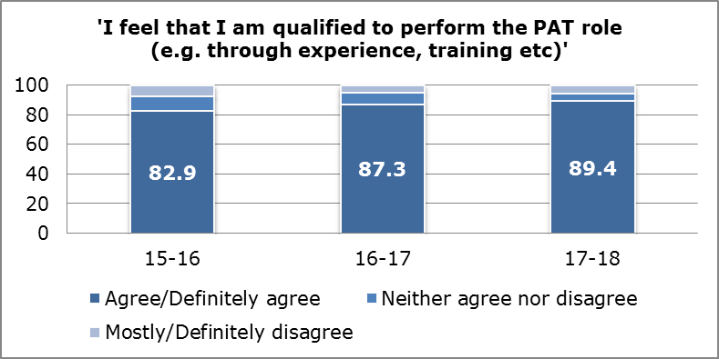
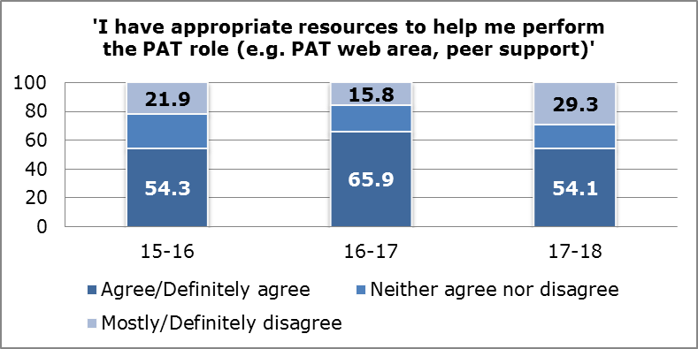
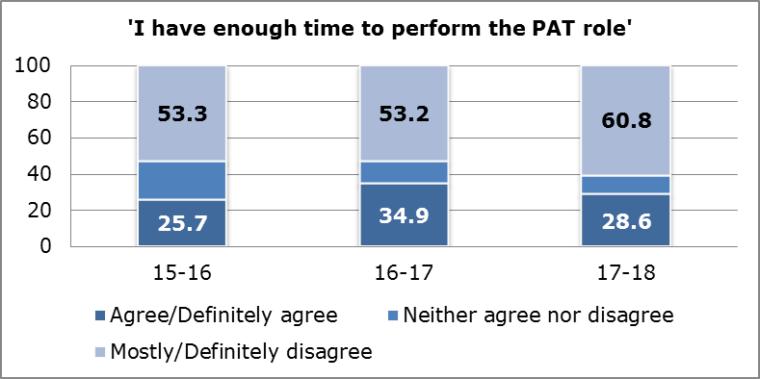
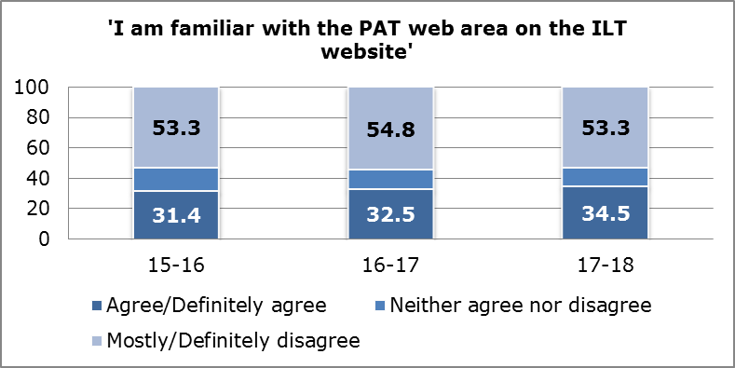
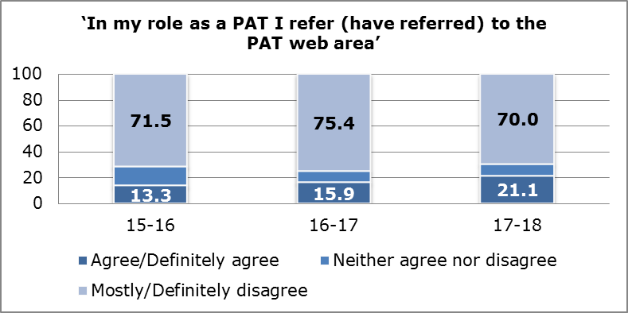
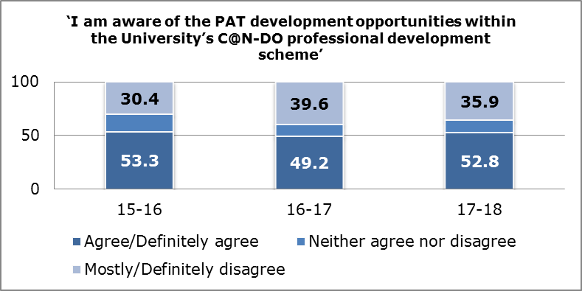
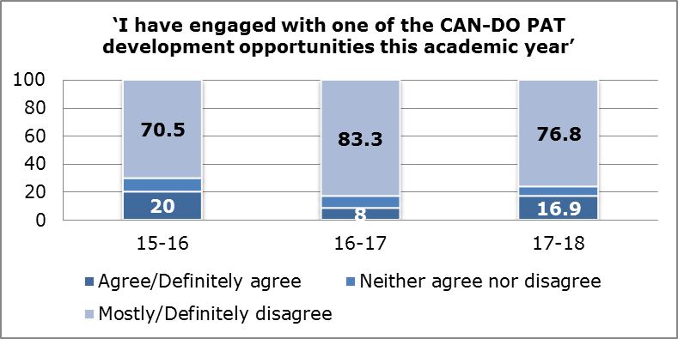
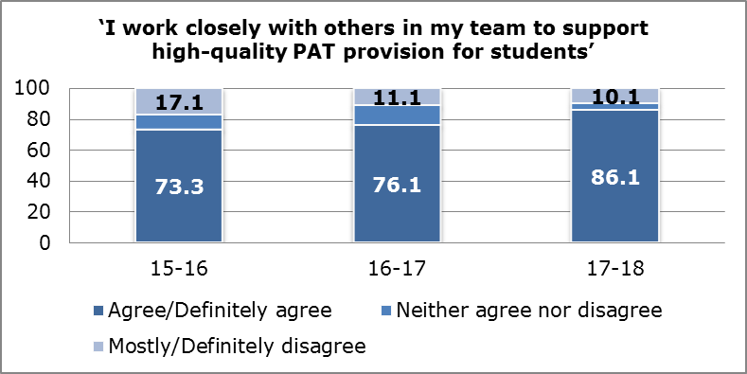
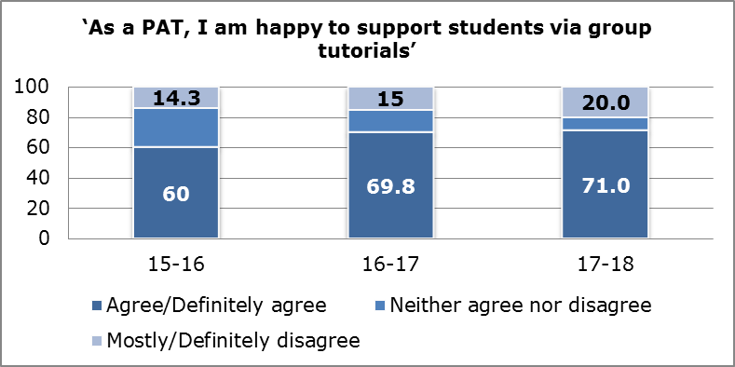
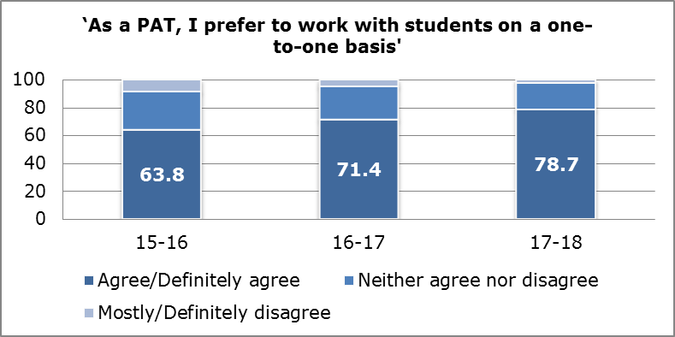
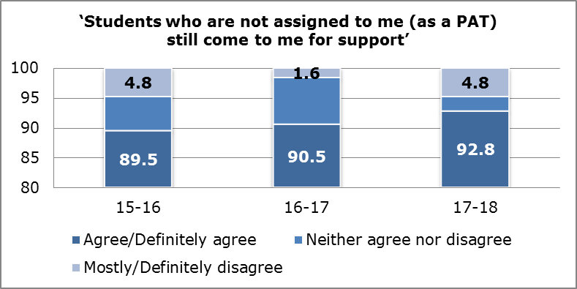
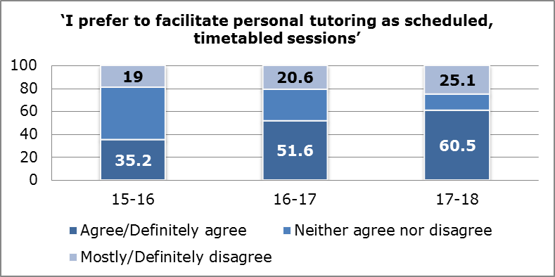
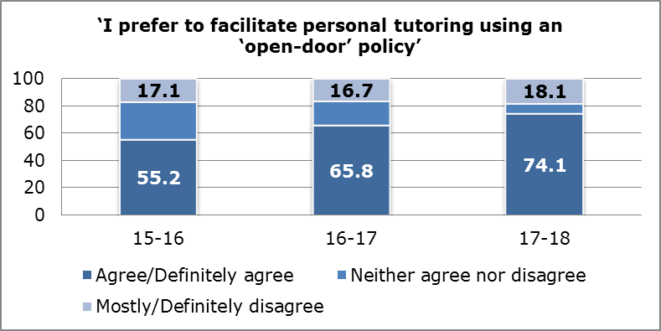
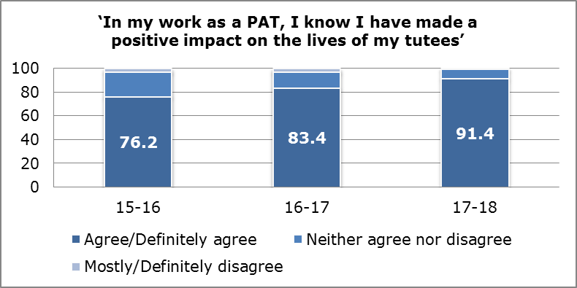
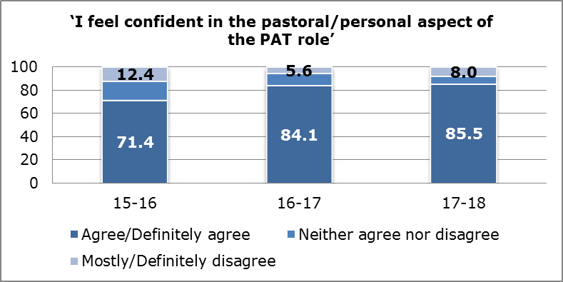
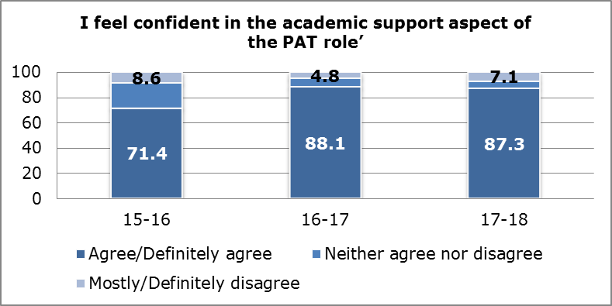

APPENDIX 4: Faculty Tables by Key Questions
I feel that I am qualified to perform the PAT role (e.g. through experience, training etc)
 | FAST | FBL | FEH | FHS
Agree | 82.9% | 91.1% | 95.5% | 87.7%
Neither Agree or Disagree | 2.9% | 4.4% | 4.5% | 6.2%
Disagree | 14.3% | 4.4% | 0.0% | 6.2%

I have appropriate resources to help me perform the PAT role (e.g. PAT web area, peer support)
 | FAST | FBL | FEH | FHS
Agree | 40.5% | 51.2% | 80.5% | 53.8%
Neither Agree or Disagree | 21.6% | 17.1% | 17.1% | 15.4%
Disagree | 37.8% | 39.0% | 12.2% | 29.5%

I have enough time to perform the PAT role
 | FAST | FBL | FEH | FHS
Agree | 18.9% | 31.7% | 41.5% | 25.6%
Neither Agree or Disagree | 13.5% | 0.0% | 22.0% | 9.0%
Disagree | 67.6% | 68.3% | 36.6% | 65.4%

I work closely with others in my team to support high-quality PAT provision for students
 | FAST | FBL | FEH | FHS
Agree | 87.2% | 76.2% | 97.6% | 84.3%
Neither Agree or Disagree | 5.1% | 7.1% | 2.4% | 2.4%
Disagree | 7.7% | 16.7% | 0.0% | 13.3%

Students who are not assigned to me (as a PAT) still come to me for support
 | FAST | FBL | FEH | FHS
Agree | 94.7% | 93.5% | 91.1% | 92.3%
Neither Agree or Disagree | 5.3% | 0.0% | 4.4% | 1.3%
Disagree | 0.0% | 6.5% | 4.4% | 6.4%

In my work as a PAT, I know I have made a positive impact on the lives of my tutees
 | FAST | FBL | FEH | FHS
Agree | 83.8% | 90.5% | 93.0% | 95.9%
Neither Agree or Disagree | 16.2% | 9.5% | 7.0% | 2.7%
Disagree | 0.0% | 0.0% | 0.0% | 1.4%

I feel confident in the pastoral/personal aspect of the PAT role
 | FAST | FBL | FEH | FHS
Agree | 75.7% | 86.0% | 95.1% | 84.4%
Neither Agree or Disagree | 13.5% | 2.3% | 2.4% | 7.8%
Disagree | 10.8% | 11.6% | 2.4% | 7.8%

I feel confident in the academic support aspect of the PAT role
 | FAST | FBL | FEH | FHS
Agree | 94.1% | 91.1% | 90.0% | 80.3%
Neither Agree or Disagree | 2.9% | 0.0% | 5.0% | 10.5%
Disagree | 2.9% | 8.9% | 5.0% | 9.2%

