

Ignite Your SPARK with the University of Northampton

The Schools Engagement (Widening Access) team are proud of our range of diverse opportunities designed to support young people to demonstrate:

Social Impact
Positivity
Aspiration
Resilience
Knowledge

Our opportunities support young people from underrepresented
backgrounds to understand future career and education choices, whilst
developing their curiosity, confidence to ask questions and work with others.

Meet the Schools Engagement team here!

The following opportunities are limited in capacity.
Email us at schoolsengagement@northampton.ac.uk
to register your interest in any of these activities, workshops or events.
Table of Contents
Our Opportunities Menu 3
Debating Champions 4
Dental Health workshops 5
Ignite Your Future 6
School Tasking 7
Seizing Futures 7
SPARK Student Award 8
STEAM Northants 9
Take One Picture 10
Important Information 11
Transport Reimbursement 11
Data and Consent 11
SPARK and Partner Schools/Colleges 11
Risk Assessment 11
Photography and Videography Disclaimer 11
Partners and Sponsors 12

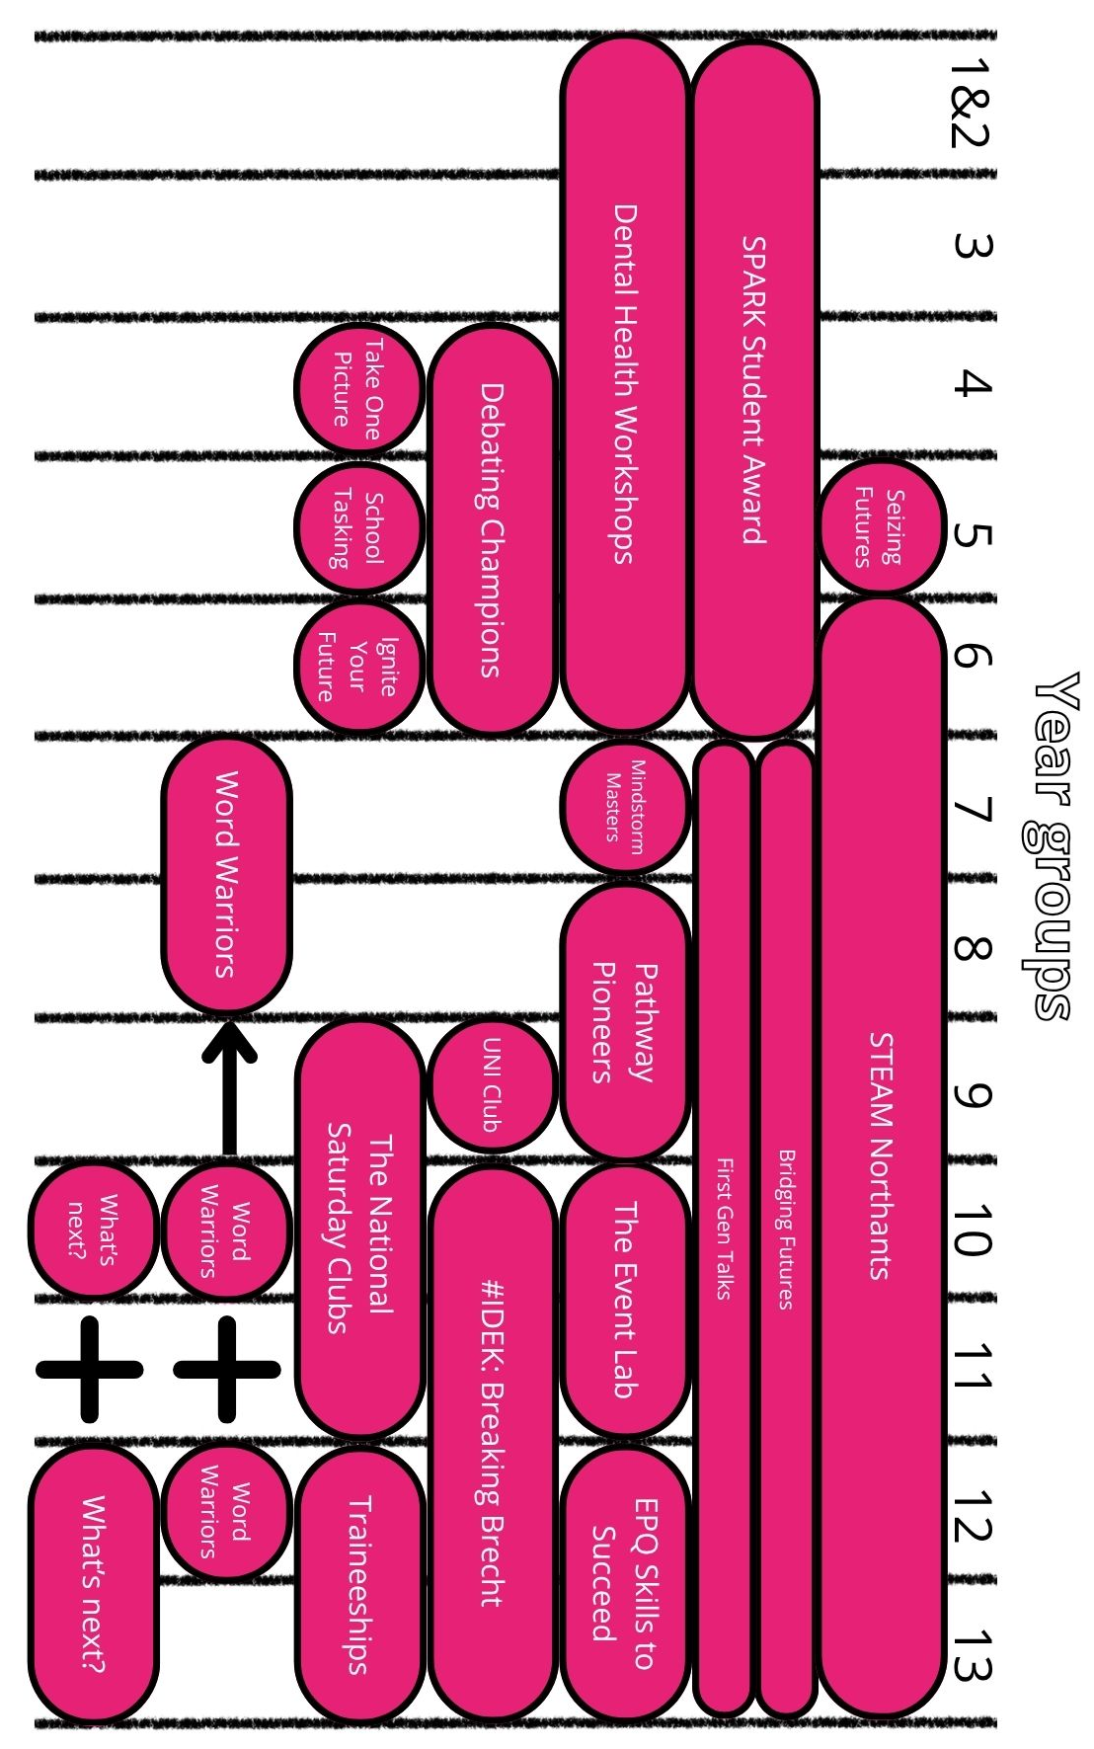
Our Opportunities Menu

Debating Champions
(DRET schools only)

Years: 4 - 6
Location: Waterside Campus & in your school

Transport reimbursement of up to £350 available

Empower your pupils to become confident speakers, critical thinkers and persuasive communicators through Debating Champions, delivered in partnership with
Noisy Classrooms, the UK's leading experts in critical oracy.

From learning to debate, to competing and celebrating success, this programme
gives pupils the chance to find their voice and shine.

Phase 1: Cicero Cup National Competition
Each school receives:
- A 2-hour in school oracy and debating workshop for up to 30 pupils
- Debating skills training for a team of 8 pupils at the Debating Champions
launch event at UON
- Staff CPD and supporting resources
- Entry into the Northamptonshire heat of the Cicero Cup – the winners and runners-up progress to the National semi-finals!

Phase 2: Oratory Festival
- A celebration of pupil voice and achievement.
- Each school receives places for 6 pupils in a year group to attend the Oratory Festival at the University of Northampton

Key Dates (Commitment from participating schools and pupils is required for all programme dates):
- September/October 2026: In school debating workshop
- 13th October 2026: Debating Champions Launch Event at UON
- 27th January 2027: Cicero Cup Northamptonshire Heat at UON
- Spring Term: Additional support for progressing teams in Cicero Cup semi-finals
- 19th May 2027: Oratory Festival at UON
- Summer Term: Cicero Cup national semi-finals for winning teams

Noisy Classrooms has a long-standing partnership with the University of Northampton and is recognised as a national leader in developing oracy skills in schools.

Dental Health workshops
Years: 1 - 6
Dates: Between January to July 2027
Location: In your school

30 students per workshop

Facilitated by qualified, registered dental professionals within the Dental Nursing team,
with support from student dental nurses.

This FREE one-hour workshop focuses on promoting oral health care, covering topics including toothbrushing, diet, basic anatomy (tailored to the audience's age),

along with interactive activities such as dressing up and singing.

Ignite Your Future
Year: 6

An exciting opportunity for year 6’s to understand more around
future choices and progressing into higher education.

Phase 1 - Your Future Your Choice Workshop
Dates: Flexible
Location: In your school hall
Duration: 45-60 minutes

Unleash the excitement of what's ahead with some pre-learning before
you set foot on a university campus.

Led by our Student Ambassadors, explore endless subjects, dispel university myths
and learn more about pathways through education. Students discover the exciting opportunities awaiting them after they finish school. It's not just about making choices;
it's about making their future a blast!

Phase 2 - Ignite Your Future Primary Open Day (University Visit)
Date: Tuesday 23rd March 2027
Location: University of Northampton, Waterside Campus
Transport reimbursement of up to £350 available

Dive into the exciting world of university life with our Ignite Your Future
day. Designed for year 6 students, the primary open day at UON includes a campus hunt, engaging subject workshops and myth-busting about who goes to university.

Students will get hands-on experience of university subjects led by current academics, explore the vast array of subjects available, and uncover the connections
between them, careers and future job possibilities.

Don't miss out on this fun glimpse into university life!

Commitment is required from your school for both phases.

School Tasking
Year: 5
Dates: February – June 2027
Location: In school & at the University of Warwick

Transport reimbursement of up to £350 available for the regional finals and the
Champion of Champion finals, should your school’s team progress
30 pupils per school

Do you and your pupils love watching Taskmaster? The University of Northampton is excited to run School Tasking again for 2026–27. Inspired by Channel 4’s Taskmaster, this national initiative sees us join 48 universities across the UK to help Year 5 pupils explore the law through creative, hands-on challenges. Pupils work in teams of 5 or 6 and compete against other schools, locally and nationally, for the title of School Tasking Champions.

Tasks include drawing, word searches, role-playing court cases and using Lego & Playdoh to bring legal scenarios to life. The project encourages every pupil to showcase their unique strengths while building teamwork, communication and problem-solving skills
all wrapped up in friendly competition.

The final competition promises spirited rivalry and lots of fun!

Seizing Futures
Year: 5
Dates: Flexible on request from April 2027
Location: In your school hall
Duration: 45 minutes

This interactive workshop encourages Year 5 pupils to recognise the many opportunities available to them, both in school and beyond. Through engaging activities and discussion, pupils will explore how trying new experiences can help them make friends, develop new skills, build confidence and learn more about who they are.

Using familiar and inspiring role models, the session introduces the concept of opportunity and highlights how stepping outside of their comfort zone can open doors to new interests, talents and future possibilities.

The workshop also provides an age-appropriate introduction to higher education, helping to lay the foundations for future conversations about supporting aspirations, learning pathways and the options available after school.

SPARK Student Award
Years: Key stage 2*
Dates:
Wednesday 14th October: Launch at UON
Thursday 1st July 2026: Celebration Day at UON
Transport reimbursement of up to £350 available for the launch event
8 – 12 places per school

*Ideally for KS2, the Award can be adapted to work with cross-phase groups,
such as the School Council, with in-school staff support.

Ignite the spark in your schools to foster social responsibility, collaboration, problem-solving and innovation. Focussed on the UN Sustainable Development Goals (SDG’s), the SPARK Student Award encourages students to work together on projects
that positively impact their school and community.

A part of the #iwill movement, the SPARK Student Award contributes to the Power of Youth Charter, where students could become an #iwill changemaker. Participants will develop teamwork, communication and presentation skills while promoting respect and collaboration.

The Award offers opportunities to gain practical skills and strengthen connections with the local community, allowing students to have an active voice in their school. Previous projects have included enhancing well-being, promoting healthy lifestyles, improving playground behaviour, creating outdoor learning areas and supporting the elderly community.

Schools will be allocated a dedicated Student Ambassador who will visit the school
and be able to support the group with their planning.

In school commitment:

The Award will need the support of a dedicated member of staff in school and
regular fortnightly meetings in place for the SPARK team to be able
to monitor progress and make an impact.

STEAM Northants
Years: 6 - 12
Dates: Wednesday 9th June 2027
Location: Waterside Campus

Gatsby Benchmarks: 2, 4, 5, 7
Transport reimbursement of up to £350 available
1 coach per school

Join us at the University for our exciting and inspirational day full of workshops, shows and exhibitions with hands-on activities. These will inform, inspire, excite and encourage
young people to explore the amazing world of science, technology,
engineering, art and maths (STEAM).

Meet University experts, participate in science with real scientists, explore our specialist
work areas - such as the TV studios, Engineering labs, Sports Rehab clinic and our
Ambulance training suite, and discover what studying at university is like
through discussions with our own students.

Your students will meet Apprentices and trainees, talk to business and employers, explore volunteering opportunities and discover the skills needed to land their dream job.
With hands-on, interactive exhibition areas, they'll ignite their imaginations
and leave buzzing with exciting career ideas!

Spaces are limited and the event is open to all Primary
and Secondary schools in Northamptonshire.

Visit the STEAM Northants webpages for more information.
northampton.ac.uk/steam-northants

Take One Picture
for NPAT schools only

Years: 4
Dates: January to July 2027 teaching in schools
Location: Waterside Campus and in your school

The UON Take One Picture project is a collaboration between the University,
Northampton Primary Academy Trust (NPAT) and The National Gallery, London
which aims to improve learning and teaching of art, writing and 21st Century skills
including self-belief, motivation, empathy and critical thinking.

The Take One Picture project invites schools and educators to teach children by
focusing on a single picture from The National Gallery’s collection.

Art students from UON will take up residence in all NPAT schools to assist teachers and school children from year 4 to develop their thinking, making skills and their understanding of art.

Students will create a final piece of work to be displayed at UON.

All artwork will be displayed either digitally or physically in an inspiring display at
Waterside Campus as a formal art exhibition. NPAT schools will be invited to
visit the university to see the exhibition and the year 4 student’s loved ones
will be invited to a special private viewing of the exhibition.

Key dates:

- January 2027: Take One Picture Teacher Launch at Waterside Campus (artists in residence will meet their partner teachers)
- February – March 2027: Artists in Residence in schools for weekly art sessions
- 7th and 8th July 2027: Exhibition viewings for NPAT schools
- 7th July 2027 (6pm-8pm): Evening exhibition viewing for families, friends, loved ones and the community

Important Information

Transport Reimbursement
Schools with a signed Information Sharing Agreement, a returned Data Collection Form and Register for the pupils who attended an on campus opportunity will be eligible to apply for a Transport Reimbursement of up to £350. Please click here to find out how to claim it.

Data and Consent
The University of Northampton offers free enriching experiences for students, including assemblies, workshops, events and activities. To track student engagement and
evaluate impact, we need your full cohort data, a list of names of students who attended specific activities/events, as well as signed Partnership Agreement and Information Sharing Agreement. This helps us report accurately to the Office for Students and secure ongoing funding. Your cooperation is vital to continue providing free opportunities
for your school.

For further information, email the Schools Engagement team
or view the Data and Information Sharing Agreements, Data Collection Forms
or Activity Register sections of our website.

SPARK and Partner Schools/Colleges
Need to know if your school or college is able to work with the Schools Engagement Team?
Click here.

Risk Assessment
Find our latest risk assessment for campus visits here.

Photography and Videography Disclaimer
Photography and filming may take place during any of our activities/events (on campus or in your school/college) for publicity purposes. It is your schools’ responsibility to acknowledge that photography and filming will take place during our activities/events. The school/college must inform our team of any relevant image consent restrictions relating to participating students and will work collaboratively with the team to ensure that photography, filming, safeguarding, data protection and any required consent arrangements are managed in accordance with both organisations' policies and procedures.

Please see our photography and filming guidance for engaging with minors.

Partners and Sponsors

