
​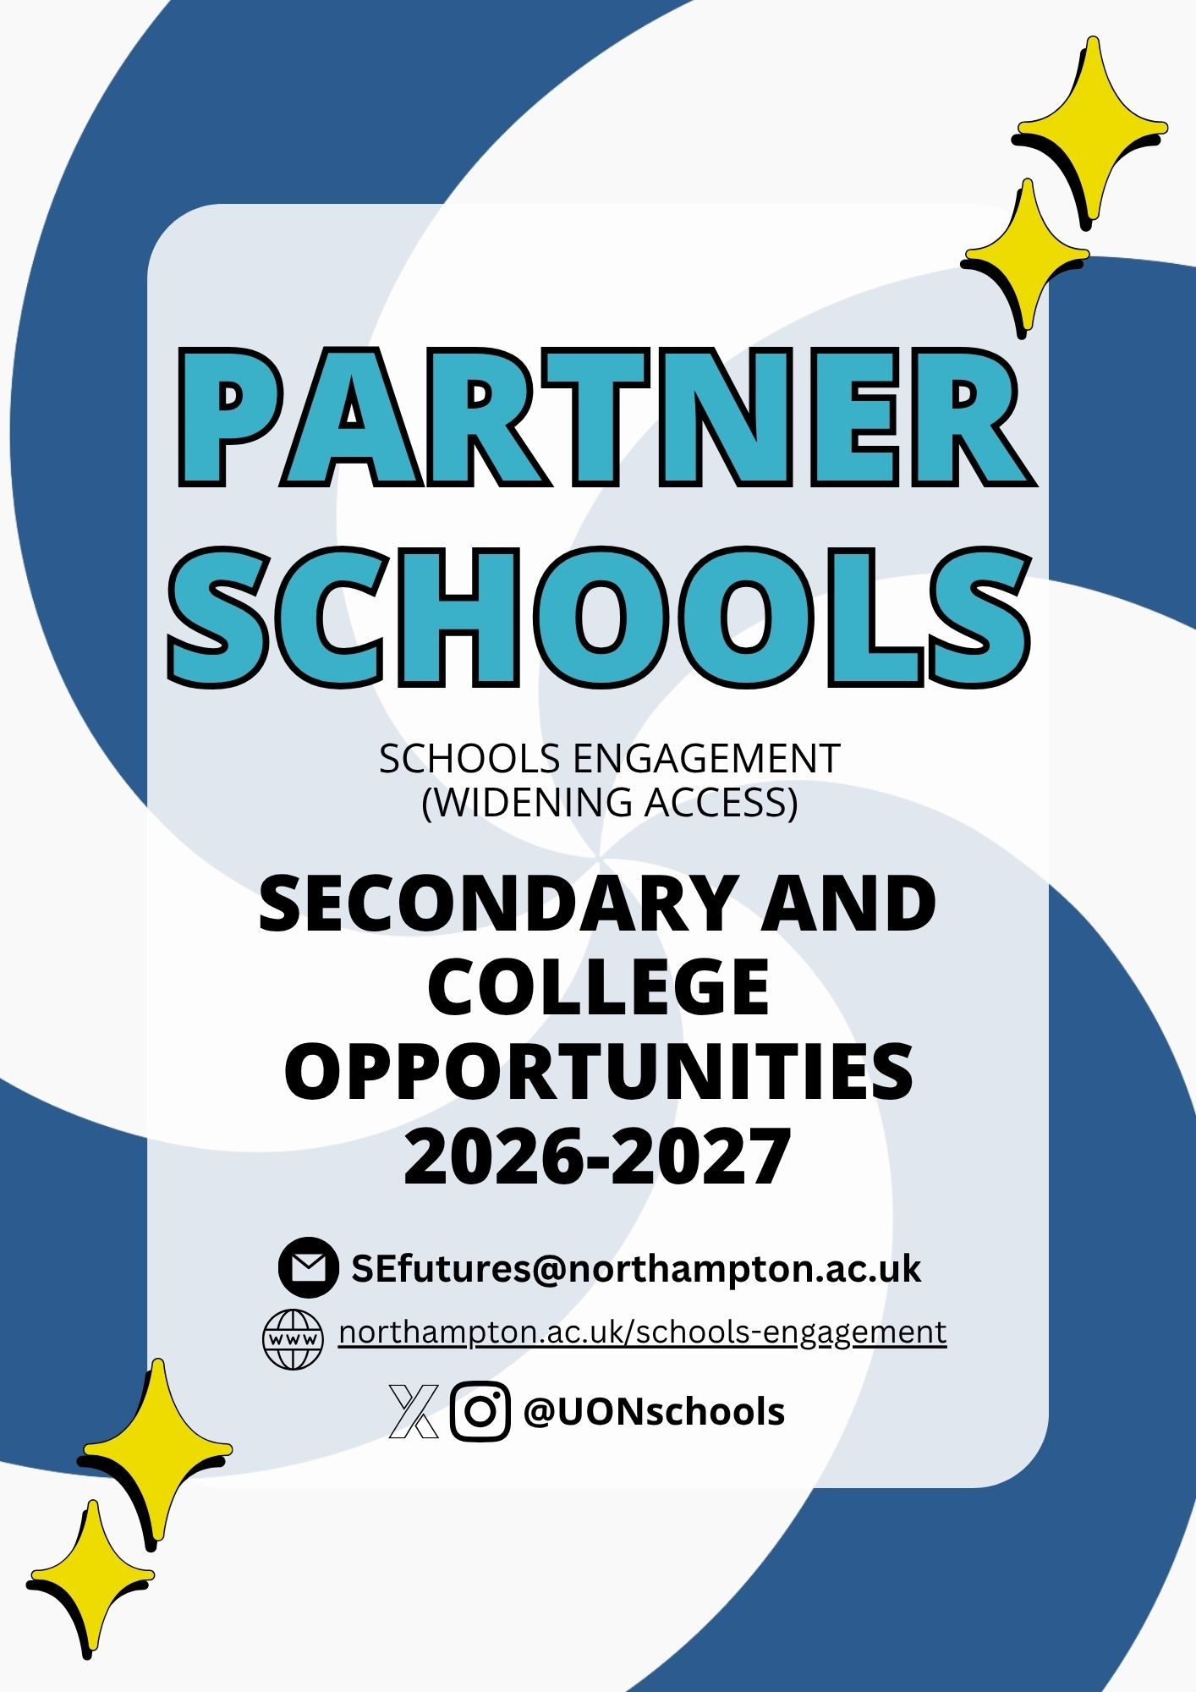
Ignite Your SPARK with the University of Northampton

The Schools Engagement team are proud of our range of diverse opportunities designed to support young people to demonstrate:

Social Impact
Positivity
Aspiration
Resilience
Knowledge

Our opportunities support young people from underrepresented
backgrounds to understand future career and education choices, whilst
developing their curiosity, confidence to ask questions and work with others.

Meet the Schools Engagement team here!

The following opportunities are limited in capacity.

To register your interest in any of the activities, workshops or events email us SEfutures@northampton.ac.uk

The University of Northampton is part of Aspire Higher (Uni Connect). The Schools Engagement team offer to schools includes targeted opportunities to reduce inequality and work with specific underrepresented groups in higher education. The team works collaboratively to support underrepresented young people to progress to further and higher education.

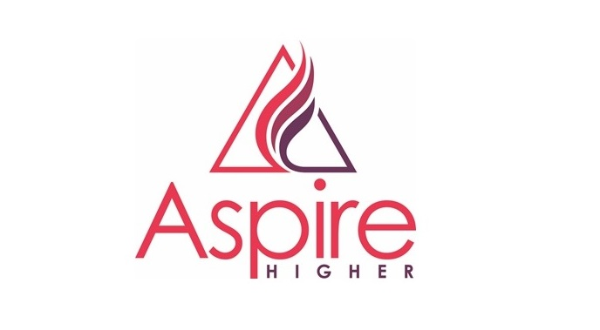



Table of Contents
Our Opportunities Menu 4
#IDEK: Breaking Brecht 5
Bridging Futures 6
EPQ Skills to Succeed 7
First Gen Student Talks 8
Mindstorms Masters 9
Pathway Pioneers 10
Schools and Colleges Liaison Team at UON 11
STEAM Northants 12
Teacher Networks 13
The Event Lab 14
The National Saturday Club at UON 15
Traineeships 16
UNI Club 17
Webinars for Parents and Carers 17
What’s Next? 18
Word Warriors 19
Important Information 20
Transport Reimbursement 20
Data and Consent 20
SPARK and Partner Schools/Colleges 20
Risk Assessment 20
Photography and Videography Disclaimer 20
Partners and Sponsors 21

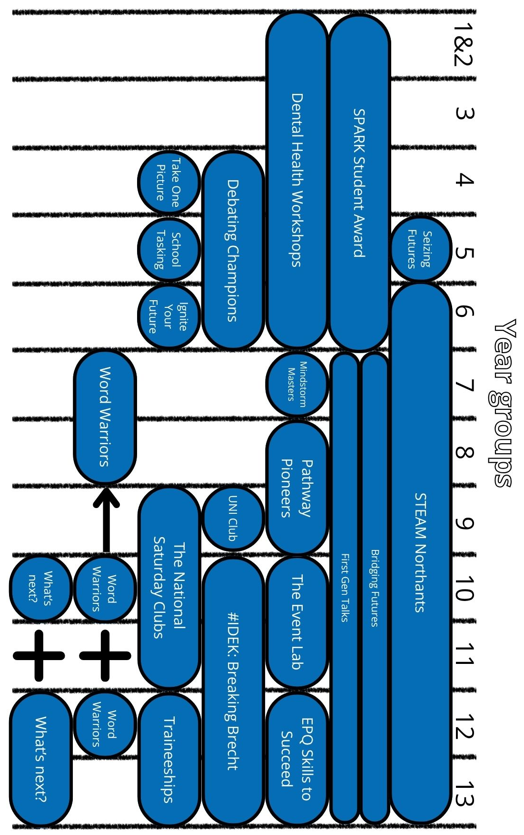
Our Opportunities Menu

#IDEK: Breaking Brecht
Years: 10, 12 or 13
Dates: Whole school year
Location: In your school

Gatsby Benchmarks: 3, 5, 7

IDEK Theatre Company is a physical theatre company based in the Acting department at
the University of Northampton. Founded in 2017, they strive to be relatable
to each of their audience members.
This project uses the work of German playwright and theatre practitioner Bertolt Brecht as inspiration. Working with your Acting, Drama, and/or Performance students, the programme will include practical lessons to develop knowledge, support attainment and model techniques for teachers to develop their own practice. Schools have attributed an increase in GCSE grade to previous #IDEK interventions.

Starting in the Autumn term, the #IDEK team will model lessons and support with delivery, with lessons linked to the National Curriculum. The #IDEK team will work with the school to identify the best year group and approach that is needed. The programme will continue into the summer term, working in partnership with the school.

Schools will be expected to be flexible and be open to collaborative teaching. The team will work with you to enable the programme to complement existing curriculum delivery.



Bridging Futures
Years: 7 – 9 and 10 – 13
Dates: November 2026 - June 2027
Location: In-school & Waterside Campus

Gatsby Benchmarks: 3, 5, 7
A maximum of 12 students per workshop
Multiple workshops can be delivered during the school day

Campus visit:
Transport reimbursement of up to £350 available

Bridging Futures is a pilot programme developed as part of the University of Northampton's commitment to widening participation in higher education.

Specifically designed for children and young people with care experience, the programme aims to raise awareness of higher education opportunities and support participants in making informed decisions about their future. Through engaging and interactive sessions, young people will be encouraged to explore their aspirations,
challenge common misconceptions about university and recognise
higher education as a realistic and achievable option.

Participants will have the opportunity to attend informal information sessions, hear from University of Northampton student ambassadors with care experience and visit the University's Waterside Campus. The programme will provide an insight into university life
and increase understanding of the academic, financial and pastoral
support available to care-experienced students.

By improving knowledge, confidence and awareness of post-16 and post-18 progression pathways, Bridging Futures aims to equip young people with the information and support needed to make positive, informed choices about their future.

EPQ Skills to Succeed
Years: 12 & 13
Dates: October 2026 to June 2027
Location: Waterside Campus & in your school

Gatsby Benchmarks: 3, 5, 7

Extended Project Qualification (EPQ) Skills to Succeed is a tailored intervention consisting of both in-school workshops and/or an on-campus visit, depending on the school's delivery timetable.

Through this programme, we will support your students in becoming more critical,
reflective and independent learners.

Enhancing their:
- Planning
- Research
- Analysis
- Synthesis

EPQ Days on campus:
These on-campus skills days include workshops on critical thinking, research skills and academic writing, led by experts. Students will also have the chance to explore academic materials and identify useful books and journals for their projects.
Held during half term and school holidays, these dates will provide students with a dedicated space and support to make progress on their project.
Students will sign up independently, and travel support available will be discussed upon request and depend on the distance to campus from your school.

EPQ Workshops in school:
These in-school workshops can cover the benefits of studying an EPQ, selecting and narrowing down your topic, tracking and managing your research,
as well as providing guidance on searching for appropriate sources.

First Gen Student Talks
Years: 7 – 13
Dates: Flexible on request
Location: In your school

Gatsby Benchmarks: 4, 7, 8
Bookable workshop | Up to one timetabled lesson

Our First Gen Students Talks are delivered by current university students who are the first generation in their family to access higher education, meaning their parents
or grandparents did not attend university.

Through honest and inspiring personal stories, our First Gen student ambassadors share their journeys to university, including the challenges they have faced,
how they adapted to university life and the barriers they have overcome.

These sessions help challenge misconceptions about higher education, support aspirations, and show pupils that university is accessible regardless of family background
or prior experience.

Each session can be tailored to your school's needs, with content adapted to suit specific year groups, themes, audiences or priority areas.

To book a First Gen Student Talk, please let us know your preferred dates and times. Sessions can be delivered within a single timetable lesson.

Mindstorms Masters
Year: 7
Dates: January to July 2027
Location: Launch event at Cummins in Daventry or at Waterside Campus
& sessions in your school

Gatsby Benchmarks: 4, 5, 6, 7
Transport reimbursement of up to £350 available for the launch event
30 places available per school

An exciting opportunity for year 7 students to participate in Mindstorms Masters, a weekly LEGO and coding club where they will build and programme their own robot in small teams.

By participating in Mindstorms Masters, students will build a LEGO Mindstorms robot and gain experience in using Word Blocks (a LEGO software similar to Scratch)
to code a programme and complete various challenges.

Mindstorms Masters has been designed to nurture the following skills in year 7: imagination, creativity, perseverance, resilience, teamwork, problem solving and communication.

The programme starts with a Launch Day at Cummins or at Waterside Campus where pupils will build their robots, followed by 4 x 1 hour workshops in the following 4 weeks. Students will be supported by Student Ambassadors as well as apprentices from Cummins.

Your students will explore the world of engineering and delve into education routes
as well as higher education all whilst having fun!

Pathway Pioneers
Years: 8 & 9
Dates: March to June 2027
Location: Waterside Campus & in your school

Gatsby Benchmarks: 1, 4, 7
Transport reimbursement of up to £350 available for the celebration event
30 places available per school in 4 schools

This exciting programme helps year 8 and 9 pupils explore their ambitions, discover future pathways and gain the knowledge and confidence needed to make informed GCSE choices.

Please note: Sessions 1-4 should be delivered before pupils select their GCSE options, allowing them to use what they have learned throughout the programme to support their decision making.

Session 1: The Power of Your Choices
Assembly for Year 8/9 cohort (minimum 20 minutes)
- Introduction to GCSE options and future pathways

Session 2: Dare to Dream
Workshop for 30 selected pupils (1 timetabled lesson)
- Exploring future aspirations
- Post-16 options and pathways
- Interactive careers activities

Session 3: Every Choice Tells a Story
Workshop for the same 30 pupils (1 timetabled lesson)
- Delivered by a University of Northampton student ambassador
- Discusses their personal journey into higher education
- Exploring the choices, challenges and opportunities that shaped their path

Session 4: What's Your Dream?
Workshop for the same 30 pupils (1 timetabled lesson)
- Create a personal aspirations mood board
- Prepare for the celebration event & select two pupil presenters

Session 5: Pathway Pioneers Celebration Event
At the University of Northampton on 22nd June 2027
- The same 30 pupils will be invited to campus to celebrate their achievements, showcase their aspirations and hear from their peers
- The two pupil presenters from your school must be present

Schools and Colleges Liaison Team at UON
www.northampton.ac.uk/community/schools-and-colleges/schools-and-colleges-liaison

Email schools.liaison@northampton.ac.uk or call 01604 892433
The Schools and Colleges Liaison team are dedicated to informing and inspiring students across the UK about Higher Education and applying for University. Working closely with teachers, careers advisers, students and parents, they offer both in school and virtual sessions designed to prepare students for the university application process and student life.

Personal Statement Support
Getting the personal statement right is important. It not only supports your university application but reflects you. For students who have completed the Personal Statement session and have their first draft ready to go, some tips and feedback will be provided on how to improve it. Feedback can only be provided on courses offered at UON to ensure relevant advice is provided.

Talks for Students
Special talks for Years 11 to 13, and Level 3 Years 1 & 2

- Introduction to Higher Education
- Applying through UCAS
- Student life
- How to Get the Most Out of An Open Day and HE Exhibition
- Next steps: Application to Enrolment
- Student finance and/or Budgeting
- Interview Skills
- UCAS Clearing

Annual Teachers & Advisors Conference
Keep an eye on your inbox for your invite.

UON Open Days
Throughout the year. See website for more details.

Subject Events and Taster Days
A variety of events and activities for school and college groups throughout the year both for specific course areas and for general advice, guidance and information. See the website for more details and dates.

Guest Lectures
To inspire and inform 16 – 18 year old students on the range of opportunities open to them, giving an introduction to university study. Lectures last approximately 1 hour with a minimum of 10 students per session. Please note, lectures may also be available virtually and
are subject to availability.

STEAM Northants
Years: 6 – 12
Dates: Wednesday 9th June 2027
Location: Waterside Campus

Gatsby Benchmarks: 2, 4, 5, 7
Transport reimbursement of up to £350 available
1 coach of pupils per school

Join us at the university for our exciting and inspirational day full of workshops, shows and exhibitions with hands-on activities. These will inform, inspire, excite and encourage
young people to explore the amazing world of science, technology,
engineering, art and maths (STEAM).

Meet university experts, participate in science with real scientists, explore our specialist
work areas - such as the TV studios, engineering labs, sports rehab clinic and our
ambulance suite, and discover what studying at university is like
through discussions with our own students.

Your students will meet apprentices and trainees, talk to businesses and employers, explore volunteering opportunities and discover the skills needed to land their dream job.
With hands-on, interactive exhibition areas, they'll ignite their imaginations
and leave buzzing with exciting career ideas!

Spaces are limited and the event is open to all primary
and secondary schools in Northamptonshire.

Visit the STEAM Northants webpages for more information.
northampton.ac.uk/steam-northants

Teacher Networks
Dates: September 2026 to June 2027
Location: Waterside Campus

Gatsby Benchmarks: 1

EPQ Coordinator Network

Join a dynamic community of teachers dedicated to enriching the EPQ experience for students across Northamptonshire. Whether you're new to supervising or a seasoned coordinator,
the EPQ Network offers a space to share best practices, tackle challenges and spark innovation.

From project ideas to informal moderation, we’re here to support each other in guiding students toward independent, meaningful research. Schools who do not currently deliver the EPQ are also welcome to attend. Lunch will be provided.

Heads of 6th Form County Network
The Head of 6th Form County Network has been running since 2016 and meets at UON's Waterside Campus three times across the year (Nov, March, June) between 1.30pm and 4.30pm and includes free parking and lunch.

The agenda is focused on staff CPD and student outcomes and includes workshops on apprenticeships and UCAS among others. At each meeting there is also a collaborative session for Heads of 6th to talk to each other about aspects of their own schools and post 16 learners.

The Event Lab
Years: 10 & 11
Dates: October 2026 to February 2027
Location: Waterside Campus

Gatsby Benchmarks: 3, 4, 7
30 places, 4 places per school

This traineeship at the university focuses on project management and event management. Students will learn through in a mix of theory and practice, gaining transferable skills while collaborating with university staff and peers. They will also join the university ceremonies team for the Faculty of Business and Law graduation.

The program covers:
- Introduction to event management
- Idea sessions and event design
- Planning and project management
- Teamwork and budgeting
- Venue sourcing and marketing
- Ticketing, sponsorship and fundraising
- Event delivery, risk management and evaluation

Participating schools will be paired with UON Student Ambassadors for support and students will present to an industry panel on a selected topic. The Event Lab is suitable for students eager to enhance their project management skills and explore new opportunities.

Key dates:
- Twilight Workshops: 14th October to 2nd December 2026 (4 – 6pm)
- UON Graduation: 12th November 2026
- Online and face to face support with the Event Lab Buddies: January to February 2027
- On campus event with industry professionals: February 2027

Registration will follow a school assembly.

The National Saturday Club at UON
Years: 9 – 11
Dates: 3rd October 2026 to mid-July 2027 (term time only)
Location: Waterside Campus & trips to London

Gatsby Benchmarks: 3, 4, 5, 7
Clubs available: Art&Design or Flim&Screen
25 places available per club – students must complete an online application

Do you know a young person aged 13–16 with a passion for creativity, art, design, photography, film or storytelling?

The University of Northampton is proud to offer two FREE clubs,
Art&Design and Film&Screen, as part of the National Saturday Club programme.

These exciting weekly sessions give young people the opportunity to develop new skills, build confidence, explore their creativity and discover future education and career pathways.

Why join a Saturday Club?
- Build confidence, wellbeing and self-belief
- Up to 60 hours of free expert tuition
- Discover higher education and creative career opportunities
- Meet likeminded young people and make new friends
- Access specialist university facilities and equipment
- Take part in national events, including industry masterclasses and public exhibitions
- Open to all abilities in a welcoming and inclusive environment

Led by expert tutors, students will take part in hands on creative projects and visits to museums and galleries️. Young people will also have opportunities to celebrate and showcase their achievements throughout the programme.

Saturday Clubs can be especially beneficial for young people who may face barriers to accessing creative opportunities, helping them unlock their potential, broaden their horizons and gain valuable future skills.

Traineeships
Years: 12 &13
Gatsby Benchmarks: 3, 4, 6, 7
Transport is available from school to campus, with return transport home provided
following each session.

Film & Screen
Dates: Spring 2027 (4pm – 6pm)
Location: Waterside Campus
15 places available

Ideal for students interested in careers in film, television, and digital media production, the Film & Screen Traineeship offers hands-on experience and insight into the contemporary media industry. Over six weeks, students will work on creative production projects with support from university academics and access to professional television and photography studios.
The programme is designed to develop confidence, communication, and teamwork skills while building practical technical knowledge and a deeper understanding of careers within the film and screen industries.

To gain the full benefit of the programme, students are required to attend all six sessions, which take place once a week after school for two hours.

Healthcare
Dates: January 2027 (4pm – 6pm)
Location: Waterside Campus
30 places available

This exciting opportunity gives students the chance to explore the world of healthcare through hands-on experiences across a range of disciplines. Ideal for those considering a future in the healthcare sector, with a focus on careers in Paramedic Science,
Occupational Therapy and Physiotherapy.

Over six weeks, students will take part in practical activities and interactive sessions designed to develop confidence, communication, teamwork and problem-solving skills. Participants will also gain a deeper understanding of healthcare professions and the pathways available into
these rewarding careers.

To gain the full benefit of the programme, students are required to attend all six sessions, which take place once a week after school for two hours.

UNI Club
Years: 9
Dates: January – April 2027
Location: In school

Gatsby Benchmarks: 3, 4, 7
30 places per school

University of Northampton Inspires (UNI) Club brings current PhD students into the classroom at your school to teach them a unique topic related to their research. Now in its eleventh year, UNI Club has significantly contributed to the personal and professional development of 37 University of Northampton postgraduate students, empowering them with employability skills and, for some, paving the way to a career in teaching. The curriculum culminates in an academic poster presentation assignment modelling the academic posters that PhD students create and present at conferences. They will gain an understanding of higher education and will have the ability to explore how subjects and topics at university can vary greatly from school!

Webinars for Parents and Carers
Years: for the families of year 11 to 13 students
Location: Online at 7pm

Parents and carers play a vital role in supporting young people as they make decisions about their future. Our free online webinar series, delivered by the University of Northampton, University of Bedfordshire and University of Hertfordshire, is designed to give parents and carers the knowledge and confidence to support their young person throughout the higher education journey. Sessions cover everything from helping them choose the right university and course, understanding the UCAS application process and personal statements, navigating student finance and budgeting, to preparing for Results Day and understanding how Clearing works. Led by higher education experts, these informative webinars provide practical advice, up-to-date guidance and the opportunity to ask questions, ensuring you feel equipped to support your young person in making informed decisions about their future.

Evening sessions starting at 7pm.

Dates:
14th October – Post 16 Options
10th February – Student Finance
12th May – Additional support for Students applying and whilst at University

What’s Next?
Years: 10 - 13
Dates: September 2026 – May 2027
Location: In your school

Gatsby Benchmarks: 3 & 7
30 students per workshop or assembly

Not every young person chooses university, and it is important that students understand all the opportunities available to them. Our assemblies and workshops for years 10 - 13 provide impartial information about the full range of post-16 and post-18 progression routes, enabling students to make informed choices about their future. These sessions present up-to-date information and signpost students to trusted sources where they can explore each pathway in more detail. Through engaging activities, real-life examples and practical information, students will gain a better understanding of the options available,
the entry requirements, what employers and providers are looking for
and where each pathway could lead.
Post-16 pathways (Year 10 - 11)
Students will explore information about:

- A Levels
- T Levels
- Vocational and Technical Qualifications (including BTECs and other Level 2 and Level 3 qualifications)
- Intermediate and Advanced Apprenticeships
- Foundation Learning programmes
- Supported Internships
- T Level Foundation Year
- Employment with education or training
- Specialist colleges and training providers

Post-18 pathways (Year 12 - 13)
Students will receive information about:

- Higher and Degree Apprenticeships
- Higher Technical Qualifications (HTQs)
- Employment
- Professional qualifications and
industry training
- Further Education colleges
- Gap year opportunities
- Volunteering
- Self-employment and entrepreneurship
- Armed Forces careers
- University as one of several
progression options

All sessions are designed to raise awareness of the breadth of opportunities available, helping students understand the different routes they can take and signposting them to reliable resources so they can continue exploring the options that best suit their interests,
aspirations and future goals.

Word Warriors
Years: 7, 8, 10 & 12
Dates: Flexible
Location: In your school & celebration event at Waterside Campus

Gatsby Benchmarks: 4 & 7
Transport reimbursement of up to £350 available for the celebration event
30 students per school, 5 school places

Word Warriors is a mentoring reading programme where older pupils are trained to mentor younger pupils to encourage them with their reading. Designed for Year 7 and 8 students with a reading age below 10, this flexible programme fits into your school's timetable and complements initiatives like Accelerated Reader. Younger readers enhance their reading skills and academic success, while older students gain confidence, leadership skills
and improved attendance.

Programme Structure:

- Participants: Up to 15 Year 7/8 students receive one-on-one reading support.
- Mentors: 15 selected students from Year 10 or Year 12 will undergo a 2-hour training
course to engage with younger readers effectively.
- Duration: 14 weeks
- Celebration: All participants will be invited to the University of Northampton for a
celebratory event at the end of the programme.

Important Information

Transport Reimbursement
If your opportunity has a transport reimbursement available,
please click here to find out how to claim it.

Data and Consent
The University of Northampton offers free enriching experiences for students, including assemblies, workshops, events and activities. To track student engagement and
evaluate impact, we need your full cohort data, a list of names of students who attended specific activities/events, as well as signed Partnership Agreement and Information Sharing Agreement. This helps us report accurately to the Office for Students and secure ongoing funding. Your cooperation is vital to continue providing free opportunities
for your school.

For further information, email the Schools Engagement team or view the Data and Information Sharing Agreements, Data Collection Forms or Activity Register sections of our website.

SPARK and Partner Schools/Colleges
Need to know if your school or college is able to work with the Schools Engagement Team?
Click here.

Risk Assessment
Find our latest risk assessment for campus visits here.

Photography and Videography Disclaimer
Photography and filming may take place during any of our activities/events (on campus or in your school/college) for publicity purposes. It is your schools’ responsibility to acknowledge that photography and filming will take place during our activities/events. The school/college must inform our team of any relevant image consent restrictions relating to participating students and will work collaboratively with the team to ensure that photography, filming, safeguarding, data protection and any required consent arrangements are managed in accordance with both organisations' policies and procedures.

Please see our photography and filming guidance for engaging with minors.





Partners and Sponsors
Correct as of 16th September 2026

