University of Northampton Privacy Notice

This privacy notice is to inform you about the information we collect about you from your school/college, which is to enable us to analyse our projects which help school-age pupils learn about and consider University Education. In collecting this information, we are acting as a data controller and, by law, we are required to provide you with information about us, why and how we use your data, and about the rights you have.
We are The University of Northampton, Waterside Campus, University Drive, Northampton, NN1 5PH. You can contact us by post at the above address, by email at DPO@northampton.ac.uk or by telephone on +44 1604 892823. We are required to have a Data Protection Officer, so any enquiries about our use of your personal data should be addressed to the Data Protection Officer at these contact details. You can also ask us to stop using your information once collected at any time, and the simplest way to do this is to send us an email or telephoning us using +44 1604 892823.
We will use your information to evaluate the impact of the University’s Widening Access funding in relation to the institution’s Access and Participation Plan. It is in the Public Interest for us to do this, and we will only use the data for the said research and evaluation.
Your information is stored in a national database called HEAT, and it is not sent outside of the UK. We will not use the information to make any automated decisions that might affect you.
By law, you can ask us what information we hold about you, and you can ask us to correct it if it is inaccurate using the contact details above. You can also ask for it to be erased, and you can ask for us to give you a copy of the information. Data may be retained until the student has reached their 30th Birthday. If you would prefer UoN to stop processing your information at any time, please contact DPO@northampton.ac.uk at any time.
Your right to complain – If at any time you have a complaint about our use of your information, please contact our Data Protection Officer. If after that you are still dissatisfied, you can contact the Information Commissioner’s Office via their website at www.ico.org.uk/concerns or write to them at: Information Commissioner’s Office, Wycliffe House, Water Lane, Wilmslow, Cheshire, SK9 5AF.
Below are links to the privacy notices for the HEAT database and the Office for Students.
HEAT | Office for Students
https://heat.ac.uk/privacy-notice  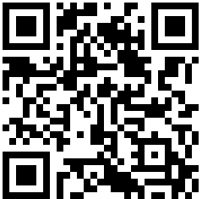 | www.officeforstudents.org.uk/ofs-privacy/privacy-notice  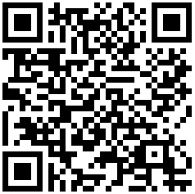

Additional Information for Parents and Guardians
The University of Northampton receives pupil information directly from your child’s school or college. We do not collect any personal information directly from parents, guardians, or pupils.
How the University uses this information
The information shared by your child’s school or college is used only to evaluate the impact of our outreach and widening participation activities, and to help us understand how effectively these activities support pupils in learning about and considering university education.
We do not use this information for marketing, decision-making about your child, or any purpose unrelated to research and evaluation.
Who to contact
If you have a question about:
- what information the school or college has collected about your child,
- what information has been shared with the University, or
- you need something corrected or updated at source,
Please contact your child’s school or college first, as they are the original collector of the data.
If you need to contact the University
If your enquiry relates to how the University of Northampton uses the data once it has been shared with us, you may contact our Data Protection Team:
📧 DPO@northampton.ac.uk
When contacting the University, we kindly ask that you copy in your child’s school or college and the Schools Engagement Team Via seaccess@northampton.ac.uk.
This ensures that any changes or decisions relating to the data are handled correctly and consistently.
Your rights
Parents/guardians (or the young person, where appropriate) may exercise rights only in relation to the information that the University of Northampton holds about their child. These rights include the ability to:
- ask what information the University holds,
- request corrections,
- Right to erase information we hold about your child.
However, any requests involving data originally collected by the school must be directed to the school first.

