

EQUALITY DIVERSITY AND INCLUSION ANNUAL REPORT
2024/25

Table of Contents
1. Introduction 4
2. Highlights 2024 4
3. Updates against our EDI Priorities 5
4. EDI Activities Across UON 11
5. Race Equality Work 12
6. Inclusion Activities 14
9. Benchmarking Staff Diversity Data 17
10. Going Forward 22

FOREWORD

As the Vice Chancellor of the University of Northampton, I am delighted to present our Equality, Diversity, and Inclusion (EDI) Annual Report for 2024/25. This report encapsulates our unwavering commitment to fostering a diverse and inclusive community where every individual is valued and empowered to thrive.

Over the past year, we have made significant strides in our EDI initiatives, guided by our core value of inclusivity and our legal and moral obligations under the Equality Act 2010 and the Public Sector Equality Duty. Our achievements include the launch of the Advance HE Race Equality Charter project, membership in the Stonewall Diversity Champions programme, and the introduction of online Race Equity training. These milestones reflect our dedication to creating an environment where everyone feels a sense of belonging.

We have also made notable progress in addressing the gender pay gap and increasing the visibility of our Staff Equality Networks. Our efforts to recruit a diverse workforce, particularly from the Global Ethnic Majority (GEM), LGBT+, and disabled communities, have been bolstered by the appointment of a dedicated Talent Acquisition Manager. Additionally, our GEM Career Development Programme and various EDI-focused learning opportunities have supported the career progression of our staff.

As we look to the future, we remain committed to advancing our benchmark charters, including the Race Equality Charter and the Stonewall Workplace Equality Index. Our new EDI Strategy, set to launch in early 2026, will take an intersectional approach to reducing inequalities and ensuring that our university continues to be a place where everyone can succeed.

I am proud of the progress we have made and grateful to everyone who has contributed to our EDI efforts. Together, we will continue to build a university community that is inclusive, diverse, and equitable for all.

Professor Anne-Marie Kilday
Vice Chancellor and CEO
University of Northampton

Introduction
This report provides an overview of the work undertaken during the academic year 2024/25 to promote equality, diversity and inclusion (EDI) across our staff community at the University of Northampton. This report also provides an update on the progress made towards achieving the objectives outlined in our 2020–2025 five-year strategy.
The report meets our legal obligation to comply with the Equality Act 2010 and the Public Sector Equality Duty it creates. It can also be argued that the University also has a moral obligation to perform this duty.
The Public Sector Equality Duty states that the University must have due regard to the need to:
- eliminate discrimination, harassment, victimisation and any other conduct that is prohibited by the Equality Act
- advance equality of opportunity between persons who share a relevant protected characteristic and persons who do not share it
- foster good relations between persons who share a relevant protected characteristic and persons who do not share it
Our overarching aim is to drive meaningful social impact, guided by our core value of inclusivity. We are committed to fostering and celebrating a diverse and inclusive community where everyone is valued and empowered to thrive.

Highlights 2024
Our highlights and main achievements for 2024 include:
- Improved use of data to inform decisions across our EDI working groups and EDI Forum
- Launched Advance HE Race Equality Charter project working towards a Bronze Race Equality Charter
- Members of the Stonewall Diversity Champions to support LGBT+ inclusion work and drive towards Stonewall Workplace Equality Index Marker
- Progressed drafting of the Gender Equality Plan
- Launched online Race Equity training to support our delivery for an inclusive organisation
- Increased Staff Equality Networks visibility to support staff wellbeing and increase a sense of belonging
- The University has seen a significant improvement in its gender pay gap over the past year

Updates against our EDI Priorities
The university has had a five-year EDI Strategic Plan and accompanying action plan to support delivery of objectives and actions that support our inclusion agenda. In 2024 we consolidated actions from various working groups and projects focusing on EDI, into one action plan identifying the various cross overs and identified three main themes running across the work areas to streamline our reporting.
The actions were drawn from the Race Equality Project, Empowering the Black Professional and the revised EDI Strategic Action Plan.
Three broad themes emerged as touch points across all the action plans and these were, recruitment, staff development and creating a sense of belonging.

Recruitment of a diverse workforce
Our EDI Plan set out to increase recruitment of diverse groups across our university staff members with a particular emphasis on increasing members from the Global Ethnic Majority (GEM), LGBT+ and disabled people into higher grades 9 and above.
The recruitment activity has been shaped by the demands of the Resilience and Institutional Sustainability Exercise (RISE). The operational pressures and limited resourcing have inevitably slowed progress on some of the strategic EDI goals.
During the period under review, the organisation recruited a dedicated Talent Acquisition Manager to focus on recruitment, retention, and advancement, with the goal of increasing the representation of underrepresented groups across the organisation. This role has been pivotal in strengthening our core recruitment infrastructure, laying the groundwork for long-term improvements. However, further progress will require adequate systems, capacity, and structural support. Our ambition is to take targeted actions to address and improve the underrepresentation of Global Ethnic Majority (GEM) colleagues, particularly at senior levels.
We have begun promoting a wider analysis of our recruitment and development data, which is reviewed at various meetings, including our EDI Forum and the Race Equality Working Group. This ensures we remain focused and can address gaps as they emerge. Members of these working groups have had the opportunity to scrutinise data from the past ten years, covering the span of our current EDI Strategy 2020-25, to support discussions around recruitment and development strategies.
Our five-year recruitment data indicates some improvements in increasing the diversity of applicants overall. However, we still need to focus on increasing the representation of underrepresented groups, such as ethnic minority groups, disabled, and LGBT+ colleagues, particularly in higher grades (Grade 9 and above) which we committed to as part of our plan. (Refer to Appendix A for detailed data).
The focused data analysis has highlighted the need for strategies to support career advancement across the organisation. We anticipate further opportunities to analyse and reflect on our data through our engagement with the on-going Race Equality Charter process.

Recruitment Webpages & Inclusive Imagery
Last summer, the recruitment webpages underwent a comprehensive refresh, incorporating inclusive imagery and messaging that emphasises accessibility and our commitment to Equality, Diversity, and Inclusion (EDI). This initiative was part of a broader effort to align the tone and visual language with the wider University of Northampton (UON) website.
We will continue to make ongoing content improvements in the coming year.

Workplace Adjustment Passport
Since the launch of the Workplace Adjustment Passport last year, we have focused on promoting its use. We are currently developing a system to monitor its usage. Increased communication about the passport through the university’s newsletter has enhanced its visibility. Additionally, the passport's promotion has been integrated into candidate communications and onboarding materials. However, there is still room for improvement in terms of overall visibility and consistent usage.
We will continue to build awareness as part of broader onboarding processes and provide guidance to hiring managers to ensure the consistent application of the passport across the organisation.

Disability Confident Scheme
The University continues to maintain its Disability Confident status. As we prepare to refresh the EDI Strategy, we want to explore how this framework aligns with our current approaches to adjustments, confidence in disclosure, and broader inclusive practices.

Digital Inclusion
The Digital Services team, and the Digital Accessibility Group, has continued to promote the accessibility and inclusion toolkit 'ReciteMe' on the website, adding two new features: a tutorial mode and a page summariser. Key initiatives include:
Ensuring that accessibility standards and guidelines are consistently adhered to when adding new features to the website. Revamping the jobs.northampton website on behalf of HR to ensure compliance with accessibility standards following a government audit.

Workforce Development
Our ambition through this objective is to ensure that our staff and managers are supported in creating inclusive behaviours and that we proactively address any gaps in EDI knowledge and any concerning behaviours through training and communication.

EDI Learning and Development Activity
A broad range of EDI-focused learning opportunities is available to both academic and professional services staff through the Staff Development Team and via LinkedIn Learning. The following participation figures demonstrate engagement during the reporting period:

Equality and Diversity Essentials | 483 completions
Challenging Unconscious Bias (e-learning): | 90 completions
Cultural Inclusion Workshops | Delivered to 5 teams, reaching 74 staff
LGBT+ and Trans/Nonbinary Awareness | 78 completions
How to Be a Good Ally | 22 completions
Confronting Gender Bias | 8 completions
Race Equity (face-to-face): | Delivered to 2 teams, involving 17 staff
Introduction to Race Equity (e-learning, launched January 2025) | 53 completions
LinkedIn Learning (EDI-tagged content | 623 unique viewers

Cross-university awareness of EDI is also being supported through collaborative initiatives. Notably, the “So Here’s the Thing” series from Library, Learning and Student Services (LLS) has provided accessible, thought-provoking content on topics such as neurodiversity (as part of Disability History Month), religion, belief, and cultural awareness in the context of higher education.

Academic and Professional Practice Scheme
During 2024-25, the focus has been on implementing the Academic and Professional Practice Scheme, accredited by Advance HE from 1 September 2024 to 31 August 2028, in alignment with the Professional Standards Framework for teaching and supporting learning in higher education (PSF 2023). The Scheme offers clear routes for staff to achieve Fellowship status, with assessment options including a written Reflective Account of Practice or an oral presentation and discussion.
The Academic Practice area of the Learning and Teaching Enhancement website provides detailed guidance on the Scheme, including specific guides for each Fellowship category.
Throughout the year, several workshops have been held to support academic staff development, covering topics such as Decolonising Yourself and Your Teaching, Enhancing Representation in the Curricula, Enhancing the Engagement of International Students, Learning and Teaching for LGBTQ+ Inclusivity, and Supporting Neurodivergent Students in Higher Education.
Data on fellowships across the institution shows favourable outcomes for most groups, out of a total headcount of 930 staff members, 43% (398 individuals) have achieved fellowship status, while 57% (532 individuals) have not.
UON Fellowships

Gaps and Opportunities
We are actively working to increase uptake of EDI learning opportunities across the organisation, particularly to build inclusive behaviours and support our race equality commitments. While the overall reach of EDI learning is encouraging, data indicates significant disparities in participation:
Self-directed training uptake is declining, whereas team-based engagement has increased where targeted interventions have been introduced.
Gender disparity remains a concern. Analysis of internally delivered training (excluding mandatory/induction sessions) shows participation rates at 72% female and 28% male.

Proposals
To maximise engagement and impact, we intend to prioritise team-based EDI development. Where teams have committed to structured programmes—such as Cultural Inclusion Workshops and Race Equity sessions—feedback has been overwhelmingly positive, and measurable improvements in team performance have been reported.
We propose working with the University Leadership Team (ULT) to identify priority teams for a rolling programme of targeted EDI interventions drawn from the existing Staff Development portfolio. This approach not only supports sustainable culture change but also has the potential to reduce engagement disparities across gender and staff groups.

Supporting Career Progression for Global Ethnic Majority (GEM) Staff
Career progression across grades remains a key area for development across the institution, and we recognise the specific need to address the progression barriers experienced by Global Ethnic Majority (GEM) staff. Addressing these disparities is central to our commitment to equity, talent development, and inclusive organisational culture.
A previous engagement with the StellarHE programme—designed to support leadership development among GEM staff—was limited in its reach and impact. Due to financial constraints, only three participants were able to access the programme, and subsequent feedback highlighted the need for more scalable, embedded, and locally relevant development interventions.
      - Developing a Home-Grown GEM Development Programme
In response, the Staff Development Team is collaborating with the EDI Team and the GEM Staff Network to co-design a new GEM Career Development Programme. This initiative is inspired by proven models such as Springboard and Navigator and is tailored to support career development at all grades and career stages. The programme will combine personal development, skills building, career mapping, and peer support, with an emphasis on overcoming structural and cultural barriers to progression.
A broader package of support is also in development to strengthen progression pathways for GEM staff, including:
Reverse mentoring as a tool to foster inclusive leadership by pairing GEM staff with senior leaders to facilitate two-way learning and a deeper understanding of lived experiences and reviewing senior sponsorship as a potential high-impact intervention to actively support the advancement of high-potential GEM staff through visible advocacy and the creation of opportunities at senior levels.
These initiatives will be underpinned by robust evaluation mechanisms to ensure meaningful outcomes and sustained change and will be monitored and supported by the People Strategy. Our aim is to create transparent, equitable progression pathways and foster an environment where GEM staff can thrive and lead at all levels of the University.

Mentoring Initiative
A major initiative for the university is the promotion of mentoring among colleagues. To support the Empowering the Black Professionals mentoring programme, specifically targeting Global Ethnic Majority (GEM) colleagues, 25 colleagues trained as mentors. The pilot programme has successfully formed over 20 mentoring relationships, involving women and GEM colleagues across the university.
Additionally, through our online platform, we have supported a student peer-to-peer mentoring programme aimed at Access and Participation students, which will continue into the next year.
Plans are in place to expand the mentoring programme across the university, encompassing other cohorts as identified needs arise.

Increasing a sense of belonging
This includes initiatives to support in creating and increasing a sense of belonging across the organisation including creating safe spaces for staff and students to report racism, harassment and sexual abuse, how we develop benchmarks against others in the sector, increase staff and student involvement in development of our policies/procedures, promote organisational dignity and respect pledges/policies and how we celebrate each other.
The university has implemented several initiatives to support a safe space for both staff and students. We have developed responsive mechanisms to report racism, harassment, and sexual abuse, including an updated online reporting system that allows for anonymous submissions and ensures that emerging themes are addressed promptly.
As part of the Empowering the Black Professional Project, various initiatives have been advanced to enhance the sense of belonging among staff and students. For example, we have increased the diversity of meals offered across campus outlets in response to student feedback. Additionally, we have included students in our working groups to ensure they can inform and co-create solutions on matters that impact them.
In collaboration with the Access and Participation team, students developed Trust Guidelines to promote engagement between staff and students across the university. These guidelines are now being incorporated into the Learning and Teaching Strategy.
Following changes to our EDI governance at the end of last year, where the Staff-Student EDI Forum was disbanded, the Students' Union now leads the Student EDI Forum. This provides an opportunity to better understand and address the challenges that students may face across the university.
    - Promoting and Developing a Sense of Belonging
Building on last year's initiative to develop an understanding of belonging across the university, we have established a Building Belonging Community of Practice . This group aims to share best practice and develop effective mechanisms to support both students and staff. Several sub-groups have emerged, focusing on enhancing the sense of belonging for students, promoting student engagement, and ensuring positive student experience.
The Belonging Practice Group plans to lead on efforts through the Staff People Strategy, which is currently under development and has identified an objective to promote Sense of Belonging. Areas of focus have included engagement with our communities, and how we can implement early interventions. This work has been identified as a priority within the People Strategy 2025-30 and further work will take place going forward.

EDI Activities Across UON
Over the year under report we have seen several initiatives to support EDI activity across the organisation.
In October 2023, the Faculty of Arts, Science and Technology (FAST) established an Equality, Diversity, and Inclusion (EDI) Steering Group with representation from all subject areas to promote and share best practices. The Steering Group has since led EDI-related workshops during FAST Staff Development Days.
  - Inclusive Curriculum Toolkit
In September 2024, the FAST EDI Steering Group was awarded a Learning Enhancement and Innovation grant to support the development of an Inclusive Curriculum Toolkit. This initiative has involved extensive consultation with students, academic staff, and relevant professional services. Additionally, the group has reviewed Inclusive Curriculum Toolkits developed by other higher education institutions (HEIs).
The development of the UON Inclusive Curriculum Toolkit is well underway, with a soft launch scheduled for June 2025. The toolkit has also undergone review by external specialists to ensure its effectiveness and comprehensiveness.
    - Stonewall Diversity Champions
The organisation is actively promoting LGBT+ inclusion through our participation in the Stonewall Diversity Champions programme. This initiative involves reviewing and enhancing our supportive policies and procedures, as well as benchmarking ourselves against the Workplace Equality Index, now Proud Employers initiative.
This effort aims to identify gaps in our LGBT+ inclusion practices and provide a roadmap for improving support for our colleagues.
Our LGBT+ Network has reviewed the organisation-wide Trans Inclusivity Statement, which will be made available on our website and demonstrates our commitment to supporting trans inclusion.
    - Gender Equality Plan
Over the year a cross organisational team has worked on delivering a Gender equality Plan (GEP) for the organisation which demonstrates our commitment to aligning with the Horizon Europe Gender Equality Plan (GEP). The GEP is a set of commitments and actions that aim to promote gender equality through institutional and cultural change and will form a good basis of how we work to deliver for an Athena Swan in the coming years.

Race Equality Work
In the past year we have continued to advance work on the actions within the Race Equality Plan and actions in the Empowering the Black Professional Project which were developed to promote race equality in the organisation.
  - Race Equality Working Project
Three objectives were identified to support our work in race equality and through the year we have made some progress in advancing the objectives . Develop a holistic approach to completion of Equality Impact Assessments across the organisation to develop an inclusive organisation.
To continue supporting colleagues with the completion of EIAs we redrafted our guidance across the organisation to make it simpler and more effective. We have seen an increase in EIA completions for all our papers that are presented to the University Leadership team, as well as our HR policies and procedures. Work continues to support all areas with EIA screening and completions and we plan on integrating this in project initiation programmes across the university.
Improve our learning and understanding of race and racism and its impact
We launched the online Advance HE Race Equity training programme and enrolled all students and staff onto the training. Although not mandatory the training programme comes as highly recommended. We will use the following months to assess participation and feedback in order to continue to develop any required interventions around our race equality training.
Increase diversity of our staff and support career progression for GEM Staff
Our aim across this objective is to deliver a better experience for our GEM members of staff through increased recruitment, retention and progression. The year under review has seen decreased recruitment across the organisation due to the restructuring process. Our plan with the new EDI Strategy and Plan is to ensure that we continue to utilise data to inform decisions and that the this will inform any gaps for our GEM Staff. The on-going Race Equality work is also at the centre of the Race Equality Charter assessment process.

  - Empowering the Black Professional
The Empowering the Black Professional (EBP) Project has delivered a wide range of initiatives aimed at supporting the progression and success of Global Ethnic Majority (GEM) students and staff. Over the past year, the project has focused on amplifying student and staff voices, ensuring Black colleagues are represented in key university decisions, and creating safe, dedicated spaces for Black staff.
Key activities have included:
- Mentorship programmes for Black staff and students
- Campus enhancements to create a more aspirational and engaging environment, particularly for Black and commuter students
- Celebratory use of university facilities to reflect and honour diversity
- Development of Trust Guidelines
- Exploration of a buddying scheme
- Study Skills support projects for undergraduate and postgraduate students
- Introduction of a Cultural Awareness Course for staff
- Digital integration support for international students
Many of these initiatives are now embedded into wider institutional structures, such as the Progression Working Group, which is focused on developing sustainable mechanisms to support student progression across the university.

Advance HE Race Equality Charter
In line with our commitment made two years ago to embark on the Advance HE Race Equality Charter as part of our race inclusion efforts, the institution signed up as members of the charter in September. We are now actively working towards attaining a Bronze Charter.
To oversee this initiative, we have established a cross-organisational self-assessment team comprising over 40 members of staff and student representatives with plans to submit our application by mid-2027.
Our work towards the Charter will enable us to identify current gaps in our staff and student pipelines, as well as in our learning and teaching practices. This process presents an opportunity to thoroughly examine our context and formulate an action plan to address the identified gaps. Additionally, it allows us to benchmark ourselves against other universities, thereby enhancing visibility for our student and diverse staff recruitment efforts.

Inclusion Activities
We continue to mark a range of inclusion events across the university, celebrating the richness of our diverse community. These initiatives are shaped by the evolving needs and voices of our staff.

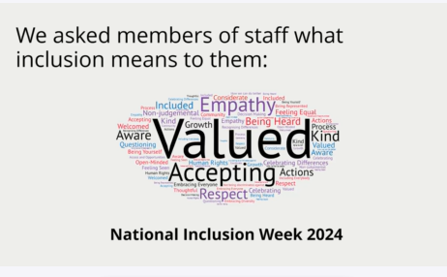

Our university screens are used to show celebrations of weeks, days and months linked to our Inclusion and Diversity Calendar and driven by university members input on what they want to see celebrated. We have also initiated signature banners that are used on Outlook signatures to celebrate various inclusion months which brings members of the university together in acknowledging and celebrating different diversity and inclusion months.
During 2024 the organisation carried out a Staff Engagement Survey and this has provided us with a basis to develop engagement initiatives. The 2025 pulse Staff Engagement Survey will provide further information on progress made in terms of staff satisfaction and areas we need to improve on which will be included in our EDI Strategy.

Promoting Inclusion through Staff Equality Networks
Throughout the year, we have continued to build awareness across the organisation by collaborating with our eight staff equality networks, LGBT+, Parents and Carers, GEM, Disability, Women’s, Menopause, Early Careers and Faith and Belief, to promote inclusion and enhance the sense of belonging. The organisation has recently introduced an events Outlook calendar to enhance engagement and participation across the organisation.
In November, we launched the Faith and Belief Network, which represents a diverse group of individuals working together to share ideas, foster networking, and create a safe peer support network. Over the course of the year, the network has successfully built relationships with external partners including Northamptonshire Council, Northamptonshire Police, and the Northamptonshire Interfaith Forum—engaging them across various events and beginning to foster strategic connections for longer-term collaboration.
Informal sessions provided a space for reflection and dialogue across faiths, featuring a ‘Short Talk Series’ by network members
The network hosted several sessions open to staff and students that include;
Seeds of Change (November 2024), part of Islamophobia Awareness Month and reflecting on the impact of Islamophobia and promoting collective change
More Than Just Fasting (March 2025) to celebrate Ramadhan which included an open prayer space and an Iftar meal.
Not All Pancakes and Chocolate! (April 2025) looking at the significance of Lent and Easter in the Christian tradition
Journeying to an Inclusive Church (April 2025) : Exploring faith and sexuality through inclusive church practices.
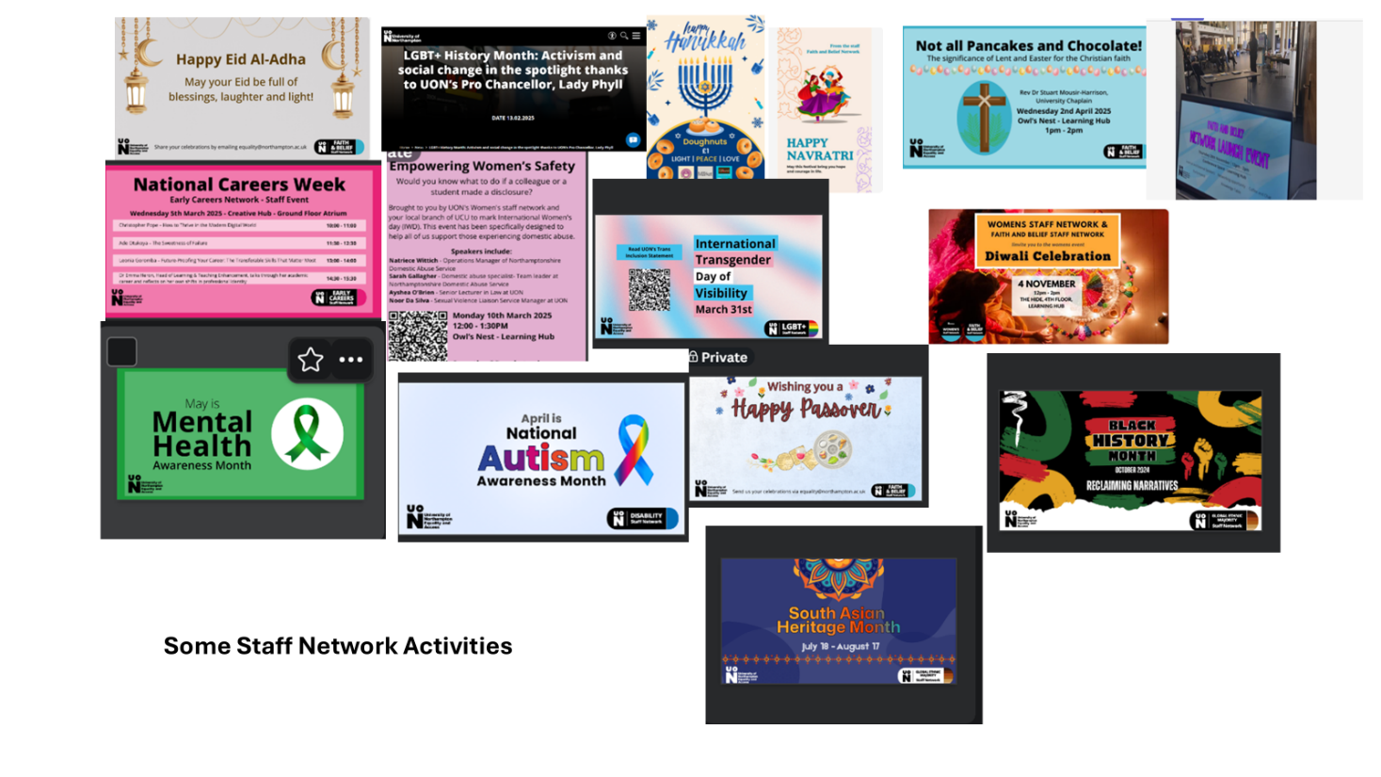
The GEM Network hosted a Poetry Night as part of its Black History Month celebration, featuring poets such as Ayan Aden, Birmingham’s Poet Laureate for 2024-26. Additionally, the network has established GEM TALKS, a monthly safe space where GEM members can come together and engage in open discussions. The GEM Network is also in the process of developing its strategy as a staff network.
The Menopause Support Group continues to advocate for the creation of a menopause-friendly workplace. In celebration of World Menopause Day, the group invited a range of speakers to raise awareness about the challenges women may face in the workplace due to menopause.
This year's International Women’s Day event, organised by the Women’s Network, focused on supporting employees who may face domestic violence. The event included engagement with external partners to provide insights and resources.
The LGBT+ Staff Network continues to play a vital role in fostering inclusion, visibility, and support for LGBT+ staff and students across the University. Highlights include:
During LGBT+ History Month, we delivered a highly successful programme of events, culminating in a keynote talk from Pro-Chancellor and activist Lady Phyll, which was exceptionally well-received by the University community. The Network is currently leading the Stonewall Diversity Champions Working Group, supporting the University’s ongoing engagement with this national benchmarking programme. Additionally, the Network drafted and presented a Trans Inclusion Statement to the University Leadership Team (ULT), affirming our commitment to creating a safe and supportive environment for trans, nonbinary, intersex, and gender non-conforming staff and students. The Network has also been consulted by the University on key external developments, including the University of Sussex fine and the High Court ruling on the legal definition of sex, to help guide institutional responses and ensure the protection of LGBT+ communities.
The Early Careers Network facilitated discussions on full proofing your Career with external and internal experts providing career advice to members of the network and interested staff members.
During the course of the year we have also worked at increasing the profile of the staff equality networks through increased communications in the staff newsletter Unify and increased support from our senior staff sponsors. We have ensured cross network engagement with events such as Diwali celebrations and the Pride History month talks.
We are actively working to enhance the role of networks in policy development. To achieve this, we are collaborating with HR to involve networks in the policy development and review processes. We have also provided our Staff Network leads with training to provide skills to our network leads to support sustainable and impactful networks. This effort will be carried forward in the next academic year to provide appropriate support to our networks who lead on many inclusion initiatives across the university.

UON Building Community
In the year under review we have continued to support external engagement with the team taking part in the Northampton Diwali, Carnival, Eid, Refugee Week and Pride celebrations. Our presence in the community helps us to develop networks and position our institution as an institution of choice for staff and students.

Benchmarking Staff Diversity Data
Data on staff profiles is drawn from university records over the 23/24year and represents an annual average figure. Sector benchmark data is taken from the Higher Education Staff Statistics: (HESA) UK, 2023/24, staff return.
  - Gender Pay Gap Reports
Our Gender pay gap over the last year has steadily decreased and in comparison, to other HEs we are making good progress. We have committed to eliminating the Gender Pay Gap by 2030 and each year we identify actions to reduce the pay gap and work through the identified actions through the year to ensure that we continue to minimise the gender pay gap.
The overall mean gender pay gap (GPG) has decreased from 7.3% last year to 6.9% in 2024. This can be attributed to the increase in female employees in the upper quartile since 2022 which has impacted significantly upon the downward trend and a reduction in the overall pay gap. However, the mean GPG in the lower and upper middle quartiles has remained consistent and the proportion of female staff who are working at grade 5 and below remains high at 70.9%.
Intersectional data with ethnicity further shows up challenges particularly for Black women. (see below).
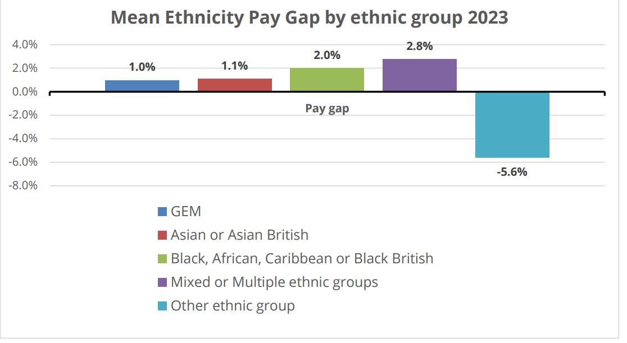
There has been a positive change in the pay gap for colleagues in Mixed or Multiple ethnic groups but quite a significant negative change of 3.7% for colleagues in the Black, African, Caribbean or Black British group.
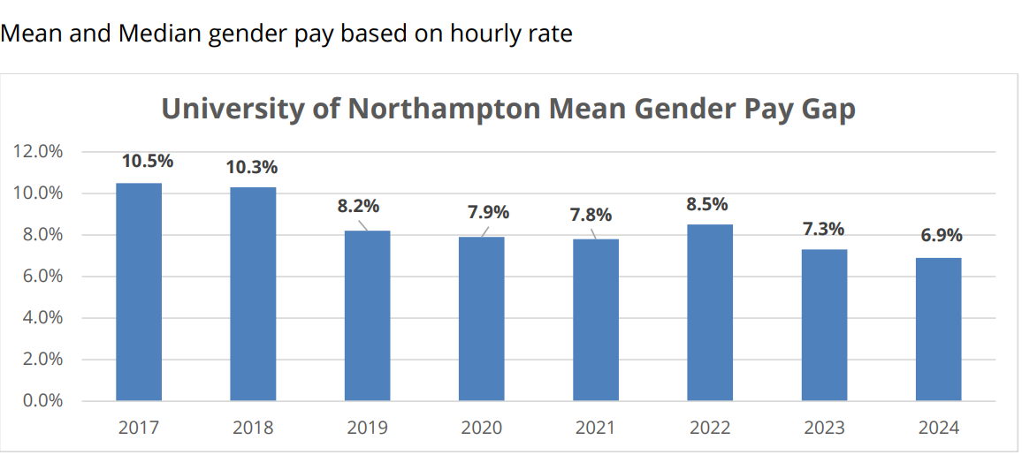

The below infographics from Universities and Colleges Employers Association (UCEA) 2023-24, show our significant progress in minimising the gender pay gap and that our gap is significantly smaller than other HEIs in the sector, and still noticeably smaller than comparative HEIs.
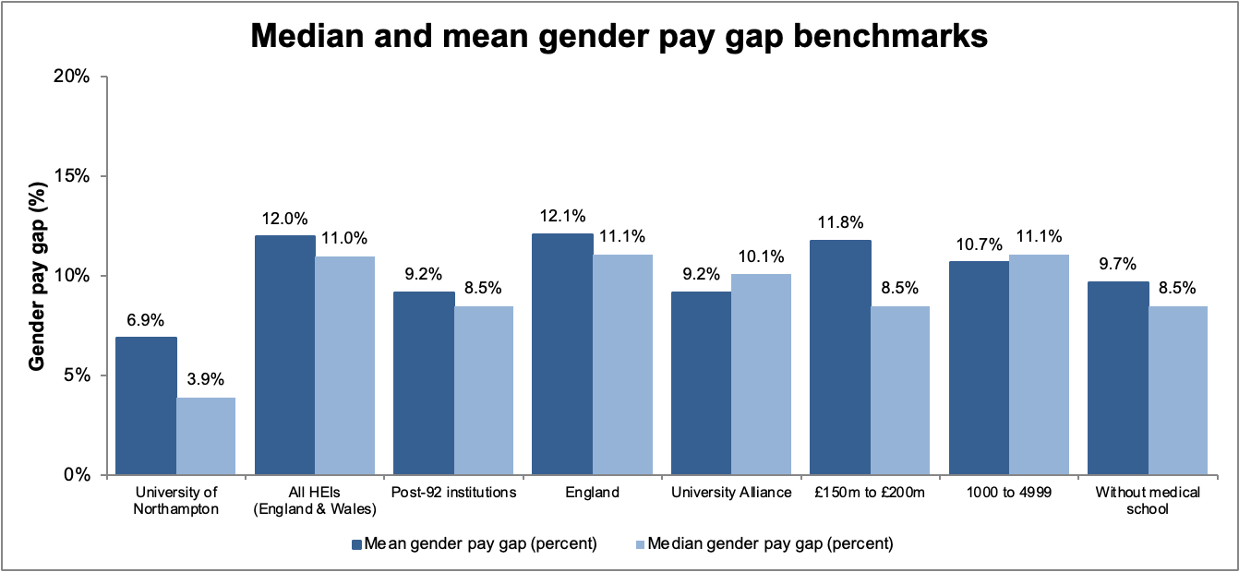

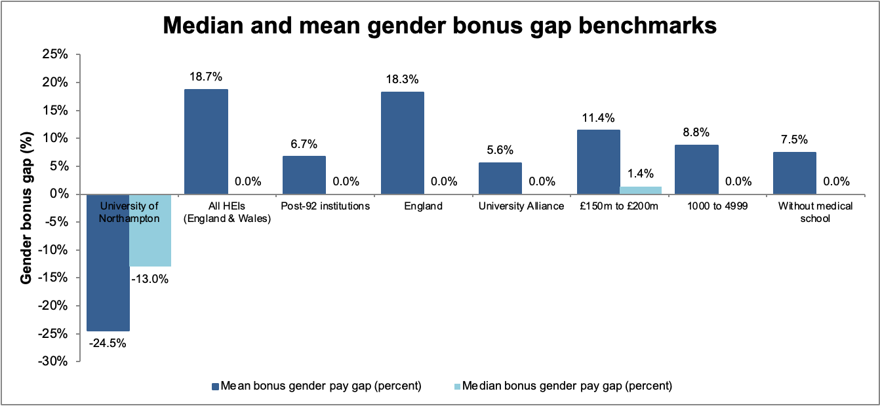
  - Reporting on ethnicity and Disability Pay gaps
We have reported on our ethnicity and disability gaps since 2021 and continued to monitor our progress in closing the gaps through the year under review.
The mean pay gap across all GEM colleagues is 1.9% which means that overall, GEM colleagues are paid 1.9% less than white colleagues. This has increased since last year by 0.9%.
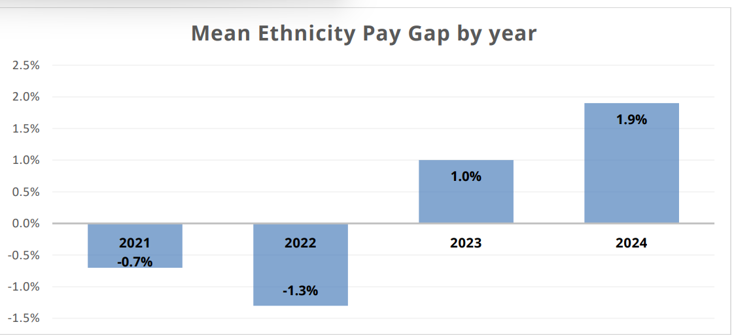
The representation of colleagues from the Global Ethnic Majority (GEM) has continued to rise, aligning with observations from Advance HE. Over the past number of years, we have observed a steady increase in GEM representation which is reflective of the wider sector.
Despite this progress, the majority of GEM colleagues are still predominantly employed in lower-grade positions. To address this, we are actively pursuing various initiatives, including the development of a targeted training program aimed at supporting GEM colleagues in overcoming these challenges.
While there has been an improvement in representation, the mean ethnicity pay gap across UK higher education institutions remains a significant concern. Disparities persist, particularly in senior roles for GEM colleagues, highlighting the need for ongoing efforts to achieve equity.

UON Ethnicity groups of staff by grade
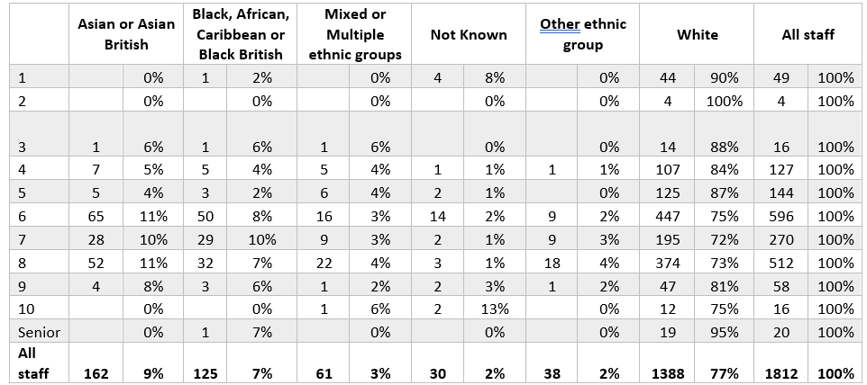

UON Ethnicity groups of staff by contract type
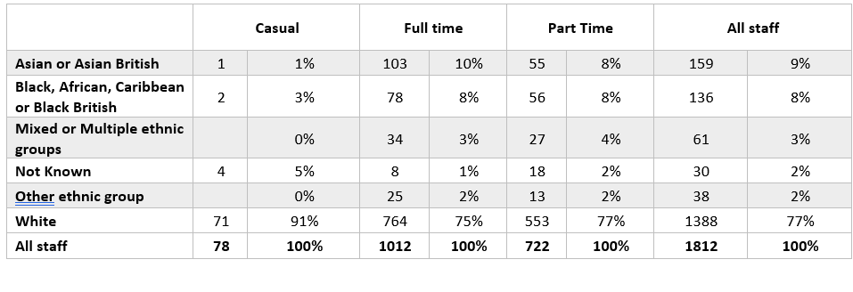

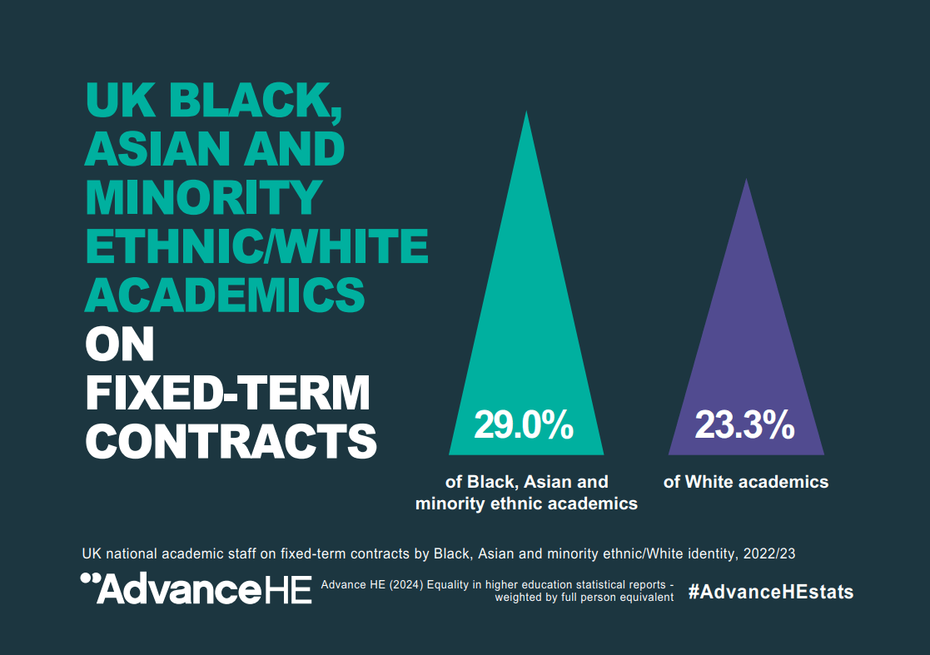

  - Disability Pay Gap
We have observed a continued increase in disability disclosure rates across the organisation, reflecting sector-wide trends. Our disclosure rates have surpassed sector levels, reaching 11% in 2024 compared to the sector average of 7.2%. Over the years, there has been a significant decrease in the number of staff who prefer not to disclose their disability status, alongside a 1% increase in disclosure rates from the previous year.
However, the disability pay gap has slightly widened, increasing from 4.2% in 2023 to 4.8% in 2024. To address this, we have implemented several actions, including the development of our Workplace Adjustment Passport, enhancements to web accessibility, and outreach efforts to engage external partners in promoting diverse recruitment.
Declared Disability by staff category 2024
 | Academic |  | Prof. Services |  | Senior |  | All staff
Declared disability | 105 | 10% | 99 | 14% | 2 | 10% | 206 | 11%
No known disability | 971 | 89% | 585 | 83% | 18 | 90% | 1574 | 87%
Not known / prefer not to say | 15 | 1% | 17 | 2% |  | 0% | 32 | 2%
All staff | 1091 | 100% | 701 | 100% | 20 | 100% | 1812 | 100%

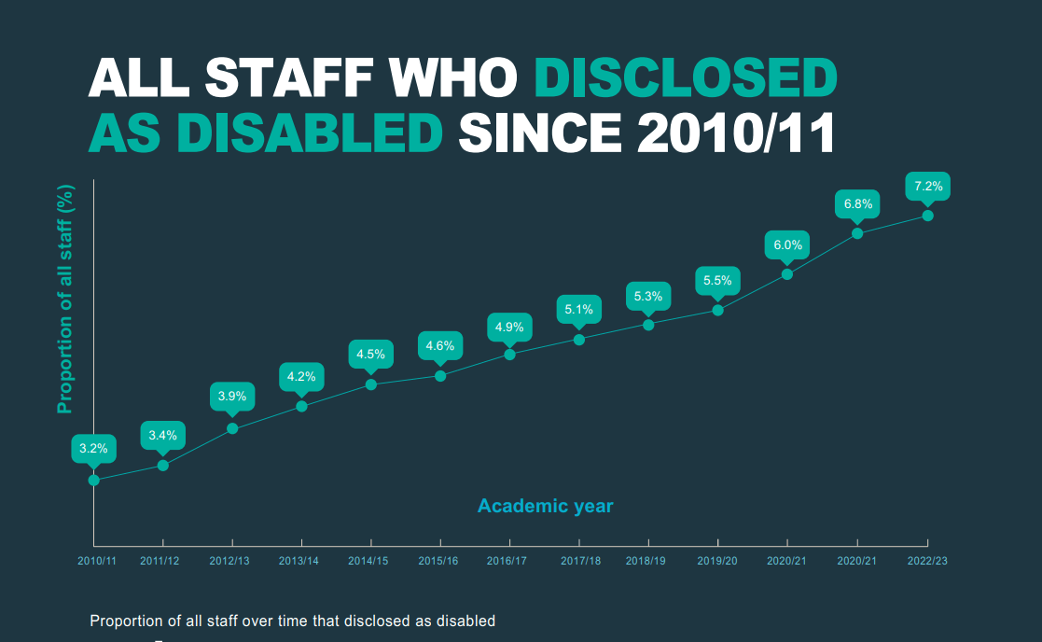

Going Forward
In the coming year, we will concentrate on advancing the benchmark charters we have committed to. We will deliver against the Race Equality Charter and continue to support the working group through the process. This will enable us to monitor our progress against other institutions and position us competitively as a university of choice for both staff and students.
Work on the Stonewall Workplace Equality Index is being launched and this should support efforts to continue to promote an inclusive space for LGBT+ colleagues and students.
Our first Gender Equality Plan is in draft and once completed will initiate work to take forward work on applying for an institutional wide Athena Swan.
The Staff Workplace Adjustment Passport will be the cornerstone of our efforts in addressing disability support within the organisation. This initiative aims to identify and bridge existing gaps in the support provided to our staff, ensuring a more inclusive and accommodating workplace for everyone.
As our current strategy concludes, we are now focusing on developing a new strategy to address identified gaps. We have conducted a thorough data analysis to pinpoint relevant interventions. The consultation process is ongoing, and the new strategy is expected to be ready for implementation at the start of the new calendar year.
Our EDI Plan which is set to run from early 2026 will take an intersectional approach to reducing inequalities facing the organisation, be data driven and informed through a consultative process. The People Strategy provides a positive backdrop to develop KPIs and specific targets in the new EDI Strategy.

