1) Once you click on the accommodation link, this is the first page you’ll see when you access the accommodation portal. At the top of the page, you can click the register button, or you can scroll down the page and click on “new user”. If you already have an account, you’ll be able to log in through the login button or the ‘already registered’ button.
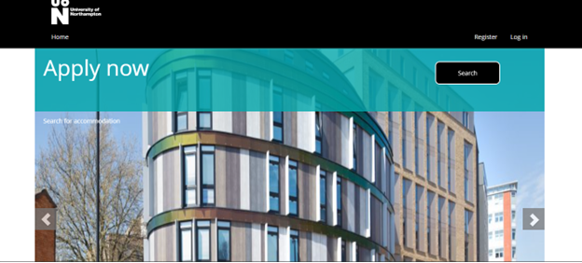
2) You will need to fill out the details below to register.

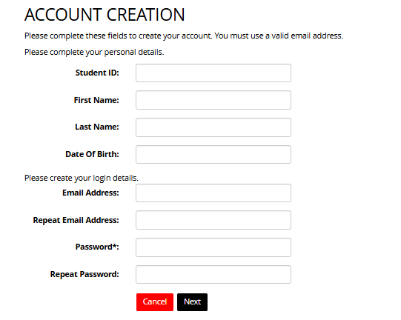

Use your personal email address as you likely won’t have access to your university one yet. Please don’t use a school or college email as you may lose access to this.
Make sure you put your first name and surname and be careful not to add any unnecessary spaces as this will impact your registration.
If you have any confusion over what names to include, please reference any prior university emails. Fill out your date of birth.
For your password, please bear in mind that it needs to be eight characters minimum and include one of the following:
- An uppercase letter
- A number
- A symbol (e.g !)
Please note that you will only be able to make an application for halls once you have made UON your firm choice. The email containing your offer will also contain your student ID.

Then click next and you’ll get the chance to check your details.

3) From here, press finish and you’ll be sent a validation code to your registered email address.
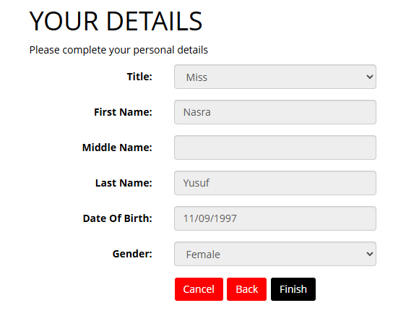
4) Enter the validation code from your email and press okay.

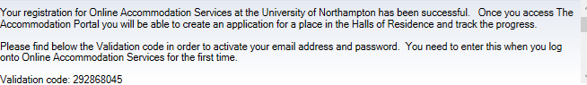
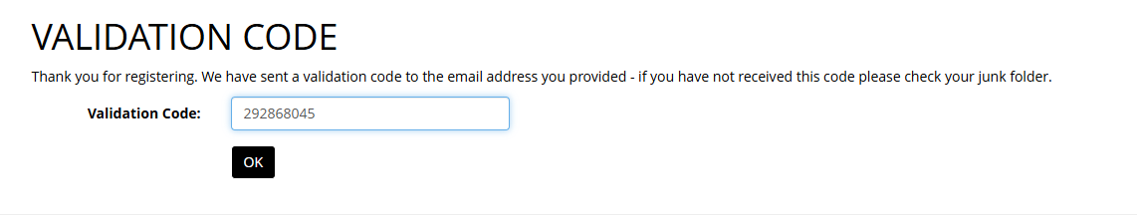

5) When you log on, you will be directed to this page. Please press apply to begin your application.
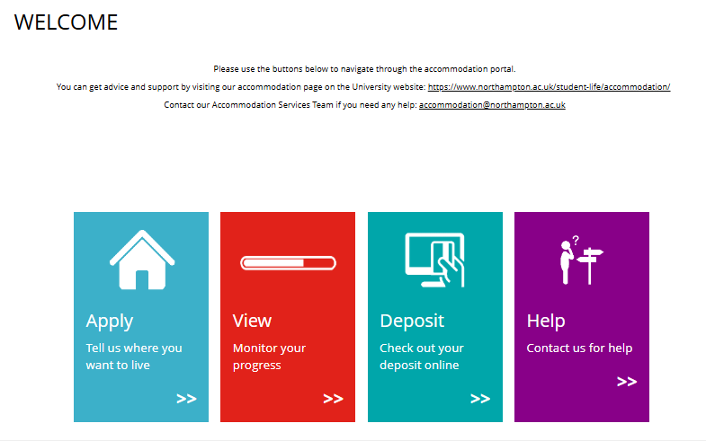

6) This page shows the current pathways we have available. You will be able to select from various pathways. Select the 2025-2026 pathway as you are enrolling for the next academic year in September 2025. It’s very important you select the correct pathway as this impacts on your contract’s start and end dates, as well as its duration.

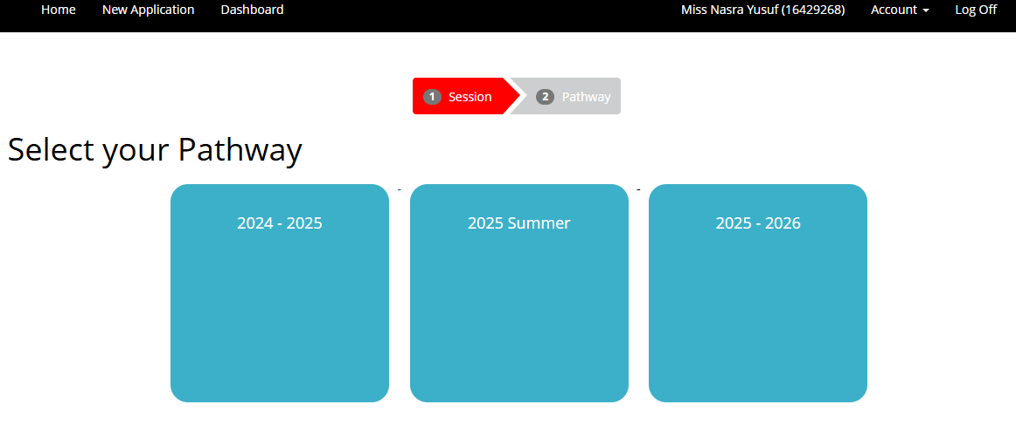

7) Please select 2025-2026 pathway if you are a UK student, postgraduate, international undergrad, continuing student, or if you are on a short-term course.

The UK student pathway is for permanent UK residents going into their first year of study in September 2025/2026. Students studying a postgraduate course will select the postgraduate student pathway for 25/26.

The international student pathway is for international or EU students going into their first year of study in September 2025/2026.
Students in their first year of study onwards will need to select the continuing student pathway. Lastly, students who are on short-term courses should select the short-term course pathway.

I’m going to use the UK student pathway as an example to demonstrate how to apply for halls as this will assist with the navigation process.
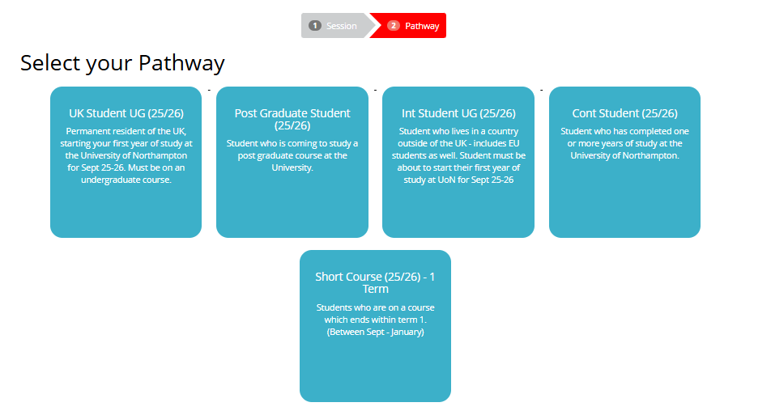

8) The next page will show you the halls we have available. The portal will reflect our availability in halls of residence. Please select your preference by clicking on the apply button.

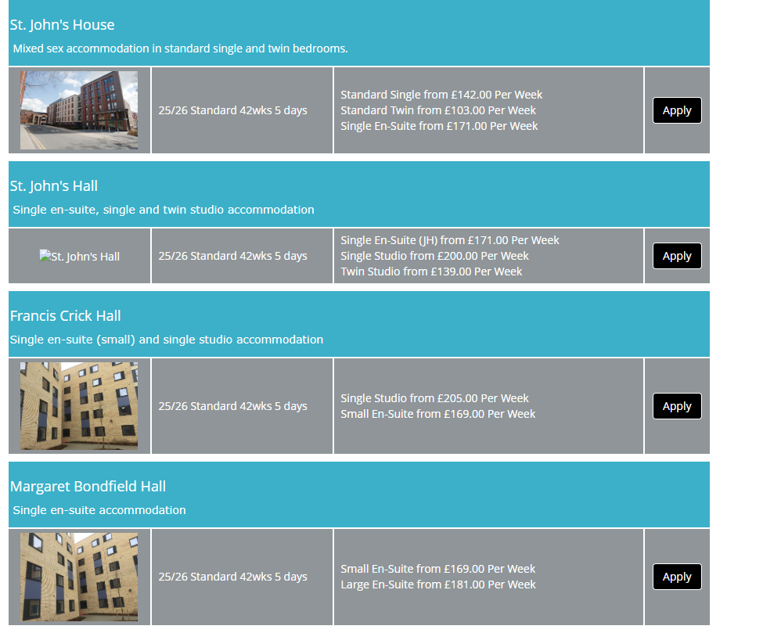

For the UK student pathway, first-year students have a choice of all sites: Waterside Campus accommodation, St. John’s Hall and Scholars Green.

9) On the left-hand side, there’s a drop-down menu. Tick the blue boxes to refine your search. The menu will allow you to select your preferred site and to look through what we have available on the search page. You will be able to refine the site, prices, and room type.

With regards to room type, if you wish to select a twin room, you must provide the name and student ID of the person you wish to share within the notes section of your application. The other person must do the same otherwise we are unable to allocate this type of room.
Full board refers to fully catered. If you select this option, you will pay an extra £85 per week and receive £105 to spend at UON food outlets. The self-catered option is for if you prefer to sort out your own meals.



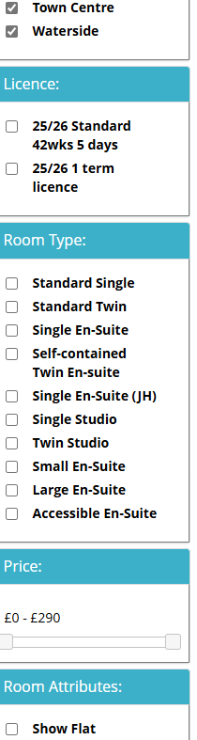

10) Once you select “apply”, you’ll be led to the next page. From here, you’ll see information about your chosen hall. You can view photos of the rooms and communal areas and select your preferred room type. The information includes price, license type and contract start and end date.

If you wish to know more information on the types of rooms available for each building, there is a link to a 360-degree virtual tour as well as photos available. This can be accessed in the description of each room. The specific attributes of each hall will be noted within the description.

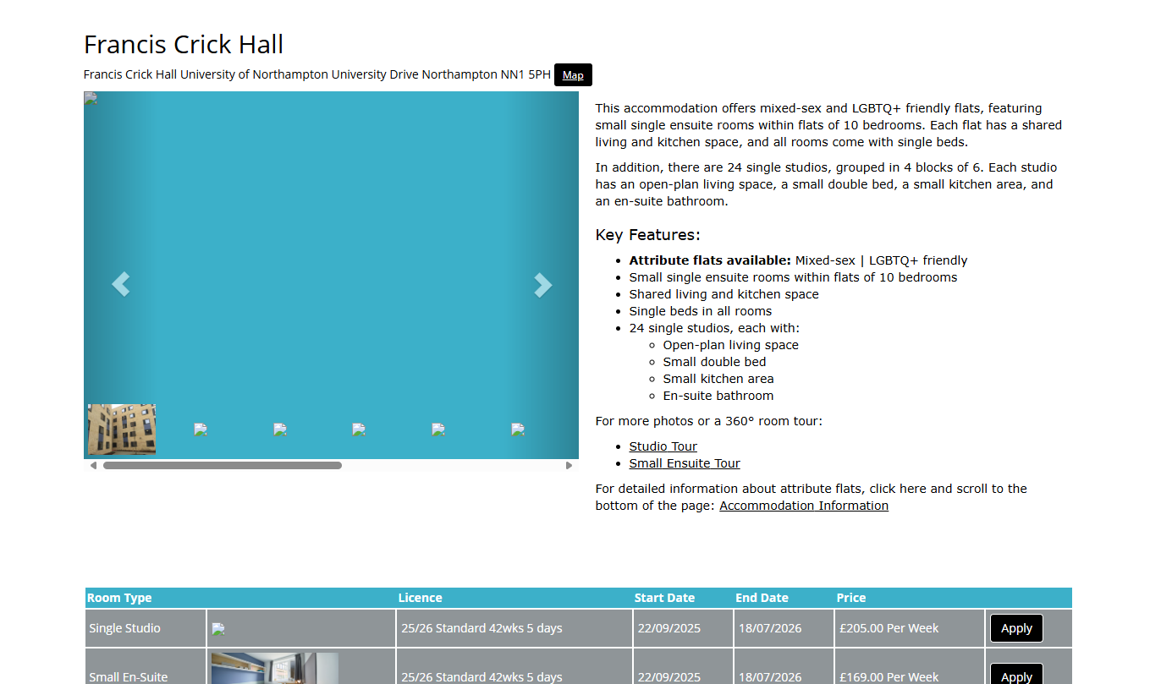

11) Once you have selected a preference, you are required to add another. Please note that your choices must be in order of preference e.g. most desirable at the top of the list. This enables us to allocate you based on your highest preference. Please be aware that this is subject to availability. You can select a maximum of 5 preferences and a minimum of two.

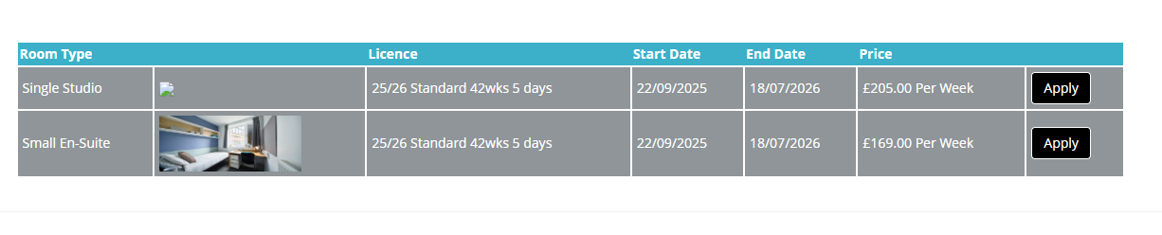

12) This is the final page before you submit your application. Please ensure that you check your details regarding preferences and attributes to make sure the information is correct. At this stage, you can still edit if you have made any errors. Please double-check the pathway and session as this impacts your contract start and end dates, as well as contract length and eligibility. Please be aware that your application may be withdrawn if you select the wrong pathway.

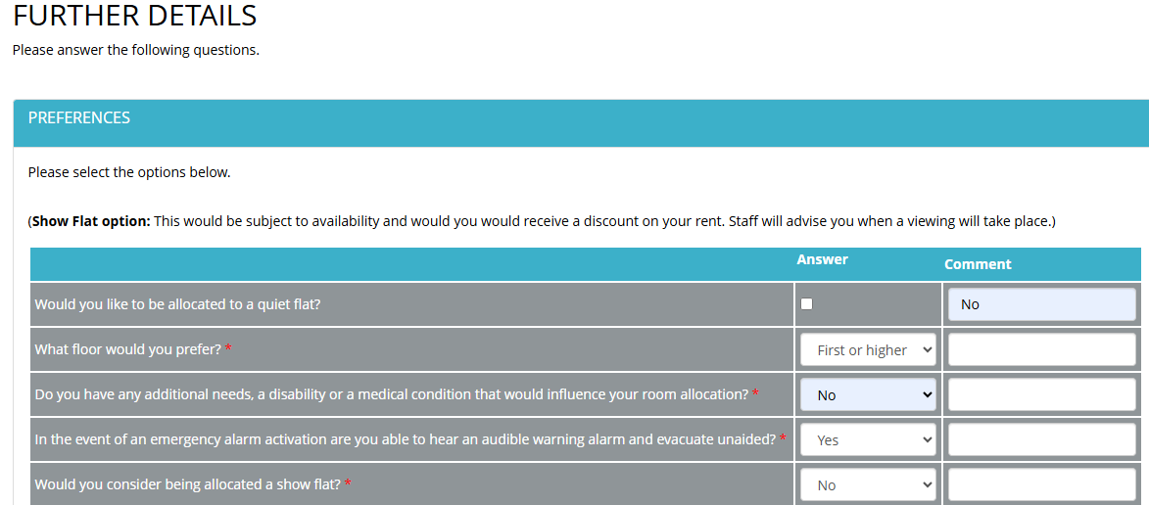

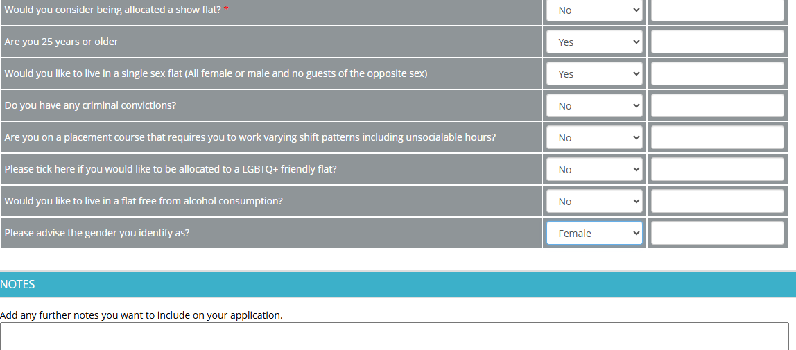
13) As you can see, there is a space that allows you to add notes. Please include any relevant information such as if you’re an ASSIST student or on placement, or details regarding your previous/current contract end dates and personal circumstances so we can help adjust your contract accordingly.
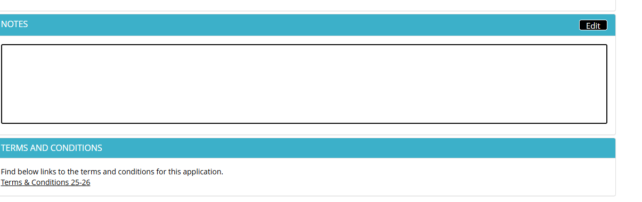

14) Please ensure that you have read the terms and conditions carefully and then tick the box to confirm. Click submit when you are ready to proceed.

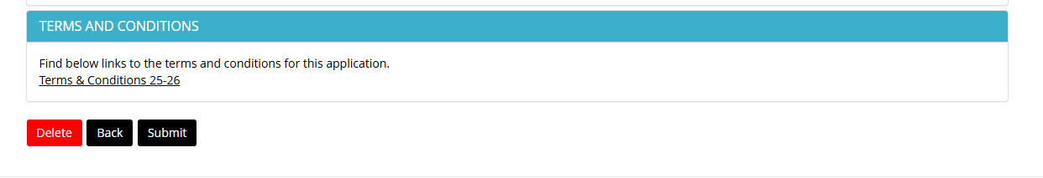

15) On this page, you can see that your application is complete but not submitted. Please proceed past this page otherwise your application will be delayed and potentially withdrawn. When you’re happy to proceed, press submit.

[State: Complete but not submitted.]

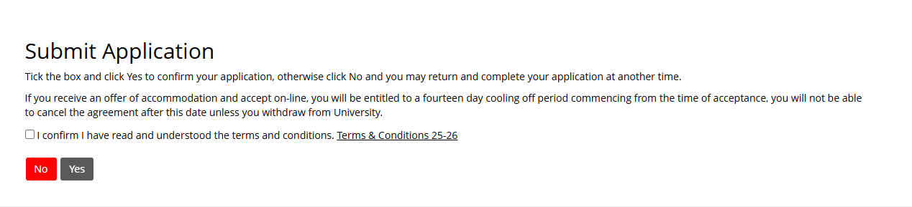

16) You will get confirmation that your application has been submitted on the next page.

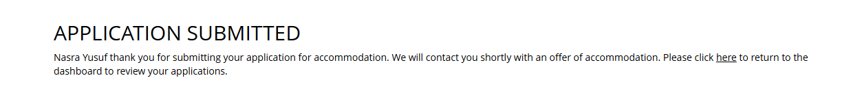

17) To view your application, log into the portal and then select the home button at the top of the navigation bar.



18) Select the view button to monitor your application’s progress. From here, you will be able to view your room details and accept or reject your room offer.

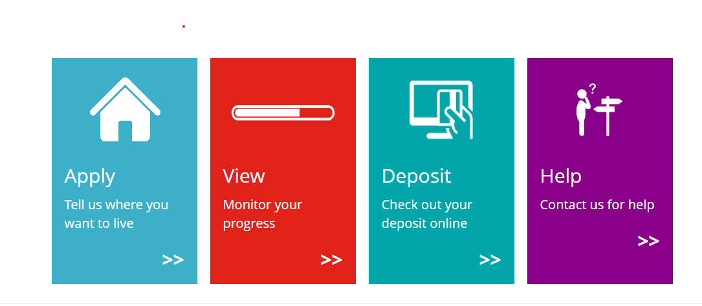

19) Click view on your most recent application session:

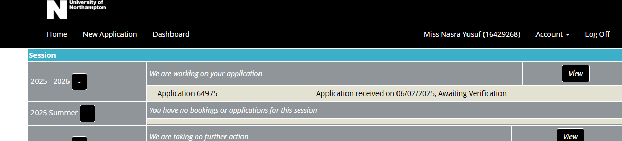

20) Review the details: This page will consist of the booking reference, the date of the offer, expiry date of offer, room type, license, contract start and end date. Also, the price shown on this page would be for a full contract. Students are expected to pay in termly installments.

Please note you have 7 days to accept from when the offer was made, or your application will be withdrawn.

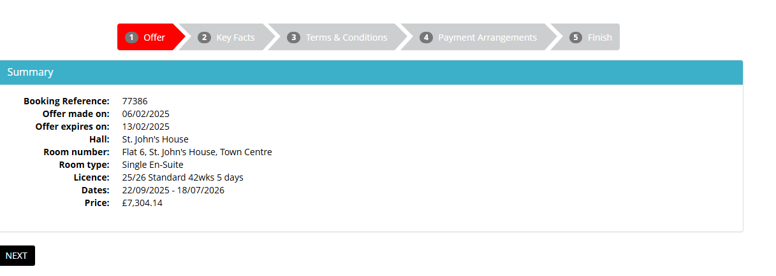

21) Read the guidance relating to the terms and conditions.

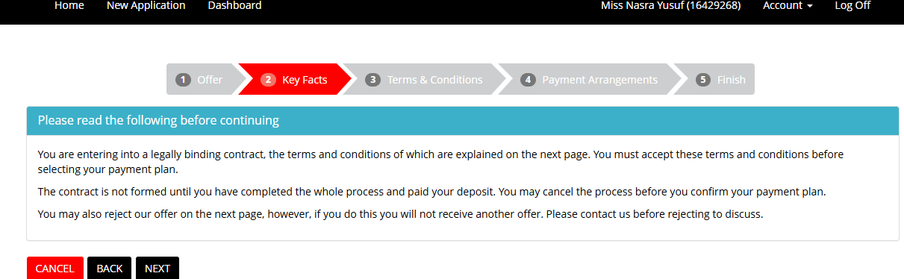

22) On this page, you view able to review the terms and conditions for 25-26, application T&C 25-26, withdrawal policy 2025-2026, Guest Policy 2025 and terms of allocation 25-26.

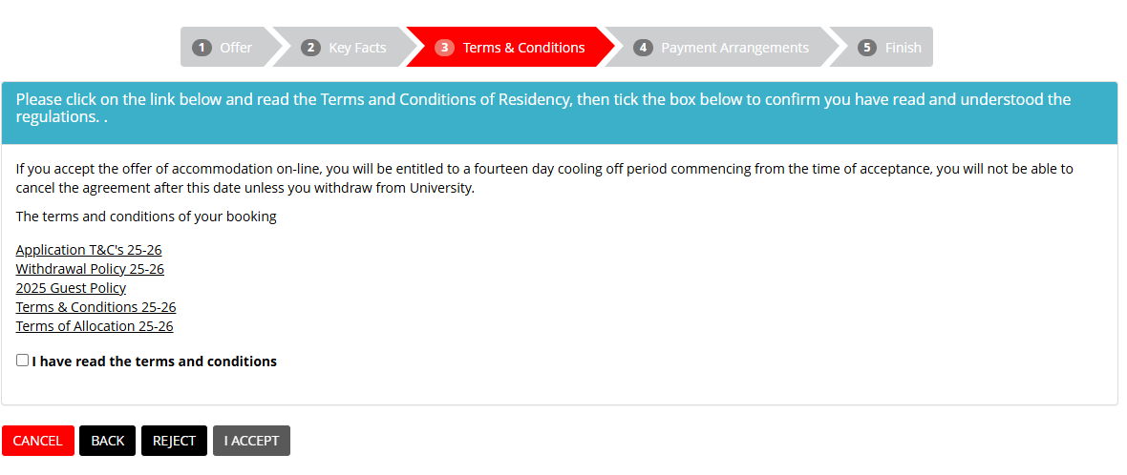

23) On the payment plan page, you will see the total for your contract. The fee is outlined in full but please be aware that if you have a standard 25/26 contract, you will be able to pay in three equal instalments through the finance portal when you arrive. For more information regarding payment due dates, you can refer to your accommodation offer email.

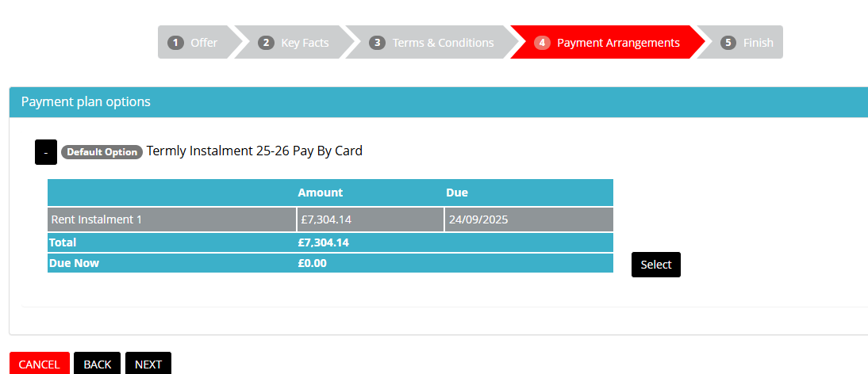

24) On this page, you will see information regarding the induction process. Please ensure that you complete your online induction when it becomes available. Once you are happy, click finish.

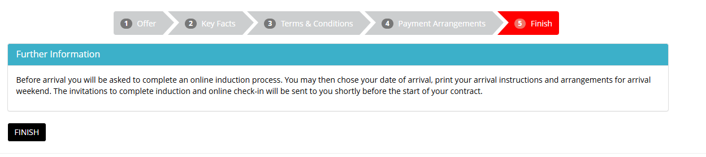

25) Here, you will see confirmation that you have accepted your contract. As well as information regarding your contract start and end dates, and payment statements.

