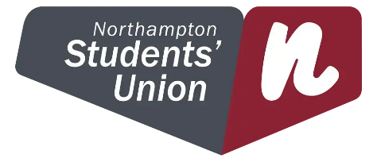
Harm Reduction and Supporting Students - Our Commitment

The University of Northampton and Northampton Students’ Union are committed to supporting the health, wellbeing and safety of all our students and staff. This includes aiming to reduce harms associated with a range of behaviours, including the use of alcohol and other drugs within our University Community.

While the safest approach is to consume alcohol at or below the government guidance and not take drugs, we acknowledge that some students will not follow this advice. We will therefore take a Harm Reduction approach, rather than zero-tolerance, to protect the wider University community while supporting students to reduce potential harms from alcohol and/or drug consumption.

To achieve this we will work with internal and external stakeholders and agencies to embed a joined-up approach that supports and reduces the harm of drugs and alcohol on the whole University community by;

- Highlighting the harm reduction guidance, information and support available to students about drug and alcohol use.
- Discouraging the harmful use of alcohol and other drugs through the provision of accurate and useful advice to students on the effects and risks associated with alcohol and other drugs.
- Educating and train staff about substance misuse to better understand student support needs and appropriate referral channels.
- Protecting the University community from harm and risks associated with the problematic use of alcohol or other drugs.

Date: December 2023
Owner: Chris Powis (for the University) and Rosie Harvey (for the Student Union)
Approving Body: University Leadership Team
Review Date: December 2024

