University of Northampton Privacy Notice
This privacy notice is to inform you about the information we collect about you from your school/college this is to enable us to analyse our projects which help school age pupils learn about and consider University Education. In collecting this information, we are acting as a data controller and, by law, we are required to provide you with information about us, why and how we use your data, and about the rights you have.
We are The University of Northampton, Waterside Campus, University Drive, Northampton, NN1 5PH. You can contact us by post at the above address, by email at recordsmanager@northampton.ac.uk or by telephone on +44 1604 892823. We are required to have a Data Protection Officer, so any enquiries about our use of your personal data should be addressed to Data Protection Officer at these contact details. You can also ask us to stop using your information once collected at any time and the simplest way to do this is to send us an email, or telephoning us using +44 1604 892823
We will use your information to evaluate the impact of the University’s Widening Access funding in relation to the institutions Access and Participation Plan. It is in the Public Interest for us to do this, and we will only use the data for the said research and evaluation.
Your information is stored in a national database called HEAT, and it is not sent outside of the UK. We will not use the information to make any automated decisions that might affect you.
By law, you can ask us what information we hold about you, and you can ask us to correct it if it is inaccurate using the contact details above. You can also ask for it to be erased and you can ask for us to give you a copy of the information. Data may be retained until the student has reached their 30th Birthday. If you would prefer UoN to stop processing your information at any time, please contact recordsmanager@northampton.ac.uk at any time
Your right to complain - If at any time you have a complaint about our use of your information, please contact our Data Protection Officer. If after that you are still dissatisfied you can contact the Information Commissioner’s Office via their website at www.ico.org.uk/concerns or write to them at: Information Commissioner’s Office, Wycliffe House, Water Lane, Wilmslow, Cheshire, SK9 5AF
Below are links to the privacy notices for the HEAT database and the Office for Students.
HEAT | Office for Students
https://heat.ac.uk/privacy-notice  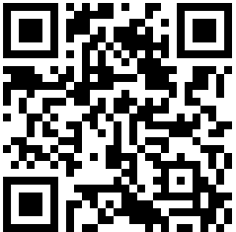 | www.officeforstudents.org.uk/ofs-privacy/privacy-notice  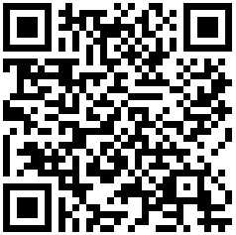

Child/Dependants Details
First Name |  | Last Name
Date of Birth |  | Postcode
Name of School |  | Gender
Is the child classified as a 'Looked after child' (Under a care order) |  |  |  | Yes | No
Is the child from a service family |  |  |  | Yes | No
Is the child receiving free school meals? |  |  |  | Yes | No
Ethnicity
White-British | White- Gypsy/Traveller | Other white background | White and Black African | White and Black Caribbean | White and Asian
Other Mixed Background | Indian | Pakistan | Bangladeshi | Chinese | Other Asian Background
Black- African | Arab | Black Caribbean | Other Black Background | Other Ethnic Background | Prefer Not To Say
As part of the research, we track data we receive to measure the long-term impact and outcomes of the activities in order to help us better design future engagements
Are you happy for us to use the names persons data in this manner? |  |  |  | Yes | No
Universities sometimes use photography for publicity purposes. We would like your permission to use photography/video of your child/dependant for possible use in our publications, website, social media platforms, and other publicity material. The image(s) will remain the property of the university providing the activity and will be used for the sole purpose of promoting similar activities.
Do you give us permission to take photographs/video of your child/dependant for these reasons? |  |  |  | Yes | No
Name of Parent/Carer
Relationships to Child/Dependant
Signature of Parent/Carer |  |  |  | Date

