Annual Review of Accredited Continuing Professional Development (CPD) Schemes
2021-22
Name of Institution | University of Northampton
Name of Scheme | C@N-DO (Descriptors 1 - 3)
Name of CPD Scheme Leader(s) | Dr Shirley Bennett

This report should be completed using the Annual Review of Accredited Continuous Professional Development (CPD) Schemes (2021 - 2022) Guidance for explanations and examples

Section 1 Analysis of institutional data

Section 1 Part a: Brief analysis of the data presented in Figures 1 and 2
Figure 1: Fellowship awarded by category through the Advance HE accredited CPD scheme between 1 August 2020 – 31 July 2021 and 1 August 2021– 31 July 2022
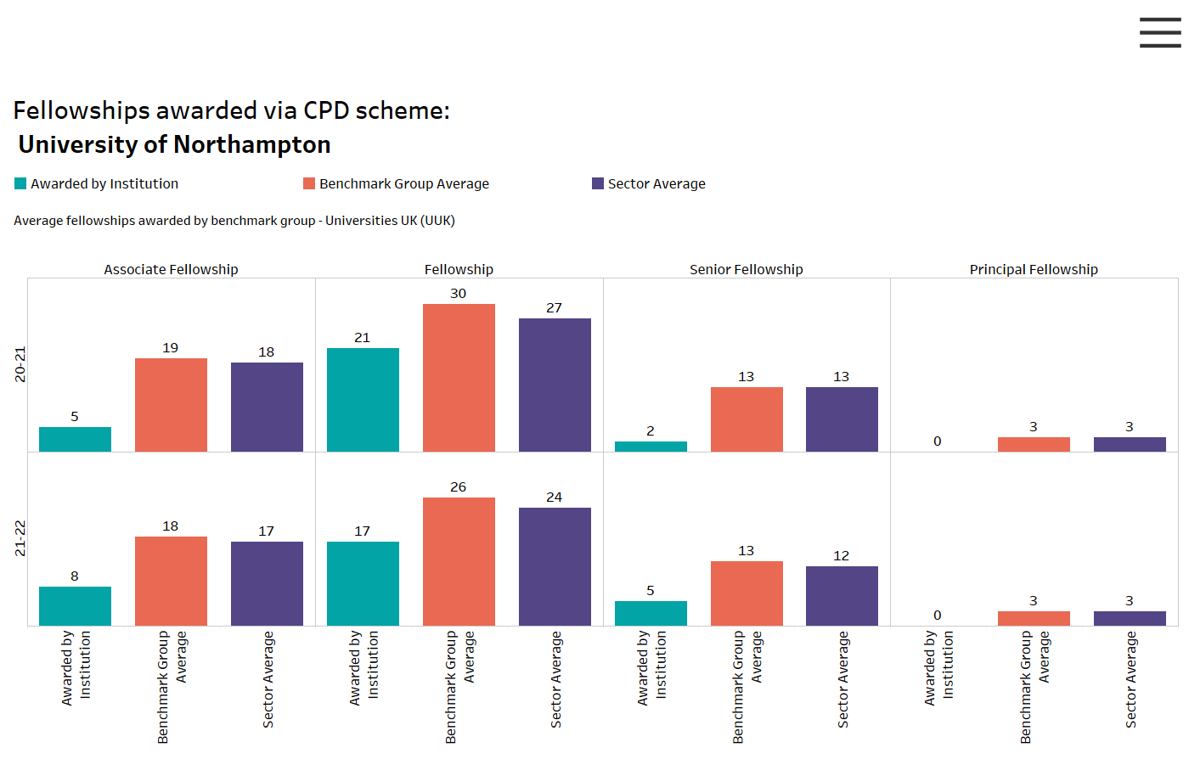

Figure 2: Fellowship awarded by category through all accredited taught provision between 1 August 2020 – 31 July 2021 and 1 August 2021– 31 July 2022

 | Descriptor 1 | Descriptor 2
1 August 2020 – 31 July 2021 | 0 | 0
1 August 2021 – 31 July 2022 | 1 | 0

at <institution> with Fellowship by year
Figure 3: Percentage of academic staff at with Fellowship by year
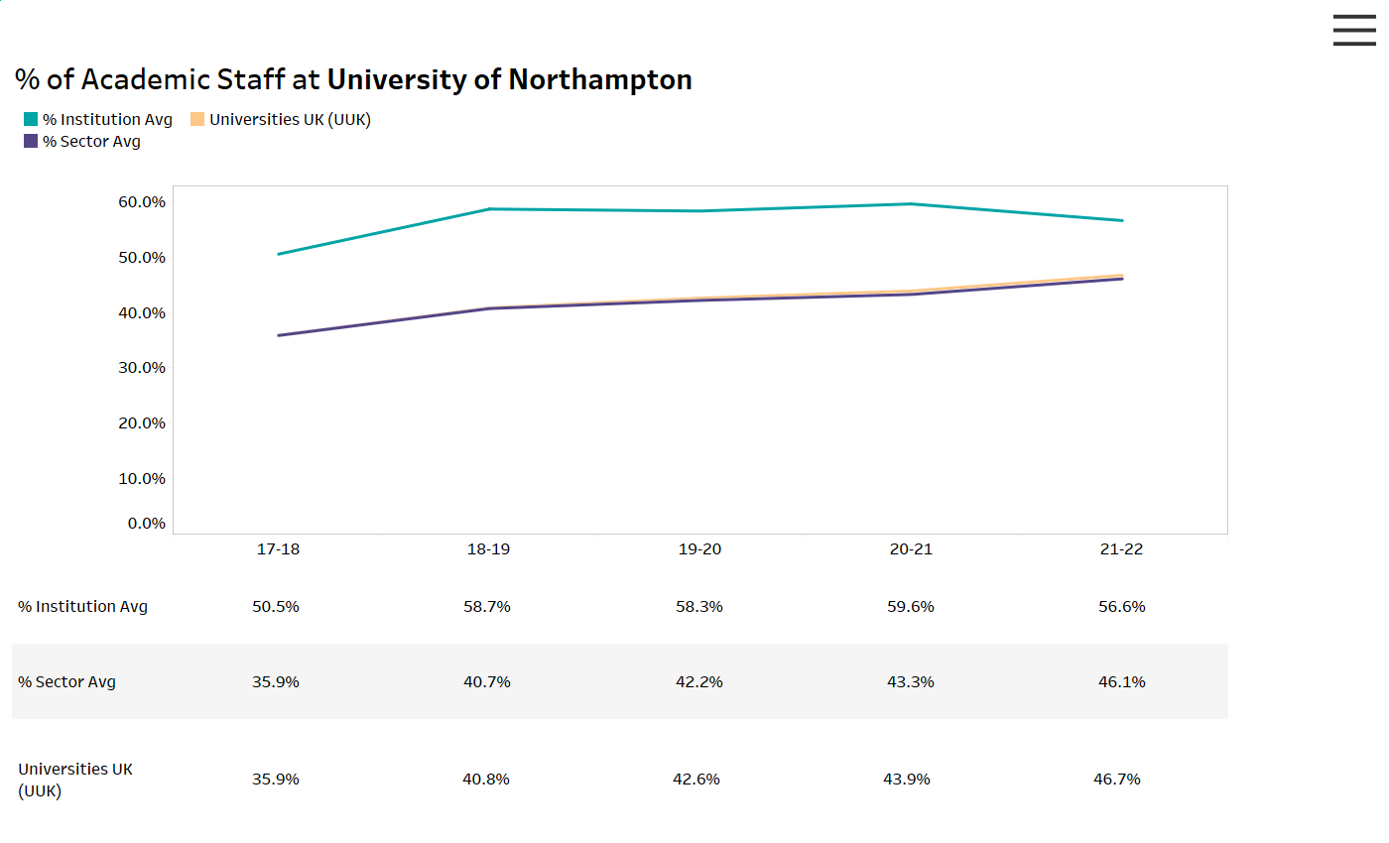
Drawing on the data presented in Figures 1,2 and 3, please provide a brief analysis
Overall, the numbers and percentages of institutional staff holding some form of professional recognition has been maintained, reflecting the importance that the institution places on professional recognition, especially HEA Fellowship @ FHEA. As a key element of this, the institution continues to actively seek to recruit staff who hold Fellowship for new appointments.

The number of applications and awards through the accredited institutional C@N-DO scheme has, on the whole, been maintained. Applications, and the quality of applications (which is related to the number of awards)are strongly influenced by work pressures on staff. Obviously the Covid pandemic has impacted all institutions, but in Northampton the pressures and associated workloads have been compounded by internal curricula changes and these impact on applications for Fellowship.

The imbalance between C@N-DO awards of FHEA and SFHEA in particular may reflect the particular burden carried by those leading in learning and teaching in. steering teams through curricular change etc and anecdotally there are notable numbers of staff who have ‘started’ an application for SFHEA but have been unable to complete to date.

Section 1 Part b: Success rates at first attempt for accredited CPD Scheme

Please complete the areas below to report the number of successful applicants at first submission for each Descriptor within your accredited scheme over the last twelve months (1 August 2021 – 31 July 2022). Please do not estimate if exact details are unknown but indicate why the data may not be available.
 | Total number of applications processed | Number of successful submissions at first attempt
Descriptor 1 | 8 | *Unknown
Descriptor 2 | 17 | *Unknown
Descriptor 3 | 5 | *Unknown
Descriptor 4 | N/A | N/A
Applications for professional recognition through the scheme continue to be hit hard in recent years by challenges and heavy workloads arising from the demands inflicted globally by the Covid pandemic. Nevertheless whilst the number of submissions for AFHEA and FHEA is healthy, the patterns shown for SFHEA are concerning:

- The number of submissions for SFHEA coming to panel in 2021-22 was low as numbers of potential applicants did not manage to complete in time for panels.

New strategies to be adopted for the 2021-22 academic year included:

- A more structured and formalised submission process involving three additional steps:

  - An ‘Expression of Interest’ step will give an indication of potential applications across the institution and facilitate liaison with local faculty Fellowship Champions
  - An ‘Intention to Submit’ step should enable more efficient panel planning, and facilitate targeted applicant support
  - A refreshed system of faculty Fellowship Champions, sponsored by Faculty Deans and/or Subject Leads to replace a less formal network of ‘mentors’ should enable more focused and localised support for applicants. The applicants will liaise with faculty Fellowship Champions for a ‘faculty check’ which created direct support and guidance for individual applicants – it did prove to be more accessible than centralised support.

- New sources and forms of support and guidance introduced for 2021-22:

  - As noted above, liaison with faculty Fellowship Champions and the expectation of a ‘faculty check’ should facilitated a point of direct support and guidance for individual applicants
  - A stronger profile for the Fellowship Writing Support Resource ensured that more staff took advantage of this resource.
  - New Fellowship Peer Support Circles (at AF/F and at SF) fostered mutual support amongst applicants and broad-based access to a consistent source of focused support.
*Note: Unfortunately due to staff changes and approaches to recording data the success at first attempt data is currently unavailable. This will be rectified as soon as possible.

Section 2: Strategic impact of Advance HE accredited provision

Section 2 Part a: Institutional strategic impact
This section should be completed by a DVC/PVC (or equivalent) with responsibility for the strategic leadership of learning and teaching at your institution. Please comment on how/ the extent to which fellowship and accreditation have enhanced teaching and learning at an institutional level and impacted on student learning/ outcomes (please refer to the guidance for further information).

Name: Shan Wareing Role: Deputy Vice Chancellor
Within the University of Northampton, we have alignment of HEA fellowship awards to probation policies, together with some alignment of fellowship awards to promotion. Most notably, achievement of SFHEA is aligned within the criteria for the Learning & Teaching route to Associate Professor, to date there are now five Associate Professors in Learning and Teaching.
The institution has long-established KPIs for HEA Fellowships (and other TQUALS), which provides an indicator to staff of the importance of teaching, and of recognition for teaching, in line with international benchmarks through the PSF. A challenge going forward into the next period of accreditation beyond 2024 will be to encourage staff to see the benefit of engaging in academic development for purposes of enhancement of practice over and above ‘getting the badge’ through the award of Fellowship.
Other benefits deriving from accreditation include the personal reward and professional satisfaction that Fellowship can provides for individuals. Within an institution that has a relatively flat structure, SFHEA offers staff a focused opportunity to stand back and reflect on the achievements within their career, the impact they have had on other colleagues and the contribution they have made to the enhancement of the student experience. The accredited provision also offers ongoing professional development opportunities for staff to contribute to C@N-DO and to the institution. This includes engagement as Mentors (now termed Fellowship Champions – currently 28 in number - 25 Faculty-based and 3 in ‘central’ units) or as assessment panel members (12 in number – 10 Faculty-based and 2 in ‘central’ unit). Over and above this, the nature of the provision enables experienced staff to contribute directly to the professional development of colleagues. Whilst the scheme is managed centrally by the Head of Academic Practice, Faculty academics make an essential contribution to leading workshops within the accredited scheme (19 Faculty academics facilitate at least one C@N-DO workshop, as do 10 staff from ‘central’ units.)
The design of the accredited scheme has also, from the start, taken advantage of the scope that accreditation offers to design provision in line with institutional needs and priorities and to act as a driver in working towards institutional goals. When first established, the accredited provision was designed specifically to target several institutional priorities.
The original planning of C@N-DO was aimed to support curricular re-design towards the institutional move to the new ‘Waterside Campus’ and the adoption of ‘Active Blended Learning’ (ABL) as institutional pedagogy and teaching. This goal was embedded in the accredited provision through provision of targeted workshops focusing on design + planning [UKPSF A1], technology use [K4] + active student engagement [V2], and the inclusion of critical analysis of own course provision as a core element of assessment for AFHEA/FHEA. This focus was consolidated by the establishment of the main workshop intervention, team ‘CAIeROs’, as a core element of the quality process, ensuring engagement by a significant proportion of the academic staff body, something which has been seen within Fellowship applications. So too, period of re-design and introduction of active learning methods, including via digital technologies, can be seen as having provided a strong foundation for the online pivot resulting from the pandemic and the subsequent “back to campus” approach in 2021-22.
It was identified that the goal of curricular re-design towards ‘Waterside’ and ‘ABL’ brought an imperative of inclusive CPD opportunities to be available across the whole staff body, not only to those who are new-to-teaching, or pre-FHEA. This imperative underpinned the inclusive and flexible nature of the CPD scheme, with academic development offered as centrally provided workshops which can also be arranged on a subject- or programme-team basis. Data are still being collated and analysed, but indications are that success has been mixed. However, whilst this represents engagement by c.34% of core staff, engagement of Associate Lecturers stands at only 8% and per person engagement was low. When available, data aligning levels of engagement to career stage are likely to indicate poor engagement amongst more experienced staff, suggesting a new imperative for the 2024 re-design.
A third goal underpinning the original planning of C@N-DO was the embedding of a newly established, developmentally focused, structured peer observation scheme. This was embedded in the accredited provision through the incorporation of Peer Observation within the assessment for all three categories of Fellowship provided by C@N-DO. Applicants for AFHEA and FHEA must reflect on learning gained through being observed, and applicants for SFHEA on their own support for less-experienced colleagues by observing them and helping them to enhance their practice. Anecdotal indications do suggest that integrating POT within Fellowship assessment contributed effectively to the embedding of the 2014 Peer Observation COP where a consistent approach had been missing for several years. Records on engagement beyond Fellowship applications are not kept, but indications suggest that peer observation is now established practice within many Subject areas, for sharing of good practice, and as a tool for team development and cohesion.
There have therefore been a few ways in which the accredited provision has contributed to support priorities and strategy around teaching and learning at institutional level over the years since the inception of C@N-DO. However, success has been mixed, and new highly pressing institutional priorities will be addressed through the process of re-design for submission in 2024. In particular, the key issue to be addressed is that of diversity, and engaging staff in changes to learning and teaching to address identified award gaps. Strategies will be needed to involve staff in development beyond solely ‘getting the badge’ of Fellowship, to develop better provision for experienced staff and to better use the expertise of Senior and Principal Fellows to support and lead the initiatives established in line with institutional strategy and priorities for the coming 4-5 years.

Section 2 Part b: Evaluating impact of fellowship and accreditation on institution, staff and students
Please comment on how the institution is evaluating the impact of the accredited scheme and fellowship
Standard evaluation of the impact of the accredited scheme includes the following elements:

- An annual watching brief on numbers of HEA Fellowships (and TQUALS more broadly), to monitor progression against institutional KPIs for attainment of Fellowships and TQUALS more generally; year by year targets have increasingly been devolved down to Subject Leads to promote engagement amongst team members
  - Effectiveness/limitations of this approach:
    - A positive impact of devolved responsibility and analysis has been a broader ownership of the issue of professional recognition, and the opportunity for support and drive at subject level
    - One limitation of the institutional KPI for Fellowships is that records of workshop participation suggest a tendency to prioritise workshops perceived as contributing directly to ‘getting the badge’ over workshops more intrinsically focused on enhancing L&T practice.
    - A limitation, or challenge, is the format of the Advance HE records available for checking and confirming internal records. The format makes the process of comparison a very labour-intensive process.

- Staff participation in the 40-50 workshops that comprise the academic development offer within the accredited scheme is routinely recorded within the institutional HR system, which feeds into individual HR records. As all workshops are aligned to PSF Dimensions of practice, these records indicate engagement with development with respect to these dimensions.
  - Effectiveness/limitations of this approach:
    - In principle the approach makes it possible to analyse engagement across academic faculties, across various PSF Dimensions of practice and to ascertain any link between staff engagement and NSS results.
    - However, a significant limitation is the challenges encountered in obtaining the data and that analysis; we are starting to consider an alternative, more easily accessible, tool for data recording and reporting.
    - One specific limitation is that although there was an aspiration to analyse engagement in the academic development available within the accredited provision with respect to career stage, principally engagement pre- or post- obtaining FHEA. This was intended to ascertain success, or otherwise, of the aspiration of an inclusive scheme, engaging staff across their career. Such analysis has however, not yet been possible, apparently due to non-alignment of separate databases.
The standard evaluation processes are under review considering re-accreditation in 2024. Our approaches will include:
- Quantitative analysis as above, including an attempt to undertake at least some analysis with respect to career stage.
- Interviews with Faculty Deans and other institutional and subject leaders regarding perceived strengths of the current provision and where it could be improved as well as their perspectives on key challenges and priorities for the institution, and their areas, over the coming 4-5 years.
Carpe-Diem style engagement of colleagues around the university to focus on both their evaluation of existing implementation of the provisions and their aspirations for the future.

Section 2 Part c: Participation in accredited provision 2021-22
Please identify whether any groups of staff are under-represented within accredited provision and explain measures in place/proposed to address any issues identified (if appropriate)
Engagement in academic development opportunities through C@N-DO

C@N-DO is designed as a broad, inclusive, CPD scheme offering academic development opportunities through around 40-50 workshops which are aligned and structured around all 5 UKPSF Areas or Activity. Individual staff member participation is recorded within the HR system, including alignment with UKPSF Dimensions. There are some ‘blips’ in the records, and thus figures are only broadly accurate, however data indicates that across 2020-21 and 2021-22, around 24% of the staff on academic contracts had some level of engagement in the workshops within the accredited provision.

Data is not available with respect to protected characteristics, but figures indicate a clear gap with respect to contract type:
- The figure for core staff engagement in at least one C@N-DO workshop stands at approximately 34% of the total
- The figure for Associate Lecturer engagement in C@N-DO workshops is as low as 6%.

Since the start of the pandemic, the large majority of C@N-DO workshops have been provided online, so this low figure cannot be explained in terms of access to face-to-face provision on campus. Timing may well be an issue but attempts at running asynchronous workshops were not successful. Provision exists for Associate Lecturers to be paid for engagement in agreed development but is not publicised widely.

Section 3: CPD Scheme management and operation

Section 3 Part a: Support for effective operation of the scheme
Outline any model/ initiative in place that ensures effective and sustainable operation of the accredited scheme in line with demand (please leave blank if none exist)
Fellowships and other Professional Recognition:

We do not hold data more specifically for Fellowship awards, or award on first submission, through C@N-DO with respect to protected characteristics but will explore ways in which this could be monitored.

In terms of overall HEA Fellowship numbers, contact type is significant. Internal data indicates that around 60% of Core staff hold some form of HEA Fellowship, but that the number of Associate Lecturers holding HEA Fellowship stands only at 8%. Associate Lecturers therefore represent a group which is significantly under-represented within our Fellowship numbers.

Several strategies have been adopted in the 2021-22 academic year in the hope that they may help to address this situation, including new sources of information, guidance and support regarding Fellowship applications. Strategies include:

- a stronger profile for the online Fellowship Writing Support Resource – accessible by all staff
- facilitation of direct liaison with faculty Fellowship Champions and the expectation of a ‘faculty check’ – this should facilitate a point of direct support and guidance for Associate Lecturer applicants
- new Fellowship Peer Support Circles (at AF/F and at SF) – meetings are arranged around the availability of the members and therefore should provide better flexibility for Associate Lecturers than centrally-organised writing retreats etc.

Section 3 Part b: Focus of scheme management during 2021-22
Which phase of the accreditation cycle was the institution in during 2021-22 (delete as applicable below) - Preparing towards reaccreditation
Outline below key areas of focus related to scheme management during 2021 - 2022 reporting period
Several areas related to scheme management have been addressed under other headings, to address identified problems, such as low engagement by Associate Lecturers and the high referral rate at AFHEA and to ensure sustainability in the light of increasing workload pressures. Additionally, the 2020-21 academic year has been utilised as an opportunity to pilot strategies such as a more formalized submission process and group approaches to supporting Fellowship applications through Fellowship Peer Support Circles as preparation for the reaccreditation redesign for submission in October 2022.

Section 3 Part c: External reviewers/assessors/mentors involved in the scheme and key staff changes in 2021-22
In the table below, please provide the name and details about any External Examiners/Reviewers/Mentors appointed to your accredited scheme.
Name of External | Employing Institution or Independent | Fellowship Status | Role (e.g. external reviewer/examiner or mentor)
Julie Baldry-Currens | Independent | PFHEA | Lead External – External Examiner role
Barbara Thomas | Independent | PFHEA | External member of assessment panel
*Please add lines if required
Key staff changes – please complete the table below if relevant:

Provide details of any staff changes/ new staff involved in delivery/management of the scheme during 2021-2022
Dr Shirley Bennett left her role as Head of Academic Practice at the University of Northampton in September 2022 but led the scheme during the 2021-22 academic year. Due to the previous disbandment of The Institute for Learning and Teaching in 2021, the scheme has been incorporated within the Learning and Teaching Enhancement unit, operating alongside Academic Integrity, Educational Linguistics, Learning Design Team, and Learning Development.

As in other years, there have been changes in terms of the delivery of the scheme:

- the C@N-DO Assessment Panel has been maintained, and the Lead External has been involved in supporting the integration of the new members into the panel and the development of confidence in their judgements
- the system of ‘mentoring’ has continued with involvement of Deans in the identification of Faculty Fellowship Champions.
- the provision of workshops within the scheme is deliberately flexible, to respond to institutional needs; thus, the team of colleagues involved in workshop delivery evolved in 2021-22 as in other years, with all provision, and alignment to the PSF, managed by the scheme leader.
Julie Baldry-Currens tenure as Lead External ceased at the end of 2021-22 and a new Lead Examiner has been appointed, Dr Duncan Jackson, Head of Academic Practice, University of York.

Section 4: Engagement with Advance HE
Please comment on your engagement with Advance HE in 2021-2022
Dr Shirley Bennett, as the Lead of the University of Northampton accredited provision has participated in several events with Advance HE during 2021-22. Including:
- Meetings of the Accredited Programme Leaders Network (APLN

These meetings always provide an opportunity to discuss shared challenges, an update on matters pertaining to the PSF, accreditation and recognition, and a source of new ideas for adaptation locally.

- Advance HE Calibration events
These provide vital reassurance and guidance regarding the calibration of Fellowship judgements, which in turn feeds back into my oversight and support of Fellowship judgements made internally.

- Advance HE Accreditation Guidance Events

These provided not only an opportunity to stand back and reflect on our internal provision, but an update on policy and an opportunity to discuss matters of accreditation with others similarly going for re-accreditation. The events provided insights into different approaches to dialogic/presentation forms of assessment, something to be potentially introduced within our next accreditation round.

Review Sign Off

Scheme Leader Signature (return written by Kate Coulson)
Date | 5 January 2023

The completed review should be returned as a Microsoft Word document to provide ease of access for the information to enable analysis – please do not send as a pdf file.

Please email the completed review template to cpdreview@advance-he.ac.uk by the deadline of Monday 9 January 2023.

Appendix 1 Data Tables
Figure 4: Total fellows employed at some point during the academic year awarded through all routes
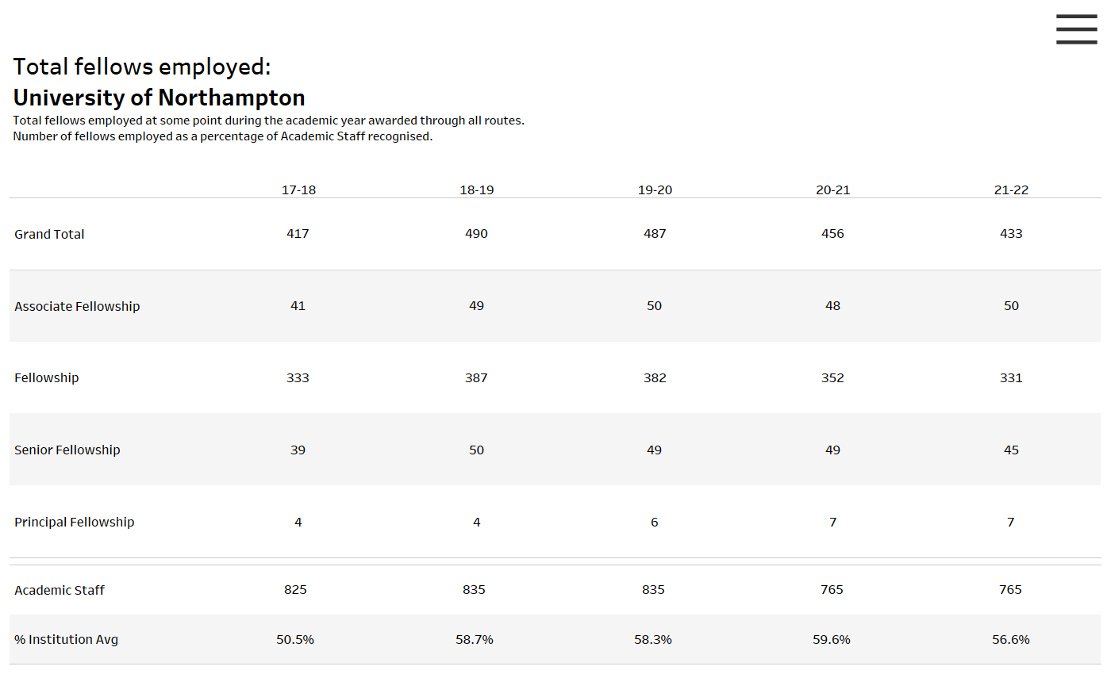
Figure 5: Total fellows employed at benchmark group some point during the academic year awarded through all routes
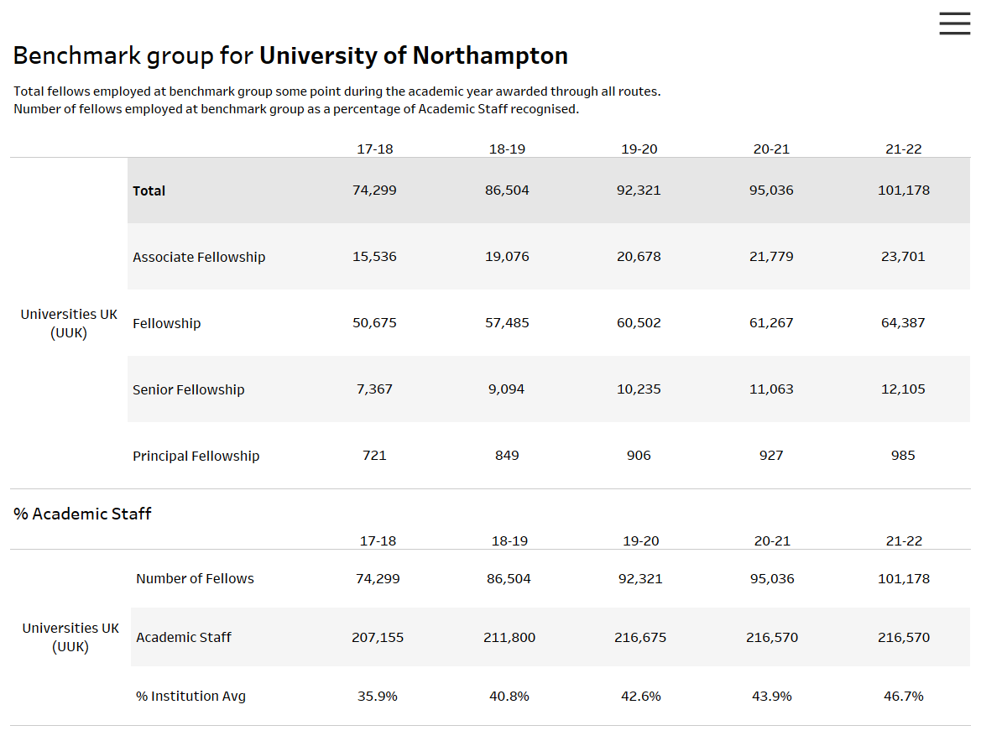

Figure 6: Total fellows employed in UK sector (HESA organisations) at some point during the academic year awarded through all routes
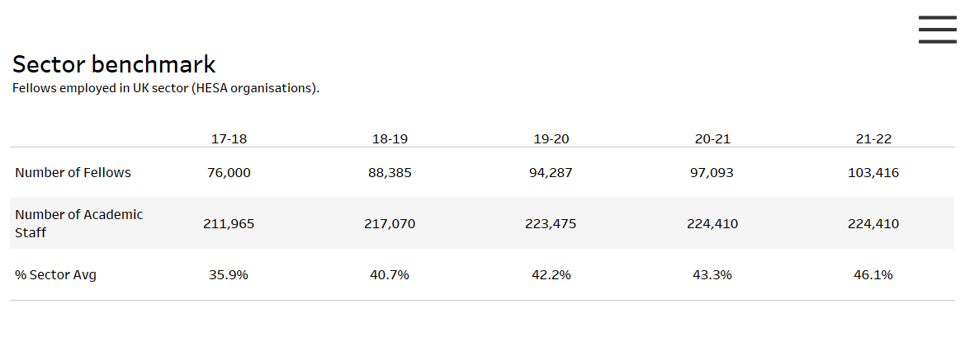

“Academic Staff” data is provided from the HESA Staff Record 2020/21, Higher Education Statistics Agency Limited 7/06/2022.
Neither the Higher Education Statistics Agency Limited nor HESA Services Limited can accept responsibility for any inferences or conclusions derived by third parties from HESA data or other information supplied by the Higher Education Statistics Agency Limited or HESA Services Limited through Heidi Plus.

