Student Experience Committee
June 2022
Agenda Item XX
Paper XX
Status: Open
Purpose: For discussion

Author: Rob Howe
Team: Learning Technology
Email contact: Rob.Howe@northampton.ac.uk
Phone contact: 2483

Northampton University Student Digital Experience Tracker 2022

- Background
The University of Northampton was one of the institutions selected to engage in the ongoing JISC survey focusing on the Student Digital Experience. Whilst the questions were set by JISC and could not be altered they provide useful feedback on the student experience. Where data exists from the survey conducted in 2020 then the change will be shown inside rounded brackets (). The change from sector comparison data from over 43 HE institutions covering 33,000 students is shown in square brackets [] where there is more than 2% variation. This report is a summary of the key issues being raised from the responses. The full report is also available to view to add more context to this paper.
- Demographics
The survey was distributed to students via dedicated messages from the SU and from a link on the front of NILE between 14th November 2021 and 1st February 2022. It was eventually completed by 411(-271) students. There were responses from all Faculties: Health, Education and Society FHES 36.9% (+0.2) Arts, Science and Technology FAST 25% (-7.6) and Business and Law FBL 40.2% (+5%) The respondents also covered a range of stages: Foundation 7.4% (+2.5); Undergraduate 59.6% (-17.2); Postgraduate (taught) 29.7% (+13.3).
Quantitative Findings
In the most recent semester students’ taught classes have been delivered though a mix of online and on site (45%) [+3%]; Mainly online (28%) and mainly on site (27%). 85.4% [+15.4%] tend to be at home or in shared family home. 20% [-7%] are on site and 18% [-15%] are in student accommodation. For future delivery, students would prefer to be taught through a mix of online and onsite (50%) [+5%]; mainly onsite (30%) [-12%] and mainly online (20%) [+7%].
Students are using a range of digital devices to support their learning. 93.2% (-0.2) use their personal laptop. 12.9% (-8.5) [-10%] respondents use their own tablet devices and 58% (-17.2) [-5%] use their own smartphone.
Students were asked how they preferred to develop their digital skills. 39% valued online tutorials and how-to videos. 23.5% want this to happen as part of their taught course. 14% wish to develop skills informally as they go along. 13% like drop-in workshops and 11% want accredited training.
With regards to access to learning online, 46.4% [-3%] are hindered by poor wifi connections; 16.3% by high mobile data costs; 15.8% have problems accessing learning platforms and 12.6% have no suitable computer / device.
When questioned around guidance and support: Support for student’s general development came from online videos and resources 51.9% (+30.1) [-2%]; lecturers on the course 53.4% (+11.4) [+5%]; friends and family 29.6% (+18.2) [-5%]; fellow students 53.4% (+32.6) [-5%]; and IT Staff 34.1% [+10%].
55.6% (+12.3) feel that their course prepares them for the digital workplace. This is a University KPI – the target form 21/22 was 58%. The current figure is 2.4% lower but represents progress.
45.4% (+8.4) [+12%] had been made aware of the digital skills they needed to improve.
94.7% feel that online assessments are managed and monitored fairly. 91.1% of students feel they have a good range of online assessments.
Students who use assistive technology are indicating a range of preferred devices / software. These include 14.3% (+3.3) using screen readers (text to speech); 11.8% (+3.3) using dictation software (speech to text); and 6.5% (=) using screen magnification. 14.3% [-14%] use captions or transcripts on video. 23% now use spelling or writing support.
19.8% (-5.9) respondents indicated that they were unaware of how their personal data was stored suggesting that more work needs to be done to communicate this to students and provide further transparency.
Students were asked about areas they wanted the University to invest in. 39% [-2%] students asked for an upgrade to platform / systems. 24% [+10%] asked for more IT Support; 23% [-5%] asked for specialist software for their course.
51% [+9%] of students feel that their online materials are engaging and motivating; 72% [-4%] feel they are accessible; 59% [+11%] feel that learning online allows them to contribute in the ways that they prefer; 40% [+13%] agreed that being online made them feel part of a community of staff and students.
The final question allowed students to rate the support for learning online
Best imaginable | 6.5% [+2%]
Excellent | 25.4% [+5%]
Good | 39.3%
Average | 20.2% [-4%]
Poor | 4.5% [-2%]
Awful | 2.3%
Worst imaginable | 1.8%

- Qualitative Comments
Students were asked to comment on NILE usability. Of the 240 comments, 172 commented on the ease of use. 27 had access issues either due to network connectivity or due to browser problems. 14 students commented that they needed enhanced induction to make best use of the tools. It was not clear if they had been directed to view the self-paced induction already available on NILE.
192 students commented on the one thing the University could do to help them learn effectively online. 70 students noted that support needed to be improved (this includes connectivity / Wi-Fi, Tutor and Professional Support staff responses to queries). 30 asked for improved inductions.
“Have easier access / contact with IT and maybe have basic lessons at the begin of the degree since not everyone is computer literate.” Student Response.

19 students asked for more interactive and engaging material. 17 requested design changes to delivery such as making material easier to navigate or providing material ahead of the sessions to aid with preparation.
Students were asked what aspect of learning online, if any, is most negative for them. 211 students responded. 82 noted that they felt distant from tutor or other peers.
“Not the same learning environment on-line as opposed to physically being in class and seeing people and hearing their responses.” Student response.

48 students commented on connectivity issues (Wi-Fi or connections to particular systems); 21 commented on the distractions when working offsite; 16 commented on course design problems which did not facilitate online learning. 11 commented on communication problems during delivery which caused problems with engagement
“Most responses are via text messages - by the time you have typed a response the lecturer might have moved on.” Student response.

228 students commented on the aspect of learning online which was most positive for them. 143 noted that being online provided more personal balance in their lives – although some situations may be more complex.
“So I have a child and learning online is very convenient to me because I do not have to pay for childcare. With the semesters, it is very hard to find childcare for one semester and then have to change it for the next semester, and also the same with work. I am expected to have my own laptop, because you, the uni of Northampton, did not allow me to change my perk when I started at the uni because I was not able to live at the university due to personal reason. however, this was not taken into account at all so i have to buy my own laptop which i have to earn money for. So being able to work at go to uni is needed and obviously it was not helpful when you provided me with no help what so ever. so learning online is very positive for me” Student response.

29 students noted that there tended to be more positive interactions with course material and peers whilst online. 17 noted that they valued the recordings which were generated from the online sessions.
302 students commented on an example of a digital tool or app they find really useful for learning and these are represented in the following word cloud (larger = more popular):
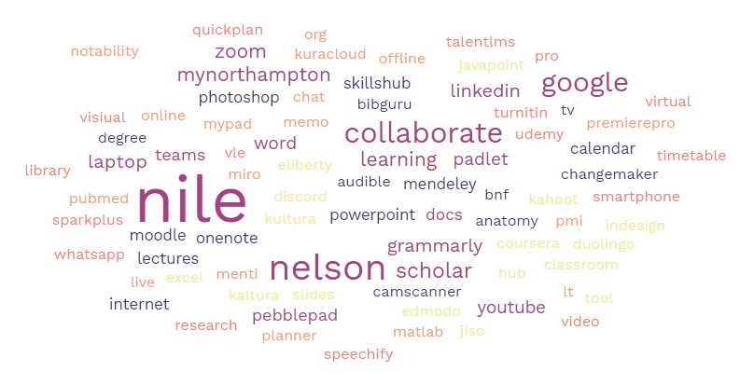
NILE, Nelson, Collaborate and Google Tools still tend to dominate the main areas supporting student learning activity.

Recommendations
The survey results have provided ongoing feedback from students regarding their digital capabilities and experience. Actions have now been identified as a result of further discussions. The recovery plan is in appendix A.

Appendix A

General Area | Actions | Unit responsible | Timing
Online and Hybrid delivery | Student forum to discuss implications of student preference for future delivery | Student Forum
Wifi | Continue to enhance the wifi technical infrastructure to better support students and access. Consider ways to help students with poor wifi or low bandwidth | IT
Inductions | Enhance student induction to systems. Provide induction pathway – ideally with rewards. Students and staff to complete discovery tool.  Better promotion of digital skill development via online tutorial (e.g. LinkedIn Learning) and also through course pathways. | DSG and Tutors
Student Support and software on digital devices | IT to better promote how they support students with software on digital devices and promote licensed software for students. | IT
Online course materials | Further promote the range of online course materials. Consider how to recognise digital skills development. Tutors to continue to provide interactive and engaging material. | LLS and Tutors
Enhancing employability | Focus on the support within courses to enhance student’s digital capabilities to engage with subject material and enhance employability.  Provide more opportunities to check digital skills that students need to improve in preparation for a digital workplace. | LLS, Changemaker, Tutors
Low Student digital capability | There will be many students who did not complete the questionnaire as their skills level is too low. How do we obtain their views? | Student Forum
Social isolation | Promote activities which enhance community and avoid digital isolation. | Tutors
Data Use | Provide more information on how personal data is stored and used. | DSG

