Status: Open
Purpose: For Discussion

Author: Rob Howe
Email: Rob.Howe@northampton.ac.uk
Phone contact: 2483

Digital Capabilities Staff and researcher survey March 2022

1. Recommendation/s

The survey results have provided ongoing feedback from staff and researchers regarding their digital capabilities and general experiences around these. Faculty Student Forums and relevant professional support departments will be used to discuss the findings and identify further actions needed to improve the ratings during 2022.

2. Summary and any major implications

Where data exists then the trend from 2021 figures will be shown in brackets (). The change from sector comparison data from over 43 HE institutions covering 3526 academic staff is shown in square brackets [] where there is more than 2% variation. The survey was divided into three parts: one for professional staff; one for academic staff; and one for researchers. Many of the questions were similar but contextualised for particular roles.

The digital capabilities surveys were made available from 13th October 2021 to 1 February 2022 and completed by 229 (+46) respondents. 83 academic staff FHES– 32(+11); FAST – 24(+19); FBL– 23(+17);LLS – 4.
46 Researchers FHES– 18 (-7) FAST – 19 (-3); FBL– 8 (-11); Other 1.
Professional Services – 100(+18).
The full report in Appendix A provides the detail which was gathered.

3. Risk

The survey has noted several areas which will impact on the staff and student experience. It should be noted that the survey was conducted during the Covid recovery period which may also have impacted on results.

Appendix A

A1) Digital Capabilities Staff survey

Where data exists then the trend from 2021 figures will be shown in brackets (). Some questions were only applicable to certain groups hence the numbers of staff who indicated that the question was not appropriate to them were removed prior to calculating the percentage values.

A2) General digital capabilities
The average self-rating confidence level is 86.5% (-8). The slight drop may be explained by some of the problems that staff had working remotely and feeling less empowered. 90% of staff feel that digital skills are important for their career.

A3) Personal responses

In the two weeks prior to the survey being completed 27% were mainly onsite; 32% were mainly online and 39% were hybrid. In the future 22% would like to work mainly onsite; 19% would like to work mainly online; with 58% wanted to maintain a hybrid mix of both.

When working online the most common issues were wifi 32% (-4) followed by access to services 31% (-1); access to a suitable working area 16% and access to a suitable device 10%.

12% (+4) of staff are making use of assistive technology or devices. This tends to be dominated by spelling support 17%; dictation tools (speech to text 13%) but also includes screen readers and magnification tools.

“I am dyslexic so the integrated speech to text is absolutely required.” Professional Staff Response.

31% do not feel supported in using their own device and 13% do not feel supported when working offsite.

A4) Institutional comments

48% did not feel involved in decisions regarding online working and teaching. However, 31% feel that there is support for using their own devices. 86% felt there was effective online communication, collaboration and tools to enable online engagement.

14% do not feel that there is effective general University online communication. 37% feel that there should be more investment in keep systems up to date and well maintained. 34% feel that there should be more investment in IT support.

A5) Support and guidance
18% (+4) of staff do not currently feel that they are provided with guidance about the digital skills that they need in their job role. Furthermore 37%(+2) do not feel that they have the chance to assess their digital skills (e.g. for career planning). 52%(+6) indicate that they do not have the time to explore new digital tools and approaches. 62% (+2) of respondents do not feel that the institution provides reward and recognition for the digital skills they are developing.

In terms of where respondents go for help with technical issues: 76% (=) use colleagues; 71% (+17) use online videos; and 22% (+2) use friends.

22% of staff noted that teaching / working online does not allow them to teach / work in the way that they prefer (although this seems to be dominated by academic staff (53%) as opposed to only 4% of professional staff. However, 76% of staff do feel that working online is convenient. This could be at the expense of feeling a sense of community with only 25% feeling that this was supported whilst working remotely.

25% did not feel that they were able to access all the support they needed whilst online. 23% did not feel that there was someone that they could speak to regarding their worries. 42% did not feel that their concerns were being listened to.

When asked about how staff rated the quality of their online teaching, working or research environment, the following average responses were received:

Best Imaginable – 1%
Excellent – 16%
Good – 49%
Average – 22%
Poor – 9%
Awful – 1%
Worst imaginable – 0%

The variation between different groups of staff is shown below:

A6) Academic Specific responses

Some questions were asked just on the academic questionnaire. In the past 2 weeks, 77% [+16%] had uploaded materials, 67% [+12%] had run a live online session, and 43% [+7%] had run either a face to face or online session. 29% [-13%] had recorded their session. 30% had supported online collaboration. 35% [+8%] did not feel that teaching online allowed students to make progress. In contrast 23% [-7%] did feel that student progress was being made which may reflect preferences in different subject areas and with different delivery styles. There was a similar difference in responses when asked whether teaching online allows for fair assessment with 38% [+12%] disagreeing and 23% [-9%] agreeing that it did.
57% [-9%] of academic staff did not feel that they were able to use data to monitor engagement which may be explained through LEARN being unavailable during the prior of the survey. 39% did not understand how the University uses student data. 22% did not feel comfortable with the way in which student data was being used. 28% did not feel that recorded sessions were essential for students compared to 41% who felt that they were.
Only 6% did not feel that online assessments were being managed fairly. 14% did not feel that students had a good range of online experiences.
When asked to rate NILE for usability the following was returned:

1% felt it was the best imaginable
11% [-2%] thought it was excellent
52% [+2%] thought it was good
26% thought it was average
8% thought it was poor
2% thought it was awful
0% thought it was the worst imaginable

A7) Research Staff Responses
Most of the quantitative researcher responses have already been aggregated into the responses above since they followed the same format as the standard questionnaire. Qualitative responses will be shown below. The exception to this is the Researcher usability rating on PURE as a system.

2% felt it was the best imaginable
9% thought it was excellent
35% thought it was good
37% thought it was average
7% thought it was poor
7% thought it was awful
0% thought it was the worst imaginable

A8) Qualitative comments

Each of the three questionnaires had separate qualitative questions.

A8-1) Academic staff

A8-1A) To help you to teach effectively online, what one thing should we do?

30 staff mentioned improved / enhanced training and technology /IT support. 13 mentioned software related issues which can be picked up by relevant teams. 6 mentioned the need for more time in their workload allocation.

A8-1B) What aspect of teaching online, if any, is most negative for you?

56 staff mentioned engagement issues:

“Lack of engagement from students and not knowing if they are actually listening/paying attention. Lack of engagement because they do not wish to turn on cameras/microphones and also poor wifi connection their end causes issues.” Tutor response.

11 staff mentioned connectivity issues such as Wifi.

A8-1C) What aspect of teaching online, if any, is most positive for you?

52 staff mentioned improved flexibility:

“Personally convenient, don't have to commute. Pre-recorded lectures support students learning as they can go back over them in more detail than simply having lecture notes posted online” Tutor response.

13 mentioned design benefits:

“Being able to use other digital tools more easily blended into the sessions and use of feedback via chat functions for example” Tutor response.

A8-1D) Please give an example of a digital tool or app you find really useful for teaching

This is presented in the following Wordle, larger text items were mentioned by more staff:

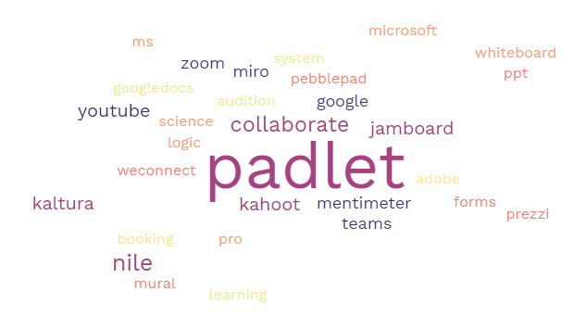

A9-2) Research Staff

A9-2a) To help you to work effectively online, what one thing should we do?

17 researchers mentioned items related to IT:

“Providing a suitable laptop which does the job, for instance high speed laptop for simulation work” Researcher response.

4 mentioned improved researcher resources.

A9-2b) What aspect of researching online, if any, has been most negative for you?

11 researchers mentioned difficulties with collaboration – For example ‘Loss of research community and sharing ideas’. 10 mentioned technical / IT issues.

A9-2c) What aspect of researching online, if any, has been most positive for you?

15 researchers mentioned improved balance and flexibility in their work. 7 mentioned improved collaboration – For example ‘Able to work with colleagues from different institutions and countries without having to travel.’

A9-2d) Please give an example of a digital tool or app you find really useful for research.

This is presented in the following Wordle, larger text items were mentioned by more researchers:

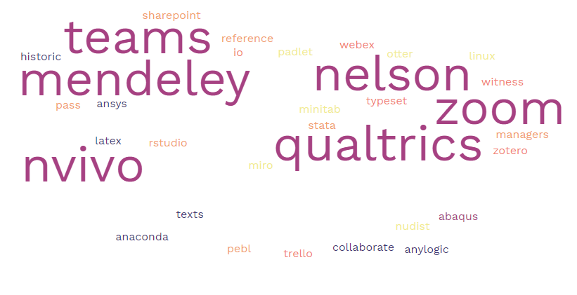

A10-3) Professional Services staff

A10-3a) To help you to work effectively online, what one thing should we do?

35 staff mentioned IT related issues – for example “Responsive IT support when help is needed.” 6 staff mentioned the need for better support – for example:

“Provide support/check in with those who struggle more with technology. Line managers and Senior staff are not always on hand or available to help you when carrying out a task that needs doing then and there. People who struggle or who do not find it as easy to ask for help may try to then just cope, this then missing deadlines or not completing a job correctly.” Professional Staff Response.

A10-3b) What aspect of remote working, if any, has been most negative for you?

45 staff mentioned feelings of isolation:

“Not having the ability to socialise with colleagues regularly or have the ability to ask a quick question, get them to show me something on the screen makes working from home more difficult. A mixed approach would be really beneficial to productivity and staff wellbeing.” Professional Staff Response.

15 staff mentioned IT related issues – for example “not having an adequate laptop to support my work.”

A10-3c) What aspect of remote working, if any, has been most positive for you?

77 staff mentioned the balance provided between home and working life:

“The ability to maintain a work/life balance has been invaluable in reducing stress whilst continuing to provide a good service.” Professional Staff Response.

A10-3d) Please give an example of a digital tool or app you find really useful in your role

This is presented in the following Wordle, larger text items were mentioned by more staff:

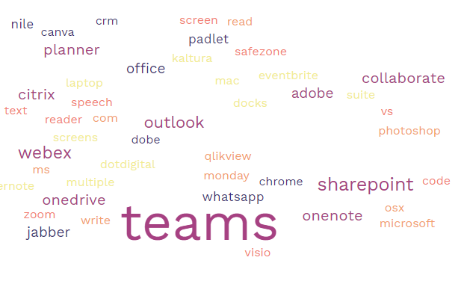
A11) Recovery Plan

The survey results have provided ongoing feedback from staff regarding their digital capabilities. Actions have now been identified as a result of further discussion.

Actions | Unit responsible | Timescale for discussions
Continue to improve stable Wifi and pickup on staff IT issues | IT | Ongoing
Investigate ways in which to recognise and reward staff for digital development. Investigate ways for staff to have time to improve their digital skills | Faculty, Learntech and Staff development | July 2022
Promote LinkedIn Learning for online skills development | LinkedIn Learning Steering Group | July 2022
Further discussions with staff on smart working to ensure suitable balance for both the institutional requirements and individuals. Consider how community may be further enhanced. | Faculty and HR | July 2022
Define key systems in use by the University and their functions. Better promotion of assistive technology or devices. | Digital Steering Group | July 2022
Improve communication to advise on all aspects of digital support. Staff and students should use the right tool for the right task. There should be centralised location for information. | Digital Steering Group | July 2022
Promote data for academic staff which allows them to monitor engagement | Learntech | July 2022
Ensure all staff know who to talk to if they have concerns and ensure these are listened and responded to. | HR | July 2022

