Neurological Physiotherapy
Neurological Physiotherapy

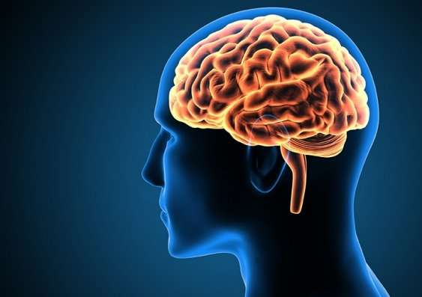

University of Northampton

This short workbook is designed to get you thinking about what neurological physiotherapy is and to serve as an introduction to the content which will be covered in the module within your first semester (PHYM001 Evidence-based neurological physiotherapy).
The module includes workbooks for completion in preparation for virtual and practical sessions. They incorporate a variety of tasks, videos, links, research papers. The workbooks are designed specifically to assist in the understanding of the background theory in preparation for clinical and practical application.

Structure of the nervous system
The link below is to a video explaining the structure of the nervous system
https://youtu.be/jmD0LBdAvlE
Following the video, aim to complete the following table with definitions and functions:-
Central nervous system (CNS)
Peripheral nervous system (PNS)
Afferent nerves
Efferent nerves
Brainstem
Cerebral hemisphere/cerebrum
Cerebellum
Spinal cord
The human Nervous System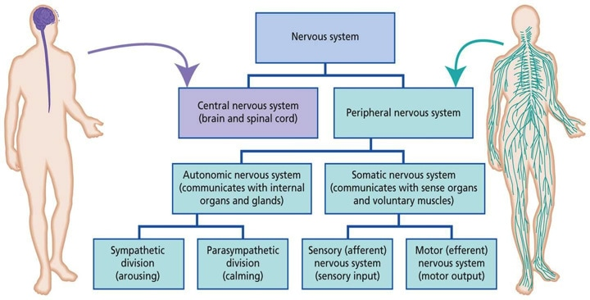

Balance
(as we are yet to meet you, ensure you do this in a safe environment and where there is a secure surface that you can hold onto if required)
Balance can often be categorised into either static or dynamic
Complete the following tasks and then answer the questions in as much detail as possible:-
Task 1 – standing
Task 2 – stand on one leg (try right and left leg, time them and is it the same?)
Task 3 – stand on one leg with your eyes closed (try right and left leg, time them and is it the same?)
Task 4 – Hop on one leg 3 times and travel forward as you hop (is your performance the same on your right and left side, if not, why not?)
- How do you maintain your balance in all of these tasks? How would you describe how ‘balanced’ you are?
- What is affecting your balance/what has changed between the tasks that has affected your state of balance?
- What information regarding the position of your body is being sent to the brain and how is it sent there?
- What is involved in maintaining your balance during these activities? Think about the musculoskeletal systems, the neurological control of these systems and from a cognitive perspective.
- If someone ‘nudges you’ whilst doing these activities…..what do you do/how does your body maintain it’s balance and ensure that you don’t fall over?

Skill Acquisition
Think of a time when you learnt a new skill or taught someone a new skill. For example, driving a car, musical instrument, riding a bike
- What affects the time it takes to master the skill?
- How did you learn or teach the skill – learn it in parts and piece it together, or as a whole?
- What do you need as the learner and as the teacher in skill acquisition?
- Now imagine that you have a patient following a neurological injury and they are unable to complete a task such as picking up a brush to brush their hair.
- They have weakness throughout the whole of their arm
- What strategies and ideas would you have to gain the restoration of function?

Useful resources
- Jawabri KH, Sharma S. Physiology, Cerebral Cortex Functions. [Updated 2019 Jun 29]. In: StatPearls [Internet]. Treasure Island (FL): StatPearls Publishing; 2019 Jan-. Available from: https://www.ncbi.nlm.nih.gov/books/NBK538496/ Found online at: https://www.ncbi.nlm.nih.gov/books/NBK538496/
- Rubenstein JL. Annual Research Review: Development of the cerebral cortex: implications for neurodevelopmental disorders. J Child Psychol Psychiatry. 2011 Apr;52(4):339-55. doi: 10.1111/j.1469-7610.2010.02307.x. Epub 2010 Aug 24. PMID: 20735793; PMCID: PMC3429600. Found online at: https://www.ncbi.nlm.nih.gov/pmc/articles/PMC3429600/
- Snell, R., 2010. Snell's clinical neuroanatomy|Clinical neuroanatomy. Philadelphia, Pa: Wolters Kluwer Health.

- Nb – The Khan Academy and Physiopedia are useful online resources for further videos and information

