Preparatory Workbook
Cardiorespiratory
Physiotherapy

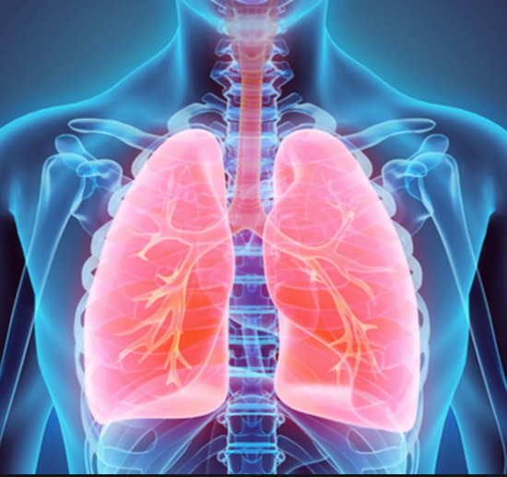
University of Northampton

Cardiorespiratory System

Welcome to your cardiorespiratory module. This workbook aims to provide you with tasks to provoke thoughts in preparation for this specialist module.
It is the first in a series of workbooks, which will continue when your module commences, designed to guide your learning in understanding the basics of the cardiorespiratory system and prepare you for the PHYM002 module in Semester 1.
Your will soon have access to resources provided in your reading list and on your module site which will support completion of the workbooks. These resources are a starting point and there is an expectation that you will find your own resources to support completion of the workbooks.

Task One
- a. What is meant by the term ‘biomechanics’?

b. Why is this term relevant to the respiratory system? Consider ventilatory biomechanics.

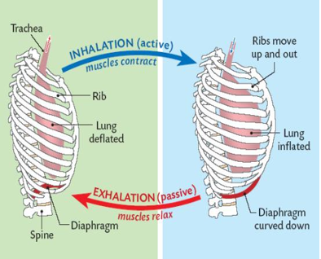

Task Two
a. Watch the video via the following link:
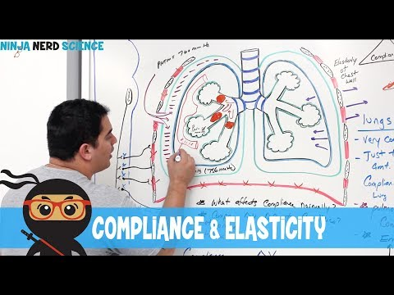

https://www.youtube.com/watch?v=BTwgmMfqOW4

b. Consider how compliance may be affected in patients with chronic lung disease e.g. Asthma or Chronic Obstructive Pulmonary Disease.

Task Three
Practical:
Physiotherapists are experts in exercise prescription for all patients. Monitoring observations is integral for cardiorespiratory patients in particular

Equipment:

Clock/ watch/ phone timer
Stairs/ step
Smart phone health app if you have one (not essential)

Task taking observations

- Take your radial pulse
- Place your index and middle finger together at the base of the thumb, press firmly and move fingers around until you find the pulse.
- Count the beats for one minute
- Right down on a piece of paper how many beats per minute
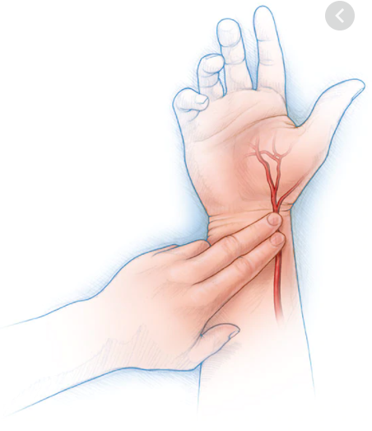

- Take your respiratory rate
- Place your hand on the top of your chest breath in and out normally
- Count the amount of breaths for one minute
- Right down on a piece of paper how many breaths per minute

- Take your oxygen saturations
- If you have a smart phone or watch
- Open up the health app
- Place finger/ wrist on the sensory probe
- This will record your oxygen saturation as a percentage
- Right down your oxygen saturation on a piece of paper

Now…
Complete moderately vigorous exercise
- Run up and down stairs/ steps for 5 minutes
- Burpees x 25
- Star jumps x 25
- Squat jumps x 25
- Repeat

Once you feel out of breath …
Repeat observations
- Take heart rate and write on paper
- Take respiratory rate and write on paper
- Take oxygen saturation and write on paper

How did your body respond to exercise?
- What do you think the immediate blood pressure response to exercise is?
- What is the immediate response of stroke volume to exercise?
Long term response?
What is the training/ long term impact of exercise on:
- Heart rate
- Stroke volume
- Respiratory rate
- Oxygen saturation
- Blood pressure

Task 4
- What signs and symptoms may you expect from a patient with a chest infection?

- What do you understand by the term Dyspnoea?

- What factors may contribute to a person’s level of breathlessness?

Resources:
Bott,J.,Bulmenthal, K., Buxton M., Ellum, S., Falconer, C., Garrod, R., et al. Guidelines for the physiotherapy management for the adult, medical, spontaneously breathing patient. Thorax. 2009. 64: 1.

Hough, A. (2001). Physiotherapy in respiratory care. (3rd ed.). Cheltenham: Nelson Thornes.

Main. E. & Denehy. L. (2016) Cardiorespiratory Physiotherapy Adults and Paediatrics. Elsevier.

Pryor, J. A. & Prasad, S. A. (Eds). (2008). Physiotherapy for respiratory and cardiac problems - adults and paediatrics. (4th ed.). Edinburgh: Churchill Livingstone.

Marieb, E. N. (2004). Human anatomy and physiology. (6th ed). London: Pearson Benjamin Cummings.

West, JB. (2012) Respiratory physiology the essentials. 9th Edition. Lippincott, Williams & Wilkins, Philadelphia.

