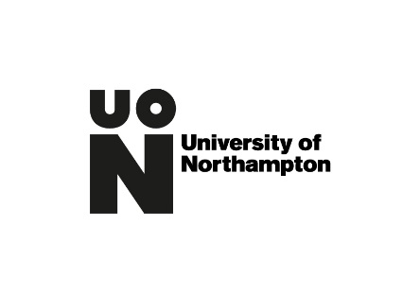

REID SCIENCE AND ENGINEERING BURSARY

APPLICATION FORM

First Name:
Last Name:
Address:

Phone:
Email:
Student No:

Please confirm the full title of your course – you must be commencing your first year of study in 2021:

Please confirm your household income per annum:

Are you in receipt of or have you applied for any other award or scholarship? If so, please provide details:

Please expand as to why you are applying for funds and how they will be used [maximum 300 words]:

Please return your completed form by 31 October 2021 to scholarships@northampton.ac.uk

