Outcomes from the Delapré Park Walking Route Public Survey – Executive Summary

In January 2021, Researchers, Delapré Abbey Preservation Trust, and Northamptonshire Sport were awarded £8,000 of funding from the University of Northampton to conduct a 2-year research project to see if the temporary installation of directional signage on one route within Delapré Park could increase walking route use and population physical activity participation. This research came about as ‘knowledge of existing routes’ had been previously highlighted as a common barrier to using local greenspaces.

As part of this 2-year research project, members of the public were invited to complete a survey that asked about the support for directional signage in local parks, the personal benefits directional signage could bring, and what information should be provided on directional signage for recreational walking. The survey received 266 responses from the local community, representing a diversity of respondents. Notably, 200 responses were women, the exact reason for this is unknown but it is common for physical activity and health research to over-represent men. Thus, the high response rate from women was welcomed as they, on average, are less likely to use open-spaces and be less physically active than men.

Key Findings
The use of directional signposts
There was strong support for directional signage with 75% (198) of respondents agreeing that they should be installed within public parks and footpaths to promote walking, running, and cycling, while only 17 respondents strongly disagreed.
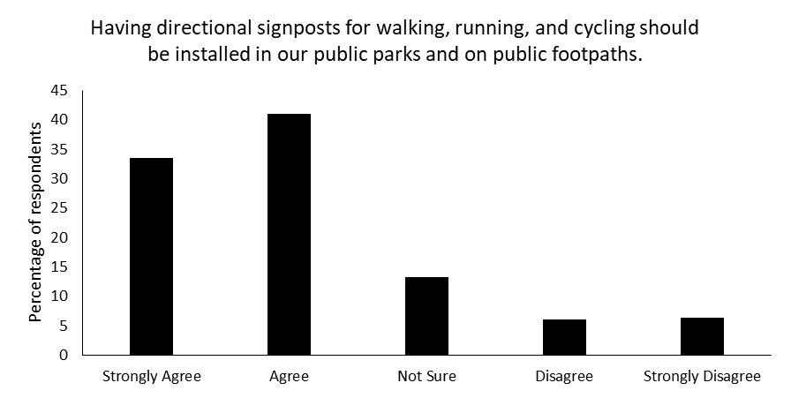
Previous research has suggested a lack of confidence and anxiety about using unfamiliar routes can be another barrier to walking and the results of our survey suggested that directional signposts could overcome this as 47% of respondents strongly agreed that directional signposts would make them feel more confident about using unfamiliar routes and 39.5% strongly agreed they would make them feel less anxious.
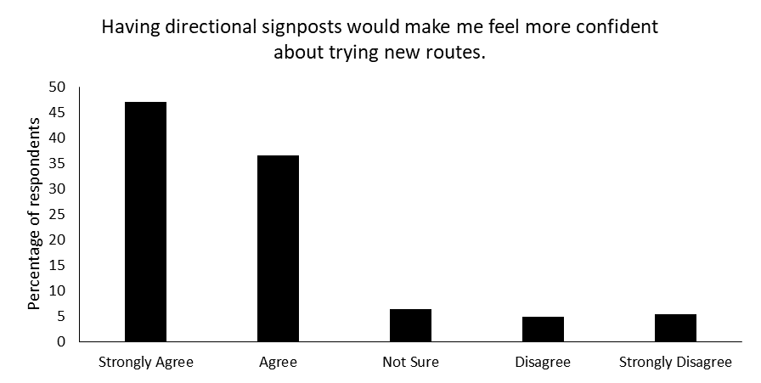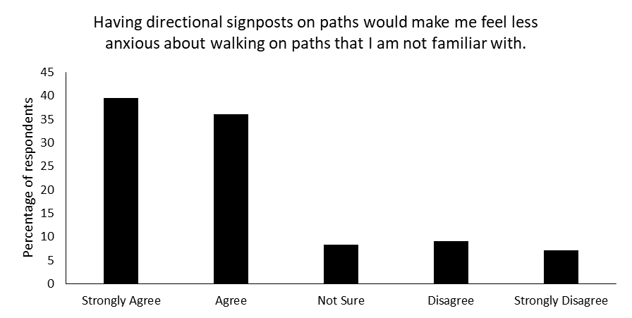

We also asked respondents to express their thoughts through open text answers. Of the 58 responses, some people felt that directional signage could take the fun and adventure out of exploring greenspaces and that they use this unfamiliarity of routes as a from of ‘escapism’ from daily life as well as concerns about what greater usage could do to the natural beauty of the area:
“I think directional signposting totally takes the fun and adventure out of a walk. It loses the sense of enjoyment from exploration and discovery.” (Female, 46-60 years)
“The joy of going down the path less travel(l)ed to find a beautiful undisturbed peaceful environment is lost…More people trudging around a beautiful environment equals more damage to the natural environment, paths encroaching on nature and inevitably more human impact on the wildlife. Lots more litter!” (Female, 46-60 years)

However, many people expressed their opinions on how the directional signage could benefit themselves and others along with some recommendations of what to include on this current signage or possible permanent installations:
“I think having clearly defined parameters would actually encourage people to explore a little further i.e. if you have a clearly defined route, it's easy to amble off and have a little poke around in the undergrowth! Whereas if there's no route, if it's overgrown etc. people often don't know where to start.” (Female, 46-60 years)
“(I am) more likely to walk a route knowing how far it is and the time it would take before hand. Otherwise may just wonder around keeping close to car/home/the familiar.” (Female, 31-45 years)
“Knowing the sort of terrain you are walking on is really helpful if you have additional needs. I've sometimes had to turn back due to stiles which weren't marked on a map or walk leaflet.” (Female, 61+ years)
“It would be inclusive to consider directional signposting use for visually impaired walkers & runners. Not everyone who wants to be active has the same level of sight.” (Female, 46-60 years)
“Just having signs pointing us in the right direction would be a great start.” (Female, 31-45 years)

What to include on directional signposts?
There were six consistent pieces of information that respondents strongly agreed should be included on directional signposts to promote recreational greenspace activities, these were:
1. directional arrows
2. total distance of the route
3. consistent colours and fonts
4. a map of the route
5. local information of interest, such as historical or nature information
6. emergency contact information

However, there were two pieces of information from the list of 13 options that respondents did not want on directional signposts, these were: motivational statements to encourage walking, running, and cycling, and the amount of people who have used the route each month. It seems removing anything that could suggest competition is important. These were explained in the open text responses:
“I'm not so keen on the motivational statements - it could be fun I suppose but it's a bit "Mr Motivator" for my liking!” (Female, 46-60 years)
“Including an average time of completion could lead to negative feelings e.g. “I am unfit/slow compared to the average person” and may stop them from walking that route again…it may make them walk faster with the sole intention of being closer to the average time but reducing the fun factor of the walk.” (Male, 18-30 years)

The Next Steps
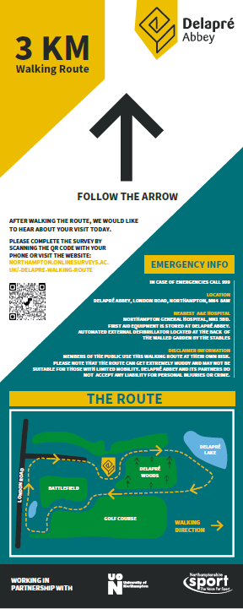
Over recent months, visitors of Delapré Park will have noticed the installation of wooden posts and footfall counters at various locations on the footpaths. During this time the researchers have been measuring how many people currently use the park to create a comparison for when the signage is installed.
The researchers have implemented responses from the public survey where possible into the design of the route signage and these signs are due to be installed by September 2021. Once the signs have been installed the researchers will continue to monitor the footfall in the park up to August 2023.
Being able to experience temporary changes to the environment is vital to developing a strong evidence base for future permanent decisions. Therefore, users of the route will also be able to share their views via on online questionnaire throughout the time the signs are in place by scanning the QR code or visiting the website address displayed on the signs.
The researchers, Delapré Abbey Preservation Trust, and Northamptonshire Sport are extremely grateful for the large public interest in this research project and encourage members of the local community to continue sharing their views throughout the remainder of the project. Every public comment helps us understand how, when, and why directional signage should be installed to help the people of Northamptonshire explore their local greenspaces.

