Test of Competence 2021:
Mock OSCE
Children’s Nursing

Children’s nursing

In your objective structured clinical examination (OSCE), four of the stations are linked together around a scenario: this is called the APIE, with one station for each of Assessment, Planning, Implementation and Evaluation, delivered in that sequence and with no stations in between.

Four of the six remaining stations will take the form of two sets of two linked stations, testing practical clinical skills. Each pairing of skills stations will last for approximately 16 minutes in total (including reading time), with no break between each paired skill.

There are also two new silent stations. In each OSCE, one station will specifically assess professional issues associated with professional accountability and related skills around communication (called the professional values and behaviours, or PV, station). One station will also specifically assess critical appraisal of research and evidence and associated decision-making (called the evidence-based practice station, or EBP). Please note that the PV and EBP stations assess generic skills, not just skills specific to children’s nursing.

We have developed this mock OSCE to provide an outline of the performance we expect and the criteria that the test of competence will assess. This mock OSCE contains an APIE, one pair of linked clinical skills, one PV and one EBP station.

The Nursing and Midwifery Council’s code (2018) outlines professional standards of practice and behaviours, setting out the expected performance and standards that are assessed through the test of competence.

The code is structured around four themes: prioritise people, practise effectively, preserve safety and promote professionalism and trust. These statements are explained below as the expected performance and criteria. The criteria must be used to promote the standards of proficiency in respect of knowledge, skills and attitudes. They have been designed to be applied across all fields of nursing practice, irrespective of the clinical setting, and they should be applied to the care needs of all patients.

Please note: this is a mock OSCE example for education and training purposes only.

The marking criteria and expected performance apply only to this mock OSCE. They provide a guide to the level of performance we expect in relation to nursing care, knowledge and attitude. Other scenarios will have different assessment criteria appropriate to the scenario.

Evidence for the expected performance criteria can be found in the reading list and related publications on the learning platform.

Theme from the code | Expected performance | Criteria
Prioritise people | Treat people as individuals and uphold their dignity | Introduces self to the patient at every contact and upholds the patient’s dignity and privacy.
 | Listen to people and respond to their preferences and concerns | Actively listens to patients and provides clear information, behaving in a professional manner, respecting others and adopting non-discriminatory behaviour.
 | Make sure that people’s physical, social and psychological needs are responded to | Upholds respect by valuing the patient’s opinions and being sensitive to feelings and/or appreciating any differences in culture.
 | Act in the best interest of people at all times | Treats each patient as an individual, showing compassion and care during all interactions.  Respects and upholds people’s human rights.
 | Respect people’s right to privacy and confidentiality | Ensures that people are informed about their care and that information about them is shared appropriately, maintaining confidentiality.
Practise effectively | Always practise in line with the best available evidence | Provides skills, knowledge and attitude that is supported by an evidence base at all times.
 | Communicate clearly | Communicates clearly and effectively to people in their care, colleagues and the public.
 | Work co-operatively | Maintains effective and safe communication with people in their care, colleagues and the public.
 | Share your skills, knowledge and experience for the benefit of people receiving care and your colleagues | Supports others by providing accurate, honest and constructive verbal and written feedback.
 | Keep clear and accurate records relevant to your practice | Provides clearly written feedback on all care given, and demonstrates accurate evidence-based verbal handover of care to others.
 | Be accountable for your decisions to delegate tasks and duties to other people | Accountably delegates to competent others, ensuring patient safety at all times.
Preserve safety | Recognise and work within the limits of their competence | Accurately identifies, observes and assesses signs of normal or worsening physical and mental health in the person receiving care, requesting timely and appropriate assistance as required.
 | Be open and candid about potential mistakes, preventing harm | Documents events formally and takes further action (escalates) if appropriate, so they can be dealt with quickly.
 | Provide assistance in an emergency | Acts in an emergency within the limits of their knowledge and competence, seeking appropriate support as required.
 | Act swiftly if there is a danger to others, maintaining safety | Delivers care according to national policies and procedures to prevent danger to others, and applies appropriate personal protective equipment (PPE) as indicated by the nursing procedure in accordance with the guidelines to prevent healthcare-associated infections.
 | Raise concerns for those who are seen to be vulnerable or at risk of harm | Shares information if someone is at risk of harm, in line with the laws relating to the disclosure of information.
 | Advise on, prescribe, supply, dispense or administer medicines within the limits of your training and competence, the law, our guidance and other relevant policies, guidance and regulations | Checks prescriptions, patient identification and administers medicines safely, highlighting appropriately any areas of concern.
 | Demonstrate awareness of any potential harm associated to their practice | Takes all reasonable personal precautions necessary to avoid any potential health risks to colleagues, people receiving care and the public.
Promote professionalism and trust | Uphold the reputation of the profession at all times | Demonstrates and upholds the standards and values set out in the code.
 | Fulfil the registration requirements | Demonstrates up-to-date knowledge, skills and competence to provide safe and effective care at all times.
 | Provide leadership to make sure that people’s wellbeing is protected and to improve their experiences of the health and care system | Identifies priorities, manages time and resources effectively, and deals with risk to make sure that the quality of care or service is maintained and improved, putting the needs of those receiving care or services first.

The mock APIE below is made up of four stations: assessment, planning, implementation and evaluation. Each station will last approximately 15 minutes and is scenario-based. The instructions and available resources are provided for each station, along with the specific timing.
Scenario
Jordan Singh, aged 4, was admitted onto the paediatric assessment unit with a painful cut on the arm, which occurred when falling over in the preschool playground 2 days ago. Jordan is also suffering with pyrexia and poor oral intake. Jordan is accompanied by a parent.

You will be asked to complete the following activities to provide high-quality, individualised nursing care for the patient, providing an assessment of needs that is based on the recovery model of care. All four of the stages in the nursing process will be continuous and will link with each other.

Station | You will be given the following resources
Assessment –20 minutes  You will collect, organise and document information about the patient. | - Assessment overview and documentation (pages 10–14)  - A Wong-Baker FACES pain rating scale (page 15)  - A paediatric early warning score (PEWS) chart (pages 16–17)
Planning – 14 minutes  You will complete the planning template, choosing two aspects of the patient’s care needs and establishing how they will be met. | - A partially completed nursing care plan for two nursing care problems or needs (pages 18–21)
Implementation –15 minutes  You will administer and document medications while continuously assessing the individual’s current health status. | - An overview and a medication administration record (MAR) (pages 22–28)
Evaluation –8 minutes  You will document the care that has been provided so that you can do a verbal handover to the nurse on the next shift (the examiner). | - Documents from the previous three stations  - A blank situation, background, assessment and recommendation (SBAR) tool (pages 29–30)
On the following pages, we have outlined the expected standard of clinical performance and criteria. These marking matrices is there to guide you on the level of knowledge, skills and attitude we expect you to demonstrate at each station.

Assessment criteria
Assess the safety of the scene and privacy and dignity of the child/infant and parent.
Cleans hands with alcohol hand rub, or wash with soap and water and dry with paper towels following World Health Organisation (WHO) guidelines.
Introduces self to infant/child and parent.
Checks identity (ID) with carer and/or child (name is essential and either their date of birth or hospital number) verbally, against wristband (where appropriate) and documentation.
Checks for allergies verbally and on wrist band.
Gains consent and explains reason for the assessment.
Uses a calm voice, speech is clear, body language is open, and personal space is appropriate.
Conducts an A to E assessment – verbalisation allowed.
Airway:
- clear;
- no visual obstructions.
Breathing:
- respiratory rate
- rhythm
- depth
- oxygen saturation level
- respiratory noises (rattle wheeze, stridor, coughing)
- unequal air entry
- visual signs of respiratory distress (use of accessory respiratory muscles, sweating, cyanosis, ‘see-saw’ breathing).
Circulation:
- heart rate
- rhythm
- strength
- blood pressure
- capillary refill
- pallor and perfusion.
Disability:
- conscious level using ACVPU scale (Alert, Confusion, Voice, Pain, Unresponsive)
- presence of pain
- urine output
- blood glucose.

Exposure:
- take and record temperature
- asks for the presence of bleeds, rashes, injuries and/or bruises
- obtains a medical history.
Accurately measures and documents the patient’s vital signs and specific assessment tools.
Calculates paediatric early warning score (PEWS) accurately.
Accurately completes document: signs, dates and adds time (when appropriate) to assessment charts.
Conducts a holistic assessment relevant to the patient’s scenario.
Disposes of equipment appropriately – verbalisation accepted.
Cleans hands with alcohol hand rub, or washes with soap and water and dries with paper towels following WHO guidelines – verbalisation accepted.
Acts professionally throughout the procedure in accordance with NMC (2018) ‘The Code: Professional standards of practice and behaviour for nurses, midwives and nursing associates’.

Planning criteria
Clearly and legibly handwrites answers.
Identifies two relevant nursing family/child-centred care problems/needs.
Identifies aims for both problems.
Sets appropriate evaluation date for both problems.
Ensures nursing and family/child-centred care interventions are current/evidence-based/best practice.
Uses professional terminology in care planning.
Does not use abbreviations or acronyms.
Ensures strike-through errors retain legibility.
Accurately prints, signs and dates.
Acts professionally throughout the procedure in accordance with NMC (2018) ‘The Code: Professional standards of practice and behaviour for nurses, midwives and nursing associates’.

Implementation criteria
Cleans hands with alcohol hand rub, or washes with soap and water and dries with paper towels following WHO guidelines.
Introduces self to child and carer.
Seeks consent from person or carer prior to administering medication.
Checks allergies on chart and confirms with the person in their care, also notes red ID wristband (where appropriate).
Before administering any prescribed drug, looks at the person’s prescription chart and correctly checks ALL of the following:
Correct:
• person (check ID with person: verbally, against wristband (where appropriate) and documentation)
• drug
• dose
• date and time of administration
• route and method of administration
• diluent (as appropriate)
• any allergies.
Correctly checks ALL of the following:
• validity of prescription
• signature of prescriber
• prescription is legible.
If any of these pieces of information is missing, unclear or illegible, the nurse should not proceed with administration and should consult the prescriber.
Considers contraindication where relevant and medical information prior to administration (prompt permitted). (This may not be relevant in all scenarios.)
Provides a correct explanation of what each drug being administered is for to the person in their care (prompt permitted).
Administers drugs due for administration correctly and safely.
Omits drugs not to be administered and provides verbal rationale (ask candidate reason for non-administration if not verbalised).
Accurately documents drug administration and non-administration.
Acts professionally throughout the procedure in accordance with NMC (2018) ‘The Code: Professional standards of practice and behaviour for nurses, midwives and nursing associates’.

Evaluation criteria
Situation
Introduces self and the clinical setting.
States the patient’s name, hospital number and/or date of birth, and location.
States the reason for the handover (where relevant).
Background
States date of admission/visit/reason for initial admission/referral to specialist team and diagnosis.
Notes previous medical history and relevant medication/social history.
Gives details of current events and detailing findings from assessment.
Assessment
States most recent observations, any results from assessments undertaken and what changes have occurred.
Identifies main nursing family/child-centred care problems/needs.
States nursing and medical interventions completed.
States areas of concerns.
Recommendation
States what is required of the person taking the handover and proposes a realistic plan of action.

Overall
Verbal communication is clear and appropriate.
Systematic and structured approach taken to handover.
Acts professionally throughout the procedure in accordance with NMC (2018) ‘The Code: Professional standards of practice and behaviour for nurses, midwives and nursing associates’.

Candidate briefing

You are a registered child nurse working on the child assessment unit.
Please conduct a holistic assessment of the patient’s physical, psychosocial, developmental and education/play/recreation needs.
As part of your assessment, please complete an A to E assessment (airway, breathing, circulation, disability, exposure), a Wong-Baker FACES pain rating and record the patient’s vital signs (blood pressure, temperature, pulse rate, oxygen saturations, respiratory rate), and calculate a paediatric early warning score (PEWS) and monitor frequency.
Please demonstrate and verbalise taking a set of observations on the paediatric manikin. You will not obtain results from the manikin; the examiner will provide a set of children’s observations for you. Using these observations, the paediatric early warning chart must be completed in full for the child before the end of the station.
As you undertake your A to E assessment, please ask the examiner for any clinical information you are unavailable to obtain from the manikin. Depending on the patient’s circumstances and condition, you may wish to focus on some areas in more depth than others.
Please note that there is no need to remove the patient’s clothing to assess exposure. Please ask the examiner for any additional clinical information you require.
All equipment has been checked, calibrated and is clean.
An observation chart is provided and must be completed within the station.
This document must be completed using a GREEN PEN.
You have 20 minutes to complete this station, including the completion of the following documentation: Wong-Baker FACES pain rating scale and PEWS.
Assume that it is TODAY and that it is 09:00 hours.

Overview of recent history
Patient information
Name: Jordan Singh
Date of birth: 01/01/2017
Address: 1 Sweet Street, Westshire
Postcode: WW6 5PQ
GP: Dr Williams, Westshire GP Surgery, Westshire, WW6 6RS
Presenting complaint:
- Jordan has a painful cut on the arm, which occurred when falling over in the preschool playground 2 days ago.
- Jordan also is suffering with pyrexia and poor oral intake. Jordan is accompanied by his parent.
History of presenting complaint:
- Acquired a painful cut on the arm 2 days ago when falling over in the preschool playground.
- Pyrexia and poor oral intake started 1 day ago.
Medical history:
- Has had all childhood vaccinations.
Social history:
- Father: Jacob, Mother: Esther, Sister: Hannah (2 years)
- All live in same house.
- Attends Red Vale Preschool.
Drug history:
- Lactulose 10g. 5ml, twice a day
Allergies:
- Peanuts (reaction anaphylaxis).

Candidate notes
This documentation is for your use and is not marked by the examiners.
Patient details
Name: Jordan Singh
Hospital: 0004321
Address: 1 Sweet Street, Westshire, WW6 5PQ
Date of birth: 01/01/2017

Airway
Breathing
Circulation
Disability

Exposure – full clinical history

Candidate notes
This documentation is for your use and is not marked by the examiners.
Physical
Psychosocial
Developmental
Education/play/recreation

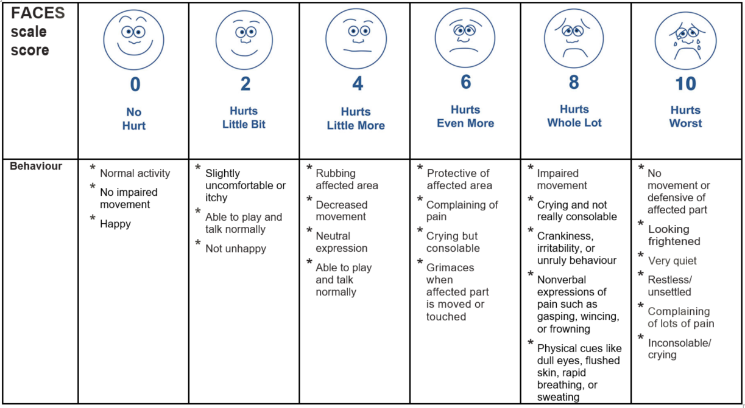

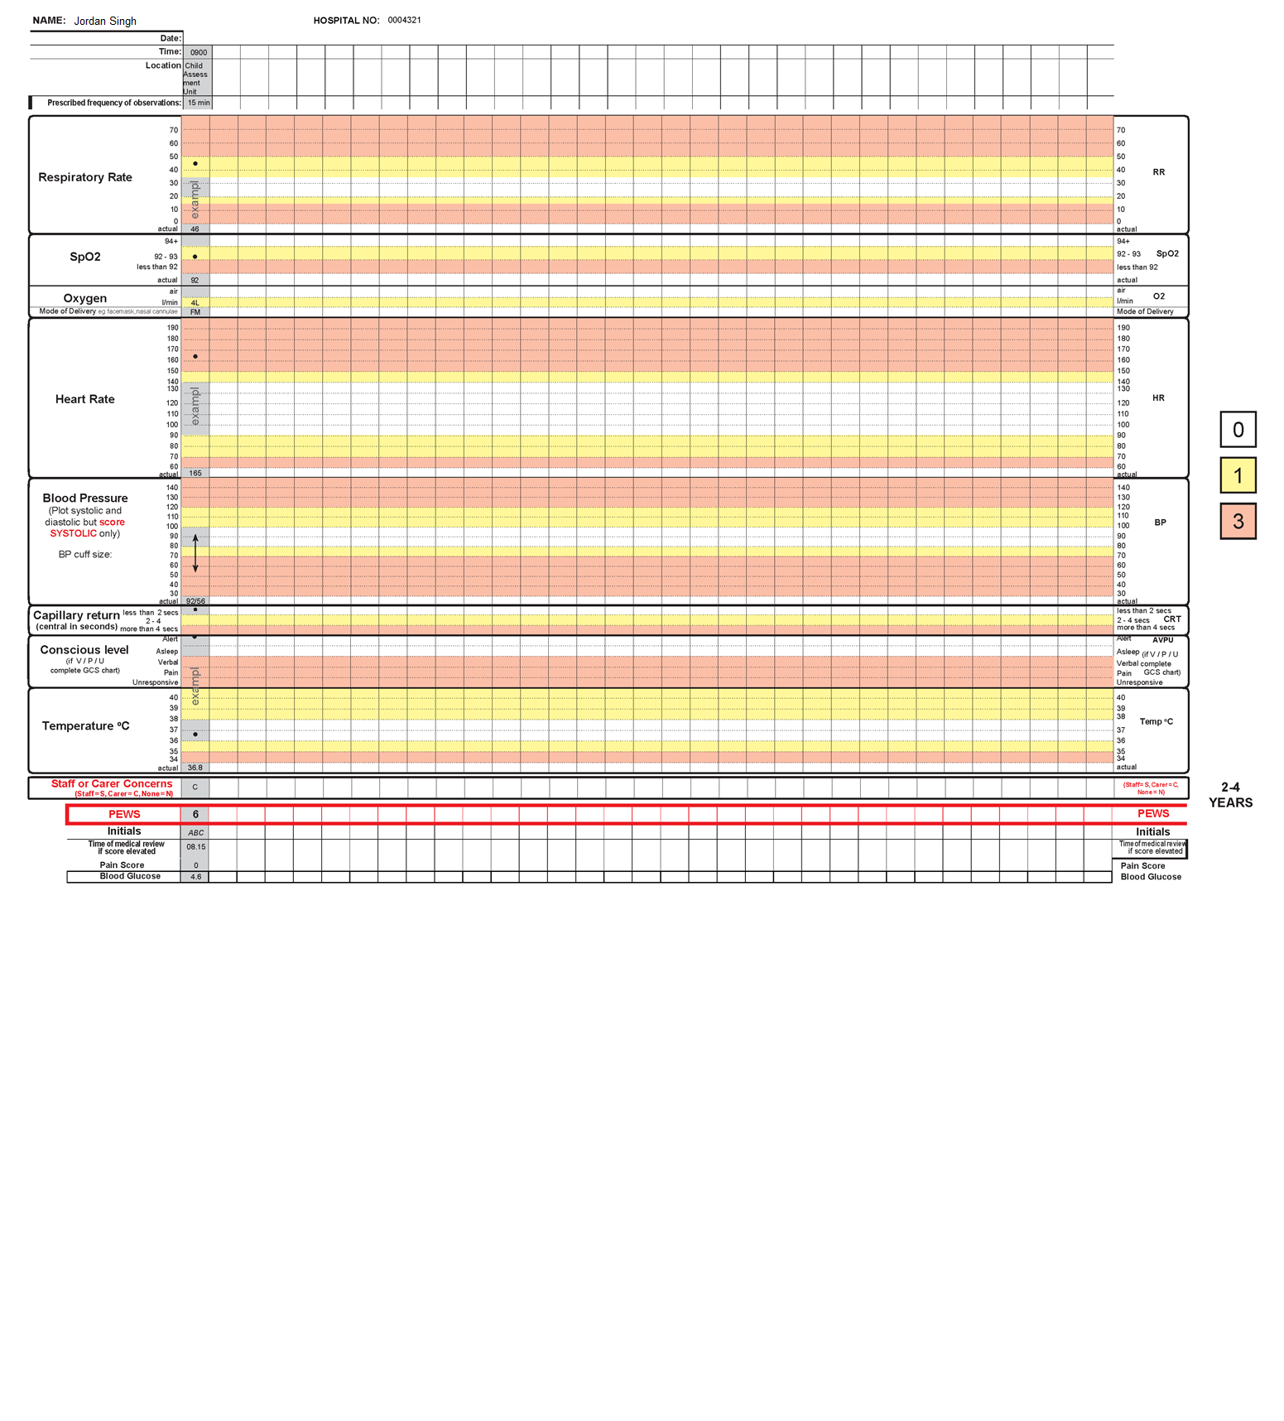
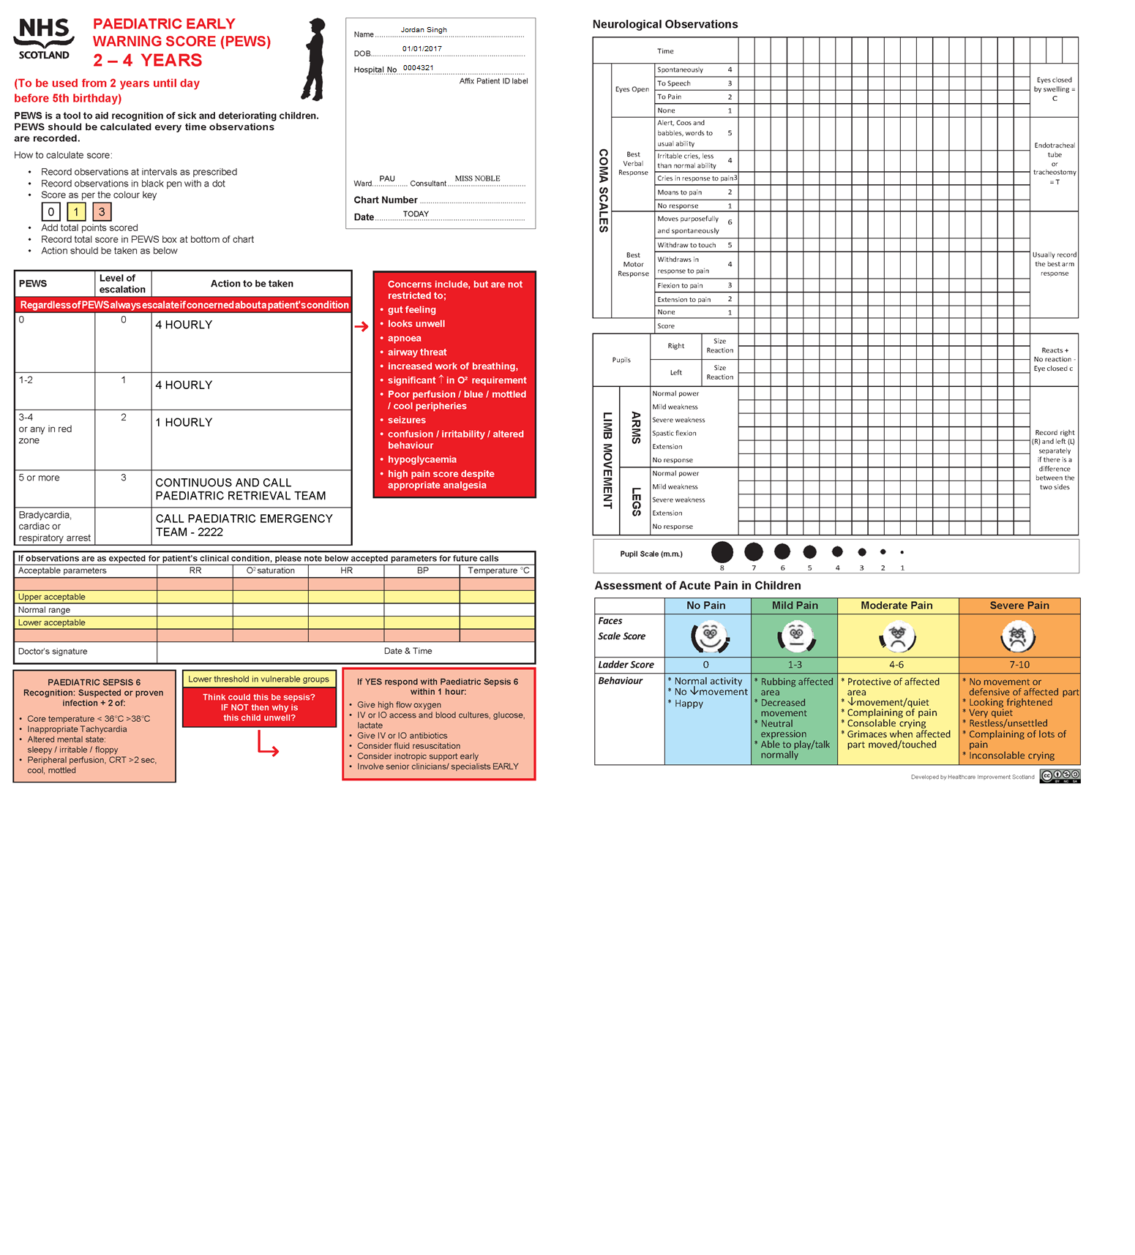

Candidate paperwork and briefing

Candidate’s name:

This document must be completed using a BLACK PEN.

Scenario
Jordan Singh was admitted to the paediatric assessment unit, accompanied by a parent, at 09:00, when you completed an A to E assessment and a paediatric early warning score (PEWS).

Based on your nursing assessment of the patient, please produce a nursing care plan for two relevant aspects of nursing and family-centred care suitable for Jordan and Jordan’s parent for the next 24 hours.

You have 14 minutes to complete this station, including all the required documentation.
Complete all sections of the care plan.
Assume that it is TODAY and that it is 09:45 hours.

Patient details:
Name: Jordan Singh
Hospital number: 0004321
Address: 1 Sweet Street, Westshire, WW6 5PQ
Date of birth: 01/01/2017
- Nursing problem/need
Aim(s) of care:
Re-evaluation date:
Nursing and family/child-centred care interventions
NAME (Print):
Nurse signature: Date:

2) Nursing problem/need
Aim(s) of care:
Re-evaluation date:
Nursing and family/child-centred care interventions
NAME (Print):
Nurse signature: Date:

This page is not a required element but is for use in case of error.
Nursing problem/need
Aim(s) of care:
Re-evaluation date:
Nursing and family/child-centred care interventions
NAME (Print):
Nurse signature: Date:

Candidate paperwork and briefing

Candidate’s name:

This document must be completed using a BLACK PEN.
Scenario
Jordan Singh has a painful injury on the arm which occurred 2 days ago after falling over in the preschool playground. Jordan is also suffering with pyrexia and poor oral intake.
Jordan was admitted into the child assessment unit accompanied by a parent at 09.00 hours, when you completed an A to E assessment and a paediatric early warning score (PEWS).
Please administer and document Jordan’s 12:00 medications in a safe and professional manner.
- Talk to the child and the carer.
- Please verbalise what you are doing and why to the examiner.
- Read out the chart and explain what you are checking/giving/not giving and why.
- Complete all the required drug administration checks.
- Complete the documentation and use the correct codes.
- The correct codes are on the chart and on the drug trolley.
- Check and complete the last page of the chart.

You have 15 minutes to complete this station, including the required documentation. Complete all sections of the documentation.
Assume that it is TODAY and that it is 12:00 hours.

Number of prescription records | Chart 1 2 3 of 1 2 3

All prescribers MUST complete the signature record
NAME | GMC/NMC Number | Signature | Bleep | NAME | GMC/NMC Number | Signature | Bleep
Dr H Pebbles | 6354003 | Dr H Pebbles | 123

ALERTS: Allergies/sensitivities/adverse reaction
Medicine(s)/Substance |  |  | Effect(s)
PEANUTS |  |  | ANAPHYLAXIS
IF NO KNOWN ALLERGIES TICK BOX
Signature: | Dr H Pebbles | Bleep Number: | 123 | Date: | TODAY
Allergy status MUST be completed and SIGNED by a prescriber/pharmacist/nurse BEFORE any medicines are administered.

Medication risk factors
Pregnancy | Renal impairment | Impaired oral access | Diabetes
Other high-risk conditions - specify |  | Patient self-medicating

Information for prescribers: | Medicine non-administration/self-administration:
Write in BLOCK CAPITALS using black or blue ink. | If a dose is omitted for any reason, the nurse should enter the relevant code on the administration record and sign and date the entry.
Sign and date and include bleep number.
Record detail(s) of any allergies. | 1. Medicine unavailable – INFORM DOCTOR OR PHARMACIST | 2. Patient off ward
Sign and date allergies box. Tick box if no allergies know. | 3. Self-administration | 4. Unable to administer – INFORM DOCTOR (alternative route required?)
Different doses of the same medication must be prescribed on different lines. | 5. Stat dose given | 6. Prescription incorrect/unclear
Cancel by putting a line across the prescription and sign and date. | 7. Patient refused | 8. Nil by mouth (on doctor’s instruction only)
Indicate the start and finish date. | 9. Low pulse and/or low blood pressure | 10. Other – state in nursing notes including action taken

ONCE-ONLY MEDICINES, PREMEDICATION, ANTIBIOTIC PROPHYLAXIS AND PATIENT GROUP DIRECTIONS
Check allergies/sensitivities and patient identity
Date | Drug | Dose | Route | Time required | Instructions | Prescriber’s signature, print name & bleep number | Time given | Signature given | Pharmacy check

PRESCRIBED OXYGEN
For most chronic conditions, oxygen should be prescribed to achieve a target saturation of 94-98% (or 88-92% for those at risk of hypercapnic respiratory failure i.e. CO₂ retainers).
Is the patient a known CO₂ retainer? Yes No
Continuous oxygen therapy  ‘When required’ oxygen therapy  Target O₂ saturation 88-92%  Target O₂ saturation 94-98%  Other saturation range: ___________  Saturation not indicated e.g. end-of-life care (state reason) ________________________ |  | Check and record flow rate (FR) and device (D) at each medicine round or other times specified.
Starting device and flow rate: | Start date: | Date | Time | FR/D
Prescriber’s signature: | Stop date:
Print name: | Pharmacy check:
Codes for starting device and modes of delivery
Air not requiring oxygen or weaning or PRN oxygen | A | Humidified oxygen at 28% (add% for other flow rate) |  | H28
Nasal cannulae | N | Reservoir mask |  | RM
Simple mask | M | Tracheostomy mask |  | TM
Venturi 24 | V24 | Venturi 35 |  | V35
Venturi 28 | V28 | Venturi 40 |  | V40
Venturi 60 | V60 | Patient on CPAP system |  | CP
Patient on NIV system | NIV | Other device (specify)

ANTIMICROBIALS
Check allergies/sensitivities and patient identity
Review IV after 24-48 hours – Review oral after 5-7 days
1. Drug | FLUCLOXACILLIN |  |  |  | Date and signature of nurse administering medications and code if not administered.
Date | Dose | Frequency | Route | Duration | Time | Today | Tomorrow | Pharmacy check
Today | 125MG | QD | PO | 5 DAYS | 08.00 | B NELL |  | L White
Start date | TODAY | Indication/  Organism |  |  | 12.00
 |  |  |  |  | 18.00
Finish date | +4 DAYS | Cultures sent? | Yes No |  | 22.00
Prescriber’s signature and bleep |  | Dr H Pebbles 123 |  |  | Print name | Dr H Pebbles

Check allergies/sensitivities and patient identity
2.Drug |  |  |  |  | Date and signature of nurse administering medications and code if not administered.
Date | Dose | Frequency | Route | Duration | Time | Today | Tomorrow | Pharmacy check
Today

Start date |  | Indication/  Organism
Finish date |  | Cultures sent? | Yes No
Prescriber’s signature and bleep |  |  |  |  | Print name

Check allergies/sensitivities and patient identity
3.Drug |  |  |  |  | Date and signature of nurse administering medications and code if not administered.
Date | Dose | Frequency | Route | Duration | Time | Today | Tomorrow | Pharmacy check
Today

Start date |  | Indication/  Organism
Finish date |  | Cultures sent? | Yes No
Prescriber’s signature and bleep |  |  |  |  | Print name

REGULAR MEDICINES
Check allergies/sensitivities and patient identity
1.Drug | LACTULOSE 10g |  |  |  | Date and signature of nurse administering medications and code if not administered.
Date | Dose | Frequency | Route | Duration | Time | Today | Tomorrow | Pharmacy check | Notes
Today | 5ml | BD | PO | 5 DAYS | 08.00 | B NELL |  | L White | New
Start date |  | Instructions/indication |  |  |  |  |  |  | Amended
Finish date | +4 |  |  |  | 18.00.0 |  |  |  | Unchanged
Prescriber’s signature and bleep |  | Dr H Pebbles 123 |  |  | Print name | Dr H Pebbles |  |  | Supply at home

Check allergies/sensitivities and patient identity
2.Drug |  |  |  |  | Date and signature of nurse administering medications and code if not administered.
Date | Dose | Frequency | Route | Duration | Time | Today | Tomorrow | Pharmacy check | Notes
Today |  |  |  |  |  |  |  |  | New
Start date |  | Instructions/indication |  |  |  |  |  |  | Amended
Finish date |  |  |  |  |  |  |  |  | Unchanged
Prescriber’s signature and bleep |  |  |  |  | Print name |  |  |  | Supply at home

Check allergies/sensitivities and patient identity
3.Drug |  |  |  |  | Date and signature of nurse administering medications and code if not administered.
Date | Dose | Frequency | Route | Duration | Time | Today | Tomorrow | Pharmacy check | Notes
Today |  |  |  |  |  |  |  |  | New
Start date |  | Instructions/indication |  |  |  |  |  |  | Amended
Finish date |  |  |  |  |  |  |  |  | Unchanged
Prescriber’s signature and bleep |  |  |  |  | Print name |  |  |  | Supply at home

AS-REQUIRED MEDICINES
Check allergies/sensitivities and patient identity
1.Drug | PARACETAMOL |  |  |  | Date and signature of nurse administering medications and code if not administered.
Date | Dose | Frequency | Route | Duration | Time | Today | Tomorrow | Pharmacy check | Notes
Today | 240mg | 4-6 HOURLY | PO |  |  |  |  | Siju Thomas | New
Start date | TODAY | Instructions/indication | 6 HOURLY PYREXIA |  |  |  |  |  | Amended
Finish date |  |  |  |  |  |  |  |  | Unchanged
Prescriber’s signature and bleep |  | Dr H Pebbles 123 |  |  | Print name | Dr H Pebbles |  |  | Supply at home

Check allergies/sensitivities and patient identity
2.Drug | IBUPROFEN |  |  |  | Date and signature of nurse administering medications and code if not administered.
Date | Dose | Frequency | Route | Duration | Time | Today | Tomorrow | Pharmacy check | Notes
Today | 150mg |  | PO |  |  |  |  | Siju Thomas | New
Start date | TODAY | Instructions/indication | 8 HOURLY PAIN |  |  |  |  |  | Amended
Finish date |  |  |  |  |  |  |  |  | Unchanged
Prescriber’s signature and bleep |  | Dr H Pebbles 123 |  |  | Print name | Dr H Pebbles |  |  | Supply at home

Check allergies/sensitivities and patient identity
3.Drug |  |  |  |  | Date and signature of nurse administering medications and code if not administered.
Date | Dose | Frequency | Route | Duration | Time | Today | Tomorrow | Pharmacy check | Notes
Today |  |  |  |  |  |  |  |  | New
Start date |  | Instructions/indication |  |  |  |  |  |  | Amended
Finish date |  |  |  |  |  |  |  |  | Unchanged
Prescriber’s signature and bleep |  |  |  |  | Print name |  |  |  | Supply at home

INFUSIONS
Check allergies/sensitivities and patient identity
Bolus IN injections should be prescribed on the standard section of the drug chart. If no additive is to be used, enter ‘nil’ in the ‘drug added’ column.
Date | INFUSION FLUID |  |  | DRUG ADDED |  | Duration or rate | Prescriber’s signature | Pharmacy check | Given by | Checked by | Start time | Stop time | Vol. given  (ml)
 | Name/strength | Volume  (ml) | Route  (IV/SC) | Name | Dose

OMITTED DOSES OF MEDICINE CODED 10 (OTHER) AND DELAYED DOSES
Check allergies/sensitivities and patient identity
Date | Drug | Dose | Route | Instructions | Time given | Reason for omission 10/delay >2 hours | Signature | Pharmacy check

Candidate paperwork and briefing

Candidate’s name:

- This document must be completed using a BLUE PEN.

- At this station, you should have access to your assessment notes (but not the assessment overview), and the planning and implementation documentation. If not, please ask the examiner for it.

Scenario
Jordan Singh has a painful injury on the arm which occurred 2 days ago after falling over in the preschool playground. Jordan is also suffering with pyrexia and poor oral intake. Jordan was admitted into the paediatric assessment unit accompanied by his parent at 09:00, when you completed an A to E assessment and a paediatric early warning score (PEWS).
Jordan has received prescribed medications and is ready to be transferred to the children’s ward for admission. Jordan is accompanied by a parent.
Jordan’s most recent observations were:
- Temperature: 37.5ºC
- Pulse: 156 bpm
- Respirations: 35 bpm
- Oxygen saturations: 92% on air
- Blood pressure: 108/65 mmHg.

Using the situation, background, assessment and recommendation (SBAR) tool, please make notes regarding your patient, and use this to verbally hand information over to the doctor (the examiner).
You have 8 minutes in total to make notes on the SBAR form (this is not assessed), and to complete the verbal handover to the examiner. You will be informed when there are 2 minutes remaining.

Complete all sections of the documentation.
Assume that it is TODAY and that it is 12:30 hours.

Candidate notes
This documentation is for your use and is not marked by the examiners.

Patient details: Jordan Singh
Hospital No: 0004321
Address: 1 Sweet Street, Westshire, WW6 5PQ
Date of birth: 01/01/2017
Situation:
Background:
Assessment:
Recommendation:

The mock clinical skills assessment below is made up of two paired stations. The instructions and available resources are provided for each station, along with the specific timing.

Station | You will be given the following resources
Female urinary catheter insertion – 8 minutes  You will insert the urinary catheter according to current evidence-based practice. | - Overview documentation (page 34)
Stoma bag change – 8 minutes  You will change a stoma bag according to current evidence-based practice. | - Overview documentation (page 35)

On the following pages, we have outlined the expected standard of clinical performance and criteria. These marking matrices are there to guide you on the level of knowledge, skills and attitude we expect you to demonstrate at each station.

Marking criteria – Female urinary catheter insertion
Explains the procedure to the patient and gains consent.
Assembles equipment required and checks equipment is sterile. Takes the equipment to the person’s bedside on trolley.
Ensures that the patient is in a supine position with knees bent, hips flexed and feet apart.
Cleans hands with alcohol hand rub, or washes with soap and water and dries with paper towels following WHO guidelines – verbalisation accepted.
Dons a disposable plastic apron.
Using an aseptic non-touch technique, opens the sterile pack and places the rest of the sterile equipment onto the sterile field.
Dons sterile gloves. Places a sterile towel under the patient’s buttocks.
Uses non-dominant hand to separate labia and uses gauze swabs soaked in sodium chloride 0.9% to clean the urethral orifice using downward strokes, being careful not to touch surrounding skin.
Applies anaesthetic lubrication to the meatus and gently inserts nozzle of anaesthetic syringe into urethra, and then instils gel into the urethra.
Places the catheter, in the sterile receiver, between the patient’s legs and attaches the drainage bag.
Uses dominant hand to introduce the tip of the catheter into the urethral orifice in an upward and backward direction. Advances the catheter until urine is draining and up to the bifurcation point (junction of the catheter/balloon inflation tubing).
Cautiously inflates the catheter balloon with prefilled syringe containing water for injection, noting any pain or discomfort.
Gently withdraws the catheter slightly, until resistance is felt.
Assists in cleaning the patient and disposing of equipment.
Supports the catheter using a specially designed support (such as Simpla G-Strap), ensuring that the catheter lumen is not occluded by the fixation device. Ensures drainage bag is supported and secure, with the drainage port away from the floor.
Cleans hands with alcohol hand rub, or washes with soap and water and dries with paper towels following WHO guidelines – verbalisation accepted.
States would document the reasons for catheterisation, time and date of catheterisation, catheter type, length and size, batch number and manufacturer.
States would measure and record urine output.
Acts professionally throughout the procedure in accordance with NMC (2018) ‘The Code: Professional standards of practice and behaviour for nurses, midwives and nursing associates’.
Marking criteria – Stoma bag change
Introduces self. Explains procedure to the person and gains consent.
Ensures that the patient is in a comfortable and suitable position where they are able to watch the procedure.
Checks all equipment required for the procedure, including expiry dates: new colostomy bag, a disposable bag, gauze, scissors and a receptacle are needed.
Cleans hands with alcohol rub or washes with soap and water and dries with paper towels according to the WHO guidelines.
Dons a disposable plastic apron and non-sterile gloves.
Places a small protective disposable pad below the stoma area to protect patient’s clothes from accidental spillage.
Removes the stoma bag slowly using adhesive remover. Peels the adhesive off the skin while using the opposite hand to apply pressure on the surrounding skin.
Folds the removed stoma bag to prevent spillage before placing into a disposable bag.
Removes any visible faeces or mucus from the stoma with a piece of gauze soaked in warm tap water.
Examines the stoma site and peristomal skin for soreness, ulceration, signs of infection and other unusual signs such as unusual site colour (black or pale), foul odour or discharge.
Washes the skin around the stoma (peristomal area) with gauze soaked in warm tap water.
Gently dries the peristomal skin with dry gauze, ensuring that the area is thoroughly dry.
Measures the stoma site, cuts a hole in the adhesive flange of the new bag, aiming for 3mm larger than the site.
Applies the clean appliance, using the flat of hand to gently press to ensure it adheres in all areas.
Disposes of equipment including apron and gloves appropriately – verbalisation accepted.
Cleans hands with alcohol rub or washes with soap and water and dries with paper towels according to the WHO guidelines.
States would document the change of stoma bag in nursing notes and would report any abnormalities to the stoma nurse and/or surgical team.
Acts professionally throughout the procedure in accordance with NMC (2018) ‘The Code: Professional standards of practice and behaviour for nurses, midwives and nursing associates’.

Overview
Female urinary catheter insertion

Scenario
You are working on the surgical admissions unit.
You are caring for Catherine Higgins aged 14, who has been diagnosed with obstruction of the bowel, and the doctor has requested the insertion of a urinary catheter for fluid monitoring.
Please insert the urinary catheter according to current evidence-based practice.
All identification checks have been completed and the patient has no known allergies.
The trolley has been cleaned.
The patient is lying in bed, with their lower clothing removed, is covered with a towel and has an absorbent pad underneath them.

All the equipment you need is provided.

You are not required to document anything during this skills station.
You have 8 minutes to complete this station.

Overview
Stoma bag change

Scenario
You are working on a post-operative surgical ward.
You are caring for Kendi Abara aged 14, who has undergone a right hemicolectomy and colostomy formation. They are 3 days post surgery, the one-piece stoma bag needs to be replaced, and Kendi is currently not well enough to do this themselves.
Please change the patient’s stoma bag according to current evidence-based practice.
All identification checks have been completed, and the patient has no known allergies.
The trolley has already been cleaned prior to the procedure.

Please change the patient’s stoma bag and speak to your patient throughout the procedure.

All the equipment you need is provided.
You are not required to document anything during this skill station, but if necessary, verbalise to the examiner what would be documented or reported.
You have 8 minutes to complete this station.
Assume that it is TODAY and that it is 12:00 hours.

You will also be required to undertake two new silent stations. In each OSCE, one station will specifically assess professional issues associated with professional accountability and related skills around communication (called the professional values and behaviours station, or the PV station). One station will also specifically assess your critical appraisal of research and evidence and associated decision-making (called the evidence-based practice station, or EBP station). Please note that the PV and EBP stations assess generic skills, not just skills specific to children’s nursing.

The instructions and available resources are provided for each station, along with the specific timing.

Station | You will be given the following resources
Professional values and behaviours  Drug misuse – 8 minutes  You will read the scenario and summarise the actions that you would take, considering the professional, ethical and legal implications of this situation. | - Overview documentation (pages 39–40)
Evidence-based practice  Sleep in intensive care – 8 minutes  You will read the scenario and summary of the research, then write up how you would apply the findings to the scenario. | - Overview documentation (pages 41–42)

On the following pages, we have outlined the expected standards of clinical performance and criteria. These marking matrices are there to guide you on the level of knowledge, skills and attitude we expect you to demonstrate at each station.

Professional values & behaviours marking criteria – Drug misuse
Recognises that taking NHS/hospital property for personal use or gain, including medication, is prohibited.
Recognises professional duty to report any concerns that may result in compromising the safety of patients in their care or the public, and that failure to report concerns may bring their own fitness to practise into question and place own registration at risk.
Raises concern with manager at the earliest opportunity, verbally or in writing. Recognises the need to be clear, honest and objective about the reasons for concern, reflecting duty of candour.
Recognises that the manager may wish an incident report to be completed, recording the events, steps taken to deal with the matter including the date, and with whom the concern was raised.
Takes into consideration own responsibility for the safety of the colleague, and considers the effects of codeine on their ability to work and drive home.
Considers that the colleague may need a medical review for their headache or may need support in dealing with a substance misuse problem.
Acknowledges the need to keep to and uphold the standards and values set out in ‘The Code’: prioritise people, practise effectively, preserve safety and promote professionalism and trust.
Handwriting is clear and legible.

Evidence-based practice marking criteria – Sleep in intensive care
Summarises the main findings from the article summary and draws conclusions, making recommendations for practice.
Writes clearly and legibly.
Informs Mrs Green that it is very common for patients to experience sleep deprivation in the Intensive Care Unit (ICU).
Explains that the disturbances in sleep may continue for several months after discharge.
Explains that the nature of a patient’s illness, previous sleep experience and severity of illness may influence sleep pattern.
Informs Mrs Green that noise, light, pain, anxiety, nursing interventions, diagnostic tests, medications and non-invasive ventilation may have impacted her sleep.
Discusses with Mrs Green any feelings of pain or anxiety that may have impacted her sleep. Invite Mrs Green back in 2 or 3 months’ time for follow-up support.

Overview

Scenario
You are just about to commence the lunchtime drug round. You enter the clinical room and one of your nursing colleagues is in the room already.
You witness the nurse take a 30 milligram codeine phosphate tablet from the drug cupboard. She puts it in her mouth and swallows it in front of you.
You ask if she is okay, and she tells you that she needs the tablet for a headache.
As far as you are aware, this is an isolated incident.

Using your knowledge of NMC (2018) ‘The Code: Professional standards of practice and behaviour for nurses, midwives and nursing associates’, consider the professional, ethical and legal implications of this situation.
Please summarise the actions you would take in a number of bullet points.
This is a silent written station. Please write clearly and legibly.
You have 8 minutes to complete this station.

Candidate documentation

Candidate name:__________________________

………………………………………………………………………………………………..
………………………………………………………………………………………………..
………………………………………………………………………………………………..
………………………………………………………………………………………………..
………………………………………………………………………………………………..
………………………………………………………………………………………………..
………………………………………………………………………………………………..
………………………………………………………………………………………………..
………………………………………………………………………………………………..
………………………………………………………………………………………………..
………………………………………………………………………………………………..
………………………………………………………………………………………………..
………………………………………………………………………………………………..
………………………………………………………………………………………………..
………………………………………………………………………………………………..
………………………………………………………………………………………………..
………………………………………………………………………………………………..
………………………………………………………………………………………………..
………………………………………………………………………………………………..
………………………………………………………………………………………………..
………………………………………………………………………………………………..
………………………………………………………………………………………………..
………………………………………………………………………………………………..
………………………………………………………………………………………………..

Overview
Read the scenario and the summary of the research below.
Please identify the main points from the summary and apply the findings to the scenario below.
This is a silent written station. Please write clearly and legibly.
You have 8 minutes to complete this task.
Scenario
You have been working on an Intensive Care Unit (ICU) for the past 6 months. Most of your patients are given medication to induce a coma while they receive care and treatment. As patients improve and are weaned off the sedation, you notice that it is common for patients to report that they have not slept for the whole time they have been on the unit. The patient you are looking after today, Mrs Green, reports this same lack of sleep. She asks if is this common and, if so, why it might be.
Article summary
A systematic review in a well-regarded peer-reviewed journal investigated the sleep disturbances in patients in intensive care units. The review found that:
- Study A, a large-scale study, showed that 60% of patients discharged from ICU reported sleep disorders and deprivations.
- Study B, a smaller study, found similar results, with 51% of patients experiencing dreams and nightmares, and 14% reporting nightmares negatively impacting their quality of life 6 months after discharge from ICU. The study recommended that patients return for a follow-up support appointment 2 to 3 months after leaving ICU.
- Study C, a quantitative study, concluded that the inability to obtain physiological sleep depends on the patient’s illness, previous sleep experience and the varying severity of their illness.
- Patients in Study C reported a number of sleep-disturbing factors impacting their sleep, including: noise, light, pain, anxiety, nursing interventions, diagnostic tests, medications and non-invasive ventilation.
The review concluded that sleep disorders in ICU were common and that there were multiple influencing factors causing sleep deprivation.

Candidate documentation
Candidate name:
What is the relevance of the findings of this research for Mrs Green, and what advice would you give her?
Give your responses here as bullet points:
………………………………………………………………………………………………..
………………………………………………………………………………………………..
………………………………………………………………………………………………..
………………………………………………………………………………………………..
………………………………………………………………………………………………..
………………………………………………………………………………………………..
………………………………………………………………………………………………..
………………………………………………………………………………………………..
………………………………………………………………………………………………..
………………………………………………………………………………………………..
………………………………………………………………………………………………..
………………………………………………………………………………………………..
………………………………………………………………………………………………..
………………………………………………………………………………………………..
………………………………………………………………………………………………..
………………………………………………………………………………………………..
………………………………………………………………………………………………..
………………………………………………………………………………………………..
………………………………………………………………………………………………..
………………………………………………………………………………………………..
………………………………………………………………………………………………..
………………………………………………………………………………………………..

Unit 109 Albert Mill
10 Hulme Hall Road
Castlefield
Manchester
M15 4LY

www.alphaplus.co.uk

+44 (0) 161 249 9249

