Nursing and Midwifery Council
Test of competence 2021: Part 2

Preparing for your OSCE examination

applicants trained outside the European Union and European

This booklet has been produced to support candidates preparing for Part 2 of the test of competence. This information complements the candidate information booklet and will be updated regularly to ensure that candidates receive the most current information.
The most recent version can be found on our website at www.nmc.org.uk/toc.

Contents

Before the objective structured clinical examination (OSCE) 4
How do I prepare for the OSCE? 5
What to expect in the test centre 6
Equipment 7
The OSCE 9
The APIE 12
Assessment (A): 12
Planning (P): (not used in the Nursing Associate OSCE) 12
Implementation (I): 12
Evaluation (E): 13
Clinical proficiencies 14
Silent stations 16
Common mistakes/errors 17
Marking and moderation 18
Results 19
How to interpret feedback 20
General tips and advice 21

Before the objective structured clinical examination (OSCE)

Introduction
The Nursing and Midwifery Council (NMC) currently offers a test of competence for internationally registered nurses, nursing associates and midwives. A new version of the test will be introduced in 2021. The test of competence assesses candidates against the current UK pre-registration standards. Nursing in the UK is made up of separate and distinct fields of practice, each requiring three years of pre-registration undergraduate education.
The distinct nursing fields of practice are:
- adult nursing
- children’s nursing
- learning disabilities nursing
- mental health nursing.
The nursing associate role is relatively new, in England only, and is designed to bridge the gap between healthcare assistants and registered nurses. Nursing associates provide and monitor care and are integral to the nursing team. The nursing associate qualification may aid the progression to becoming a registered nurse for those wishing to further develop their nursing careers.

In the UK, midwifery is a separate and distinct profession, requiring three years of pre-registration undergraduate education.

The test of competence is specific to a field of nursing practice, to nursing associates or to midwifery, and it consists of two parts.
- Part 1 is a computer-based test (CBT), made up of a numeracy test and a clinical test, which can be undertaken globally.
- Part 2 is the objective structured clinical examination (OSCE), which must be undertaken in the UK in one of the NMC-approved test centres.

This handbook provides information on how best to prepare for Part 2 of the test of competence.

General information about preparing for the OSCE is available on the website of your chosen NMC-approved test centre site. You are encouraged to read this thoroughly to plan your preparation and to maximise your chances of passing this examination.

Links to the OSCE centres’ websites can be found on the NMC website: https://www.nmc.org.uk/registration/joining-the-register/trained-outside-the-eueea/

Once you have chosen where you wish to take your OSCE, you will need to choose a date and make a payment
Tip: Remember that you will have done many of these nursing or midwifery proficiencies several times before.

How do I prepare for the OSCE?
The OSCE is designed to assess your ability to competently apply your professional skills and knowledge in the UK. For nursing associates, nurses and midwives, each OSCE is set at the level expected of candidates as they enter the profession (at the point of registration, not advanced skills). This means that you must show that you are capable of applying knowledge to the care of patients at the level expected of a newly registered nursing associate, nurse or midwife.

The examination is testing your ability to apply knowledge to the care of patients, rather than how well you can remember and recite facts. All the scenarios and any questions relate to current best practice, and you should answer them in relation to published evidence and not according to local arrangements.

Preparation materials are provided on the test centres’ learning platforms.

Tip: Example exam paperwork can be found on the learning platform. We recommend a minimum of 14 days to review the content of your learning platform, but many candidates have highlighted that more time is needed. Make the most of your chosen test centre’s learning platform and resources.

Tip: Read the candidate handbook. It is full of useful information and has lots of further helpful tips!

Tip: You are being assessed at UK pre-registration entry level. No advanced nursing proficiencies are required to pass this assessment. If you know the basic proficiencies of nursing associate, nursing or midwifery care, the scenario will not matter.

What to expect in the test centre

The test centre is a full mock-up of a hospital ward, a community setting or a patient’s home. You will be allocated one bay, where you will do all your stations. The bay will be set up with the appropriate equipment for each station.
The examination area of the centre is overseen by an invigilator. The invigilator and assessor will welcome you to the test centre and oversee your movements through the examination process. Please direct any questions, queries or requests to the invigilator or assessor. The assessor within the station will be able to answer any clinical questions. The lead assessor is there to co-ordinate the marking and moderation process.
Each bay hosts a camera. We record the assessment for moderation and review purposes only.
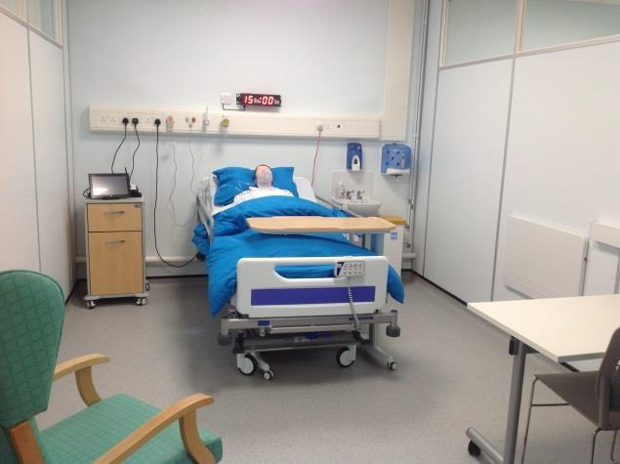

The centre uses both professional actors and manikins to conduct the assessments, to make them as real-life as possible.
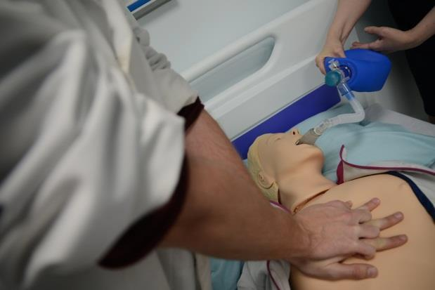
Tip: Remember to interact with the manikin during the assessment. The assessor will speak on their behalf, but the manikin is your patient, not the assessor.

Equipment
You will be provided with all the equipment needed to complete the station successfully. Below are picture examples of some of the equipment you can expect to see in the bays you might use throughout the examination. Please note that not all centres will have exactly the same equipment. A full equipment list can be found on each test centre’s learning platform.
The hospital resuscitation station – manikin, bag valve mask | Nurse call bell system
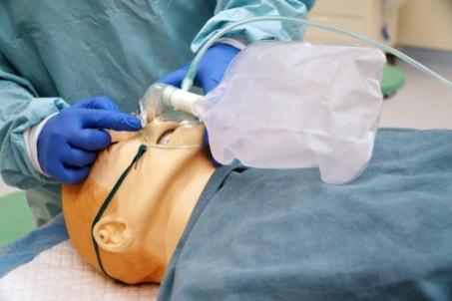 | 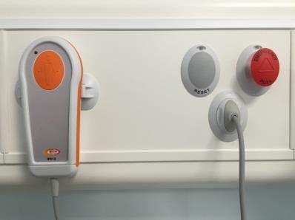
Electronic bed controls
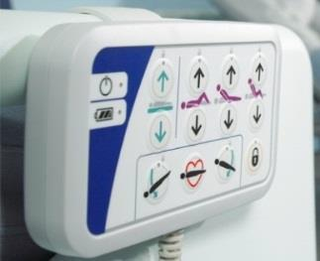
Aseptic non-touch technique station – example of a thigh wound | Vital signs monitor
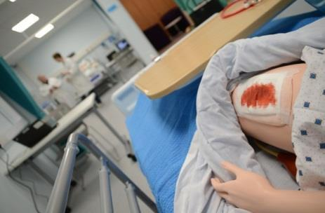 | 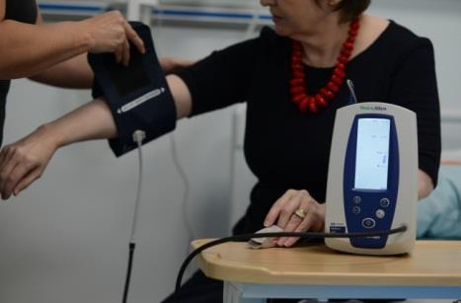

All equipment is standardised to mirror that used within a clinical environment. If you see any equipment either here or on the centre’s internal learning platform that you do not know how to use, do not worry, as your assessor will explain the equipment at the start of each station. You will be given an induction to each station before your assessment starts, when you will have an opportunity to familiarise yourself with the equipment required for the particular station you are in.

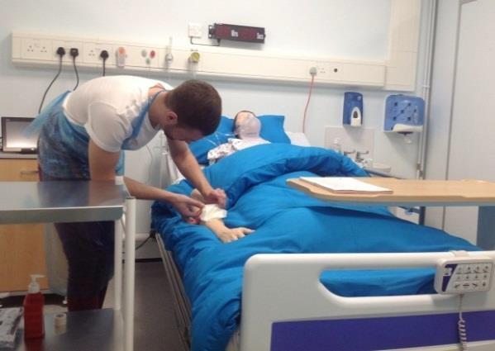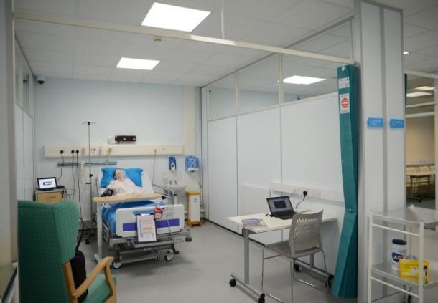

The OSCE
The OSCE is made up of 10 stations (6 for Nursing Associates), with a total testing time of about 2.5 hours. For nursing and midwifery, four of the stations are scenario-based and relate to four stages of the care process. For Nursing Associates, there is a group of three scenario-based stations which are similar but do not include the Planning station.
For each station, you will be given a warning before the station must be completed. See page 10 for more details about timings.
Part of the OSCE is scenario-based, which includes the following:
A – Patient-centred assessment
P – Planning care (not included for Nursing Associates)
I – Implementation
E – Evaluation

Four (five for Nursing Associates) of the remaining stations are skills stations, testing practical clinical skills. Stand-alone stations are up to 10 minutes long and pairs of skills stations will last for up to 20 minutes (30 minutes for midwifery) in total.
There are also two silent stations. In each OSCE, one station will specifically assess the professional issues associated with professional accountability and related skills around communication. This station is called Professional Values. One station will also specifically assess critical appraisal of research and evidence and associated decision-making. This station is called Evidence-based Practice.
The skills are based on the lists provided in the candidate information booklet and marking criteria booklet for each field. Also see page 13 of this document

Sample OSCE station materials, including the forms that may be used, are included on the test centre support sites.

In each station, you will be given information about what is expected of you as well as information about your patient, where appropriate. Please read this information and ensure that you understand what is expected of you within the station. Focus on the task and follow the requirements set out on the information sheet.
Timers will be provided so that you can keep track of your time.

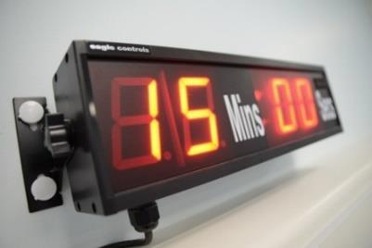
Within this time, you must demonstrate safe practice and proficiencies in each station.

Any activity outside of the allocated time will not be assessed, so please ensure that you do everything within the time frame. You will be given a 5-minute prompt before the end of an APIE station and a 3-minute prompt before the end of a skills station, to help you to manage your time.
During each of the stations, you will need to verbalise what you are doing.
We introduce new scenarios and skills regularly, so there is no guarantee that you will get the same scenario as a colleague or friend. We plan the examination to ensure that candidates receive a variety of different scenarios and skills.

Tip: If you make a mistake, do not panic. Make sure that you tell the assessor within the assessment time, share what you would do to correct it, and this will be taken into account. However, verbalisation will not overturn a critical fail.

The APIE

Tip: Ensure that you are familiar with observation charts such as NEWS and the Glasgow coma score.
The four stations are scenario-based.

Assessment (A):

Your verbal communication and non-verbal communication, and the ability to establish a rapport with your patient based on the 6 Cs of nursing will be assessed during the assessment station. The 6 Cs are:
- care
- compassion
- competence
- communication
- courage
- commitment.

Within this station, you will have time to read any forms provided. This can provide you with a structure and a systematic approach, so use this to help you. Before completing the assessment station, you may need to take observations of the patient and record them on an observation chart (such as the national early warning score, NEWS, or the Glasgow coma score). It is important to complete and record all observations, if necessary, before the time has run out in order to pass. You will then need to consider activities of daily living within this station, as this information will help you with the ongoing stations. For all fields except for learning disability and mental health, you will be asked to carry out an holistic assessment, including an airways, breathing, circulation, disability and exposure (A–E) assessment. You will be able to document any notes during your patient's assessment. These notes will not be assessed or marked but will be for your future reference at the writing stations.

Planning (P): (not used in the Nursing Associate OSCE)

This is a silent written station, and you will be monitored by the invigilator or assessor. You must write two relevant aspects of care related to the scenario from the assessment station, which should include associated/relevant self-care. Make sure that you familiarise yourself with the template provided on the test centre’s learning platform. Please note: You will be required to complete this form in a black pen, which will be provided.

Implementation (I):
In this station, you will be implementing care, such as administering oral drugs. In this bay, your patient may either be represented by an actor or a manikin, and either the actor or assessor will respond to you from a script as though they are the patient. Please remember that your verbal and non-verbal communication will be assessed in this station. Communicate with the actor or manikin, NOT the assessor, as you would with a real patient.

Evaluation (E):

This station is a verbal bay, and you will be monitored by the assessor. In this station, you will write notes about a transfer/discharge or other form of evaluation, such as a situation, background, assessment, recommendation (SBAR), and you will then be required to provide a verbal handover to the assessor. You will have access to all your previous written notes to help you in this station.

Make sure that you familiarise yourself with the template provided on the test centre’s learning platform.

In this station, you should avoid using unfamiliar abbreviations that are not universally recognised.

You will be assessed only on the verbal handover (not on your notes).

Clinical skills

You will be assessed on four clinical skills (five for nursing associates). Typical skills that you could be tested on include, but are not limited to:

RN1 Adult nursing
- Administration of Inhaled Medication (AIM)
- aseptic non-touch technique (ANTT)
- blood glucose monitoring
- catheter specimen of urine collection (CSU)
- fluid balance
- in-hospital resuscitation (IHR)
- insertion of nasogastric tube
- intramuscular (IM) injection
- intravenous bolus & visual infusion phlebitis (VIP) assessment
- midstream specimen of urine collection (MSU)/urinalysis
- pain assessment
- peak expiratory flow rate
- pressure area assessment
- subcutaneous injection
- wound assessment.

RN8 Children’s nursing
- Administration of Inhaled Medication (AIM)
- aseptic non-touch technique (ANTT)
- basic life support (BLS) – paediatric
- blood glucose monitoring
- insertion of nasogastric tube
- intramuscular (IM) injection
- midstream specimen of urine collection (MSU)/urinalysis
- peak expiratory flow rate
- removal of a catheter
- subcutaneous injection.

RN3 Mental health nursing
- de-escalation
- intramuscular (IM) injection
- midstream specimen of urine collection (MSU)/urinalysis
- pain assessment
- physiological observations
- reminiscence therapy
- talking therapies.

RN5 Learning disability nursing
- de-escalation
- in-hospital resuscitation (IHR)
- intramuscular (IM) injection
- pain assessment
- physiological observations
- pressure area assessment
- talking therapies.
RM Midwifery
- breech birth
- postnatal check and plan of care
- postpartum haemorrhage (PPH)
- sepsis
- shoulder dystocia
- systematic examination of the newborn
- term singleton labour in the birth unit.

NAR Nursing Associate
- administration of inhaled medication (AIM)
- blood glucose monitoring
- pain assessment
- oxygen therapy
- fluid balance
- hospital admission and documentation
- catheter specimen of urine collection (CSU)
- physiological observations, recording and response
- peak expiratory flow rate (PEFR)
- pressure area assessment
- gaining informed consent
- subcutaneous injection.

References are included in the candidate support reading lists for all clinical proficiencies and how to conduct them. We recommend that you read the relevant texts. More detailed information can be found on the test centre’s learning platform. You will have access to the online learning platform for your chosen OSCE centre for a minimum of 14 days before your OSCE.

We assess the full range of communication skills (verbal, non-verbal and written) by observing the interaction between the candidate and a simulated patient (this may be an actor or a manikin) and also by assessing your documentation. It is essential that you demonstrate all elements of the 6 Cs (as outlined on page 11 of this document) during your exam.
The assessor will assess your approach to the simulated patient throughout the examination. The following communication skills may be part of the marking criteria for your station:
- clearly explaining care, diagnosis, investigations and/or treatments
- involving the patient in decision-making
- communicating with relatives and healthcare professionals
- seeking and obtaining informed consent
- active listening
- dealing appropriately with an anxious patient or anxious relatives
- giving clear instructions on discharge
- giving advice on lifestyle, health promotion or risk factors
- demonstrating compassion and care during communication
- clear documentation, which meets current NMC guidelines
- professional behaviour.
Further information on this can be found in the candidate information booklet.

Silent stations

You will have one Professional Values station and one Evidence-based practice (EBP) station. These are generic issues that are relevant to all fields of nursing. Typical areas that you could be tested on include, but are not limited to:

RN1 Adult nursing, RN8 Children’s nursing, RN3 Mental health nursing, RN5 Learning disability nursing and NAR Nursing Associate:

Professional values:
- Confidentiality
- Drug error
- Signs of possible abuse
- Professional confrontation
- Social media.

Evidence-based practice:
- Diabetes
- Female myocardial infarction (MI)
- Prevention of pressure ulcers
- Cessation of smoking
- Venous leg ulcers.

RM Midwifery

Professional values:
- Safeguarding.

Evidence-based practice:
- Place of birth.

References for Professional Values stations are included in the candidate support reading lists. We recommend that you read the relevant texts. In the assessment you will be required to read the scenario and give a summary of the actions you would take, considering the professional, ethical and legal implications of the situation.

There are no references for Evidence-based practice stations as you will be provided with a scenario and a summary of research in the assessment, from which you will be required to identify the main points and apply findings to the scenario.

More detailed information can be found on the test centre’s learning platform. You will have access to the online learning platform for your chosen OSCE centre for a minimum of 14 days before your OSCE. Further information on these stations can be found in the relevant Mock OSCE booklet for each field.

Common mistakes/errors
To aid you in your preparation, the section below describes some common things that candidates often forget or miss during the OSCE examination.
All stations
- Lack of communication – verbal, non-verbal, not listening to patient.
- Not reading the scenarios or instructions accurately.
- Not completing the paperwork or assessment requested within the given time frame.
- Touching the patient before conducting hand hygiene techniques.
- Not checking for allergies.
- Not checking patient identity according to guidelines.
- Not gaining consent from patient.
- Not ensuring patient safety.
- Not completing the station within the time frame.

Assessment
- Not measuring the vital signs accurately.
- Not completing the documentation adequately or accurately.
- Not completing an A-E assessment.

Planning
- Evaluation date not within the prescribed time frame.
- Incomplete documentation.
- Illegible documentation.
- Abbreviations not recognised.
- Errors not dealt with correctly.
- Not ensuring that interventions are evidence-based.

Implementation
- Not checking the expiry date on medications.
- Not interpreting the medication chart in full to check for accuracy.
- Overdose/underdose patient.
- Signing for medication prior to administration.

Evaluation
- Not stating what is required of the person taking the handover.
- Not stating a realistic plan of action.
- Unclear or inappropriate verbal communication.
- Approach to handover is not systematic or structured.

Tip: This is a test of patient safety and public protection.

Clinical skills
- Contamination of sterile field.
- Not signing or dating documentation.
- Chest compressions not timely.
- Incorrect documentation.
- Making incorrect calculations.

Marking and moderation
The test centres must adhere to their own robust quality-assurance processes. These are also independently verified and validated by the Quality Assurance Agency for Higher Education (QAA) and the NMC to deliver the test of competence Part 2.
When you enter a room, there will be an area for the assessor to mark you during your assessment. You will be marked only on the competence you demonstrate during the assessment.
All the assessors are qualified nurses or midwives and they undergo full training prior to joining the assessor team for the OSCE.
Each OSCE station has a unique mark scheme, which is matched to the scenario or skill being assessed. Assessors will score each criterion.
Your entire exam will be digitally recorded and assessed in live time, and you will be marked as either a pass or a fail for each station. In accordance with the General Data Protection Regulations (GDPR), your consent will be sought for filming your exam, as well as for sharing data with the data processor so that the necessary analyses can take place.

Once your full assessment has been completed, documents and videos are moderated by an independent assessor and confirmed by the lead assessor or test centre manager before a final decision is made. You do not have the right to view recorded footage of your assessment as it is treated as an exam script. Once the script has been marked and moderated, the pass or fail decision is final and neither you nor any sponsoring authority may request access to the film. An appeal will involve the investigating panel reviewing your filmed assessments, but films will not be released to you or your sponsor.

Results
All results will be emailed by the NMC to your personal email address (as registered with the NMC) within up to 15 working days of your examination.

PASS – Passed all stations taken | Congratulations! You have passed.
FAIL – Failed up to seven stations across both the APIE and/or skills stations | Will require a re-sit at 50% of the cost.  You need only re-sit the stations you failed. If you need to re-sit the APIE station(s), you will be given your original paperwork from the APIE stations you passed in your previous attempt, to complete the re-sit stations in sequence.
FAIL – Failed eight or more stations across both the APIE and skills stations | Will require a re-sit at 100% of the cost.  You need only re-sit the stations you failed. If you need to re-sit the APIE station(s), you will be given your original paperwork from the APIE stations you passed in your previous attempt, to complete the re-sit stations in sequence.
FULL FAIL (3rd attempt re-sit) – Failed any station on the third attempt | Will require 6 months to elapse before you can reapply to the NMC.

How to interpret feedback
You will receive an email from the NMC, as outlined above. You will receive standardised feedback on the areas you fail. The feedback will not tell you how to make it right, but it will tell you which areas you failed and why, and, if appropriate, will recommend resources to review to help you to improve a specific area. This is to ensure consistency and equality in all candidate feedback and is also to aid you in preparing for your re-sit, should you need to undertake one.

For example, if a candidate failed the aseptic non-touch technique (ANTT) station for contaminating the yellow bag when setting up the field, the feedback would read as follows:
Aseptic non-touch technique (ANTT): The candidate failed to show competence in this station. When setting out the sterile field, they contaminated the orange bag and, as a result, contaminated the sterile field. This is a patient safety risk, resulting in a fail.

General tips and advice
- Try not to be nervous. Stay calm.
- Read, read and read again the paperwork for the stations, and make sure that you understand fully what is expected of you during the assessment.
- There is lots of information to help you when preparing for the OSCE – the candidate information booklet and the relevant test centre’s learning platform have important information, including mock OSCEs, which will help you.
- You need to bring your passport and required documentation for your ID check by the NMC.
- Water is available throughout the centre and exam, if needed. You are welcome to bring your own water bottle, which can be refilled at the centre.
- If you do not have a fob watch or you forget to bring one, do not worry. We have spares at the test centre, which you can use.
- Make sure that you have eaten before your OSCE assessment. You may be in the test centre for up to 4 hours. Once you are registered, you are not allowed to go outside the centre.
- Arrive in plenty of time and allow for traffic. It is recommended that you give yourself at least 30 minutes before the examination time to relax and find the centre.
- Keep an eye on the test centre’s learning platform. This is where you will be able to receive any announcements, updates or changes to our guidance.
- Reading tip: The assessment is based on a range of resources as set out in the reading list. We advise you to read elements of this, for reference purposes.
- Make sure that you prepare for your OSCE at the appropriate level. Remember that the OSCE is set at the level expected of nursing associates, nurses and midwives as they enter the profession.
- Be aware that you will be asked to sign the declaration of confidentiality at the start of the OSCE. You must not discuss any elements of the OSCE with colleagues or friends.
- You must not talk to other candidates while you are within the test centre.

We wish you the very best of luck in your OSCE and look forward to welcoming you to the competence test centre.

https://www.england.nhs.uk/6cs/wp-content/uploads/sites/25/2015/03/introducing-the-6cs.pdf

