Test of Competence 2021:
Practice Paper 1 (Numeracy)
Adult Nursing
EU Aptitude Test

Part 1: Measuring the correct dose

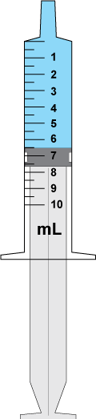

Figure 1 - Syringe
Q1. What is the volume that has been drawn up into the syringe?

Answer = __________

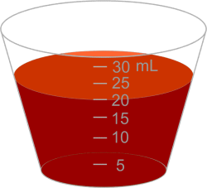

Figure 2 - medicine cup for oral medication
Q2. What is the volume that has been dispensed?

Answer = ___________

Part 2: Metric units
Q3. A patient has been prescribed 2 L of 0.9% sodium chloride.

What is the volume in mL?
Answer = ___________ mL

Q4. A patient has been prescribed 0.6 g of ibuprofen.

What is the dose in mg?
Answer = ___________ mg

Part 3: Oral medications

Q5. A patient has been prescribed 300 mg of phenytoin.

How many tablets should be administered?

______ tablet(s)

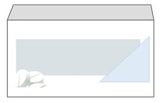

Figure 3 box of tablets.
Phenytoin
100 mg tablets

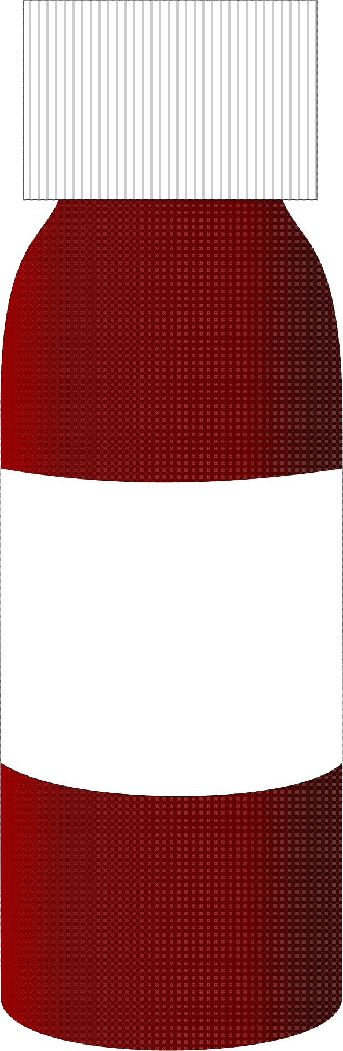

Figure 4 - Medicine bottle for liquids.
Q6. A patient has been prescribed 1 g of carbocisteine solution.

What volume should be administered?

____________

Carbocisteine solution
200 mg/5 mL

Figure 4 - Medicine bottle for liquids

Q7. A patient has been prescribed 100 mg of phenytoin suspension.

What volume should be administered?

__________

Phenytoin suspension
250 mg/5 mL

Figure 5 Bottle of liquid medication
Q8. A patient has been prescribed levetiracetam suspension at a dose of 10 mg/kg. The patient weighs 70 kg.

What volume should be administered?

__________

Levetiracetam suspension
100 mg/1 mL

Part 4: Injections

Flupentixol decanoate20 mg in 1 mL

Q9. A patient has been prescribed
60 mg of flupentixol decanoate.

What volume should be drawn up for the injection?

_________

Figure 7 sample syringe and needle
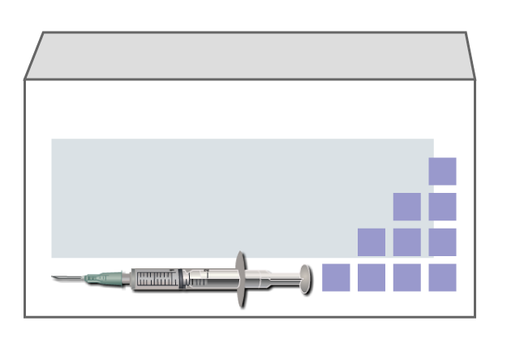

Figure 7 sample syringe and needle

Q10. A patient has been prescribed 4 mg of diamorphine hydrochloride.

What volume should be drawn up for the injection?

__________

Diamorphine hydrochloride
5 mg in 1 mL

Figure 8 syringe and needle

Q11. A patient has been prescribed pethidine hydrochloride at a dose of 0.5 mg/kg. Your patient weighs 90 kg.

What volume should be drawn up for the injection?

___________

Pethidine hydrochloride
50 mg in 1 mL

Part 5: Intravenous infusions

Q12.

Prescription
Date | Route | Infusion fluid | Vol. (mL) | Duration | Time start | Prescriber’s signature
26/03/20 | I.V. | 0.9% sodium chloride | 400 | 5 hours | 0800 | D. McCormick

At what rate would you set the infusion pump to run? _________ mL per hour

Q13.

Prescription
Date | Route | Infusion fluid | Vol. (mL) | Duration | Time start | Prescriber’s signature
26/03/20 | I.V. | 5% glucose | 1000 | 6 hours | 0800 | D. McCormick

At what rate would you set the infusion pump to run? __________ mL per hour
Give your answer to the nearest whole number.

Q14.

Prescription
Date | Route | Infusion fluid | Vol. (mL) | Duration | Time start | Prescriber’s signature
26/03/20 | I.V. | Whole blood | 800 | 5 hours | 0800 | D. McCormick

At what rate would you set the infusion pump to run? __________ mL per hour
Part 6: Fluid balance charts

Complete the following fluid balance chart to calculate whether the patient has gained or lost fluid over a 24-hour period.

If the patient has gained fluid you should include ‘+’ before your balance answer, e.g. +100 mL. If the patient has lost fluid you should include ‘-’ before your balance answer, e.g. -100 mL.

Q15.

Patient’s name: Jack Jones Hospital number: 3861050 Chart number: 1
IV Fluid type and rate: 500 mL 0.9% sodium chloride 125 mLs/hour Date: 26/03/20 Ward: G7
Time | Input |  |  | Output
 | Oral  (mL) | Intravenous  infusion  (mL/hour) | Total  (mL) | Urine  (mL) | Aspirate/  vomit (mL) | Other  ______  (mL)_ | Total  (mL)
0100
0200
0300
0400
0500
0600 |  | 125
0700 |  | 125
0800 | 100 | 125 |  | 140
0900 |  | 125
1000
1100
1200 | 100
1300 |  |  |  | 180
1400 |  |  |  |  | 80
1500
1600 | 150
1700
1800 |  | 125 |  | 200
1900 |  | 125
2000
2100 | 150
2200 |  |  |  | 310
2300
2400
Total input |  |  |  | Total output
Balance

