Nursing and Midwifery Council
Test of Competence Part 2

Candidate Information Booklet

Version 1.7
Contents
SECTION 1: BEFORE THE OBJECTIVE STRUCTURED CLINICAL EXAMINATION (OSCE) 3
01. Introduction 3
02. General information about the competence test centres 4
03. What is the UK like? 4
04. Becoming familiar with nursing or midwifery practice in the UK 4
05. Applying for OSCE Part 2 5
06. How do I prepare for the OSCE? 5
07. Overview of OSCE 6
08. Evidence base for nursing and midwifery practice 6
09. What will I be tested on? 7
10. Communication skills 7
SECTION 2: THE OSCE DAY 10
11. General information about the competence test centre 10
12. Fitness to undertake the OSCE 10
13. Fire alarm 11
14. Identification 11
15. What can I expect in the OSCE? 11
16. How should I dress? 12
17. What conduct is expected during the OSCE? 13
18. Competence test centre rules and regulations 13
19. Confidentiality 13
20. Taking the OSCE 13
21. Grounds for dismissal or cancellation of OSCE results 14
22. How is the OSCE assessed? 14
23. The passing standard 14
24. Can I have my OSCE remarked? 14
25. Unsafe practice and cessation of assessment 15
26. How do I get the results of the OSCE? 15
27. What will the feedback look like? 15
28. What are the potential results? 15
29. What happens if I pass? 16
30. Can I have more than one attempt if I fail the OSCE? 16
SECTION 3: CANDIDATE GUIDANCE 17
31. Can I appeal my result? 17
32. What is a complaint and how can I make one? 17
33. Fitness to practice during the OSCE? 17
34. What happens if I am unable to attend the OSCE because of sudden illness or circumstances beyond my control? 17
35. When can you apply for mitigating circumstances to be considered? 17
36. How will the OSCE be affected if I am pregnant or breast feeding a young baby? 18
37. I have a disability; can the competence test centre accommodate my needs? 18
SECTION 4: ANNEXES 19
Annexe 1: Mitigating circumstances guide and form 20
Annexe 2: Appeal process guide and form 23
Annexe 3: Complaint process guide and form 27
Annexe 4: Pregnant candidate checklist, risk assessment and support plan and guidance 31

SECTION 1: Before the objective structured clinical examination (OSCE)

01. Introduction
The Nursing and Midwifery Council (NMC) introduced a test of competence for internationally registered nurses and midwives in October 2014. The test of competence measures candidates against the current UK pre-registration standards for nursing and midwifery. Nursing in the UK is comprised of separate and distinct fields of practice, each requiring three years of pre-registration undergraduate education.

The distinct nursing fields of practice are:

- Adult nursing
- Children’s nursing
- Learning disabilities nursing
- Mental health nursing

In the UK, midwifery is a separate and distinct profession, also requiring three years of pre-registration undergraduate education.

There is a test of competence specific to each field of nursing practice or midwifery. You will be required to undertake a competence test specific to your field of nursing or midwifery practice. This booklet provides information about part 2 of the test of competence. The blueprints are available on the NMC website. The university learning platform also contains links to online resources, which will help candidates prepare for the test of competence.

In order to quality assure OSCEs across the NMC competence test centres in the UK (currently three), it is necessary to share OSCE data, including paperwork and video data associated with a candidate's exam, with the other competence test centres (Oxford Brookes University, Ulster University and University of Northampton) for the purposes of moderation. This information is shared securely. By submitting your application, you are confirming you have read and understood this information.

02. General information about the competence test centres
Please allow plenty of time to travel to the competence test centre. Bear in mind that rush hour traffic often causes delays. If you arrive late, you might not be able to take the OSCE.

University | Contact Details | Location Details

 | Oxford Brookes University | Oxford Brookes is comprised of two sites:
 | ctc@brookes.ac.uk  01865 488 414 | • Oxford  • Swindon
You can find out more about how to get to either campus on the travel webpage.

Ulster University - Magee
ctc@ulster.ac.uk
02871 675 150
You can find out more about how to get to Ulster University Magee Campus on the location webpage

^{University of Northampton}
ctc@northampton.ac.uk
01604 892 066
You can find out more about how to get to the Innovation Centre at the University of Northampton on our website.

03. What is the UK like?
The UK is a multi-cultural, multi-faith society where all patients must have their culture, faith and human rights respected by all health care professionals. Furthermore, all patients must be treated equally and not subject to discrimination based on disability, ethnicity, religion, gender or sexual orientation in accordance with the Equality Act 2010.

The UK may be very different from the last country you practiced in and you should spend time finding out about the population, health and social care, and other aspects of life. Your test will be related to current practice in the UK

04. Becoming familiar with nursing or midwifery practice in the UK
You must familiarise yourself with the ethical and professional standards expected of registered nurses and midwives as outlined in the NMC (2018) the Code⁸.

These are the required standards, which underpin professional nursing and midwifery practice.

All healthcare professionals must work in partnership with patients, obtaining their consent and respecting their dignity and privacy. It is unacceptable for your words or actions to imply or express disapproval of any patient’s lifestyle. You must not discriminate in any way against those in your care. Patients and the public expect high standards of professional practice from nurses and midwives.

Nurses and midwives work in partnership with other healthcare professionals. Nurses and midwives are expected to both contribute and lead in areas of care where they have expertise. Many organisations are recruiting nurses, using the six C’s of care, compassion, competence, communication, courage and commitment and you should be familiar with these and be able to demonstrate throughout Part 2 of the test of competence.

05. Applying for OSCE Part 2
Part 2 is a nursing or midwifery Objective Structured Clinical Examination (OSCE). The OSCE can only be undertaken after you have successfully passed Part 1.

Please note: Only the NMC can authorise you to undertake Part 2 the OSCE.

Once you have received your decision letter from the NMC, confirming that you have successfully passed in Part 1, you will be directed to the three competence test centres to begin the application process for Part 2.

If you have a disability requiring any reasonable adjustments, please notify the competence test centre separately after booking your OSCE. You may be entitled to extra time in the stations if you have learning support needs. Evidence must be provided from professional reports at time of booking to verify the learning support needs adjustments prior to undertaking the OSCE. The academic lead/Manager and the appropriate wellbeing and occupational health team at the University will review the report and provide advice on an individual basis. Further information can be found in see Annexe 1.

06. How do I prepare for the OSCE?
The OSCE is designed to assess your ability to competently apply your professional nursing or midwifery skills and knowledge in the UK. It is set at the level expected of nurses and midwives as they enter the profession at the point of registration. This means that you must demonstrate that you are capable of applying knowledge to the care of patients at the level expected of a newly registered nurse or midwife.

The examination is testing your ability to apply knowledge and skills to the care of patients rather than how well you can remember and recite facts. All scenarios and associated questions relate to current best practice and you should answer them in relation to published evidence and not according to local arrangements.

Once payment has been received by the competence test centre for your OSCE exam, you will be enrolled onto the competence test centre online learning platform and login details will be sent to you. Below outlines the learning platform used at each centre:

- Oxford Brookes – Moodle
- University of Northampton – NILE
- Ulster University – Blackboard Learn

On the online learning platforms there is a set of preparation materials available for each field of nursing and midwifery practice. These include:

- Mock OSCE
- Top tips
- Marking criteria

In addition there is blank examples of documentation including observation charts relating to the field of practice for which you are being tested on in the examination, reading lists, useful information and links.

You are advised to access the following required materials to begin your preparation:

NMC (2018) the Code –
https://www.nmc.org.uk/standards/standards-for-midwives/standards-for-pre-registrationmidwifery-education/

Resuscitation Council (2015) UK Guidelines for IHR –
https://www.resus.org.uk/resuscitation-guidelines/in-hospital-resuscitation/

Key books accessible through learning platform on receipt of payment for OSCE:

- The Royal Marsden Manual of Clinical Nursing Procedures, 9th Edition (student edition) (2015)
- The Great Ormond Street Hospital Manual of Children's Nursing Practices (2012)
- Skills for Midwifery Practice, 4th Edition (2016)
- Oxford Handbook of Learning and Intellectual Disability Nursing (2018)

Please note: We have become aware that some organisations and consultancies are offering OSCE preparation training sessions for candidates for Part 2 of the test of competence. Please be aware that by attending these courses offered by 3rd parties, you do so at your own risk, these training sessions are not endorsed or approved by either the competence test centres or the NMC and could prepare you inaccurately for the examination.

07. Overview of OSCE
Your ability to apply your knowledge has already been tested in Part 1 of the NMC test of competence. In Part 2 you will be tested on your clinical and communication skills. In other words, you will demonstrate how you apply holistic patient centred nursing or midwifery care and apply key clinical skills.

Everything you see in the OSCE comes from the blueprints on the NMC webpage⁹. These set out the scope and content of the examination in terms of the topics, skills and procedures that a newly registered nurse or registered midwife would need to know and be able to do.

For example, if a scenario involved a vulnerable adult or child with a non-accidental injury, candidates would be expected to know that the person or child may need to be removed from those suspected of causing the injury. Candidates would be expected to know how to raise concerns, know that they should alert the relevant safeguarding team and be able to share information appropriately within and across care teams. We do not expect candidates to have detailed information about local procedures or local policies. We cannot test everything on the blueprint, but we will test typical nursing or midwifery scenarios and clinical skills that UK nurses and midwives will encounter.

08. Evidence base for nursing and midwifery practice
You can find evidence based guidelines in nursing journals and texts and from professional organization webpages such as the Royal College of Nursing¹⁰ and Royal College of Midwives¹¹. The National

⁹ https://www.nmc.org.uk/registration/joining-the-register/register-nurse-midwife/trained-outside-the-eueea/adult-general-nursing/ ¹⁰ https://www.rcn.org.uk/
¹¹ https://www.rcm.org.uk/
Institute of Healthcare and Excellence¹² and Scottish Intercollegiate Guidelines Network¹³ are also useful sources; several useful links are also provided in the test blue print.

09. What will I be tested on?
The OSCE comprises six stations, each lasting between 8-15 minutes. Four stations will be scenario based and relate to four stages of the nursing and midwifery care process:

- Assessment- holistic patient-centred
- Planning
- Implementation
- Evaluation

Two stations will be testing practical clinical skills. Please remember that you will have done many of these nursing or midwifery skills several times before. Make sure that you read the station instructions and scenarios carefully. Do not be afraid to take the opportunity to look at them again if you are unsure. You will not be penalised for this.

Typical skills which may be tested either on their own or within a nursing/midwifery scenario include:

- Administration of Inhaled Medication (AIM)
- Aseptic Non-touch Technique (ANTT)
- Catheter Specimen of Urine (CSU)
- Fluid Balance chart (FBC)
- In-hospital resuscitation (without defibrillation) (IHR)
- Intramuscular injection (IM)
- Mid-stream Urine and Urinalysis (MSU)
- Peak Expiration Flow Rate (PEFR)
- Removal of Urinary Catheter (RUC)
- Subcutaneous injection (SC)
- Paediatric BLS - infant and child (children’s nursing)
- Auscultation of foetal heart (midwifery)
- Newborn examination (midwifery)
- Palpation (midwifery)
- Calculating drug dosages
- Hand hygiene
- Medication administration
- Physiological observations
- Safe disposal of sharps
- Wound care

10. Communication skills
Communication is central to nursing and midwifery practice and will be assessed continually during the OSCE.

We assess the full range of communication skills (verbal, non-verbal and written) by observing the interaction between the candidate and a simulated patient (this may be an actor or a manikin) and also by assessing your nursing or midwifery documentation in each station.

- https://www.nice.org.uk/
- https://www.sign.ac.uk/

The examiner will assess your approach to the patient throughout the examination, and will assess your communication skills such as:

  - Clearly explaining care, diagnosis, investigations and/or treatments.
  - Involving the patient in decision-making.
  - Communicating with relatives and health care professionals.
  - Seeking and obtaining informed consent.
  - Active listening.
  - Dealing appropriately with an anxious person or anxious relatives.
  - Providing clear instructions on discharge.
  - Providing advice on lifestyle, health promotion or risk factors.
  - Demonstrating compassion and care during communication.
  - Clear documentation which meets the requirements of the NMC (2018) the Code.
  - Professional behaviour.
  - Professional attitude.

You should speak to the patient as you would any person you are meeting for the first time. If you are being assessed using a manikin, please remember to verbalise your actions and reasons for actions in the same way that you would with a real patient. If you ask the simulated patient a question the assessor will answer accordingly.

A. Approaching the patient/manikin

- Introduce yourself and explain or clarify the purpose of the nursing or midwifery encounter.
- Check what the patient wants you to call them.
- Be polite, respectful, non-judgemental and maintain the patient’s dignity.
- Be empathic and acknowledge the patient’s emotions or concerns and show sensitivity to any discomfort.
- Ensure you gain consent from the patient prior to undertaking any procedures.
- Be sensitive to personal space, stand or sit at an appropriate distance from the actor/manikin and be aware of their body language. You are too close if the actor moves back or recoils.
- Treat a manikin as you would a real patient.

B. Explaining and advising

- Establish what the patient already knows and/or wants to know.
- Explain clearly what you are going to do and why, so that the patient can understand.
- Remember to always check if the patient has any questions and understands.
- Offer appropriate reassurance.
- Do not alarm the patient but you must be able to explain the need for urgent action if it is required.
- Do not routinely over-simplify names for parts of the body. It is reasonable to expect that most people will know common body names such as 'bladder', 'ovary', 'womb' and 'vein'. If you doubt a patient’s understanding, check and alter your communication to meet their individual needs.
- Treat the manikin as you would a real person.

C. Involving the patient in management

- Respect the patient’s autonomy and help them to make a decision based on available evidencebased information.
- Explain information and its implications so that the patient can make an informed choice about their care.
- Check the patient’s understanding and feelings about the proposed nursing or midwifery interventions. They may not always agree with your proposed plan of care.
- Treat the manikin as you would a real person.

D. Nursing or midwifery assessment

- You should be able to undertake an accurate nursing or midwifery assessment and develop a plan of care.
- Identify the patient’s nursing or midwifery care needs accurately.
- Listen attentively to the patient’s problems and concerns.
- Use clear language and questions at a comfortable pace.
- Clarify and check information and summarise understanding.
- Be able to plan safe and effective person-centred care based on your nursing or midwifery assessment and evidence-based best practice.

SECTION 2: The OSCE day

11. General information about the competence test centre
Please allow plenty of time to travel to the competence test centre. Bear in mind that rush hour traffic often causes delays. If you arrive late, you might not be able to take the OSCE.

A full refund will be given only if more than three weeks’ notice is given of a cancellation or re-schedule. The following refund rates apply:

- Over three weeks of cancellation notice: full refund.
- Less than three weeks cancellation notice: no refund unless in exceptional circumstances, for which a medical certificate may be requested.
- No refund will be given for non-attendance or if no prior notice of cancellation is given (within the stated time above).

When you arrive, we will check the documents that you are required to bring. Once all your documents have been checked, your photograph will be taken and stored on our database. We store your photograph so that we can prove that you are the person we saw in case of identity theft. You must wear the photographic ID produced at all times in the Test Centre. You will be asked to store your belongings in a small locker before moving to the waiting rooms, so please avoid bringing bulky clothing.

Unfortunately, we do not have room to allow friends or family, including children, to wait for you while you are taking the OSCE. Do not bring large suitcases to the assessment centre as we have no storage space for anything other than for small handbags/rucksack.

Smoking is illegal in enclosed public spaces and workplaces in the UK. There is no smoking in or at the competence test centre. Once you have entered the competence test centre you will not be allowed to leave until the OSCE is finished.

The use of mobile phones is strictly prohibited once inside the test centre. You will be asked to turn off your phone and place it in the locker with your other valuables

Once your OSCE starts you will then be under exam conditions until your OSCE is completed in full.

Prior to undertaking the OSCE the invigilator will provide a briefing on its format.

12. Fitness to undertake the OSCE
You need to be fit and well to undertake the OSCE. You will be asked to complete a Confidentiality Agreement and Declaration.

It is acknowledged that a candidate with a declared disability may require reasonable adjustments in order to complete the examination. The request for reasonable adjustments must be made before the date of the examination by contacting the competence test centre either by email or phone.

A reasonable adjustment will allow for a candidate to undertake nursing or midwifery care which:

- Remains effective and does not result in altered patient care.
- Is accepted within professional nursing and midwifery practices.
- Enables the candidate to demonstrate competency.
- Will not place the candidate or patient at risk of harm by injury or illness.

A reasonable adjustment will not allow the required standard of competence to be reduced because of a disability.

Please note: Reasonable adjustments can be made to assess how you demonstrate that you have met a competency or standard. The standard or competency itself is not subject to a reasonable adjustment. If you have a health condition we strongly advise you to disclose it because it means that the competence test centre can give you information about support that may be available to you and, if necessary, make any special arrangements. Disclosing a disability or health condition after the OSCE will not be considered.

13. Fire alarm
If there is a fire alarm, follow the directions of the competence test centre staff to the fire exit. If the fire alarm sounds during the OSCE, you should remain with your examiner at all times. Staff will direct you to an assembly point and will conduct a roll call to make sure that all examiners, actors and candidates are gathered together. You must not speak to other candidates during an emergency evacuation. Once the area is deemed safe, you will be directed back to the competence test centre and given instructions about resuming the OSCE.

14. Identification
We will check your identity at the competence test centre and we will only accept a valid passport. If the name on your passport is different from the email/letter from the NMC authorising you to test, you must provide original evidence that you are the person named in that email/letter.

- Your marriage certificate;
- A declaration from the awarding body, which granted your nursing or midwifery qualification, stating that both names relate to you.

If you do not bring the documents listed above, or if the passport is not valid or current, you will not be allowed to take the OSCE.

NMC staff will also be there on the day for your NMC ID check, this will take place either before or after your exam. You will need to bring all of the original documents that you uploaded as part of your application. You will find a checklist on page 2 of your OSCE decision letter, which is downloadable from your NMC portal. For more information on the NMC ID check please visit NMC website or for specific queries about your ID check, please email ID.checks@nmc-uk.org.

If for any reason you don’t have all of your original documents on the day, the NMC will schedule another face-to-face appointment with you, these are offered either at the NMC London offices or at one of the
OSCE centres. You’ll still be able to sit your OSCE exam and receive your OSCE exam result, but you won’t be able to progress to the last stage of the registration process until you have attended your follow up
ID check

15. What can I expect in the OSCE?
In stations which involve demonstrating a practical skill, you will find a manikin/actor or other piece of equipment.

In stations that require you to complete a nursing or midwifery assessment a professional actor will play the role of a patient. You must treat the simulated patient as you would a real patient. An examiner will be in each station observing you, except written stations.

You must carry out effective hand hygiene before starting the stations. Soap, water and hand gel will be available at all stations.

You may be asked to take a nursing assessment or carry out a practical clinical skill. Each station will have a scenario overview which will give relevant information about the patient, such as name, age and what is expected of you in the station.

Each station lasts between 8-15 minutes and will be in one bay throughout.

A lead assessor will be overseeing the test day with assessors based at each station observing. Each station has a camera and sound system installed. The built-in cameras will record the examination and will be used to review the examination afterwards for quality assurance purposes. This is not optional but part of the process so you will be asked, at the point of booking to consent that you understand recording will take place throughout the OSCEs. The videos are used for examination and reviewing purposes only by the university and NMC.

Please note: Filmed assessments are treated as examination scripts. Once the scripts have been marked and moderated, the pass or fail decision is final and candidates or any sponsoring authority cannot request access to the film. An appeal or complaint may involve the investigator to review the filmed assessments but films will not be released to you or any sponsor.

16. How should I dress?
We require that you dress for the OSCE in a manner that is appropriate for a clinical environment. All nurses and midwives must be dressed professionally, maintain a high standard of infection control and ensure the health and safety of themselves and their patients. The guidelines below are based on the expected standards for pre-registration healthcare students at any UK university. They mirror the professional standards required of all health care professionals in the UK.

- Clothing: Please dress as you would in clinical practice. In the UK this is normally a clinical dress, tunic or polo shirt with smart trousers or scrubs. You must not wear jeans or shorts. Nurses and midwives in the UK frequently wear dark plain trousers and plain polo shirts/tunics and where possible candidates should be dressed in a similar manner. Candidates who wish to wear alternatives, for example, because of cultural or maternity requirements, should discuss this with the competence test centre before arriving for the OSCE.

- Shoes: Must be plain flat black, rubber soled, enclosing the whole foot and not made of porous or absorbent material.

- Fingernails: Must be kept short, unvarnished with no extensions or decoration.

- Hair: Must be tied up off the face and secured with simple hair ties/bobbles above the collar of your tunic or polo shirt. Hair should be of a natural shade and style. Facial hair should be kept clean trimmed and tidy.

- Head scarf / turban: Should you wear a head veil / turban, please ensure it is appropriate in colour (plain black or navy), and it must be tucked into the collar of your tunic or polo shirt.

- Jewellery: Plain “ball” ear studs are allowed to be worn (maximum of one per ear). No tongue piercings should be worn. A single plain band wedding/commitment ring is allowed. You must be bare beneath the elbow, no bracelets or wristwatches are to be worn.

- Makeup: Must be kept to a minimum and be discreet and natural.

- Socks / tights: Flesh coloured/black tights or dark blue/black socks with trousers.

17. What conduct is expected during the OSCE?
The OSCE is a formal examination and candidates are required to behave appropriately and in accordance with university regulations and policies.
Candidates are already professional nurses or midwives and are expected to behave in a professional manner at all times while at the competence test centre.
You will be provided with all the materials you need during the examination.

18. Competence test centre rules and regulations
All personal items must be placed in the small locker provided at the competence test centre. The competence test centre will take no responsibility for any lost, stolen, or misplaced items.

The following items are not allowed in the OSCE nor can they be accessed during your time at the competence test centre:

- Any educational, test preparation or study material.
- Mobile phones, hand-held computers, personal digital assistants (PDAs), pagers, watches or any other electronic devices.
- Weapons of any kind.
- Mobile phones, pagers or other electronic devices must be turned off before storing them in the locker.

During your time at the competence test centre you are not allowed to access personal items other than medication or foods which are required at a specific time and you must have arranged this in advance with the competence test centre. If you require access to medical devices or aids during the OSCE please inform centre staff when booking your OSCE examination.

19. Confidentiality
As a registered nurse or midwife you are bound by the NMC (2018) the Code¹⁴. Any cheating or misconduct during the OSCE or breaching confidentiality of the examination may bring your profession into disrepute and may raise doubts about your fitness to practice. Such incidents will be reported to the NMC by the examiners and will be investigated.

You must not seek help or attempt to seek help from any other party during the OSCE. This includes in person or by phone, text, messaging, email or any form of social media.

You must not disclose or discuss with anyone, including instructors, information about the OSCEs. This also includes posting or discussing scenarios or skills on the internet or any form of social media, such as Twitter or Facebook.

20. Taking the OSCE
The results of the OSCE must be an accurate reflection of the authorised candidate’s knowledge and professional skills as a nurse or midwife.

¹⁴ https://www.nmc.org.uk/standards/code/
- You must not take or attempt to take the OSCE for anyone else.
- You must not allow or attempt to allow anyone else to take the OSCE for you.
- You must not engage in any behaviour deemed to be disruptive at any time while in the competence test centre or when taking the OSCE.

21. Grounds for dismissal or cancellation of OSCE results
All candidates must comply fully with the competence test centre staff instructions and the rules and regulations or they will risk having their OSCE results withheld, dismissed, or cancelled. Candidates who do not comply with this may be asked to leave the competence test centre and their fees will not be refunded. Such incidents will be reported by the examiners and investigated. The OSCE result may be withheld during an investigation.

Please note: The competence test centre will always report such incidents to the NMC.

22. How is the OSCE assessed?
Each OSCE station has a unique criterion-based assessment sheet which is matched to the scenario or skill being assessed, examiners will score each criterion. The criteria are mapped against the NMC standards for Pre-Registration Education 2010¹⁵ or NMC standards for Pre-Registration Midwifery Education 2009¹⁶ and the NMC (2018) the Code¹⁷.

The assessment, planning, implementation and evaluation stations are mapped against the above. The skills assessments are also mapped against the above but also mapped against the Royal Marsden Manual of Clinical Nursing Procedures, 9th Edition (student edition), the Great Ormond Street Hospital
Manual of Children's Nursing Practices (2012), the Skills for Midwifery Practice, 4th Edition and Oxford Handbook of Learning and Intellectual Disability Nursing (2018) depending on which field of nursing or midwifery practice you belong to. The following is an example of a planning station criterion:

Handwriting is clear and legible - failing to write clearly and legibly will result in a fail in this station as it is important that other staff are able to read your care plan to continue to provide safe and effective care.

23. The passing standard
To pass the OSCE the candidate must achieve a pass score on every criterion. This is then moderated by a panel of assessors before the final grade is awarded for the station.

24. Can I have my OSCE remarked?
All OSCEs are recorded and all OSCEs deemed a fail will always be reviewed by the panel of examiners on the day of the OSCE. Failed OSCEs are automatically remarked and checked as part of the quality assurance process.

The academic lead/centre manager and administration team will coordinate any appeals, complaints, reasonable adjustments and fitness to practice issues and refer such matters to the test panel for investigation and reporting to the NMC.

- https://www.nmc.org.uk/standards/standards-for-nurses/standards-for-pre-registration-nursing-programmes/
- https://www.nmc.org.uk/standards/standards-for-midwives/standards-for-pre-registration-midwifery-education/ ¹⁷ https://www.nmc.org.uk/standards/code/

25. Unsafe practice and cessation of assessment
In the event that any candidate demonstrates unsafe practice which may place the candidate, simulated patient or examiner at risk then a ‘U’ score (unsafe practice) must be awarded. A ‘U’ score denotes an OSCE station fail.

26. How do I get the results of the OSCE?
Candidates with a C10 number will be informed of their result from the NMC within 3-5 working days. Please do not ask the examiners or competence test centre staff, they will not be able to release any results directly to candidates. Candidates with a PRN number, will be informed of their result directly by the competence test centre within 3-5 working days.

The NMC test of competence Part 2 is split into two parts; two skill stations and four scenario stations; Assessment, Planning, Implementation and Evaluation. These form a sequential patient journey. You will undertake all of these, but the two skill stations may be assessed before or after the scenario stations.

If you are unsuccessful in to four stations, your resit will be charged at 50% cost; £397.
If you are unsuccessful in five or more stations, your resit will be charged at 100% cost; £794.

27. What will the feedback look like?
You can expect to receive feedback on the aspects of the test in which you failed to meet the level of competence. This will be a brief account of how you failed to show competence. The competence test centre is not allowed to teach you how to pass the exam so the feedback will be short and factual. For example, if a candidate failed aseptic non-touch technique (ANTT) for contaminating their sterile clinical waste bag when setting up the field the feedback may read as follows: “Aseptic Non-Touch Technique (ANTT): You failed to show competence in this station. When setting out your sterile field you contaminated the orange bag and as a result contaminated your sterile field. This is a patient safety risk resulting in a fail.”

28. What are the potential results?
Result | Description | Outcome | Cost
Pass | Passed all stations taken | Congratulations! The NMC will be in touch to issue your NMC PIN. | N/A
Fail 1-4 stations | Failed up to four stations across  both the APIE and/or skill stations | Will require a resit at 50% cost.  You will need to resit the stations you failed only. If you need to resit the APIE station(s) you will be given your original paperwork from the APIE stations you passed in your previous attempt, in order to complete the resit stations in sequence. | £397
Fail 5-6 stations | Failed five or more stations  across both the  APIE and skill stations | Will require a resit at 100% cost. You will need to resit the APIE station(s) you failed and the skill station(s) you failed. You will be given the same scenario and your original paperwork from the APIE stations you passed in your previous attempt in order to complete the resit stations in sequence. | £794
Full Fail | Fail any station on their 3rd attempt. | Will require 6 months to elapse before you can reapply to the NMC. | N/A

29. What happens if I pass?
The NMC will contact you and begin the process of registering you as a nurse or midwife in the UK.

30. Can I have more than one attempt if I fail the OSCE?
Candidates applying to the NMC on or after 6 April 2017 are permitted three attempts as part of one application (an initial sitting, a resit (partial or full) and then a final resit (partial or full). The NMC requires a minimum of 10 working days between the initial attempt and the first resit. If unsuccessful at the second sitting, candidates are required to wait 10 working days before taking the exam for the third time. However, if you appeal the process, you will have to wait for the investigation to be completed before you can book a resit if your appeal is not upheld.

If a candidate fails their re-sit(s), their NMC application will close. Applicants will need to submit a new application to the NMC but are not allowed to sit the exam again for a minimum of six months.
Candidates should use this time to ensure they are adequately prepared for the OSCE.

SECTION 3: Candidate guidance
The next section of this Information Booklet provides guidance for you when considering applying for mitigating circumstances, appeals or complaints. The competence test centre manager will always offer guidance and advice in such matters. If after pursuing such issues, you remain unhappy with the outcome and decisions reached you have the right to raise the matter with the NMC.

31. Can I appeal my result?
If you believe that a mistake has been made at any point during the process of your test of competence, or that an irregularity has occurred in the conduct of the OSCE, and you think that this has had a direct and demonstrably detrimental effect on your performance then you may be able to make an appeal. You cannot appeal the result; you can only appeal the process. See Annexe 2 for guidance on the Appeal Process and Form.

32. What is a complaint and how can I make one?
If you are dissatisfied with a service that the competence test centre is providing, or with the person who is providing it, then you can raise the matter as a complaint. You should always try to resolve a problem as close as possible to its source. So, for example, if you have a problem with your examiner you should speak to the lead assessor or invigilator at the time. If you are dissatisfied with the outcome you can make a formal complaint to the NMC. See Annexe 3 for the candidate guidance on the Complaint process and form.

Please note: Candidates do not have the right to see their filmed assessment – It is treated as an exam script. Once the script has been marked and moderated the pass or fail decision is final and candidates or any sponsoring authority cannot request access to the film. An appeal will involve the investigating panel reviewing the candidate’s filmed assessments but films will not be released to candidates or their sponsors.

33. Fitness to practice during the OSCE?
Your fitness to practice during the OSCE may be questioned if a member of the competence test centre staff, a simulated patient or another candidate expresses concerns that you are failing to maintain standards and/or that your conduct is inappropriate to your profession. Examples may include a breach of confidentiality and professional misconduct (which may call into question your honesty and integrity). If this occurs your OSCE may be stopped and an incident form will be completed and forwarded to the NMC. If you are allowed to continue an incident form will still be submitted and you will be informed of this at the time of your OSCE.

34. What happens if I am unable to attend the OSCE because of sudden illness or circumstances beyond my control?
Candidates must make every attempt to attend their booked OSCE appointment.
Cancellations before 2 working days of the OSCE will not incur a financial penalty nor will they count as an attempt for the NMC. However, cancellations made less than 2 working days before the OSCE will not be refunded and they will not count as an NMC attempt.

35. When can you apply for mitigating circumstances to be considered?
If you are unable to attend the OSCE examination because you are ill, or if you have a personal issue which prevents you from attending, you should contact the relevant competence test centre by email or telephone call. You must remember to include independent evidence, for example, a hospital appointment letter or a copy of a prescription.

Please note: It is your responsibility to collect this evidence.

If you arrive to sit your OSCE and you do not feel well enough to proceed or you become unwell during the exam, you must inform the invigilator and lead assessor straight away and they will support and advise you further.

Before taking the OSCE you will be asked to declare yourself as fit to take the exam and you will be unable to defer an assessment once you have commenced or appeal that you were unfit. Evidenced personal circumstances, such as sudden illness, may be permitted as reasons for re-booking the OSCE at short notice.

Being late for the OSCE or changing your mind about taking the OSCE less than 2 working days before the booked time will mean that you will have to pay again. If you do not sit the OSCE it will not count as an attempt.

36. How will the OSCE be affected if I am pregnant or breast feeding a young baby?
The competence test centre will seek to support candidates who are pregnant or have very young children. The competence test centre will be flexible to enable the candidate when possible to take the OSCE as planned, except when a significant risk is identified. The competence test centre must be informed in advance. Candidates can find guidance in Annexe 4.

37. I have a disability; can the competence test centre accommodate my needs?
Our staff are committed to ensuring impartiality and equality of opportunity in the delivery of our services. Our premises are wheelchair accessible and the competence test centre will also act on NMC guidance regarding this. Special adjustments are made for candidates with disabilities or those registered as dyslexic or with other additional needs. Candidates are asked to declare their evidenced needs for reasonable adjustments when booking their OSCE and will be required to produce supporting evidence. The academic lead/manager will seek advice on the reasonable adjustment which is possible for the candidate. Simple changes such as lowering beds, accommodating the need to sit or stand, or the increased need for toilet breaks during pregnancy can be easily arranged when the competence test centre is notified in advance.

Candidates who need to access medical devices during the OSCE can be accommodated with advance notification prior to booking. The competence test centre will not allow the required level of competence to be reduced because of a disability. Candidates with additional needs must declare them via the Reasonable Adjustments form that will be emailed to candidates once the competence test centre has been notified by the candidate and a booking has been made.

SECTION 4: Annexes

Please note: Blank copies of these forms are available to download on the competence test centre learning platforms.

Annexe 1: Mitigating circumstances guide and form

Mitigating circumstances guide

What are mitigating circumstances?
Mitigating circumstances are events that have significantly disrupted your OSCE.

They must be:
- serious or acute
- beyond your ability to foresee and control

When can you apply for mitigating circumstances to be considered?
If you are unable to attend, because you are ill, or if you have a personal issue which prevents you from engaging with the OSCE, you should complete and submit the form sampled on page 21 of this Guide which can be found on the competence test centre learning platform. You must remember to include independent evidence, for example, a hospital appointment letter or a copy of a prescription with your application: it is your responsibility to collect this evidence.

What outcome can you expect if you apply for mitigating circumstances?
There are a number of issues that cannot be addressed through the submission of a mitigating circumstances application:
- Under no circumstances will grades awarded to your OSCE be changed. All OSCEs are graded upon their own merits and no allowance will be made for mitigating circumstances. A mitigating circumstances application for a completed OSCE will not be considered.

- Only in very exceptional cases will applications be accepted for mitigating circumstances after the set deadline for the examination has passed. If you do apply late you must explain why.

- A known disability is not, per se, a reason to submit a mitigating circumstance application, although (for example) unforeseen illness resulting from a disability may be. Reasonable adjustments to OSCE examinations will normally be made to support candidates with a disability. Requests for such adjustments should be discussed with the academic lead and competence test centre administration team in advance of the OSCE examination.

- The NMC determines the number of opportunities a candidate has to take the OSCE examinations.

If you miss the first opportunity, did not sit the OSCE and have successfully applied for mitigating circumstances, your attempt will not count.

If you do not sit the OSCE your attempt will not count. If you sit the OSCE and are unsuccessful in applying for mitigation, the attempt will count.

What happens if I am ill on the day of an OSCE examination?
If you are too ill to start the OSCE examination then you need to let the competence test centre know as soon as possible. You then need to submit an application for mitigating circumstances.

If you become ill during an OSCE examination then you need to let the invigilator know straight away.

Candidates should make every effort to cancel their OSCE a minimum of 2 working days before the exam is booked (if the exam is on a Monday cancellation should occur on the Thursday before). Refunds will not be given routinely if OSCEs are cancelled at short notice.

Mitigating circumstances form

Version 1.
Your
Mitigating Circumstances:

You must provide precise dates of any illness or other circumstances and states how your OSCE was
(
affected and what steps you took to recover the situation

Declaration:

I declare that the details included in this application, including any appended statements, are true
and that I have read and understand the foregoing Mitigating Circumstances Guide.

Signed:

Date:

immimimmmmdo
Image partimage partimimimimimimimimimim

Annexe 2: Appeal process guide and form
What grounds can I use as the basis for an appeal?
If you believe that your result is incorrect or that a mistake occurred during the process of your assessment, or that an irregularity has occurred in the application of the Assessment Regulations or in the conduct of the examination, and you think that this has had a direct and demonstrably detrimental effect on your performance, then you may be able to make an appeal.

In what situations might appeal be worthwhile?
Marks awarded to your work will have been through a rigorous process of moderation involving at least two internal markers and the oversight of marking standards by an external examiner, who approves all grades awarded. The University will not accept an appeal against the academic and/or professional judgments of examiners per se. An appeal will only be worthwhile if it meets the grounds listed above.

Where can I obtain advice?
If you have any uncertainties about the information contained in this guide you should consult the relevant competence test centre administration team.

How should I appeal?
You will need to complete a Level 1 Appeal form which is found on the Moodle / NILE / Blackboard learning platform. Once completed, please submit it to the CTC Administration team within 5 working days of receiving your OSCE result.

Where should I submit the form?
Please email your Appeal form to the relevant competence test centre;
Oxford Brookes University | ctc@brookes.ac.uk
Ulster University | ctc@ulster.ac.uk
University of Northampton | ctc@northampton.ac.uk

How will my appeal be dealt with?
The CTC Administration team will forward your Appeal for review. If you make a legitimate appeal on acceptable grounds, an examiner independent to your OSCE will examine your case. The investigator will come to a conclusion and will write to you either stating that your appeal should be upheld or that it should not. This will include the rationale for the reviewer’s decision. See Annexe 1 for candidate guidance of the process.

How long will it take to reach a decision?
If you make an appeal then the investigation will normally be completed within 20 working days. If you want an update on the progress of your appeal then you should contact the relevant CTC Administration team:
Oxford Brookes University | ctc@brookes.ac.uk | 01865 48 8414
Ulster University | ctc@ulster.ac.uk | 02871 765 540 / 02871 675 698 University of Northampton | ctc@northampton.ac.uk | 01604 892066

What outcome can I expect if I make an appeal?
Your appeal will either be Partially Upheld, Upheld or Not Upheld. You will be notified of this decision by email.

What should I do if I am dissatisfied with the outcome?
Once your appeal has been formally heard by the University and the Level 1 outcome has been communicated to you, you can submit a request for your Appeal to be reviewed at Level 2. This request must be submitted within 10 working days of your Level 1 Appeal response.

A different examiner, independent to your OSCE and the Level 1 investigation will investigate. The investigation will normally be completed within 20 working days. You will receive notification of this decision by email. This concludes the University’s appeal process.

The complaints procedure is outlined on the NMC website https://www.nmc.org.uk/contactus/complaints-about-us

Appeal form - Level 1

This form should be submitted to the CTC Administration team within five days of receiving your OSCE result.
Date Received: | Date Logged:
Date File Created: | Appeal Acknowledged:

Name

Candidate Number

Correspondence Address

Email Address

Date of
test of competence

(
)
OSCE

Grounds for Appeal

(
)
You should provide full details of the nature of the irregularity that you feel had occurred

I declare that the
information given is true and that I am willing to answer further questions if necessary:

Signed:

Date:
Image part
Please email your Appeal form to the relevant competence test centre below;

Oxford Brookes University |
ctc@brookes.ac.uk.

Ulster University |
ctc@ulster.ac.uk

University of Northampton |
ctc@northampton.ac.uk

(For official use)

Annexe 3: Complaint process guide and form

Candidate complaint guide

What is a complaint?
If you are dissatisfied with a service that the University is providing, or with the person who is providing it, then you can raise the matter as a complaint.

How should I make a complaint?
You should always try to resolve a problem as close as possible to its source. So, for example, if a problem has arisen with your examiner you should speak to the Lead Assessor or Invigilator on the day of your OSCE.

What outcome can you expect if you make a complaint?
The University expects its entire staff to be receptive to issues raised by candidates. Complaints will be addressed initially through an informal process involving discussions with people in the Department where the difficulty has arisen.

What should I do if I am dissatisfied with the outcome? In some cases it may be felt that the candidate’s complaint has not been resolved by the informal process.
In such cases you can progress the complaint to Level 1 by completing and submitting by email, the Level 1 Complaints Form to the relevant competence test centre. See Annexe 2 for candidate guidance of the process.

What happens if I make a formal complaint?
The University will appoint an investigator to carry out an investigation into the matter(s) that you have raised and will report back to you within 20 working days. You should note that you should not submit a formal Level 1 complaint unless you have already attempted to resolve your issue(s) via the informal process.

Will my examiners treat me differently if I make a complaint about them?
It is part of the University’s Policy that no one bringing a complaint, whether successfully or otherwise will be treated less favourably by any member of staff than if the complaint had not been brought. If evidence to the contrary is reported, then the member of staff may be subject to disciplinary proceedings.

Where can I obtain advice?
If you have any uncertainties about the information contained in this Guide you should consult the relevant CTC Administration team on;
Oxford Brookes University | ctc@brookes.ac.uk | 01865 488 414
Ulster University | ctc@ulster.ac.uk | 02871 675 540 / 02871 675 698
University of Northampton | ctc@northampton.ac.uk | 01604 892 066

What if I am dissatisfied about the Level 1 Complaint outcome?
You should submit a Request to Review Complaint via email to the relevant competence test centre within 10 working days of receiving your Level 1 response. This then escalates to a Level 2 Complaint. Members of staff outside of the competence test centre will now investigate. You will receive a response within 20 working days.

How long will it take to make a decision?
If you can resolve your issues at the informal stage, then it will not take very long at all. If you make a formal complaint then the investigation may take longer, but the University endeavours to provide you with a response within 20 working days of receiving your complaint at either Level 1 or 2.
Version 1.

Complaint form - Level 1

Name

Candidate Number (if applicable)

Correspondence Address

Email Address

Date of
test of
competence

(
OSCE
)

Please give a brief outline of your complaint.

Please explain what steps you have taken to resolve your complaint with the relevant
Department (in accordance with the informal process outlined in the Complaints Guide
above
and the Complaints Policy).

Please explain why you
are dissatisfied with the response you have received.

Please indicate what outcome of further action you are expecting.

Please provide any documents you believe support your complaint.
I declare that the information given is true and that I am willing to answer further questions if necessary:

Signed: | Date:

This form should be submitted to:
Oxford Brookes University | ctc@brookes.ac.uk
Ulster University | ctc@ulster.ac.uk
University of Northampton | ctc@northampton.ac.uk

Annexe 3: Complaint process guide and form
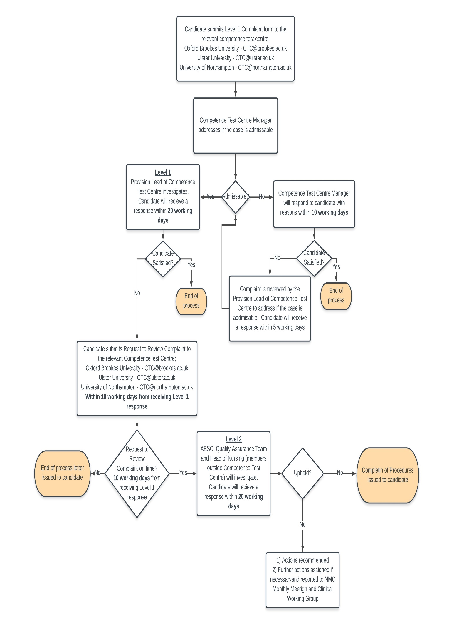

Annexe 4: Pregnant candidate checklist, risk assessment and support plan and guidance

New and expectant mothers
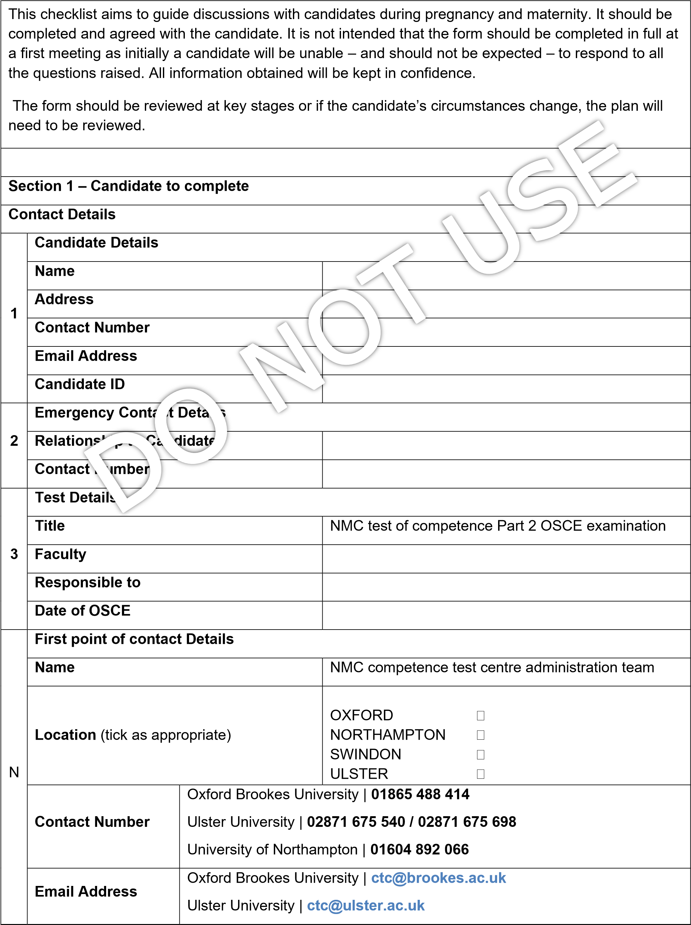
University of Northampton | ctc@northampton.ac.uk

Where changes are required to alleviate or minimise risks, who is responsible for ensuring they are implemented?

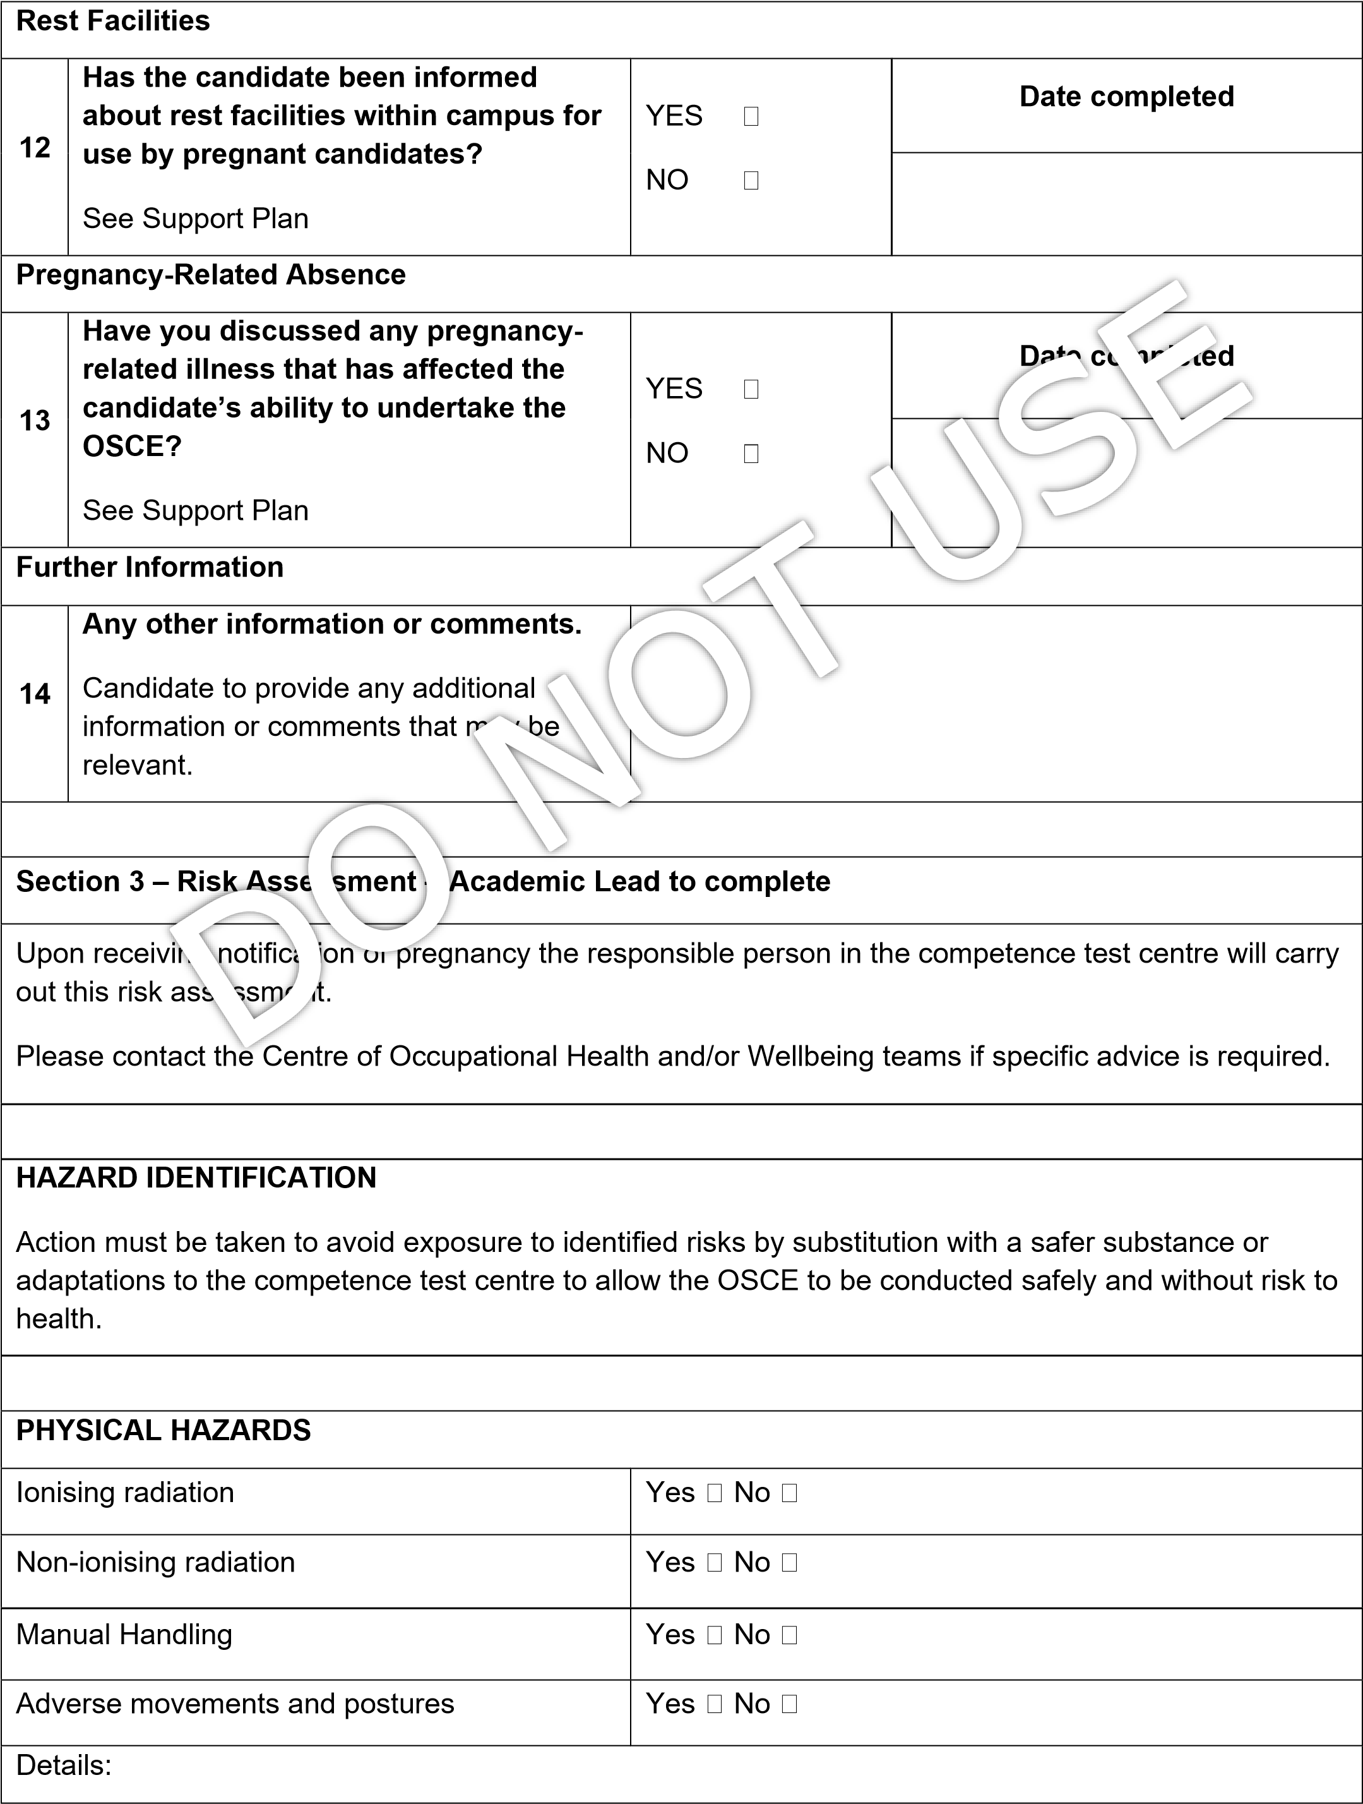
Action:
CHEMICAL HAZARDS | Yes No
Details:
Action:
Signed (candidate) |  | Date
Signed (academic lead) |  | Date

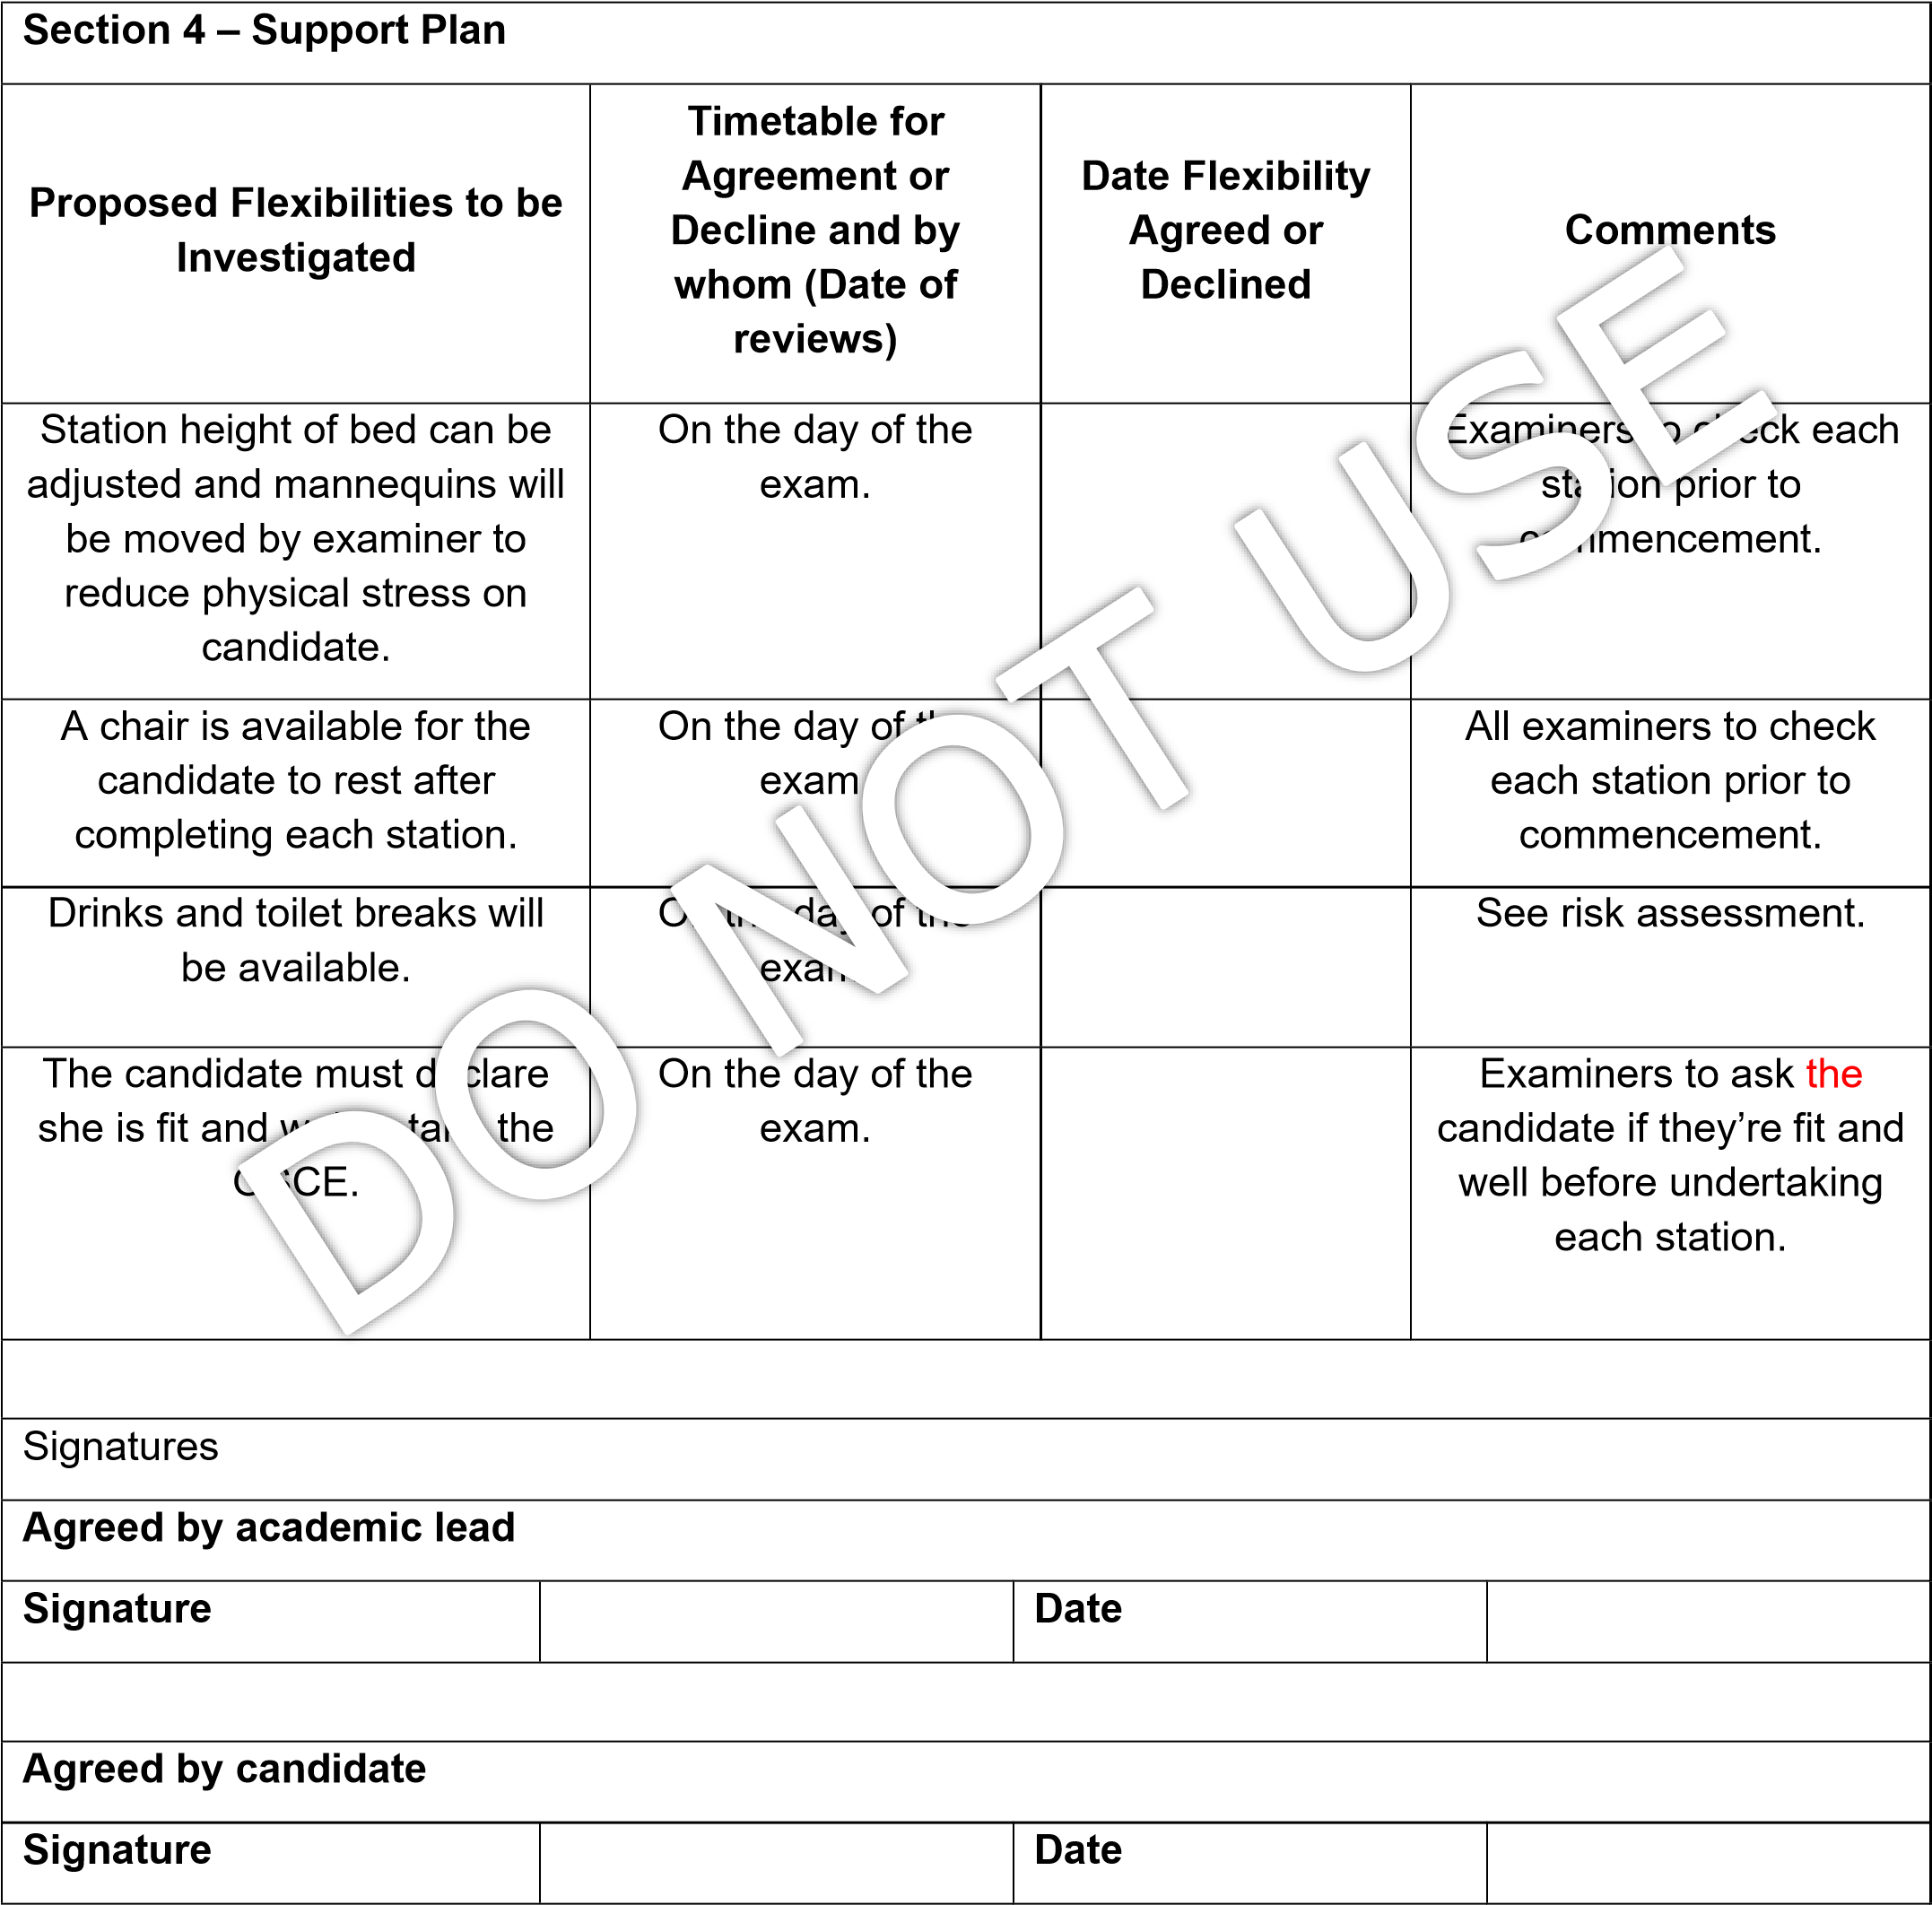

New and expectant mother’s guidance
The University will:
- Ensure that a candidate who is pregnant, or has given birth within the last 26 weeks, is protected from unfavourable treatment.
- Accommodate their needs both before and during the OSCE in so far as is reasonably practicable to allow the candidate to successfully complete the OSCE.
- Publish this guidance and review/update as necessary in order that all members of the competence test centre community are aware of the support available and their role in providing that support.
- Encourage candidates to disclose a pregnancy in confidence at an early stage to the competence test centre.

Introduction
The competence test centre recognises that being or becoming pregnant, or having a very young child should not, in itself, be a barrier to applying for, starting, succeeding in, or completing the test of competence. The competence test centre will be as flexible as is reasonable, in accordance with university regulations and the legal framework, in which the university operates.

This guide provides information and advice about the university’s approach to supporting a candidate who is pregnant.

Definitions
Candidates referring to those who are pregnant or have very young children
Very young children – those under 26 weeks of age
New parent – those with children under 26 weeks

When a candidate’s pregnancy is disclosed, the academic lead and competence test centre administration team is expected to:
- Read and follow this guidance.
- Treat any disclosure confidentially and verify that a candidate has no objections to their pregnancy being discussed with other competence test centre staff.
- Agree a support plan and ensure that it is implemented.
- Complete a risk assessment.

Candidates (and applicants) are advised to:
- Read this guidance in order to understand the University’s approach to supporting candidates who are pregnant or have very young children as defined below;
- Disclose their pregnancy at the earliest opportunity, to enable the consideration of any necessary support arrangements or adjustments during the OSCE;
- Discuss any concerns they have relating to their pregnancy with their own GP competence test centre team.
- Ensure that they have received a copy of the completed risk assessment if appropriate.

Guiding Principles
Avoiding less favourable treatment. The university will not treat a candidate (or applicant) less favourably than other candidates.

Taking a flexible approach. The university will take a flexible approach, in line with university regulations, to facilitate the ability of the candidate to take the test of competence.

Demonstrating a non-judgmental and sensitive approach. All those involved should take an open-minded and non-judgmental approach. Information provided by the candidate should be treated sensitively and only passed on to others on a need-to-know basis.

Enabling informed choices. No one should attempt to directly or unduly influence candidate’s decisions. The university’s role is to provide context and advice, and to explore, in consultation with the candidate and others, flexibility that can be applied to the test of competence. The emphasis is on candidates making informed choices based on full knowledge of the implications of these choices. However, in exceptional circumstances where it has been identified that there is a significant risk to the health and welfare of either the candidate and/or unborn child, the University may have to advise a course of action which is not negotiable.

Notification of Pregnancy
Candidates are strongly advised to inform the competence test centre as soon as it is practicable. This is particularly important where there may be a risk to the health and safety of the candidate and/or her unborn child.

Candidates are not obligated to inform the competence test centre if they become pregnant, decide to terminate a pregnancy or miscarry. However, it is important to note that the university can only adopt a flexible approach, provide support or make adjustments if it is aware of the situation.

When deciding whether to notify the competence test centre, the candidate is encouraged to consider that there may be elements of the test of competence that could present a health and safety risk to her and/or her unborn child.

Process
Step 1 - The candidate is strongly advised to consult her own GP to discuss medical issues relating to her pregnancy prior to approaching the competence test centre.

Step 2 - Candidates should inform the competence test centre of the pregnancy and/or pregnancy issues when booking the OSCE. A checklist will then be sent to the candidate to be filled in. A risk assessment is undertaken (see step 3) to ensure all issues are discussed at an early stage and a support plan initiated (see step 4).

Step 3 - Risk Assessment - The academic lead should ensure that appropriate steps are taken in relation to health and safety issues. This will involve a risk assessment for the individual candidate.

Step 4 - Candidate Support Plan - Once discussed and agreed, a candidate support plan for the test of competence will detail any specific flexibility agreed. This should be given/sent to the candidate.

Step 5 - Communicating the Support Plan - The academic lead will communicate the agreed candidate support plan to other relevant examiners. Information should be passed on sensitively and in confidence.

Determining Flexibility
The competence test centre does not have to agree to any or all requests. There may be situations where it is not possible to agree to a particular request; such as, where the consequences of agreeing to requests are likely to have a detrimental effect on the candidate. The candidate must be made fully aware of these consequences. However, the final decision will rest with the candidate as to whether they would still like to sit the OSCE.

When considering declining a request, the university’s equality and diversity adviser should be consulted before the decision is made. Candidates can seek bespoke advice on what might constitute as appropriate flexibility in a particular case from the university’s equality and diversity adviser.

If it is decided to decline a request, the reasons will be recorded and the candidate will be informed as to why this particular request is not considered “reasonable” in the circumstances. This will be recorded in the candidate support plan.

In cases where deferring the OSCE would lead to taking longer to complete the test of competence than would normally be permissible by the NMC, the competence test centre should still strive to demonstrate a flexible approach, where practicable, in relation to this deadline for completion, whilst ensuring that the student does not exceed the overall time limit allowed by the NMC. If the candidate is likely to exceed the time allowed to complete the test of competence because of pregnancy they should contact the NMC for advice.

If a candidate is unhappy with the competence test centre’s decision they can appeal or complain (whichever is most appropriate) to the competence test centre administration team who will refer all complaints or appeals to the appropriate person.

Occupational Health Adviser
If, at any stage, the academic lead would like some assistance in thinking through the practical implications of an individual pregnancy or for advice on health and safety issues including risk assessments, they should contact the university’s occupational health adviser. The academic lead may also wish to consult their line manager or other senior managers at the test of competence or the university.

The university will also consider flexibility for a candidate who has recently become a parent. As above, what constitutes a reasonable degree of flexibility to take account of a candidate’s caring/parental responsibilities may vary for particular circumstances.

Small Babies/Children on Campus
Small babies, children, partners and relatives are not allowed in the lab/examining area of the competence test centre at any time.

Candidates may be accompanied by children in general public areas such as the restaurants and the library, providing that children are supervised by the partner or relative at all times and they are not disruptive to others. It is particularly important that children are not brought into areas where there is the possibility of a risk to health and safety. The university cannot accept any liability for the child in these circumstances.
There are no restrictions on breast feeding on campus. If additional support is required for breastfeeding whilst candidates are on campus, candidates should contact the competence test centre administration team prior to their OSCE date.

https://www.nmc.org.uk/standards/standards-for-nurses/standards-for-pre-registration-nursing-programmes/
https://www.nmc.org.uk/standards/standards-for-midwives/standards-for-pre-registration-midwifery-education/
https://www.nmc.org.uk/registration/joining-the-register/trained-outside-the-eueea/adult-general-nursing/
https://www.brookes.ac.uk/documents/about/marston-road_how-to-get-here_110509/
https://www.northampton.ac.uk/about-us/services-and-facilities/nmc-test-of-competence/
https://www.gov.uk/guidance/equality-act-2010-guidance
https://www.nmc.org.uk/standards/code/

