Disclosure and Barring Service (DBS) Check

Nursing and Midwifery April 2019

Please read all the notes carefully before proceeding

There are now 2 options you can choose from when completing your DBS:

Option 1

If you wish to take your ID Documents to a Crown Post Office:

You must apply online at GBG first and then take your documents to the Post Office. The Admissions Office will not be involved in the process. We will however, be able to see the outcome of your DBS check. Please use the codes below and follow the steps for Option 1.

There is a charge at the Post Office but the University will pay this for you.
Option 1 – Post Office checking ID Documents
Course | Secret word | Org PIN
Midwifery (BSc) | POhealth | 164671
Nursing (BSc) | POhealth | 164671

Option 2

If you wish to supply your ID Documents to Admissions at the University, please use the codes below and follow the steps for Option 2 and Admissions will verify your DBS application.
Option 2 – Admissions Office checking ID Documents
Course | Secret word | Org PIN
Midwifery (BSc) | health | 105823
Nursing (BSc) | health | 105823

Choose an option before proceeding and ensure you follow the corresponding notes only.

See summary of stages below before proceeding:
1 | All: Complete online form at GBG OnlineDisclosures
2A | Option 1: Provide documentation to the Post Office  or  Option 2: Provide documentation to the Admissions Office at the University.
2B | Option 2 only: Send email to Admissions (see Important Action in Table 1)

You must complete 1 and 2 before Post Office/Admissions proceed.
3 | Option 1: The Post Office will verify your documents and inform GBG, who will complete the process on your behalf.  or  Option 2: Admissions will verify your documents and submit your application to the DBS. (You are not required to attend a Verification Meeting)
4 | All: Receipt of disclosure information (to both student in paper form and Admissions online)
For queries, hints and tips and information on the Update Service, please see the end of the document.
Option 1 - Stage One (Post Office route):
The DBS application form must be completed online at https://gbg.onlinedisclosures.co.uk/
You will need the login details below to complete the online form.
Click on Register (on right hand side of screen):

Then enter:
- Org Pin (see Page 1)
- Your full name
- Email address
- Confirm email address

You will then be asked to enter the Secret Word – (see Page 1) ensure you use the PO codes. Tick to confirm the right Organisation name and then create your own password then click on Complete Registration
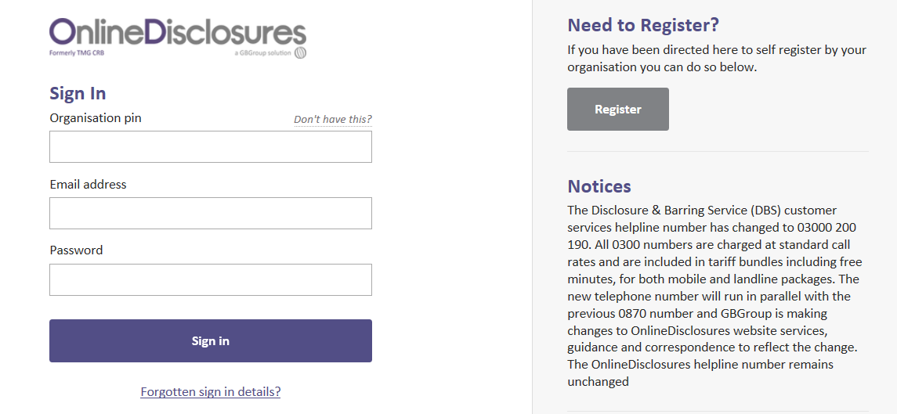
Option 1 - Stage Two
In order to progress with your application, you must have your identity documents validated at a Crown Post Office.
To find a Crown Post Office near you please go to:
https://gbg.onlinedisclosures.co.uk/
and click on Post Office Locations on the right-hand side.
The website address for the full list of acceptable documents is:
https://www.gov.uk/government/publications/dbs-identity-checking-guidelines/id-checking-guidelines-for-dbs-check-applications-from-3-september-2018#three-routes-of-id-checking
The Post office will continue to process your application.
Option 1 – Stage Three

The Post Office will verify your documents and inform GBG OnlineDisclosures to submit your DBS.
Option 1 - Stage Four
Your application can take 1 – 8 weeks to process (in the majority of cases) and you will receive a copy of the disclosure at the same time as the University of Northampton receives notification of the outcome. As we are notified online of the outcome only with no detail, if you receive a disclosure with anything disclosed ie caution/conviction etc, please send a copy to Admissions immediately (by post or email). Please use admissionsconfidential@northampton.ac.uk for this.
End of process for Option 1.
Option 2 - (Admissions route):
Option 2 - Stage One
The DBS application form must be completed online at https://gbg.onlinedisclosures.co.uk/ It is important to complete it immediately and forward any further supporting documentation to Admissions if required.
You will need the login details below to complete the online form.
Click on Register (on right hand side of screen):

Then enter:
- Org Pin (see Page 1)
- Your full name
- Email address
- Confirm email address

You will then be asked to enter the Secret Word – (see Page 1 – please do not use capital letters and ensure you use the correct codes). Tick to confirm the right Organisation name and then create your own password then click on Complete Registration
Option 2 - Stage Two
In order to progress with your application you must have your identity documents validated by an authorised Verifier from the University.

Please note that the GBG OnlineDisclosures website will indicate a verification meeting, you do not need to attend one of these.

All applicants (taking Option 2), where possible, to provide documents meeting the Route 1 criteria below. Where applicants cannot meet Route 1 criteria, Route 2 should be followed. If Route 2 criteria cannot be met Route 3 should be followed. Finger prints will be required for applicants unable to satisfy any of the 3 routes below:

Route | ID requirements | Additional requirements
Route 1 | 1 Group 1 document  plus  2 further documents from Group 1 or 2a or 2b | 1. One document, less than 3 months old, must confirm current address  2. One document must confirm date of birth  3. ID must be provided to confirm name changes eg marriage certificate, decree nisi
Route 2 | 1 Group 2a document  plus  2 further documents from Group 2a or 2b
Route 3 | Birth Certificate (UK & CI)  plus  1 Group 2a document  plus  3 further Group 2a or 2b documents

The website address for the full list of acceptable documents is:
https://www.gov.uk/government/publications/dbs-identity-checking-guidelines/id-checking-guidelines-for-dbs-check-applications-from-3-september-2018#three-routes-of-id-checking
We require 3 acceptable documents in total. At least one form of ID must confirm your current address and one must confirm your date of birth.
Please note that if you attended University for interview and provided document(s), you do not need to send this/these in again. If you are unsure as to what you provided please telephone Admissions to check. If you have changed your name, you must also provide proof of this via a marriage certificate/deed poll document etc. The original document must be provided.
Original Documents (photocopies and self-printed documents are not acceptable) should be sent to: Admissions, University of Northampton, Newton Building, St George’s Avenue, Northampton, NN2 6JB. Please include details of your name, course and date of birth.
If submitting by post, please enclose a stamped addressed envelope suitable for returning your original documents. Registered or Recorded post is advisable.
Alternatively, if you wish to bring your documents in to Admissions, they can be photocopied while you wait. Admissions are based at Waterside Campus on Wednesdays, between 10 – 4.30 pm, at the Student Information Desk, Learning Hub, University of Northampton, University Drive, NN1 5PH.
Failure to provide these documents will result in you not being able to take up your placement on the course, which may jeopardise your qualification.
Please send an email to Admissions to confirm you have completed your GBG online application (see Table 1 at the end of this document).
Option 2 - Stage Three

Once all 3 documents are received, Admissions will verify these and submit your form to DBS via GBG OnlineDisclosures. Your documents will then be returned to you (if you send them by post).
Option 2 - Stage Four
Your application can take 1 – 8 weeks to process (in the majority of cases) and you will receive a copy of the disclosure at the same time as the University of Northampton receives notification of the outcome. As we are notified online of the outcome only with no detail, if you receive a disclosure with anything disclosed ie caution/conviction etc, please send a copy to Admissions immediately (by post or email). Please use admissionsconfidential@northampton.ac.uk for this.
Useful Information for all applicants:
Any queries?
If you have any queries regarding the online application, please contact GBG OnlineDisclosures first, by telephone on 0845 251 5000 or by email at onlinedisclosures@gbgplc.com or see their Applicant User Guide online.
Alternatively, please telephone Admissions on 0300 303 2772.

Hints and Tips when completing your DBS form
- When completing your details online at GBG OnlineDisclosures, please ensure you insert all your names, as middle names are often missed out.
- Option 2 only - Please ensure you submit further ORIGINAL documents (not copies) if necessary, to the Admissions Office, once you have completed your online application.

Passport – please ensure this is a valid passport which is in date. If you provided an out of date passport at interview, we will accept a scan and email of your new passport to admissions2019@northampton.ac.uk, please call it ‘DBS Documents’.

DBS Update Service

The update service lets employers check the status of an existing DBS certificate, if it is for the same workforce where the same type and level of criminal record check is required and we have your permission.

If you have an Enhanced DBS Certificate and have subscribed to the DBS Update Service, please contact Admissions on 0300 303 2772 to discuss this or email us with full details at admissions2019@northampton.ac.uk

In the event that we are able to use the Update Service on your behalf, we will need to see your original DBS Certificate and one form of ID first. For further details, please see: https://www.gov.uk/dbs-update-service
Table 1 – relevant for Option 2 only
You have already provided 1 valid ID document:
Send 2 more documents
Complete DBS online (GBG website)
Send email (see Important Action below)

OR you have already provided 2 valid ID documents:
Send 1 more document
Complete DBS online (GBG website)
Send email (see Important Action below)

OR you have already provided 3 valid ID documents:
Complete DBS online (GBG website)
Send no further documents
Send an email (see below)

IMPORTANT ACTION
Once you have completed your DBS application online send an email to admissions2019@northampton.ac.uk to confirm this. Call your email “DBS application submitted” and include your full name, course & date of birth in the email.

For Acceptable ID Documents see:
https://www.gov.uk/government/publications/dbs-identity-checking-guidelines/id-checking-guidelines-for-dbs-check-applications-from-3-september-2018#three-routes-of-id-checking

