Disclosure and Barring Service (DBS) Check

Please read all the notes carefully before proceeding

All students on the courses below, must complete an enhanced DBS check.
DBS Fee payable for the following courses
Course | Secret Word | Org PIN
Childhood & Youth (BA) | soeducation | 105821
Early Childhood Studies (BA) | soeducation | 105821
PGCE | soeducation | 105821
Primary Education QTS (BA) | soeducation | 105821
School Direct Student | soeducation | 105821
Special Educational Needs & Inclusion (BA) | soeducation | 105821

No DBS Fee payable for the following courses
Course | Secret word | Org PIN
Child & Adolescent Mental Health (MSc) | ssciences | 105822
Counselling (MSc) | ssciences | 105822
Counselling Children & Young People (MSc) | ssciences | 105822
Dental Nursing (FdSc) | health | 105823
Health & Social Care (FdSc) | health | 105823
Midwifery (BSc) | health | 105823
Nursing (BSc) | health | 105823
Occupational Therapy (BSc) | health | 105823
Podiatry (BSc) | health | 105823
Paramedic Science (FdSc and BSc) | health | 105823
Return to Practice | health | 105823
Social Care & Community Practice (BA) | health | 105823
Social Work (BA & MA) | health | 105823
Sports Development (BA) | health | 105823

There are 4 stages to the completion of an enhanced DBS check:
1 | Complete online form at GBG OnlineDisclosures
2A | Provide documentation to the Admissions Office at the University
2B | If required, pay online on the University website, (see above list) or send email to Admissions (see Important Action in Table 1)

You must complete all of 1, 2A and 2B before Admissions proceed.
3 | Admissions will verify your documents and submit application to the DBS. (You are not required to attend a Verification Meeting)
4 | Receipt of disclosure information (to both student in paper form and Admissions online)
Stage One
The DBS application form must be completed online at https://gbg.onlinedisclosures.co.uk/ It is important to complete it immediately and forward any further supporting documentation to Admissions if required.
You will need the login details below to complete the online form.
Click on Register (on right hand side of screen):

Then enter:
- Org Pin (see table above)
- Your full name
- Email address
- Confirm email address

You will then be asked to enter the Secret Word – (see table on Page 1 – please do not use capital letters)

Tick to confirm the right Organisation name and then create your own password then click on Complete Registration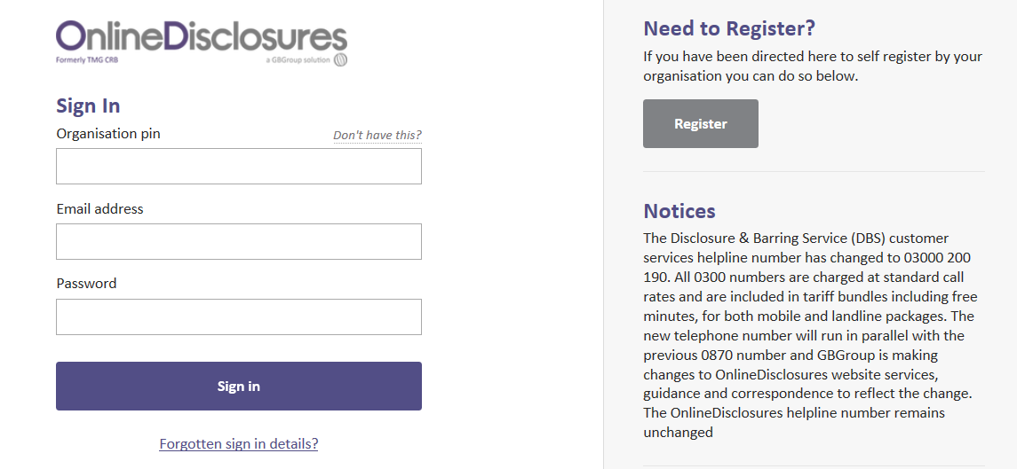
Stage Two – Send documentation (and payment where necessary)
In order to progress with your application you must have your identity documents validated by an authorised Verifier from the University.

Please note that the GBG OnlineDisclosures website will indicate a verification meeting, you do not need to attend one of these, if you provided your identification document(s) at interview.

All applicants, where possible, to provide documents meeting the Route 1 criteria below. Where applicants cannot meet Route 1 criteria, Route 2 should be followed. If Route 2 criteria cannot be met Route 3 should be followed. Finger prints will be required for applicants unable to satisfy any of the 3 routes below:

Route | ID requirements | Additional requirements
Route 1 | 1 Group 1 document  plus  2 further documents from Group 1 or 2a or 2b | 1. One document, less than 3 months old, must confirm current address  2. One document must confirm date of birth  3. ID must be provided to confirm name changes eg marriage certificate, decree nisi
Route 2 | 1 Group 2a document  plus  2 further documents from Group 2a or 2b
Route 3 | Birth Certificate (UK & CI)  plus  1 Group 2a document  plus  3 further Group 2a or 2b documents

The full list of acceptable documents and their groups is provided at the end of this document (see Table 2).

We require 3 acceptable documents in total. At least one form of ID must confirm your current address and one must confirm your date of birth.
Please note that if you attended University for interview and provided document(s), you do not need to send this/these in again. If you are unsure as to what you provided please telephone Admissions to check. If you have changed your name, you must also provide proof of this via a marriage certificate/deed poll document etc. The original document must be provided.
Original Documents (photocopies and self-printed documents are not acceptable) should be sent to: Admissions, University of Northampton, Newton Building, St George’s Avenue, Northampton, NN2 6JB. Please include details of your name, course and date of birth.
If submitting by post, please enclose a stamped addressed envelope suitable for returning your original documents. Registered or Recorded post is advisable.
Alternatively, if you wish to bring your documents in to Admissions, they can be photocopied while you wait. Admissions Reception is open between 9 – 1.30 pm (Mon – Fri). Please bring them to Admissions, University of Northampton, Newton Building, St George’s Avenue, Northampton, NN2 6JB.
Failure to provide these documents will result in you not being able to take up your placement on the course, which may jeopardise your qualification.
Payment details
If your course requires you to pay a fee for your DBS check (see page 1), please pay online as follows:
Go to http://shop.northampton.ac.uk/ >Student & Academic Services >Student Administration >Disclosure and Barring online application payment and follow the instructions.
Admissions will automatically be notified by email once your online payment is complete. We will forward the money to the DBS on your behalf.
If your course does not require you to pay a fee, please send an email to Admissions to confirm you have completed your GBG online application (see Table 1).
Stage Three

Once all 3 documents are received, Admissions will verify these and submit your form to DBS via GBG OnlineDisclosures. Your documents will then be returned to you (if you send them by post).
Stage Four
Your application can take 1 – 8 weeks to process (in the majority of cases) and you will receive a copy of the disclosure at the same time as the University of Northampton receives notification of the outcome. As we are notified online, if you receive a disclosure with anything disclosed ie caution/conviction etc, please send a copy to Admissions immediately (by post or email). Please use admissionsconfidential@northampton.ac.uk for this.
Any queries?
If you have any queries regarding the online application, please contact GBG OnlineDisclosures first, by telephone on 0845 251 5000 or by email at onlinedisclosures@gbgplc.com or see their Applicant User Guide online.
Alternatively, please telephone Admissions on 0300 303 2772.

Hints and Tips when completing your DBS form
- When completing your details online at GBG OnlineDisclosures, please ensure you insert all your names, as middle names are often missed out.
- Please ensure you submit further ORIGINAL documents (not copies) if necessary, to the Admissions Office, once you have completed your online application. (See Stage 2 and Table 2 below).
- Please ensure you submit your payment online too, if this is required for your course (See list on Page 1).

Passport – please ensure this is a valid passport which is in date. If you provided an out of date passport at interview, we will accept a scan and email of your new passport to admissions2019@northampton.ac.uk, please call it ‘DBS Documents’.

DBS Update Service

The update service lets employers check the status of an existing DBS certificate, if it is for the same workforce where the same type and level of criminal record check is required and we have your permission.

If you have an Enhanced DBS Certificate and have subscribed to the DBS Update Service, please contact Admissions on 0300 303 2772 to discuss this or email us with full details at admissions2019@northampton.ac.uk

In the event that we are able to use the Update Service on your behalf, we will need to see your original DBS Certificate and one form of ID first. For further details, please see: https://www.gov.uk/dbs-update-service

Table 1
For courses with a DBS fee | For courses without a DBS fee
You have already provided 1 valid ID document:  Send 2 more documents  Complete DBS online (GBG website)  Pay online (university website) | You have already provided 1 valid ID document:  Send 2 more documents  Complete DBS online (GBG website)  Send email (see Important Action below)
OR you have already provided 2 valid ID documents:  Send 1 more document  Complete DBS online (GBG website)  Pay online (university website) | OR you have already provided 2 valid ID documents:  Send 1 more document  Complete DBS online (GBG website)  Send email (see Important Action below)
OR you have already provided 3 valid ID documents:  Complete DBS online (GBG website)  Pay online (university website) | OR you have already provided 3 valid ID documents:  Complete DBS online (GBG website)  Send no documents or payment  Send an email (see below)  IMPORTANT ACTION  Once you have completed your DBS application online send an email to admissions2019@northampton.ac.uk to confirm this. Call your email “DBS application submitted” and include your full name, course & date of birth in the email.

Table 2 - Acceptable Documents
Group 1 Documents (Primary identity documents)
Any current and valid Passport | Biometric Residence Permit (UK)
Full or provisional Driving Licence (UK, Channel Islands, Isle of Man & EEA), photo card | Adoption Certificate  (UK and Channel Islands)
Birth Certificate (UK, Channel Islands, Isle of Man) issued within 12 months of date of birth (including those issued by UK authorities overseas, such as Embassies, High Commissions and HM Forces)

Group 2a Documents (Trusted government documents)
Valid Full or provisional Driving Licence photo card (All countries outside the EEA (Excluding Isle of Man & Channel Islands) | Marriage/Civil Partnership Certificate (UK & Channel Islands)
Valid Full or provisional Driving Licence (paper version if issued before 1998) (UK, Isle of Man, Channel Islands & EEA | HM Forces ID Card (UK)
Birth Certificate (UK, Isle of Man & Channel Islands) issued after time of birth | Fire Arms Licence (UK, Isle of Man & Channel Islands)

Group 2b Documents (Financial and social history documents)
Less than 3 months old | Less than 12 months old | Must still be valid
Bank/Building Society Statement (UK, Channel Islands or EEA) or account opening confirmation letter (UK) | Mortgage Statement (UK or EEA) | Valid EEA National ID Card  Letter of sponsorship from future employer (non UK & non EEA) residing outside UK  PASS card  Letter from Head Teacher
Utility Bill (UK), electricity, gas, water, telephone.  (mobile phone bill not acceptable) | P45/60 Statement  (UK & Channel Islands)
Credit Card Statement (UK or EEA) | Financial Statement (UK), e.g. pension, endowment (UK)
Benefit Statement e.g. child benefit,  Pension (UK) | Council Tax Statement  (UK & Channel Islands)
Document from Central/Local Government/Government Agency/Local Council giving entitlement (UK and Channel Islands) eg from Dept for Work and Pensions, Employment Service, HMRC.

