corporate_logo_mono

Thank you for accepting a place on a pre-registration healthcare course at The University of Northampton.

Following the publication of the Clothier Report recommendations, all applicants for pre-registration healthcare courses need to undertake occupational health screening. **You therefore need to do the following now:-**

As Northampton General Hospital is your Trust Host Site (which was confirmed in your offer) you will need to complete an online health questionnaire accessible by following the instructions below.

On submission of your questionnaire, Northampton General Hospital will contact you for an appointment. You do not need to call and book and appointment.

**Accessing the Occupational Health Portal**

The link below will take you to the front page of the Occupational Health Portal.

<https://northampton.warwickicsystems.com/GenohsisPortal>

From here if you have not already set up an account, please click the

**Sign up now** button.

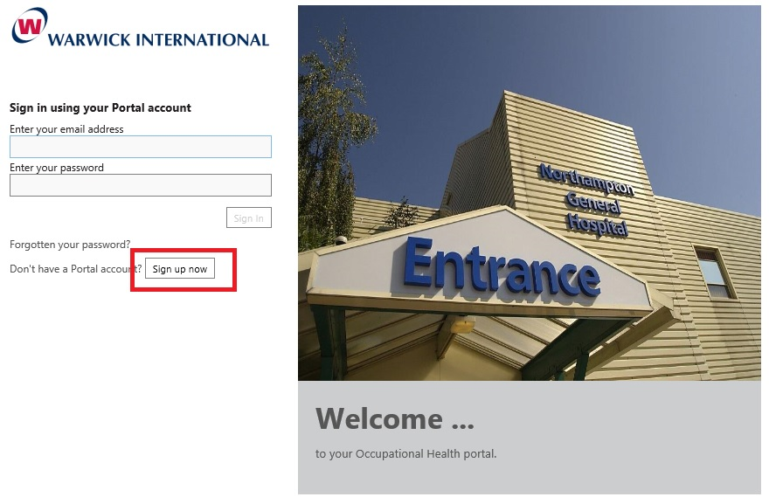

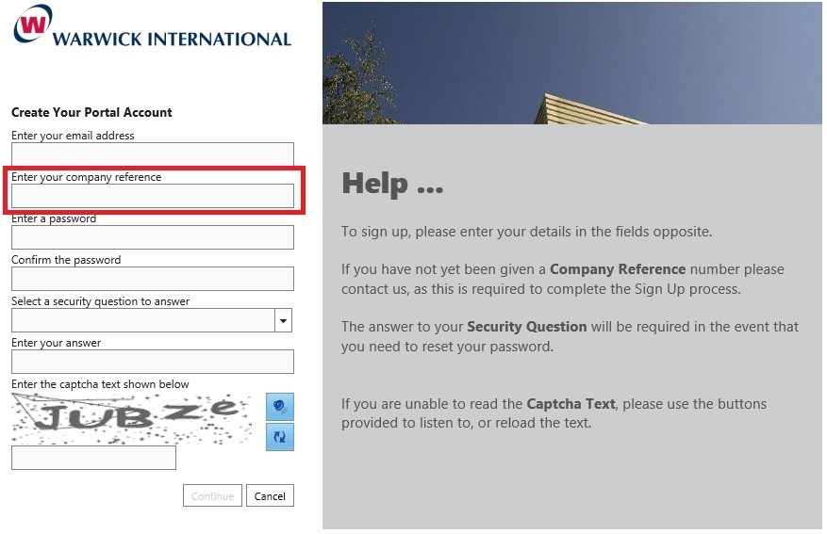

You will need a **valid email address**, that you have access to, in order to create a new account.

For the Company Reference please copy and paste the following code:

**U51624C1**

**Your Password will need to be at least 6 characters long including one upper case letter and one special character (!£$%&@\* etc.).**

Once you have completed the details click **continue,** you will now be sent a verification email.

A link in the email will return you to the Portal Login page where you will need to enter your newly created Password.

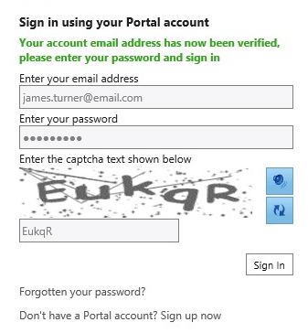

You will be directed to complete your personal details, please complete as many fields as you are able and then click **Next**.

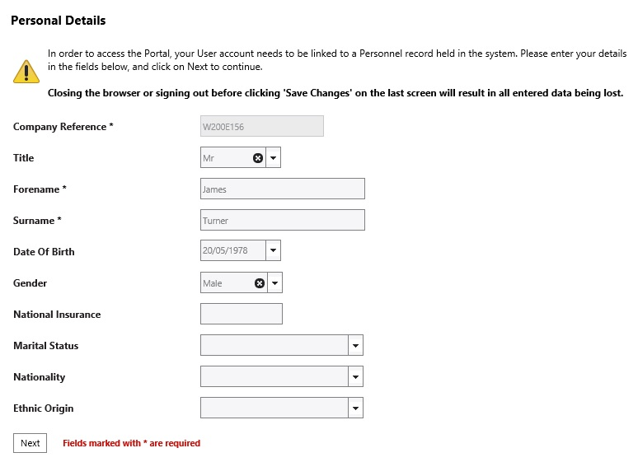

Complete your address details and then click **Next**.

On the next page just click **Next**, there is no need to complete any details here.

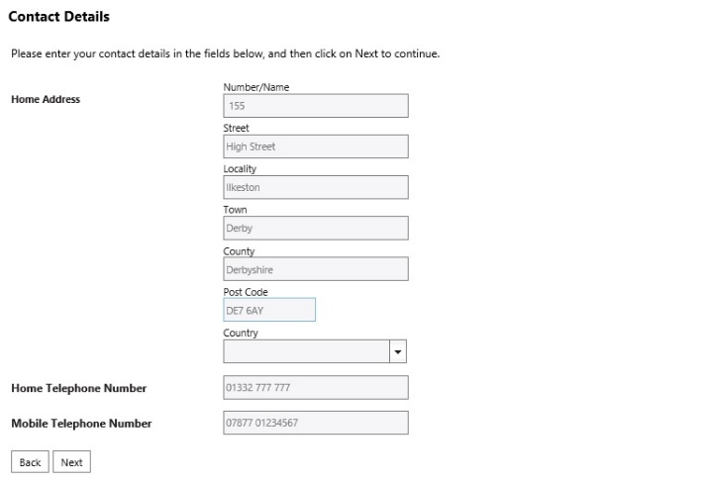

You **MAY** be asked to complete your employment details. If so just enter today’s date as the Start Date.

Then click **Save Changes**

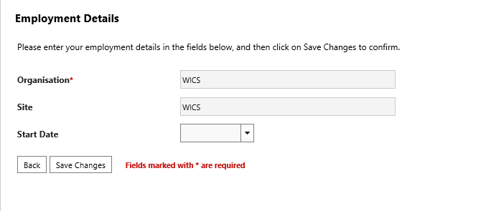

Once you have access to the Portal click on the **Create New** **Online Form** on the left hand side and it should automatically take you to the form required.

However, if it doesn’t or if you have used the portal in a previous job role you will need to select **My Forms** from the drop down list on the left hand side.

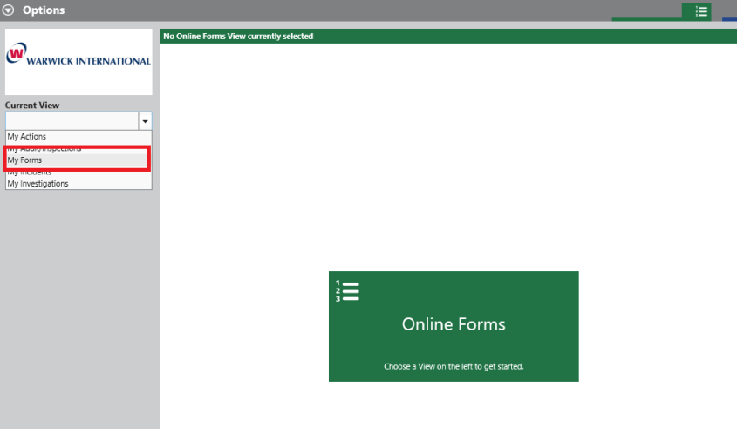

Use the **Create New** **Online Form** option on the left to start a new questionnaire. The questionnaire is called **University of Northampton Health Questionnaire**

**Help Text** – you can open and close the help text by clicking on the word ‘**Help**’ in the top right hand corner of the screen.

Once you have completed the questionnaire, select **Save Form**.

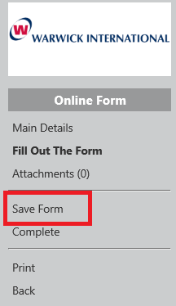

You will be prompted to set the form as Completed.

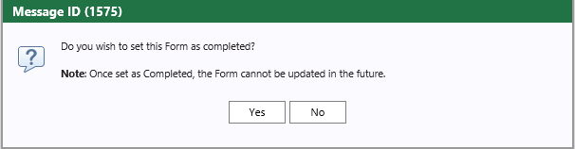

If you select **Yes** the questionnaire will be passed immediately to Occupational Health and you will no longer be able to make any changes.

If you select No the questionnaire will be saved and you will be able to come back to it at a later time and make amendments.  
Please note that Occupational health cannot proceed until you have marked your questionnaire as complete.

If you have any difficulties with the form please email Claire Brown, the Occupational Health Manager as follows: [Claire.brown@ngh.nhs.uk](mailto:Claire.brown@ngh.nhs.uk)

Occupational Health Department

Northampton General Hospital NHS Trust

Billing House

Cliftonville

Northampton

NN1 5BD