YOUR INTERVIEW DETAILS
BA (Hons) Illustration
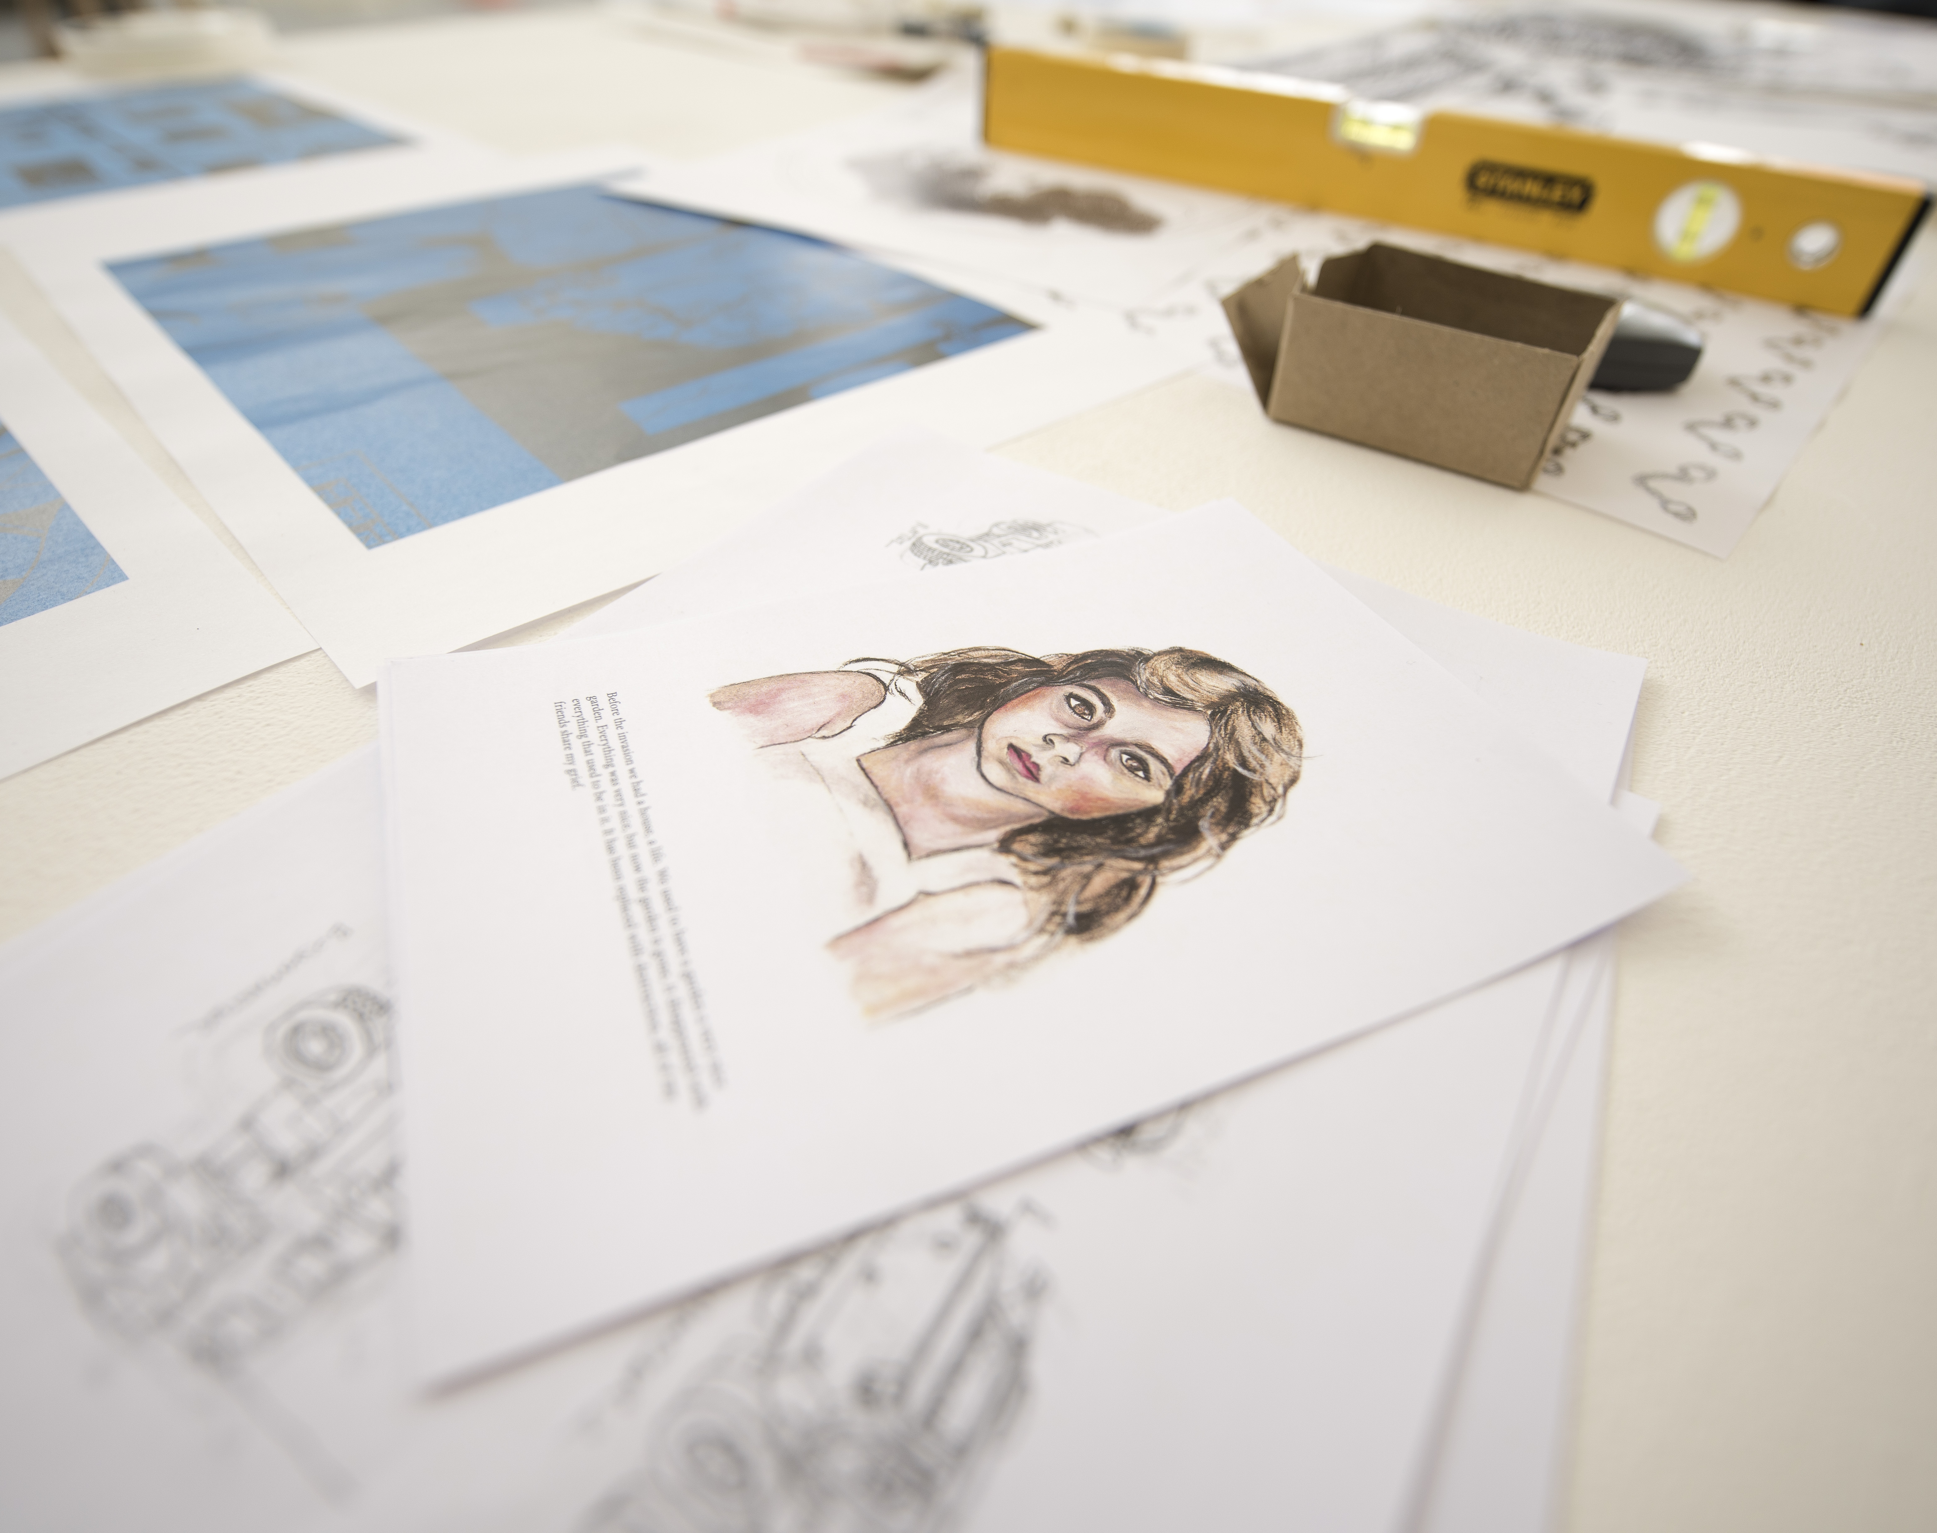
Congratulations, you have successfully been selected for an interview at the University of Northampton. We would like to wish you the best of luck.
The interview process will be kept as informal as possible and is aimed at helping us to get to know you and help you decide whether this is the right course for you.

Arrival
On arrival please register for your interview at 9:00am in Maidwell Reception at Avenue Campus.
Car Parking
Directions to Avenue Campus and a campus map can be found on our website at the following link
Please note that the car park is free to visitors during the day, however, it can be quite busy, so please allow enough time to find a space.
In order to gain access to the student car park you will need the barrier code: *2591#
The barrier code should be entered on the keypad on the access barrier at the entrance to the car park
- The * 'star' and # 'hash' must be included as part of the barrier code.
- An intercom to the Security Lodge is located on each barrier if difficulties arise.
Structure of the day
The interview day is an opportunity for you to discover more about your chosen course and the University of Northampton. The following will be available to you during your visit.
Campus Tours
Starting from the registration point in the Maidwell Reception, Student Ambassadors will provide a comprehensive tour of the University. Tours will take place on the hour and at half past the hour between 10am and 4pm. The last tour will depart at 4pm.

Waterside
Students joining us in September 2017 for a three-year study programme will spend their first year of study at the existing campuses, with the following years of study at the new Waterside Campus. Members of our Welcome Team will be able to introduce the new campus facilities and answer any questions about it from 9am till 4:30pm in Maidwell Reception.
Accommodation
The University of Northampton’s Halls of Residence are a popular accommodation choice for our first year students due to their convenient location on campus. There will a show flat available for demonstration tour throughout the day between 10am and 4:30pm.
Student Services
The University of Northampton offers all students extensive support throughout their studies. The Student Help Desk is a one stop shop for all student issues and queries, including accommodation and residential life, additional needs and disability support, counselling and mental health, financial guidance etc. Based in Basset Lowke, it will be available throughout the day from 10am till 4:30pm.
Student Life
Studying at a university and living away from home is a very different and unique experience. With this in mind we have organised for one of our current students to present their university life experience and what it is like from a student’s perspective.
Students’ Union
All students automatically become members of the Students’ Union as soon as they enrol and it’s absolutely free. On your interview day you will have an opportunity to drop in there from 10am till 4:30pm to find out about its services and opportunities, including sports, societies, volunteering, advice and representation.
Changemaker Hub
The Changemaker Hub aims to support our students in every aspect of developing their employability whilst here at the University. You will be able to hear more about their activities between 10am till 4:30pm.
Parents and Guardians
The interview day is designed with you, the applicant in mind, however parents and guardians are very welcome to come along and can take part in campus tours and drop-in sessions or wait in a specifically designated waiting area. Alternatively our Welcome Team will be happy to provide information on visiting the Town Centre.
Food and beverages are available for purchase on site.
Preparing for your interview
Please read carefully the following information and instructions, which are intended to help you with your interview.
We would like you to bring a portfolio of creative work including: examples of sketchbooks, visuals and drawings, creative ideas and concepts as well as more finished outcomes. Your aim is to show the breadth and quality of your experiences working with drawing and illustration to date.
Try not to over edit – we like to see work that shows potential for development.
Any bulky 3D pieces can be photographed, and digital work can be viewed on screen. Don’t attempt to bring every piece of work you have ever produced, try and show around 15-20 key pieces of work.
Interview process
We know that an interview can be a daunting experience. We make allowances for nerves and we endeavor to make the process as enjoyable as possible.
The interview will give you an opportunity to explore the potentials of the course. It will also give us the chance to know you better and provide you with early guidance in how to successfully start the course.
The interview will be relatively informal and will include a BA (Hons) Illustration programme overview, a tour of the resource area with an opportunity to meet students from the course who will talk about their project work, as well as an interview with the members of our academic staff team.
During your interview you will be asked to talk us through your portfolio, discuss your creative work and answer any questions about it. Do not worry about preparing a presentation for your interview. Instead, your portfolio will provide a starting point for an informal conversation about you and what motivates you as a creative practitioner, so come ready to talk about your interests and your work.
Request for reasonable adjustment
It is the policy of the University of Northampton that candidates should not be prejudiced as a result of any disability and reasonable adjustments will be made to mitigate unfair discrimination.
Therefore all candidates with disabilities are encouraged to identify and/or request support for actual or potential circumstances in advance.
Please contact admissions2017@northampton.ac.uk. Please note you will be required to provide suitable medical evidence that confirms the nature of your condition and the need for adjustment.
Summary: preparation checklist
- Car parking permit ☐
- Portfolio of your work ☐
- Request for reasonable adjustment ☐

