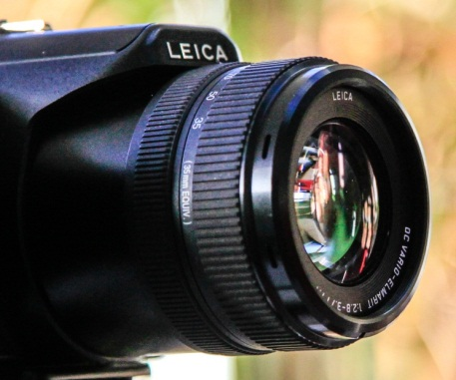
Images of Research 2014-15 competition results

The Images of Research competition offers researchers a chance to illustrate or represent their research with a unique image, along with an abstract of (up to) 150 words describing how the image reflects their research. As a guide, a winning image would be that which:

- Is visually appealing AND
- Has an accompanying abstract which is well written, clearly connects with the image and ensures viewers, who know nothing about the research topic, will understand and find interest in the research presented.

We held two competitions:
- Professional image maker and PhD student, John Sunderland, was invited to choose his top three.
- Visitors to the exhibition, and online poll on the Research Support Hub, voted for their favourite three images.
Images of Research 2014-15 competition results
INVITED JUDGE - John Sunderland
Professional image maker & researcher; PhD student

John was asked to choose his top 3 images.
1st | Determination!  Lauren Samet, Moulton College, Doctoral Student
2nd | Love in the face of dementia  Jane Youell, School of Health, Doctoral Student
3rd | A dog's life?  Professor Philip Garner, School of Education

John has written descriptively about why he chose these three images.
I was delighted to see this initiative to link the visual image with research, and honoured to be asked to judge the competition. As a professional image maker and researcher, I understand that they can and do function as ways of communicating knowledge and ideas in ways that words (spoken or written) do not.
An image of research can go beyond simply showing something. As well as producing evidence, images can evoke thoughts, memories and emotions in viewers that can help to elucidate subtle nuances in research that are otherwise hard to get across.
In judging this competition I began with the prints alone, without any text, to get a sense of what the images themselves were communicating. Throughout I have not known whose work I was looking at or the school that they were in. After a period of gestation I revisited the works and read the texts. I sought continuity between the two and in some cases, although I found the images evocative, it was at odds with what the text expressed and therefore had to be ruled out. This repetition of viewing over time continued whittling down my selection.
In the end the final decisions were difficult, I think my decision was guided by three factors, continuity between text and image, passion and compassion for the research subjects. Above all it was the strength of communication visually as a whole that won through.

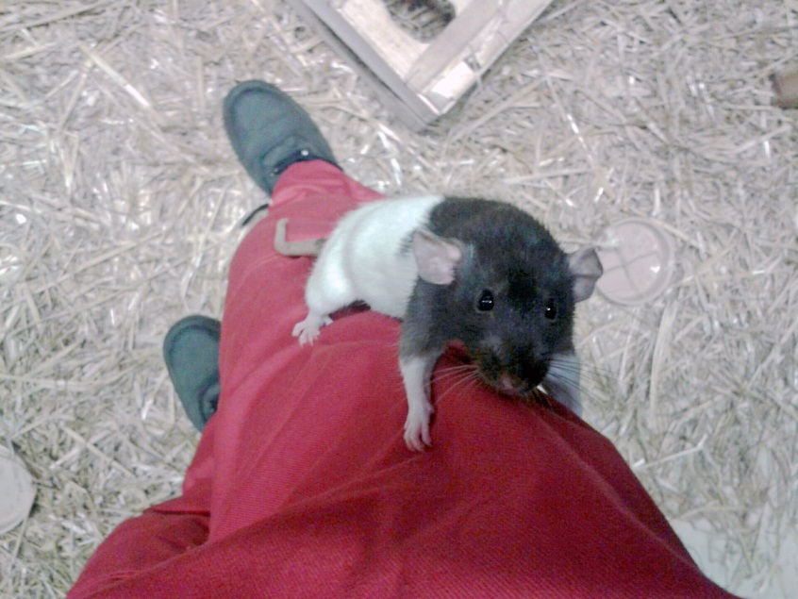
1st Prize: Lauren Samet
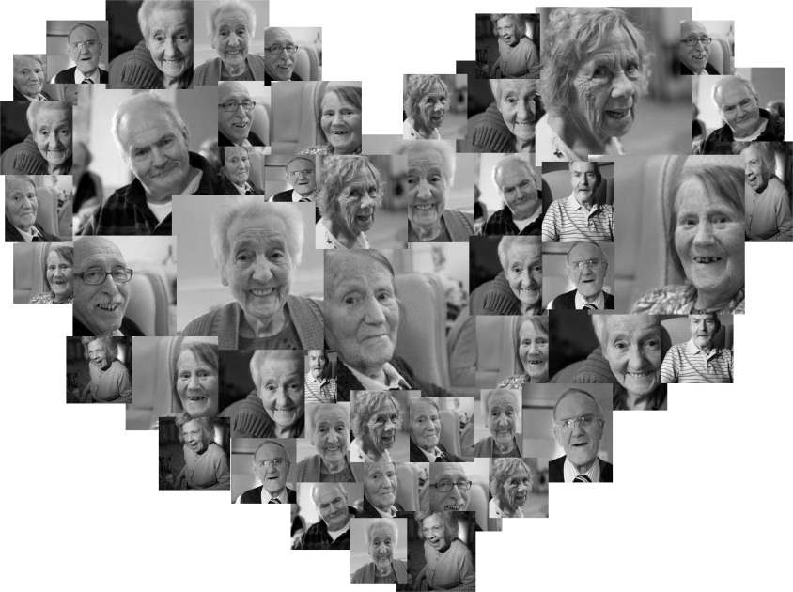
2nd Prize: Jane Youell
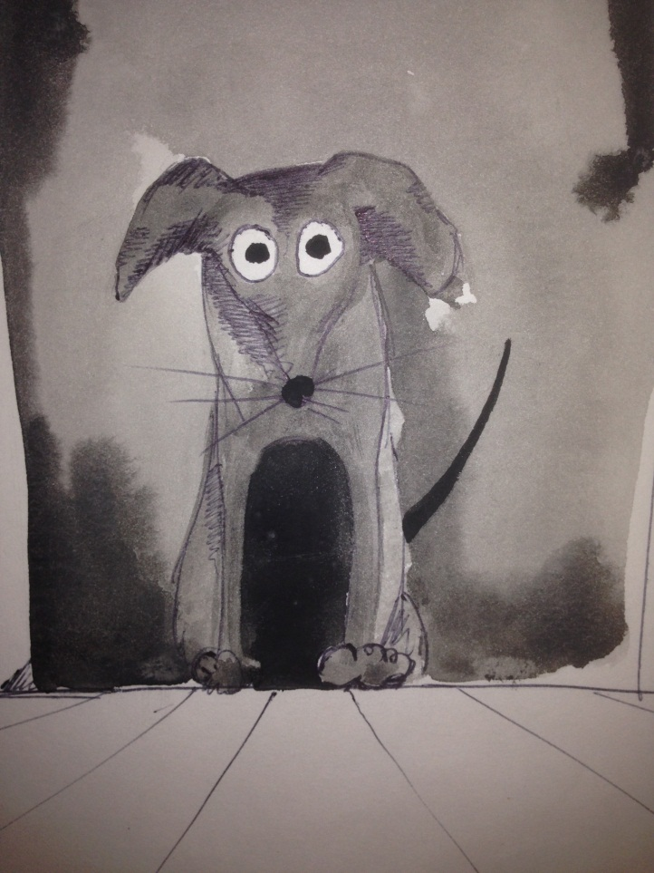
3rd Prize: Philip Garner

Images of Research 2014-15 competition results
The People’s Vote!
Over 930 votes online and in person at the exhibitions, which were held outside the Art Gallery, Park and Avenue Libraries from January to April 2015.

1st | Does the shoe have to fit..?  Saneeya Qureshi, School of Education  PhD alumni and Early career researcher | 168 votes
2nd | Love in the face of dementia  Jane Youell, School of Health, Doctoral student | 154  votes
3rd | I want to live until I die  Kim Stuart, School of Health, Doctoral student | 103 votes
Joint 3rd | Alternative femininities: Embodiment, constructions and representations of tattooed women  Charlotte Dann, School of Social Sciences, Doctoral student | 103 votes
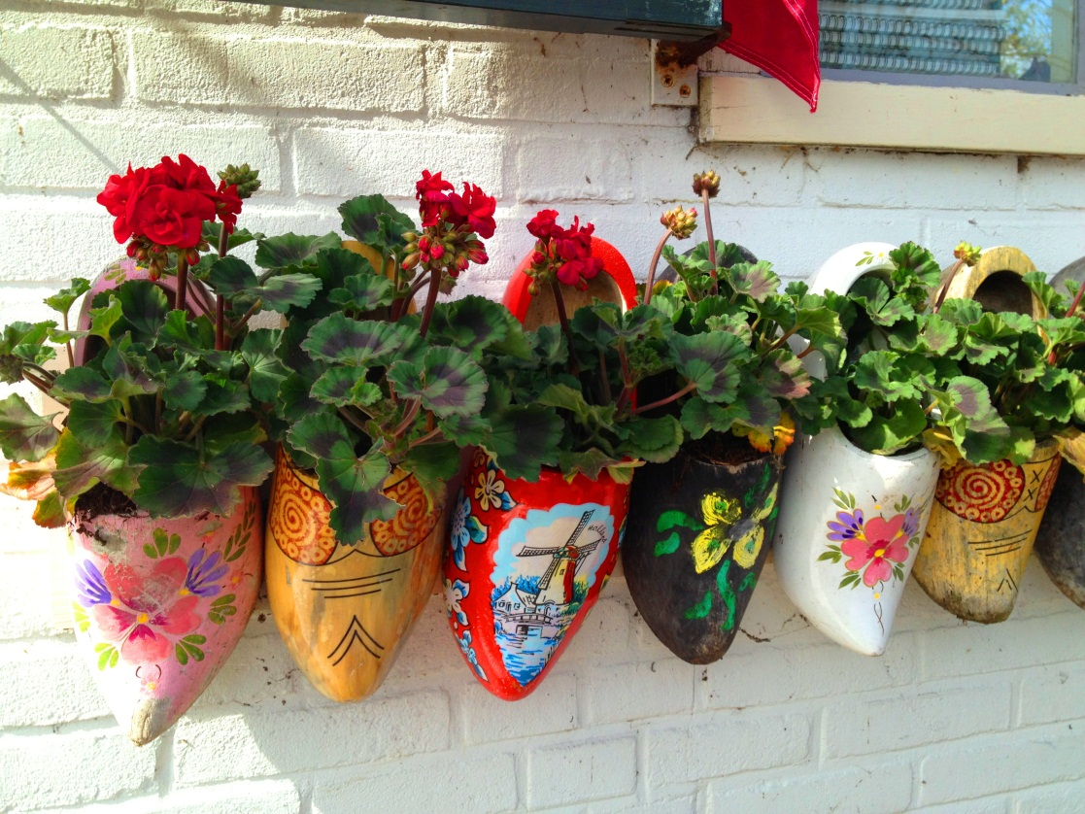
1st Prize: Saneeya Qureshi
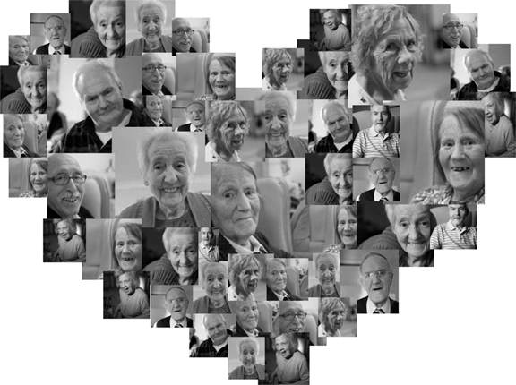
2nd Prize: Jane Youell
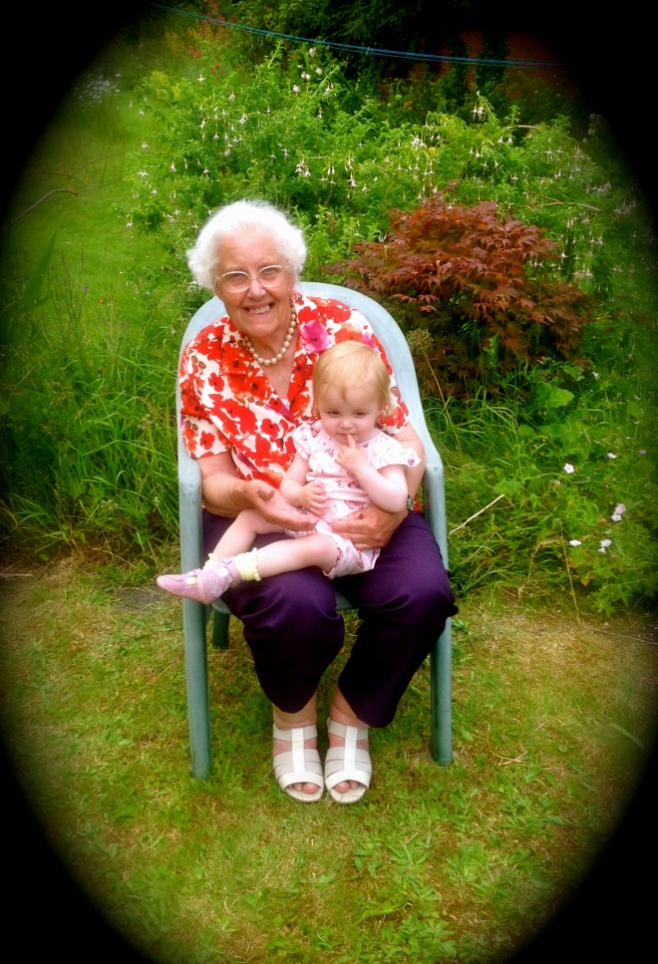
Joint 3rd: Kim Stuart
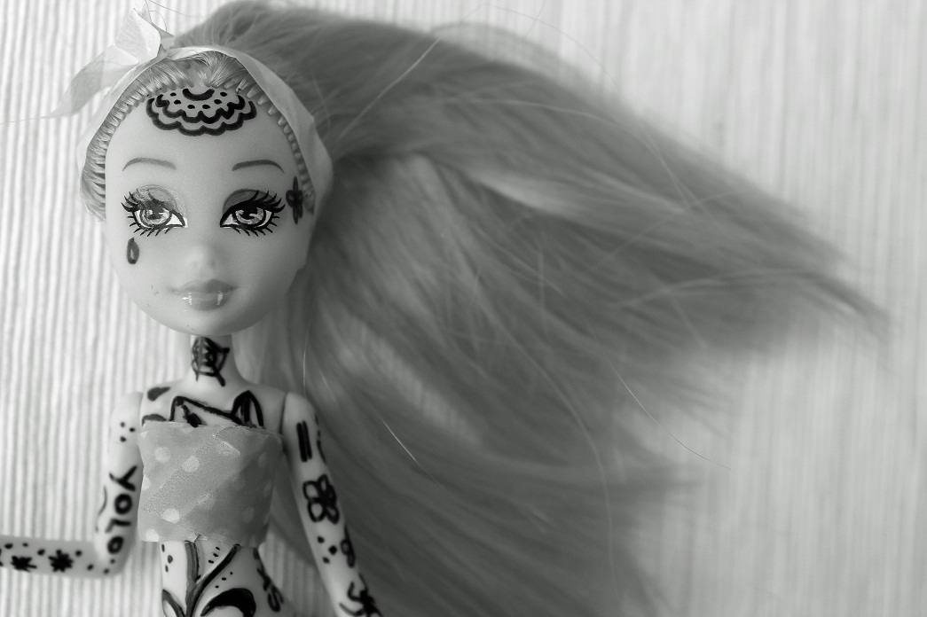
Joint 3rd: Charlotte Dann

