Halls of Residence Descriptions and Photographs

Bassett Lowke Hall
Bassett Lowke Halls is based at the University of Northampton's Avenue Campus. This hall has bedrooms with private washrooms and each flat usually has six single bedrooms with private washrooms and a communal kitchen. The flats are generally mixed sex. A small number of twin bedrooms with private washroom facilities are available.

The rooms have wifi and network access providing links to the university computer network.

Single with private washroom facilities

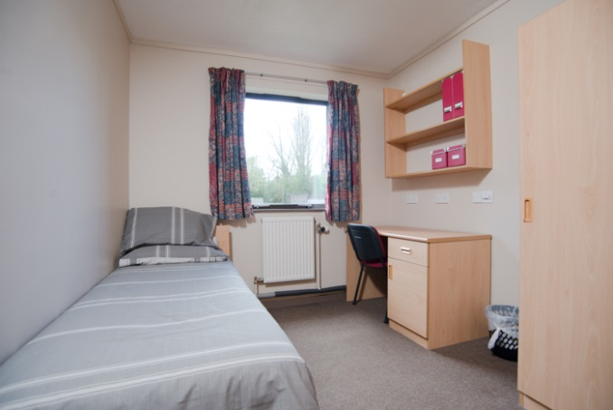

Shared kitchen

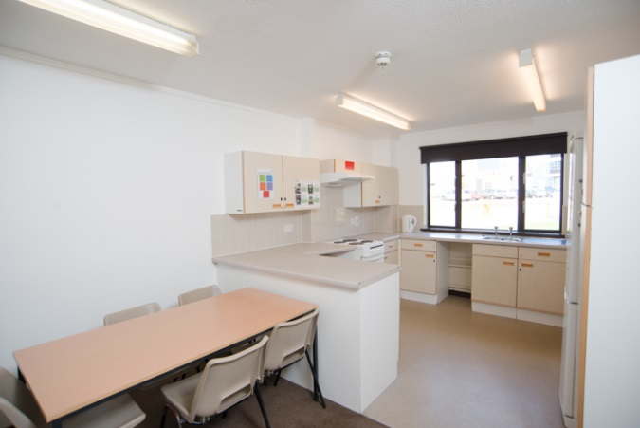

Charles Bradlaugh Hall
Charles Bradlaugh Hall comprises two traditional halls and seven small 'houses' located at the University of Northampton's Park Campus.
The traditional halls have 92 standard single bedrooms divided into single sex flats of five to ten bedrooms, the kitchen and bathroom facilities are shared. The halls are mixed sex. The single sex houses can accommodate ten residents in a variety of 'small, standard single' and 'small, standard twin' rooms. Kitchen and bathroom facilities are shared.
The rooms have wifi and network access providing links to the university's computer network.

Shared Kitchen Standard single
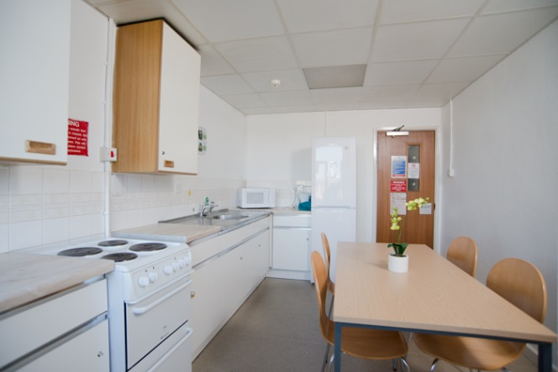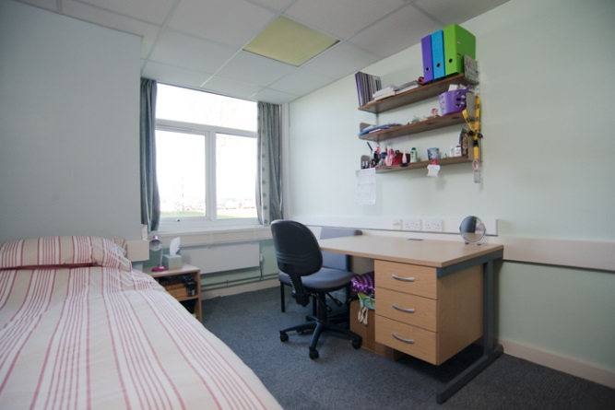

Small Standard Bedroom Single sex House - kitchen
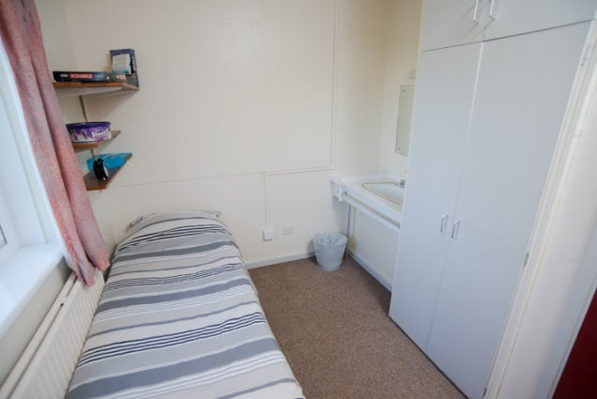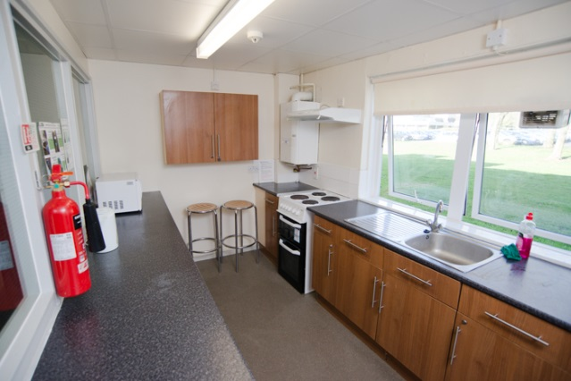

Small Standard Twin
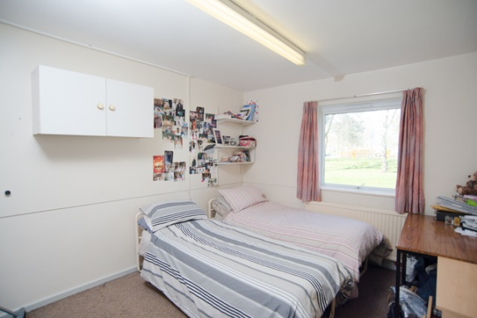

John Clare Hall
John Clare Hall comprises two traditional halls located at the University of Northampton's Park Campus. The halls are situated close to the library and social activities. John Clare Hall has 92 bedrooms (standard single) divided into flats of five to ten rooms. Each flat has a shared kitchen and bathroom. One hall is designated female only.
The rooms have wifi and network access providing links to the university's computer network.

Shared kitchen
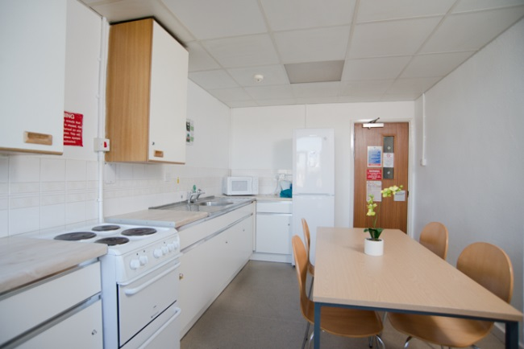

Standard single

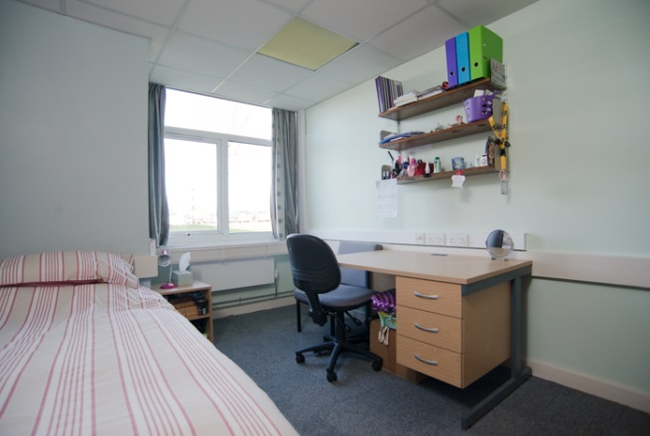

Margaret Bondfield Hall
Margaret Bondfield Hall at the University of Northampton is based at Park Campus. This hall offers standard single and standard twin accommodation. Flats accommodate five to eight residents. Kitchen and bathroom facilities are shared. The flats are generally mixed set, although there are a small number of single sex flats.
The rooms have wifi and network access providing links to the university's computer network.

Standard Single

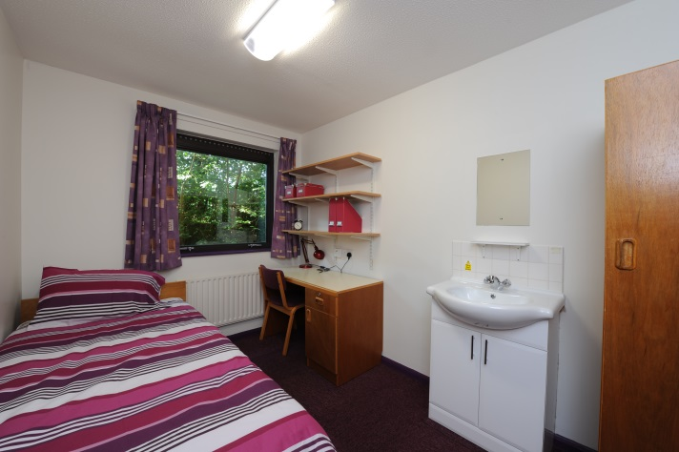

Standard Twin
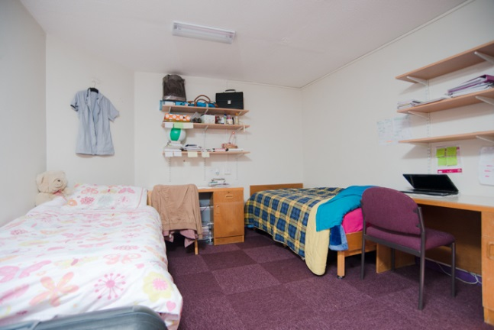

Shared Kitchen

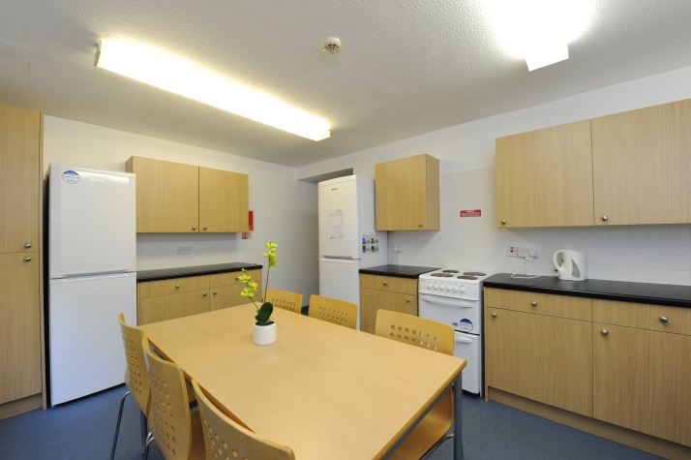

Simon Senlis Hall, Spencer Perceval Hall and William Carey Hall
These Halls are situated at the University of Northampton's Park Campus. Each hall offers 287 single en-suite bedrooms. Flats usually contain six rooms and a communal kitchen. The flats are generally mixed sex, although there are a small number of single sex flats. A small number of twin bedrooms with private washroom facilities are available in these halls.

The rooms have wifi and network access providing links to the university's computer network.

Single with private washroom facilities

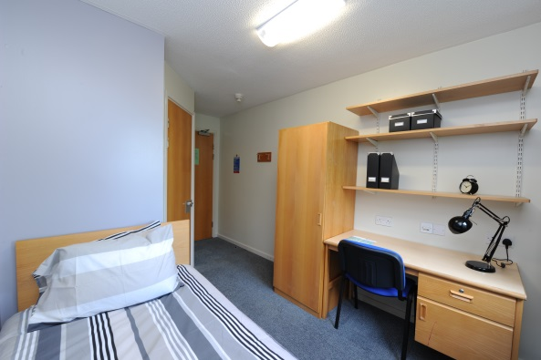

Self-contained Twin with private washroom facilities

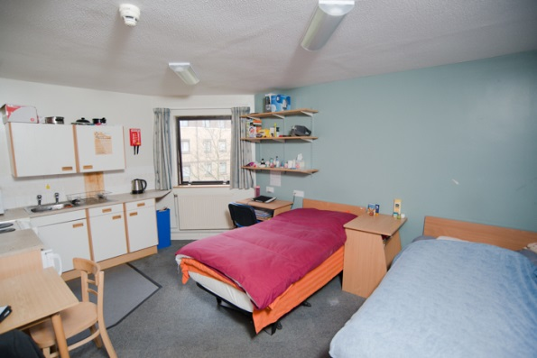

Shared Kitchen
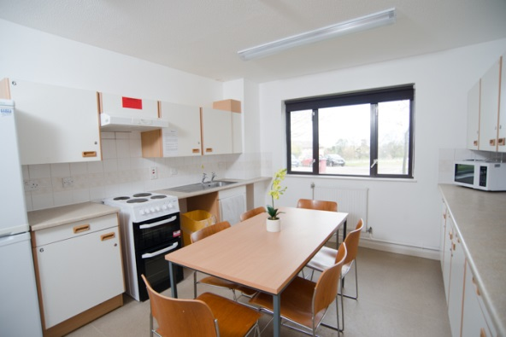
St John's Hall
St John's Hall is located in Northampton town centre and is a brand new hall of residence. Owned and managed by the University of Northampton, the hall contains 468 bed spaces, most of which have private washroom facilities. The flats vary in size ranging from 3 to 8 bedrooms per flat. There is a communal kitchen and living space in each flat. We also have a number of twin and single studios available. The flats are generally mixed sex. The rooms have network access providing links to the university's computer network. The beds in the single rooms are ¾ size, so double bed size bedding is required. The twin studios contain 2 single beds.
Twin Studio Twin Studio Kitchen area
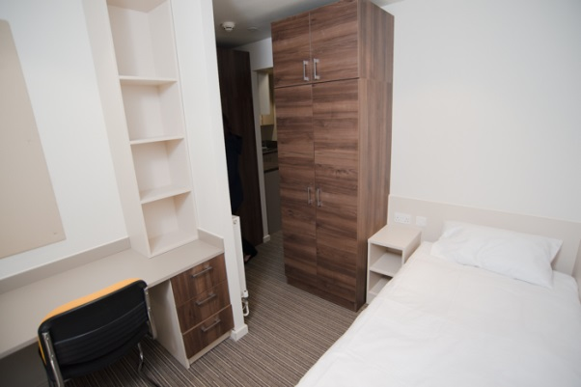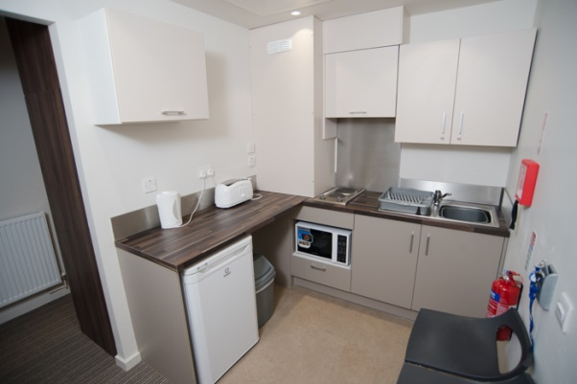
Single Studio
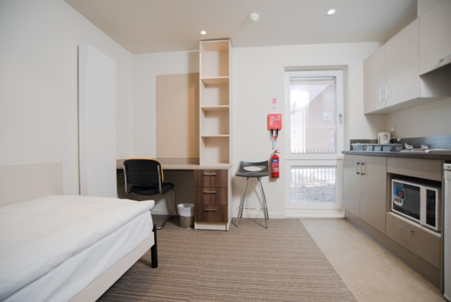
Single with private washroom facilities Shared Kitchen
