The University of Northampton

Carbon Management Plan (CMP)

Issue Date: 23 March, 2011

Version number: CMP2011 (version 1)

Owner: Paul R. Taylor, Sustainability Officer

Approval route: Programme Board – Vice Chancellor – Governing Council

Approval status: Approved by the Governing Council on 22 March, 2011
Contents
Foreword from the Vice Chancellor 3
Management Summary 4
1. Introduction 6
2. Carbon Management Strategy 7
2.1 Context and Drivers for Carbon Management 7
2.2 Our Low Carbon Vision 9
2.3 Strategic Themes 9
2.4 Targets and Objectives 10
2.5 Adaptation to Climate Change 10
3. Emissions baseline and projections 11
3.1 Scope 11
3.2 Scope 1 and 2 Baseline 11
3.3 Scope 1 and 2 Emissions since Baseline Year 13
3.4 Scope 3 Data Sources 14
3.5 Scope 3 Emissions 15
3.6 Future Scope 3 Emissions Reporting 15
3.7 Projections and Value At Stake 15
4. Carbon Management Projects 20
4.1 CMP2009 Projects Implemented (Table 11) 20
4.2 Existing Projects (Table 12) 21
4.3 Scope 1 and 2 Projects 2011-2015 (Table 13) 21
4.4 Scope 1 and 2 Projects 2016-2020 (Table 14) 22
4.5 Scope 3 Projects (Table 15) 23
5. Implementation Plan financing 23
5.1 Assumptions 23
5.2 Financial Costs Due to Existing and Planned Projects up to 2015 (Table 16) 23
5.3 Benefits / Savings Due to Existing and Planned Projects up to 2015 (Table 17) 24
5.4 Financial Costs Due to Planned Projects from 2016 to 2020 and Scope 3 Projects 24
6. Actions to Embed Carbon Management in the Organisation 25
6.1 Policy 25
6.2 Responsibility 25
6.3 Data Management 25
6.4 Communication and Training 26
6.5 Finance and Investment 26
6.6 Procurement 26
6.7 Monitoring & Evaluation 26
7. Management of the CMP 27
7.1 The Programme Board – Strategic Ownership and Oversight 27
7.2 The Carbon Management Team – Delivering the Projects 27
7.3 Succession Planning for Key Roles 28
7.4 Ongoing Stakeholder Management 29
7.5 Annual Progress Review 30
Appendix A: Carbon Management Matrix - Embedding 31
Appendix B: Definition of Projects 32

Foreword from the Vice Chancellor

This second revision of the University’s Carbon Management Plan commits us to a 43% reduction in our CO₂ emissions by 2020, compared to our 2005/6 baseline. This is a challenging target given that the University continues to grow in student numbers and building floor area, with the resultant increases in carbon emissions between 2009 and 2011. As a responsive institution we accept our responsibility to contribute to reducing the sector’s overall CO₂ emissions.

Our Carbon Management Plan has been developed in line with HEFCE’s carbon reduction target and strategy for higher education in England, which in turn is based on the UK government’s historic 2008 Climate Change Act. It provides an opportunity for us to take significant strides towards lessening the impact that the University’s activities have on the local and global environment, while lessening our reliance on fossil fuels and reducing the risk to the institution of volatile energy markets.

Our transition to a lower-carbon institution will impact on every member of the University community, but will also provide opportunities for us to benefit from the growing low-carbon economy through research, innovation and social enterprise. Embedding carbon management into the workings of the University is a strategic process and as such I am requesting the support of students, staff and our stakeholders alike in order to achieve our goal.

Achieving the targeted reduction in CO₂ emissions will be both a major challenge and a sensible precaution for the future financial and environmental sustainability of the University. By establishing carbon management as a core business process, we will become better able to identify opportunities for enterprise and adapt to an increasingly carbon-constrained economy.



Professor Nick Petford Mrs Deirdre Newham
Vice Chancellor Chair of Governors
The University of Northampton The University of Northampton

Management Summary

The University of Northampton acknowledges that climate change is a real and growing threat for countries, economies, and organisations in the public and private sector. In 2008/9, the University took the opportunity to participate in Phase 4 of the Carbon Trust’s Higher Education Carbon Management (HECM) Programme in order to make progress towards lessening the impact that its activities have on the local and global environment, and to contribute to local and national commitments to reduce emissions of carbon dioxide (CO₂) and other greenhouse gases (GHG).

The University’s Low Carbon Vision:

To be known as an organisation that pro-actively manages carbon in an efficient and environmentally responsible manner; thereby reducing our environmental impact and our exposure to the cost of carbon.

The HECM Programme was undertaken systematically by the University over a ten month period from April 2008 to February 2009, culminating in the production of its first Carbon Management Plan (CMP2009) in March 2009 which set out an organisation-wide strategy for managing carbon emissions up to 2011. Under the direction of its Environmental Working Group, the University has been implementing the actions set out in CMP2009 and has spent in excess of £1.3m on carbon management projects and initiatives since 2008.

The purpose of this updated Carbon Management Plan (CMP2011), which follows-on from CMP2009, is to set out the framework to deliver a carbon management strategy and implementation plan for The University of Northampton up to 2020, in line with the Higher Education Funding Council for England’s (HEFCE) ‘Carbon reduction target and strategy for higher education in England’ (2010/01).

The University’s principal carbon reduction target:

The University of Northampton will reduce its annual Scope 1 and 2
CO₂ emissions by 43% to 4530 tonnes of CO₂ by the end of 2019/20 academic year,
compared to its 2005/6 emissions baseline of 7947 tonnes of CO₂.

The University’s principal target aligns with the HE sector target set by HEFCE in support of the national targets set by the UK Government in the 2008 Climate Change Act, and focuses on Scope 1 CO₂ emissions (from direct on-campus combustion of fossil fuels) and Scope 2 CO₂ emissions (from indirect combustion of fuel due to on-campus usage of grid-supplied electricity).

Achieving this CO₂ emissions target will present a significant challenge for the University and will require radical and significant changes to the way that the institution operates and manages its infrastructure. The transition to a lower carbon University will impact every member of the University community, but will also provide opportunities for the institution to show leadership and to benefit from the growing low-carbon economy and reduce its risk to volatile energy markets.
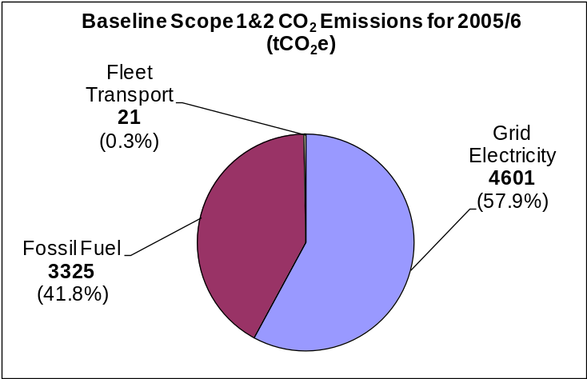
Achieving the targeted reduction in CO₂ emissions is both a major challenge and a sensible precaution for the financial and environmental future of the University.

The University’s carbon emissions baseline for Scope 1 and 2 emissions has been calculated using data from the 2005/6 academic year (1st August 2005 to 31st July 2006), including emissions due to gas and electricity used at both Avenue and Park Campus, and from fuel used by the University’s transport fleet.

Figure A: Breakdown of baseline figure for Scope 1 and 2 CO₂ emissions for 2005/6.
Based on the University’s emissions baseline and actual emissions up to 2010/11, two different consumption scenarios have been projected: The Business As Usual (BAU) scenario predicts the effect on cost and carbon emissions of taking no action to limit the organisations increasing consumption of energy, while the Reduced CO₂ Emissions Scenario (RES) predicts the effect on cost and carbon emissions of reducing the emissions baseline by the targeted 43% by 2020.
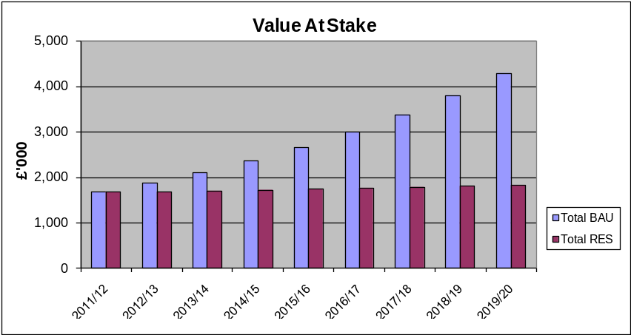
The Value At Stake (VAS) is the difference in emissions or costs between the BAU and the RES; that is, the hypothetical potential value that could be obtained by undertaking a carbon management approach and implementing emissions reductions initiatives in order to reduce baseline emissions by 43% by 2020.
Annual Value at Stake

Figure B: Energy-related Value At Stake to 2020.

The total aggregated Value At Stake postulated from 2011/12 to 2019/20 in energy
-related costs is £9.4 million and 29,186 tonnes of CO₂e (refer to Table 10)

Thirteen distinct project areas across Scopes 1, 2 and 3 have been identified to achieve the carbon reduction targets set out in this CMP; each area contains a number of carbon saving actions, activities or technologies which will be progressed over the course of implementing the CMP to 2020. Further details on specific project areas can be found in Chapter 4 and Appendix B. Projects have been grouped within the following categories:

Scope 1 and 2 emissions: | Scope 3 emissions:
- Low Carbon ICT | - Divert waste from landfill
- Building management technologies | - Reduce water consumption
- Awareness & behaviour campaigns | - Sustainable travel
- Low and zero carbon energy generation | - Sustainable procurement
- A range of non-technical solutions

Total aggregated emissions savings of 7865 tCO₂e are predicted to be realised between 2010/11 and the end of 2015/6, with further savings of 1977 tCO₂e annually thereafter as a result of the projects undertaken up to that point. Further emissions savings will be made from projects implemented between 2016 and 2020.

The aggregated cost of the Scope 1 and 2 projects to be implemented from 2010/11 to 2015/16 will be £1.72m, with aggregated savings of £1.34m predicted up to the end of 2015/16. However, on-going savings of £342k (minus an annual revenue budget cost of £74k) are predicted to be realised each year after 2015/16 as a result of the projects financed and undertaken up to that point.

 | 2010/11 | 2011/12 | 2012/13 | 2013/14 | 2014/15 | 2015/16
Total annual capital cost | £77,000 | £185,000 | £343,000 | £352,400 | £356,350 | £100,000
Total annual revenue cost | - | £43,000 | £59,000 | £64,000 | £69,000 | £74,000
Total cost per annum | £77,000 | £228,000 | £402,000 | £416,400 | £425,350 | £174,000
Annual cost saving | £25,000 | £134,000 | £234,000 | £280,000 | £329,000 | £342,000
Annual CO₂ saving (tCO₂e) | 154 | 892 | 1341 | 1609 | 1892 | 1977

Figure C: Financial costs and savings for projects to be implemented up to 2015/16.

1. Introduction

The University of Northampton is a dynamic, modern university situated in the heart of England, which was awarded full university title and research degree awarding powers in 2005. The University has over 12,500 full and part-time students and 1500 staff based on two campuses within Northampton which cover 100 acres of land. The campuses house nearly 70 buildings comprising 100,000m² of property, including more than 1,600 bed spaces in residential accommodation.

The University of Northampton acknowledges that climate change is a real and growing threat for countries, economies, and organisations in the public and private sector. In 2008/9, the University participated in the Carbon Trust’s Higher Education Carbon Management (HECM) Programme in order to take a strategic view of carbon emissions and to contribute to national commitments to reduce emissions of CO₂.

Governance of the programme, as well as the strategic ownership of the University’s carbon reduction target, rested with the Programme Board, composed of the University’s Pro Vice Chancellor (Strategic Planning & Resources), Director of Estates, Director of Finance and Dean of the School of Science and Technology.

The HECM Programme is based around a five-step process through which participating Higher Education Institutions (HEIs) create an organisation-wide carbon management strategy and action plan, leading to emissions reductions that maximise benefits to the institution and its stakeholders.

The five steps in the HECM process that the University followed are:

Step 1: Mobilise the organisation
Step 2: Set Baseline, Forecasts & Targets
Step 3: Identify & Quantify Options
Step 4: Finalise Carbon Management Plan
Step 5: Implement Plan

The first four steps in the process were undertaken systematically by the University over a ten month period from April 2008 to February 2009, culminating in the production of the University’s first Carbon Management Plan (CMP2009). Since the launch of CMP2009 in March 2009, the University has spent over £1.3m implementing many of the carbon reduction projects set out in CMP2009 (listed in section 4.1). Over the same period of time the University has seen the number of students studying on its campuses increase by over 20% and has weathered two of the harshest winters in the last twenty years; neither scenario was predicted in CMP2009, but these circumstances have led to increased CO₂ emissions in 2008/9 and 2009/10 (see chart 2 in section 3.3 for details).

In preparing this updated CMP, the University has used the learning gained from its participation in the HECM programme to build on CMP2009 and extend its carbon reduction target and programme of proposed projects up to 2020, in alignment with HEFCE’s carbon management strategy.

2. Carbon Management Strategy
The objective of carbon management for every organisation, of whatever sector, is to minimise the risks and maximise the opportunities arising from carbon emissions and climate change, in the short, medium and long term, against a background of rapidly evolving regulation, market forces and stakeholder concerns.

The University of Northampton recognises carbon management as a strategic, whole-organisation approach that integrates with our existing strategy and management, enabling the institution to understand the impact of carbon emissions, to identify key risks and opportunities, to formulate a plan to reduce carbon emissions, to effectively implement, review and update the plan into the future, and to communicate success.

The outcome of successfully adopting and implementing carbon management is an increased awareness of the potential impacts of climate change on the HE sector and on the University as an individual HEI, and a greater capacity to identify and deal with these impacts. By establishing Carbon Management as a core business process, we will become better able to adapt to an increasingly carbon-constrained economy.

2.1 Context and Drivers for Carbon Management
Climate change is real. Over the period to 2050 the world will change fundamentally. The daily effects of climate change, the availability and price of fossil fuels, environmental regulation and new technology will change the face of energy supply and use, and make the emission of greenhouse gases one of society’s key concerns.

In 2000 the Royal Commission on Environmental Pollution (RCEP) recommended that, in order merely to contain the effects of global warming, the UK should reduce CO₂ emissions by 60% below existing levels by 2050. In 2008 the UK’s Climate Change Committee recommended introducing a target to reduce emissions by 80% below 1990 levels by 2050, which has since been included in the UK government’s historic Climate Change Act 2008.

There are good reasons why the adaptation to and mitigation of climate change are of concern to HEIs. HEIs are permanent institutions that plan for the long term. Climate change-driven regulation will increasingly impact the HE sector, for example through the Energy Performance of Buildings Directive and the CRC Energy Efficiency Scheme (CRCEES), and pressure from central government to engage with sustainability and carbon emissions issues will rise in future. HEIs are concerned with the provision of education and research, with the application of knowledge to solve contemporary problems, and ultimately with the transformation of individuals and of society. They have a global context for their funding, research, teaching and student recruitment, and need to communicate values and to differentiate their brands in an increasingly competitive environment. Many internal and external stakeholders of HEIs are concerned about and affected by climate change.

The HE sector is a significant user of energy and emitter of CO₂. Taken as a whole the HE sector has an annual primary energy consumption costing around £200M. Electricity and gas prices have seen significant volatility, partly in response to increased climate change regulation. The HE sector is reported to occupy some 9% of the UK’s total office space and have an estimated carbon footprint of around 3.3mtCO₂ per annum. The sector is still growing, with student numbers increasing by a factor of five over the past thirty years, and with a current policy to increase participation rates, although the future is somewhat uncertain due to changes in future funding arrangements.

HEIs are often substantial businesses, operating in an increasingly competitive environment. Other leading organisations in the private and public sectors recognise the need to reduce carbon emissions as a critical business issue for today. Climate change is set to have a fundamental impact on business performance and value. Leading businesses are putting this issue at the heart of their strategic thinking and are already taking advantage of the opportunities and managing the risks associated with climate change. The University recognises the importance of climate change adaptation and acknowledges the need to manage future risks and modify operations accordingly (see section 2.5).

There are many drivers that have led to the University strengthening its focus on sustainable development and environmental management over the last few years, including legislation, cost factors, increased stakeholder awareness and ethical aspects. More specifically, the key drivers that have led the University to engage with carbon management more significantly are listed in Table 1. The list highlights the key drivers; however, it should not be regarded as entirely exhaustive as many other factors continue to have an impact upon the University’s objective of reducing its carbon emissions.

Table 1: The key drivers for carbon management

Generic Category | Driver | Areas of Impact | Nature of Impact | Importance (High, medium or low) | Consequences/ opportunities/ issues for carbon management
Political | HEFCE carbon reduction target and strategy for higher education in England (HEFCE 2010/01) | The University | HEFCE’s carbon reduction target has set overall HE sector targets with individual HEIs required to set own targets | High | Capital funding is now being related to sustainability criteria including progress against carbon management plans
Economic | Rising cost of utilities and volatility of energy market (plus rise in CCL charge) | The University | Utility prices unstable and rising – lead to financial pressures & less money to spend overall | High | Opportunities for lower utilities consumption & usage of renewables to lessen exposure to market volatility
Ethics | Corporate Social Responsibility | The University | Responsibility to do the right thing | High | Taking a leading role in local, town, county & regional community, as well as in HE sector
Legislative | UK CRC Energy Efficiency Scheme | The University | Annual financial and reputational impact | High | Carbon seen to have further economic value especially when traded on open market
Legislative | EU Energy Performance of Buildings Directive | Estates Management | All campus buildings >1000m² require a DEC (energy label) | Medium | Higher visibility of carbon performance by all building users
Legislative | Building Regulations | Estates Management | Stricter design controls for refurbishment & construction | Medium | Added up-front cost means life-cycle analysis is now a very high priority
University Policy | Environmental Policy and Environmental Management System (EMS) | The University | University’s Environmental Policy updated in 2010 | Medium | Energy reduction targets set as part of EMS objectives
Reputation | P&P League Table / Sound Impact Awards | The University / The Student Union | Environmental performance ranked in league table | Medium | Improvements in CO₂ emissions, waste arisings & water usage will improve ranking
Reputation | Perception of potential students & the public | The University | Improved image to enhance recruitment | Medium | Increased public awareness of climate change offers opportunity
Reputation | The University’s teaching and research | The School of Applied Sciences | Improved image to enhance recruitment | Medium | Two-way link with Environmental Science staff and courses

2.1.1 Dependencies and Assumptions
Dependencies and assumptions that have been taken into account during the programme include:

- The University’s financial year runs from 1st August to 31st July;
- Budgetary requirements must be submitted by January of the prior financial year, in order to be agreed and included in capital or revenue budgets;
- The University’s official academic terms start in late September and run to early July, although an increasing number of courses operate throughout the year;
- Predictions about the size of the University’s student population up to 2020 are not readily available, with uncertainty caused by future funding changes;
- The University is purchasing a number of additional buildings in 2011 and is extending a number of campus buildings which will increase the total building area from 2011/12. Predictions about how this will affect the overall carbon emissions of the University have been included in Section 3.3.2 of this document;
- The University’s teaching facilities and accommodation are being promoted more and more as a conferencing venue during the summer and other holiday periods;
- The University has historically procured gas and electricity through fixed-price contracts, which are typically tendered every two years. However, since October 2009 the main gas and electricity supplies have been procured through flexible contracts.

2.2 Our Low Carbon Vision

To be known as an organisation that pro-actively manages carbon in an efficient and environmentally responsible manner; thereby reducing our environmental impact and our exposure to the cost of carbon.

2.3 Strategic Themes
The key aspects that will move the University towards our low carbon vision are set out below:

- Existing environmental management structure
Carbon management will continue to be progressed through the University’s existing cross-functional environmental management structure, with relevant communication updates given to staff, students, governors and other external stakeholders;

- Technical and inter-personal carbon saving measures
Emissions savings to be sought through a combination of technical/infrastructural measures & change management/human interaction measures;

- External partnerships and funding
Partnerships will be further cultivated with external organisations such as West Northamptonshire Development Corporation (WNDC), North Northamptonshire Development Company (NNDC), Northamptonshire County Council (NCC), Northampton Borough Council (NBC), Northamptonshire Enterprises Ltd (NEL), Carbon Trust (CT), Building Research Establishment (BRE), Higher Education Funding Council for England (HEFCE) and Salix Finance to secure innovative carbon reduction opportunities and funding; The University successfully bid to the HEFCE LGM Fund in 2010 and is leading a project entitled ‘Keeping it Local: Shared Solutions for Sustainability’ which aims to secure local shared solutions to key sustainability challenges such as improving energy efficiency and reducing carbon emissions.

- Data collection
The building of business cases for technical energy reduction measures and then the verification of emissions savings are to be based on data gathered from the University’s automatic sub-meter monitoring and analysis;

- Sector networking
The University will keep up to date with the development and use of innovative carbon saving measures and best practice within the HE sector by using its membership of the Environmental Association for Universities and Colleges (EAUC) and East Midlands Universities Association (EMUA) to network with other HEIs and suppliers;

- Environmental benchmarking
Environmental benchmarking against other HEIs is to be undertaken via the HEFCE-funded annual ‘Universities That Count’ project.

2.4 Targets and Objectives

The University’s key carbon reduction target is set out below:

The University of Northampton will reduce its annual Scope 1 and 2
CO₂ emissions by 43% to 4530 tonnes of CO₂ by the end of 2019/20 academic year,
compared to its 2005/6 emissions baseline of 7947 tonnes of CO₂.

Further objectives are set out here:

- The University will develop a full Scope 3 emissions baseline by 2013;
- The University will raise awareness of climate change and carbon management at both strategic and individual levels across the University, and encourage collective responsibility and action amongst staff and students;
- Carbon management and emissions reduction related funding will be actively sort and considered by the University;
- The University will participate in the annual ‘Universities That Count’ corporate responsibility index, and aims to improve its overall index score year on year;

2.5 Adaptation to Climate Change

Adaptation to climate change means ensuring the delivery of core services to staff, students and relevant stakeholders through the future-proofing of the University’s assets, services and infrastructure against the risks associated with climate variability. Additionally, adaptation means having appropriate contingency plans to deal with extreme climatic events when they arise. Within this CMP, which is time bound to 2020, the risks associated with climate change are considered as minor. The University is confident that it is able to manage the risks associated with climate change adequately and that significant actions are not required at present.
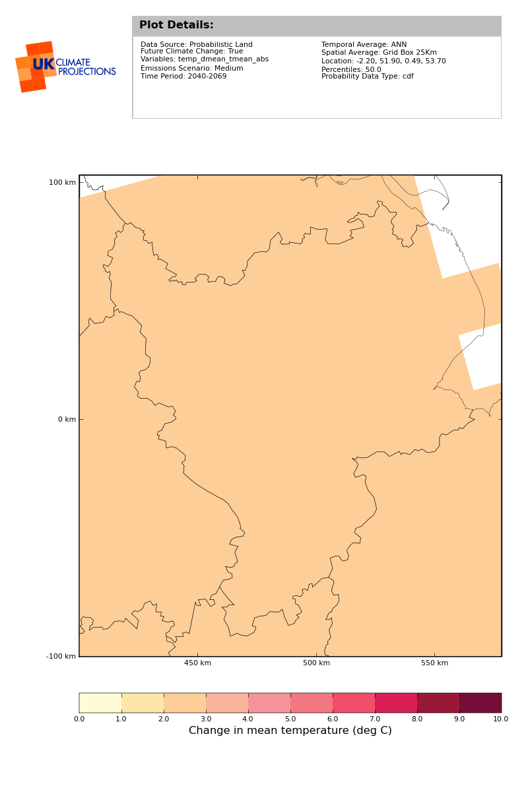
In the longer term it is apparent that adaptation to climate change will need to be substantial and significant, with projections of warmer, drier summers; milder, wetter winters; and increases in the number of storm events, including periods of significant rainfall. By adopting a proactive approach to climate change adaptation the University will increase the resilience of its assets, services and infrastructure to manage risks presented by climate change. Responding to the impacts of climate change will potentially result in significant capital expenditure, but from an estates perspective decisions that are made today can materially affect the capability of the University to adapt to climate change, whether in 2020 or 2080.

UKCIP projections under a medium emissions scenario (UKCIP, 2009) indicate that the average mean daily temperature in the East Midlands in 2050 will increase by 2.5°C against a baseline of average mean daily temperatures calculated between 1961 and 1990; however, the increase could be as much as 4.7°C.

3. Emissions baseline and projections

3.1 Scope
Calculating an emissions baseline is the first step in enabling the University to quantify its carbon footprint and to gain a better understanding of its overall carbon contribution. This section will detail the sources that have been included and how the emissions baseline has been calculated. The baseline will be used to measure the University’s emissions reduction performance as carbon-saving initiatives are implemented during future years.

3.1.1 Source Boundaries
All the emissions sources to be included in the Scope 1 and 2 baseline calculation are under the direct control of the organisation. Other indirect emissions do occur as a result of the organisation’s activities, from sources not directly controlled by the organisation, and will be included in the University’s future Scope 3 baseline calculation.

3.1.2 Material Emission Sources
The emission sources included in this CMP are detailed below and in the associated diagram:

Scope 1 and 2:
- Energy consumption (gas and electricity; no oil utilised);
- Fleet transport (fuel used in University owned or leased vehicles).

Carbon emissions relating to residential and non-residential buildings on both Avenue Campus and Park Campus have been included. Gas and electricity usage at the University-managed Podiatry Clinic, based at Northampton General Hospital, have also been included.

Scope 3:
- Water consumption;
- Life-cycle emissions due to waste arisings (from 2007/8).

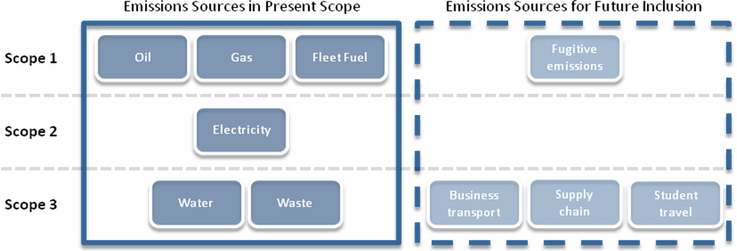

3.2 Scope 1 and 2 Baseline
The institution’s carbon emissions baseline has been calculated using data from 2005/6 academic year (1st August 2005 to 31st July 2006). This year has been chosen as it is the earliest year for which reliable and complete data is readily accessible, and is the year that HEFCE is using for the HE sector emissions baseline. The University’s financial year also runs concurrently with the academic year from 1st August to 31st July so resource implications and financial savings will be reported concurrently.

3.2.1 Compilation of Scopes 1 and 2 Baseline Data
Table 2 identifies the sources of data used to calculate the baseline, as well as assumptions and CO₂ conversion factors (as utilised by HEFCE). This information is documented to ensure that any future carbon emissions calculations can be performed using the same methods, therefore ensuring consistency throughout the programme.
Table 2: Data obtained to calculate Scope 1 and 2 baseline.

Data | Owner | Sources | CO₂ Conversion Factors
Gas consumption | Estates Services | Invoices, backed up by meter readings & automated sub-metering system | Gas 0.1852 kgCO₂e/kWh
Fleet transport (University’s owned or leased vehicles) | Estates Services | Fuel purchases & mileage records;  Purchase orders;  Vehicle tracking data | Diesel 2.67 kgCO₂e/litre  Petrol 2.32 kgCO₂e/litre
Electricity consumption | Estates Services | Invoices, backed up by meter readings & automated sub-metering system | 2005/6: 0.5394 kgCO₂e/kWh  2006/7: 0.5433 kgCO₂e/kWh  2007/8: 0.5552 kgCO₂e/kWh  2008/9: 0.5452 kgCO₂e/kWh  2009/10: 0.5452 kgCO₂e/kWh

Notes to Table 2:

- CO₂e is a unit into which greenhouse gases other than CO₂ are converted so that they can be directly compared (‘e’ is for equivalent);

3.2.2 Estimate of Emissions
The overall University electricity and gas consumption and fleet fuel consumption have been entered into the Carbon Trust’s Emissions Baseline Tool; the tonnes of CO₂e calculated using the conversion factors listed in Table 2 are shown in Table 3 and Chart 1.

The University’s Scope 1 and 2 CO₂ emissions baseline for 2005/6 is 7947 tCO₂e.

Table 3: Breakdown of Scope 1 and 2 baseline CO₂ emissions for 2005/6

 | Tonnes of CO2 (tCO₂e)
Baseline Year | Electricity | Fossil Fuel | Fleet Transport | Annual Total
2005/6 | 4601 | 3325 | 21 | 7947

Chart 1: Breakdown of baseline CO₂ emissions for 2005/6

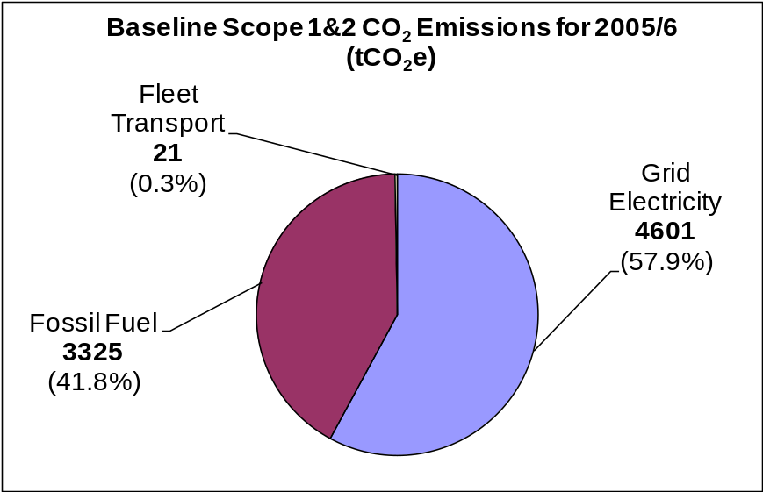

3.3 Scope 1 and 2 Emissions since Baseline Year
The overall University electricity and gas consumption and fleet fuel consumption for the years since the baseline have been calculated using the conversion factors listed in Table 2 are shown in Chart 2.

Chart 2: The University’s actual annual Scope 1 and 2 emissions from 2005/6 to 2009/10

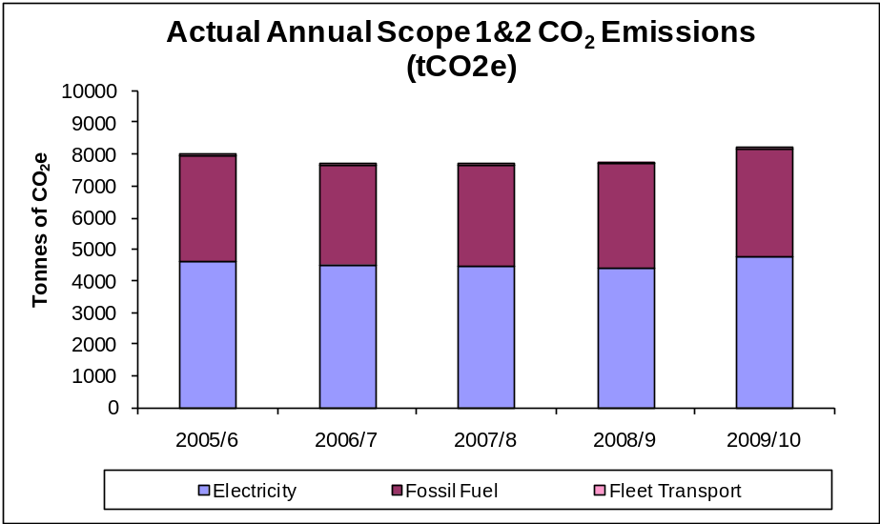

Chart 3: The University’s Scope 1 and 2 emissions intensity from 2005/6 to 2009/10
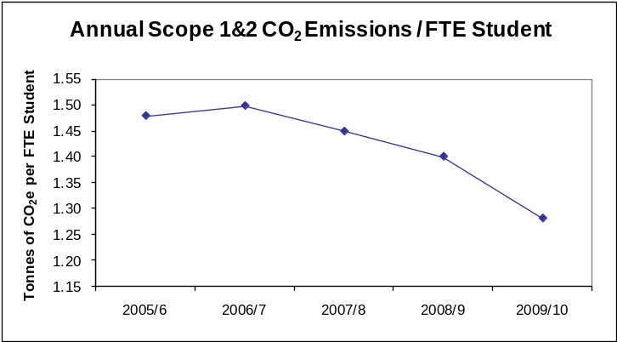
From 2007 to 2010 the University has seen the number of students studying on its campuses increase by over 20% and has weathered two of the harshest winters in the last twenty years; neither scenario was predicted in CMP2009, but these circumstances have led to increased CO₂ emissions in 2008/9 and 2009/10 (as seen in Chart 2). However, despite the increase in absolute carbon emissions over this period of time, there has been a reduction in carbon intensity measured in tCO₂ per Full-Time Equivalent (FTE) student.

Chart 4: Split of 2009/10 Scope 1 and 2 emissions by source

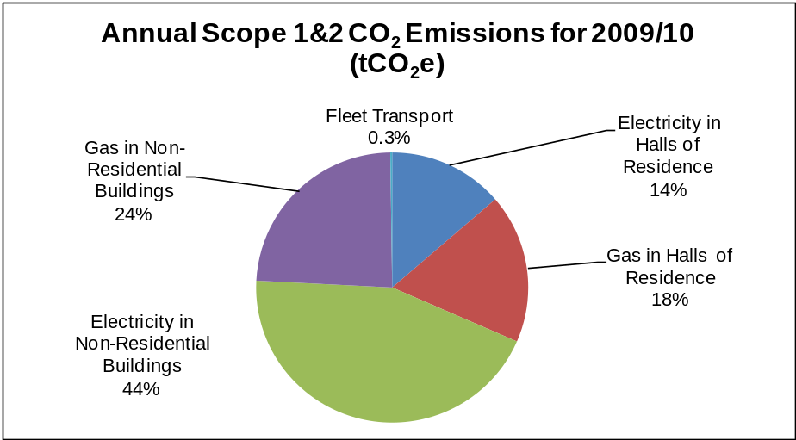

Chart 4 shows that in 2009/10 over 32% of the University’s Scope 1 and 2 CO₂ emissions came from electricity and gas consumption in Halls of Residence and 68% came from non-residential usage.

3.4 Scope 3 Data Sources

Table 4: Information about Scope 3 data sources
Data | Owner | Sources | Data accuracy | CO₂ Conversion Factors | Inclusion date
Water consumption | Estates Services | Invoices, backed up by meter readings & automated sub-metering system | Accurate | Water supplied 0.400 kgCO₂e/m³  Water treated 0.750 kgCO₂e/m³  Emissions calculated using DEFRA GHG reporting guidelines, Annexe 9, table 9a. | Included in CMP - data from 2005/06 onwards
Lifecycle waste emissions | Estates Services  Waste contractors | Invoices;  Tonnage estimate or actual weight for waste sent to landfill and recycling | Accurate | Life cycle waste emissions depend on material type and disposal route; emissions recorded using DEFRA GHG reporting guidelines, Annexe 9, table 9d. | Included in CMP - data from 2007/08 onwards
Land based business travel | Finance Department | Expense claims | Inaccurate at present | Will be calculated using DEFRA GHG reporting guidelines, Annexe 6 – passenger transport | 2012/13
Commuting (staff and students) | Estate Services | Travel survey | Staff – Accurate but limited  Students – Inaccurate | Will be calculated using DEFRA GHG reporting guidelines, Annexe 6 – passenger transport, table 6l | 2012/13
Business air travel | Finance Department | Expense claims | Inaccurate | Will be calculated using DEFRA GHG reporting guidelines, Annexe 6 – passenger transport, table 6l | 2012/13
Air travel – International students | International Office | Data not collected | N/A | Will be calculated using DEFRA GHG reporting guidelines, Annexe 6 – passenger transport, table 6l | 2012/13
Air travel – Student exchange | International Office | Data not collected | N/A | Will be calculated using DEFRA GHG reporting guidelines, Annexe 6 – passenger transport, table 6l | 2012/13
Procurement | Finance Department | Limited data | N/A | To be confirmed | 2013

- CO₂e is a unit into which greenhouse gases other than CO₂ are converted so that they can be directly compared (‘e’ is for equivalent);
- The emissions for waste arisings are based on life-cycle values including the extraction of raw materials, processing, disposal according to waste stream and energy saved by re-use, recycling or energy recovery;

3.5 Scope 3 Emissions

At present the University is able to accurately calculate carbon emissions based on reliable data sources for two specific Scope 3 carbon emission sources; water consumption and lifecycle emissions from waste (see Table 4 above). Availability and accuracy of data prevents the University from reporting on wider Scope 3 emissions sources at the present time.

The University is able to monitor water consumption utilising a sub-metering system to provide real time consumption and cross referencing information with utility billing. To establish carbon emissions associated with water consumption it is necessary to acknowledge that emissions are a result of two processes, namely the supply of water and in the treatment of waste water. In Table 5a below it is assumed that the volume of water supplied and treated is equal.

Table 5a: Emissions from water consumption
 | 2005/06 | 2006/07 | 2007/08 | 2008/09 | 2009/10
Total University water consumption (m³) | 101.0 | 92.0 | 90.0 | 95.0 | 98.0
Emissions due to water supply (t CO₂e) | 27.9 | 25.4 | 24.8 | 28.5 | 29.4
Emissions due to water treatment (t CO₂e) | 70.0 | 63.8 | 62.4 | 71.3 | 73.5
Total emissions (t CO₂e) | 97.9 | 89.1 | 87.2 | 99.8 | 102.9

Emissions from waste detailed in Table 5 take into account emissions generated as a result of extraction, processing, manufacturing, transporting and disposal of waste. Emissions have been calculated on the assumption that all waste generated by the University is general commercial waste. In future years it is anticipated that further information will be collected to differentiate the different waste streams and establish associated carbon emissions. Construction waste is not included within the figures in Table 5b.

Table 5b: Lifecycle emissions from waste
 | 2007/08 | 2008/09 | 2009/10
Waste to landfill (tonnes) | 632 | 583 | 457
Waste recycled (tonnes) | 220 | 267 | 293
Percentage of waste recycled | 25.8% | 31.4% | 39.1%
Lifecycle emissions of waste (t CO₂e) | 2431 | 2409 | 2106

3.6 Future Scope 3 Emissions Reporting

Comprehensive Scope 3 emissions reporting is a natural progression from the carbon accounting that is being undertaken at present. The University is aware of the contribution that Scope 3 emissions have on the University carbon footprint and is striving to establish appropriate data collection methodologies to enable Scope 3 emissions reporting in the future. The University understands that HEFCE have commissioned research into establishing sector specific guidance on measuring Scope 3 emissions with a view for Universities to report on Scope 3 emissions from 2013. Once published, the University will align its Scope 3 data collection methodologies with the guidance published from HEFCE.

3.7 Projections and Value At Stake

3.7.1 Context and Assumptions

Given the extremely volatile nature of energy markets during the recent past and the unprecedented highs in the price of crude oil, it is very difficult to predict the price of fuel and utilities in a year’s time, let alone in ten year’s time. This has led to all costs within the carbon saving projects being costed at 2011 prices.

Historically, the University purchased the majority of its gas and electricity under fixed price contracts which were tendered every two years. In summer 2006 the University saw a 93% increase in gas and a 64% increase in electricity costs versus 2005. The University re-tendered its gas and electricity contracts in summer 2008 and saw a further 33% increase in each. In summer 2009 the University moved its main electricity and gas supplies onto flexible contracts and saw a 30% reduction in costs due in part to the UK recession. The flexible contracts then saw an increase of 10% on electricity and 13% on gas prices in summer 2010. The current assumption is that there will be a continual upward trend in costs in the coming years.

Climate Change Levy (CCL) is paid by the University on all non-residential gas and electricity consumption. CCL for gas started at 0.150p/kWh in 2001 but increased to 0.154p/kWh in April 2007, then to 0.159p/kWh in April 2008 and then to 0.164p/kWh in April 2009. Similarly, CCL for electricity increased from 0.43p/kWh to 0.441p/kWh, then to 0.456p/kWh and to 0.470p/kWh at the same time. The government has indicated that it will be increased in line with inflation each year in the future.

The UK Government’s CRC Energy Efficiency Scheme is a carbon trading scheme that the University is mandated to participate in due to the volume of our electricity and gas consumption. The scheme starts in 2011/12 and for the first three years will require the University to pay £12 for every tonne of CO₂ emitted from Scope 1 and 2 sources (except transport), giving the University a bill of just over £100k. After the third year of the scheme, carbon will be traded in the open market at which point the price per tonne will be market-driven and therefore likely to increase above £12/tonne.

3.7.2 Additional Buildings

In 2008, the University purchased a 4000m² Grade II listed building, now called Newton, which was refurbished during 2009. The building is now the home of the School of Science and Technology and is partially occupied by a number of external tenants. This building was not included in the emissions baseline, future projections or target within CMP2009, but is included in CMP2011. The building was operational from January 2010, so only six months of emissions were included in 2009/10 data, whereas a full twelve months of emissions will be seen in 2010/11 data.

The University is in the process of developing or purchasing a number of buildings which will add extra floor area to the building stock and add extra CO₂ emissions from 2011/12:
- Cottesbrooke building extension;
- Sulgrave building extension;
- ‘ICon’ new building in Daventry;
- The Mounts new student residences (electrically heated);
- St John’s new student residences (gas heated).

Table 6: Predicted additional CO₂ emissions due to extended or newly purchased buildings

Building | Additional GIA  (m²) | Estimated electricity usage  (kWh) | Estimated  gas  usage (kWh) | Estimated electricity emissions (kgCO₂) | Estimated gas emissions (kgCO₂) | Estimated Overall Emissions (tCO₂)
Newton (additional 6 months of occupation in 2010/11 compared to 2009/10) | 4,253 | 470,000 | 230,000 | 256,253 | 42,603 | 298.9
Cottesbrooke extension | 576 | 35,000 | 74,300 | 19,083 | 13,763 | 32.8
Sulgrave extension | 600 | 25,000 | 95,000 | 13,631 | 17,597 | 31.2
The Mounts student residence | 1,097 | 330,000 | N/A | 179,923 | 0 | 179.9
St John’s student residence | 669 | 40,000 | 145,000 | 21,809 | 26,858 | 48.7
ICon, Daventry | 4,030 | 161,200 | 403,000 | 87,889 | 74,648 | 162.5
TOTAL | 11,225 | 1,061,200 | 947,300 | 578,587 | 175,468 | 754

Table 7: Predicted effect of additional CO₂ emissions from extended or newly purchased buildings on University’s overall 2010/11 and 2011/12 Scope 1 and 2 emissions figures

 | Tonnes of CO₂ (tCO₂e)
Baseline Year | Electricity | Fossil Fuel | Fleet Transport | Annual Total | Data Accuracy
2005/6 | 4601 | 3325 | 21 | 7947 | Actual
2006/7 | 4511 | 3109 | 21 | 7642 | Actual
2007/8 | 4434 | 3212 | 21 | 7666 | Actual
2008/9 | 4371 | 3332 | 19 | 7723 | Actual
2009/10 | 4738 | 3421 | 19 | 8178 | Actual
2010/11 | 4975 | 3592 | 19 | 8586 | Predicted
2011/12 | 5297 | 3725 | 18 | 9040 | Predicted

This means that in order to reach the target of a 43% reduction in 2020 against the 2005/6 baseline (meaning actual emissions of 4530 tCO₂ in 2020), the University will in reality have to achieve a 50% reduction against predicted 2011/12 emissions (a saving of 4510 tCO₂ from the 2011/12 estimate).

3.7.3 Business As Usual Scenario
The Business As Usual (BAU) scenario predicts the effect on cost and carbon emissions of taking no action from 2012 to limit the organisations increasing consumption of energy, as well as the extra cost of energy associated with inflation and market related increases. The assumptions used within the BAU calculation are highlighted in Table 8.

Table 8: Business As Usual assumptions

Aspect | Assumption
Gas unit cost | Contract cost up to end of 2010/11 and then rising 10% per annum
Electricity unit cost | Contract cost up to end of 2010/11 and then rising 10% per annum
Fleet fuel cost | Rising 5% per annum
Gas consumption | Rising 2% per annum
Electricity consumption | Rising 2% per annum
Fleet fuel consumption | Rising 1.8% per annum
CRC Energy Efficiency Scheme | Cost of allowances rising 20% per annum after Phase 1

Chart 5: Projected energy costs based on Business As Usual Scenario
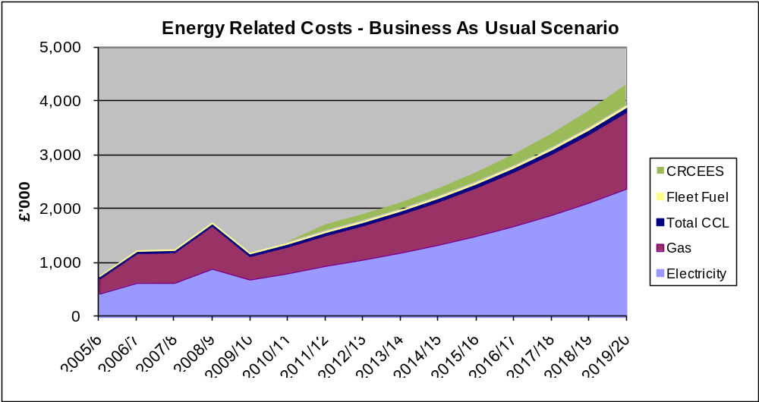
Actual Cost
3.7.4 Reduced Emissions Scenario
The Reduced CO₂ Emissions Scenario (RES) predicts the effect on cost and carbon emissions of the targeted 43% reduction in CO₂ emissions by 2020 against the 2005/6 baseline (meaning an 8.3% per year reduction in emissions from 2012 to 2020, with actual emissions of 4530 tCO₂ in 2020), while off-setting this against the extra cost of energy associated with inflation and market related increases. The assumptions used in the RES calculation are highlighted in Table 9.

Table 9: Reduced CO₂ Emissions Scenario assumptions

Aspect | Assumption
Gas unit cost | Contract cost up to end of 2010/11 and then rising 10% per annum
Electricity unit cost | Contract cost up to end of 2010/11 and then rising 10% per annum
Fleet fuel cost | Rising 5% per annum
Gas consumption | Falling 8.3% per annum from 2012 (based on achieving CMP target)
Electricity consumption | Falling 8.3% per annum from 2012 (based on achieving CMP target)
Fleet fuel consumption | Falling 3.2% per annum from 2012

Chart 6: Projected energy costs based on Reduced Emissions Scenario
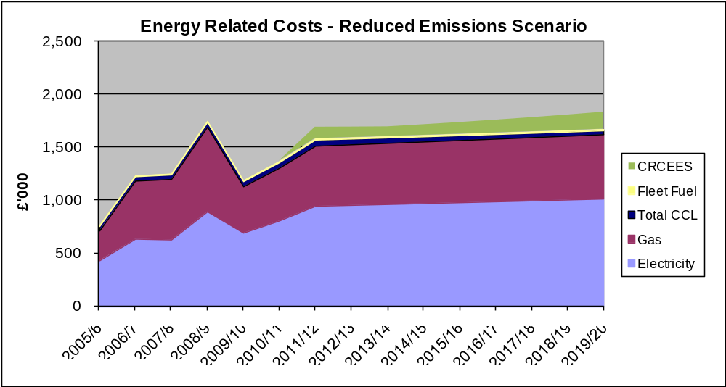
Actual Cost

The results of the BAU and RES calculations for costs and emissions can be seen in Table 10 below.

3.7.5 Value At Stake
The Value At Stake (VAS) is the difference in emissions or costs between the Business as Usual Scenario and the Reduced Emissions Scenario; that is, the hypothetical potential value that could be obtained by undertaking a carbon management approach and implementing emissions reductions initiatives in order to meet the CMP target; this would require an emissions reduction of 8.3% per annum from 2012 to 2020. The VAS has only been calculated for Scope 1 and 2 energy-related costs.
VAS can be aggregated over a period of time or calculated for a particular year.

The total aggregated Value At Stake postulated from 2011/12 to 2019/20 in energy-related costs is £9.4 million (see Table 10 and Chart 7 for details) and 29,186 tCO₂e (see Table 10 and Chart 8 for details).

Table 10: Energy-related Value At Stake monetary and carbon breakdown

 | 2011/2012 | 2012/2013 | 2013/2014 | 2014/2015 | 2015/2016 | 2016/ 2017 | 2017/ 2018 | 2018/ 2019 | 20/19/ 2020
Total BAU (£'000) | 1,694 | 1,885 | 2,098 | 2,361 | 2,657 | 2,993 | 3,373 | 3,804 | 4,293
Total RES (£'000) | 1,694 | 1,694 | 1,697 | 1,717 | 1,738 | 1,760 | 1,784 | 1,809 | 1,836
VAS per year (£'000) | 0 | 190 | 402 | 644 | 920 | 1,233 | 1,589 | 1,995 | 2,457
VAS aggregated savings (£'000) | 0 | 191 | 593 | 1,237 | 2,156 | 3,389 | 4,979 | 6,974 | 9,431
Total BAU (tCO₂) | 9,041 | 9,222 | 9,407 | 9,595 | 9,786 | 9,982 | 10,182 | 10,385 | 10,593
Total RES (tCO₂) | 9,041 | 8,291 | 7,604 | 6,973 | 6,395 | 5,865 | 5,379 | 4,934 | 4,525
VAS per year (tCO₂) | 0 | 931 | 1,803 | 2,621 | 3,391 | 4,117 | 4,802 | 5,452 | 6,068
VAS aggregated savings (tCO₂) | 0 | 932 | 2,735 | 5,356 | 8,747 | 12,864 | 17,666 | 23,118 | 29,186

Chart 7: Monetary Value At Stake to 2020
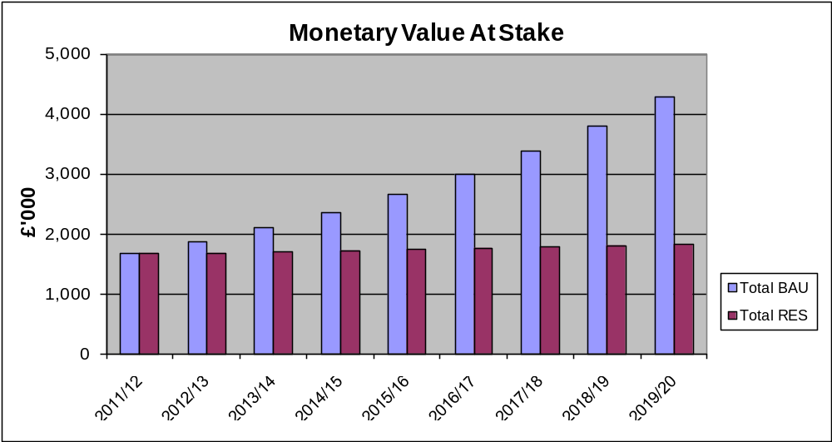
Annual Value At Stake

Chart 8: Carbon Value At Stake to 2020
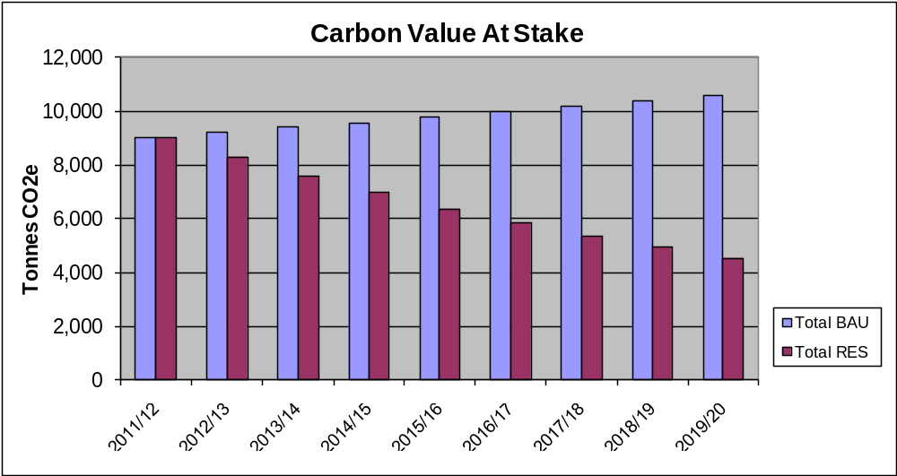
Annual Value At Stake

4. Carbon Management Projects
Since 2005/6, under the direction of CMP2009, the projects and initiatives listed in Table 11 have been undertaken.

4.1 CMP2009 Projects Implemented (Table 11)

Ref | Project | Lead | Cost |  | Annual Saving |  | Pay back | % of Target | Year
Ref | Project | Lead | Capital | Revenue | Fin | CO₂ | Pay back | % of Target | Year
i). | Sub-Metering of Utilities in Campus Buildings | Terry Cox, Deputy Director Estates | £150,000 | £2,670 pa | N/A | N/A | N/A | N/A | 2008
ii). | Lighting & Control Upgrades – various buildings | Terry Cox, Deputy Director Estates | £280,000 |  | £30,200 pa | 165t pa | 9.3 years | 4.8% | 2008
iii). | Boiler Upgrades in 10 buildings plus district heating at Park Campus | Derrick Harris, Estates Manager | £735,000 |  | £22,700 pa | 140t pa | 31.0 years | 4.1% | 2008-2010
iv). | Computer Out-of-Hours Automatic Shutdown (Student PCs managed by IS) | Alan Clark, IT Technical Infrastructure Manager | £5,200 |  | £7,500 pa | 56t pa | <1 year | 1.6% | 2009
v). | Voltage Optimisation – Phase 1 – Avenue Campus | Terry Cox, Deputy Director Estates | £60,331 |  | £16,160pa | 88t pa | 3.7 years | 2.6% | 2009
vi). | Improve Insulation – Fit Valve Insulation Jackets | Robert Morsley, Project Manager | £8,000 |  | £2,250 | 14t pa | 3.6 years | 0.4% | 2009
vii). | Improve Insulation – Fit Loft & Cavity Wall Insulation in Buildings Across the Campuses | Robert Morsley, Project Manager | £60,000 |  | £6,000 | 37t pa | 10 years | 1.1% | 2010
viii). | Install Variable Speed Motor Drives on A/C Units | Derrick Harris, Estates Manager | £27,000 |  | £2,700 | 15t pa | 10.0 years | 0.4% | 2010

The implementation of the projects in Table 11 has led to carbon savings equivalent to 15% of the CMP’s targeted reduction of 3,417 tCO₂. Of these total savings, 4.5% will be realised in 2010/11.

Other actions that have been undertaken since 2005/6 include:
- BREEAM modelling implemented in new build and refurbishment programme; Innovation Centre and Newton building refurbishments awarded ‘Very Good’ status;
- Energy awareness campaign in student halls of residence;
- Strategic review of printing and copying in offices in progress;
- Green Travel Plan re-written to highlight transport priorities;
- Improved recycling facilities put in place to reduce waste sent to landfill;

In order to develop carbon reduction projects and initiatives for this updated CMP, the project team has undertaken the following actions:
- Reviewed progress of CMP2009 and projects undertaken on both campuses since 2005/6 to extract opportunities that were identified but have not yet been undertaken;
- Used the process of producing Display Energy Certificates, associated advisory reports and air conditioning surveys to assist in the development of opportunities;
- Spoken in depth to members of the University’s Environmental Working Group and other stakeholders to discuss carbon saving opportunities in their own areas of work;
- Utilised information from the projects undertaken since 2005/6 to prioritise opportunities based on cost, cost saving, carbon saving, practicality, persistency and qualitative benefits.

A number of existing projects from CMP2009 have been carried over to CMP2011, and thirteen distinct project areas across Scopes 1, 2 and 3 have been identified to achieve the carbon reduction targets set out in this CMP; each area contains a number of carbon saving actions, activities or technologies, as summarised in the tables below, which will be progressed over the course of implementing the CMP. Detailed analysis of each distinct project can be found in Appendix B.

4.2 Existing Projects (Table 12)

Ref | Project | Lead | Cost |  | Annual Saving |  | Pay back | % of Target | Year
Ref | Project | Lead | Capital | Revenue | Fin | CO₂ | Pay back | % of Target | Year
0a. | Employ Energy Officer | Gill Winder, Director of Estates |  | £30,000 pa | £30,000pa | 165t pa | On-going every year | 4.8% | 2011
0b. | Computer Out-of-Hours Automatic Shutdown (Staff PCs) | Roy King, IT & Media Facilities Manager | None |  | £3,750 pa | 28t pa | N/A | 0.8% | 2011

The implementation of the existing projects in Table 12 will lead to carbon savings equivalent to 5.6% of the CMP’s targeted reduction of 3,417 tCO₂.

4.3 Scope 1 and 2 Projects 2011-2015 (Table 13)

Ref | Project | Lead | Cost |  | Annual Saving |  | Pay back | % of Target | Year
Ref | Project | Lead | Capital | Revenue | Fin | CO₂ | Pay back | % of Target | Year
1a. | Low Carbon ICT – Server Virtualisation | Alison Brook, Deputy Director of IS | £167,000 |  | £52,500 | 320t pa | 3.2yrs | 9.4% | 2011-2013
1b. | Low Carbon ICT – Thin Clients | Alison Brook, Deputy Director of IS | No marginal cost |  | £7,800 | 42t pa | 2 years | 1.2% | 2012-2016
1c. | Low Carbon ICT – Server Room Cooling | Alison Brook, Deputy Director of IS | £180,000 |  | £37,000 | 200t pa | <5 years | 5.9% | 2013-2015
2a. | Spatial Heating & Cooling – BMS Optimisation | Derrick Harris, Estates Manager | £15,000 |  | £16,500 | 92t pa | <1 year | 2.7% | 2011
2b. | Spatial Heating & Cooling – TRVs in Margaret Bondfield Hall | Derrick Harris, Estates Manager | £22,000 |  | £2,050 | 13t pa | 10.7 years | 0.4% | 2012-2013
2c. | Spatial Heating & Cooling – Coordinated Academic Timetabling | Simon Arnold, Timetabling Manager | None |  | £3,500 | 20t pa | N/A | 0.6% | 2011
2d. | Spatial Heating & Cooling – Boiler Upgrades to 12 buildings | Derrick Harris, Estates Manager | £550,000 |  | £45,000 | 277t pa | ~12 years | 8.1% | 2012-2015
2e. | Spatial Heating & Cooling – Building Insulation | Terry Cox, Deputy Director Estates | £60,000 |  | £3,000 | 18.5t pa | ~20 years | 0.5% | 2012-2015
3a. | Lighting & Control Upgrades – T5 Upgrades (Cottesbrooke stairs & Library) | Terry Cox, Deputy Director Estates | £20,000 |  | £3,300 | 18t pa | 6.1 years | 0.5% | 2012-2013
3b. | Lighting & Control Upgrades – Automated Lighting Controls | Terry Cox, Deputy Director Estates | £20,000 |  | £2,700 | 12t pa | 7.4 years | 0.4% | 2012-2013
Ref | Project | Lead | Cost |  | Annual Saving |  | Pay back | % of Target | Year
Ref | Project | Lead | Capital | Revenue | Fin | CO₂ | Pay back | % of Target | Year
3c. | Lighting & Control Upgrades – LED Replacements for Halogens in SMC | Terry Cox, Deputy Director Estates | £5,000 |  | £450 | 2t pa | 11.1 years | 0.1% | 2012-2013
4a. | Voltage Optimisation – Park Campus Transformer 1 | Terry Cox, Deputy Director Estates | £86,000 |  | £17,000 | 93t pa | 5.0 years | 2.7% | 2012
4b. | Voltage Optimisation – Park Campus Transformer 2 | Terry Cox, Deputy Director Estates | £52,400 |  | £5,800 | 32t pa | 9.0 years | 0.9% | 2013
4c. | Voltage Optimisation – Park Campus Transformer 3 | Terry Cox, Deputy Director Estates | £56,350 |  | £6,500 | 35t pa | 8.7 years | 1.0% | 2014
6a. | Awareness & Behaviour Campaign | Paul R. Taylor, Sustainability Officer |  | £20,000 pa | £45,000 | 245t | 0.5 years | 7.2% | 2011
7. | Devolved Monitoring, Metering & Targeting | Paul R. Taylor, Sustainability Officer | £3,000 | £2,000 | N/A | N/A | N/A | N/A | 2011-2012
5a. | Low and Zero carbon energy generation – On site | Gill Winder, Director of Estates | £150,000 | £2,000 | £15,000 inc. FIT | 26t pa | 10 years | 0.8% | 2011-2012
8. | Construction & Refurbishment | Terry Cox, Deputy Director Estates | TBC |  | TBC | 85t pa | TBC | 2.5% | On-going
9a. | Other Non-Technical Solutions – Estate Rationalisation | Gill Winder, Director of Estates | None | £20,000 | £20,000 | 100t pa | TBC | 2.9% | 2012-2015

The implementation of the projects in Table 13 will lead to carbon savings equivalent to 47.7% of the CMP’s targeted reduction of 3,417 tCO₂.

4.4 Scope 1 and 2 Projects 2016-2020 (Table 14)

Ref | Project | Lead | Cost |  | Annual Saving |  | Pay back | % of Target | Year
Ref | Project | Lead | Capital | Revenue | Fin | CO₂ | Pay back | % of Target | Year
2f. | Spatial Heating & Cooling – Free/Evaporative Cooling | Terry Cox, Deputy Director of Estates | £200,000 |  | £18,000 | 100t pa | 11 years | 2.8% | 2016-2018
5b. | Low and Zero carbon generation – Extension of district heating system and assessment of CHP | Paul R. Taylor, Sustainability Officer | TBC |  | TBC | TBC | TBC | TBC | 2018
8. | Construction & Refurbishment | Terry Cox, Deputy Director Estates | TBC |  | TBC | 85t pa | TBC | 2.5% | 2016-2020
9b. | Other Non-Technical Solutions – Amend Academic Timetable | John Hoskinson, Pro-Vice Chancellor | N/A |  | TBC | TBC | TBC | TBC | 2016-2020
9c. | Other Non-Technical Solutions – Devolve Halls of Residence | John Hoskinson, Pro-Vice Chancellor | Potential capital gain | Potential revenue loss | TBC | 2050t pa | N/A | 60% | 2016-2020

The implementation of the projects in Table 14 will lead to carbon savings equivalent to in excess of 60% of the CMP’s targeted reduction of 3,417 tCO₂. Projects will be further developed and costed in the interim years as part of the implementation and review of this CMP.

4.5 Scope 3 Projects (Table 15)

Ref | Project | Lead | Cost |  | Annual Saving |  | Pay back | Planned Implementation
Ref | Project | Lead | Capital | Revenue | Fin | CO₂ | Pay back | Planned Implementation
10. | Diverting Waste from Landfill | Paul R. Taylor, Sustainability Officer | TBC |  | £43,200 pa | In excess of 150t CO₂e pa | TBC | In progress
11. | Reduce Water Consumption | Derrick Harris, Estates Manager | TBC | £10,000 | £20,000 pa | 10t CO₂e pa | TBC | 2011-2013
12. | Sustainable Travel Projects | Paul R. Taylor, Sustainability Officer | TBC |  | TBC | TBC | TBC | 2011-2016
13. | Sustainable Procurement | Carol Barrett, Procurement & Contracts Manager | TBC |  | TBC | TBC | TBC | 2012-2016

Further information about the Scope 3 projects above can be found in Appendix B. Projects will be further developed in light of the conclusions from the HEFCE-funded Scope 3 research being undertaken in 2011.

5. Implementation Plan financing
Based on the information in Tables 11, 12 and 13, the financial costs due to Scope 1 and 2 emission reduction projects to be implemented from 2010/11 to 2015/16 have been aggregated together in Table 16 below. The associated emissions savings have been aggregated together in Table 17 below.
Scope 1 and 2 emission reduction projects to be implemented between 2016 and 2020 will be further developed and costed in the interim years as part of the implementation and review of this CMP. Some estimated costs have been included in Table 14, but much of the cost data will need to be considered as the projects are developed in more detail.

5.1 Assumptions
- Cost of electricity: 10.00p/kWh
- Cost of gas: 3.0p/kWh
- All costs for future carbon saving projects are quoted at 2011 prices.
- Total funding of £128k from Salix/HEFCE Revolving Green Fund is available.

5.2 Financial Costs Due to Existing and Planned Projects up to 2015 (Table 16)

 | 2010/11 | 2011/12 | 2012/13 | 2013/14 | 2014/15 | 2015/16
Total annual capital cost | £77,000 | £185,000 | £343,000 | £352,400 | £356,350 | £100,000
Total annual revenue cost | - | £43,000 | £59,000 | £64,000 | £69,000 | £74,000
Total costs | £77,000 | £228,000 | £402,000 | £416,400 | £425,350 | £174,000

Table 16 shows that the aggregated cost of the Scope 1 and 2 projects to be implemented from 2010/11 to 2015/16 will be £1.72m, with aggregated savings of £1.34m predicted up to the end of 2015/16. (Note that the additional costs for predicted energy usage in 2010/11 and 2011/12 shown in Table 7 have not been taken into consideration here). However, on-going savings of £342k (minus an annual revenue budget cost of £74k) are predicted to be realised each year after 2015/16 as a result of the projects financed and undertaken up to that point.

Sources of Funding:
In 2009 the University successfully applied to receive £100k from the HEFCE/Salix Finance Revolving Green Fund (RGF) in order to establish a spend-to-save rotating fund to enable the funding of some of its carbon reduction projects. The University added £28k to the HEFCE/Salix money to give a total fund of £128k which has been in operation since April 2009.
Some of the projects will be funded via the RGF spend-to-save fund, some via the University’s internal Estates and Information Services capital and revenue budgets, and some via construction and refurbishment capital budgets.

5.3 Benefits / Savings Due to Existing and Planned Projects up to 2015 (Table 17)

 | 2010/11 | 2011/12 | 2012/13 | 2013/14 | 2014/15 | 2015/16
Annual cost saving | £25,000 | £134,000 | £234,000 | £280,000 | £329,000 | £342,000
Annual CO₂ saving (tCO₂e) | 154 | 892 | 1341 | 1609 | 1892 | 1977
% of target achieved | 4.5 | 26.1 | 39.2 | 47.1 | 55.4 | 57.9

Table 17 shows that total aggregated Scope 1 and 2 emissions savings of 7865 tCO₂e are predicted to be realised between 2010/11 and the end of 2015/6, with further savings of 1977 tCO₂e annually thereafter as a result of the Scope 1 and 2 projects undertaken up to that point.
Notes to Table 17:
- Cost savings for some projects will be returned to the RGF spend-to-save fund to pay off loans.
- CO₂ savings of 393 tCO₂ per annum from Scope 1 and 2 projects implemented up to 2009/10 are not shown in the table, but are assumed to have reduced actual emissions in the years up to 2009/10, while being off-set by increased emissions of 624 tCO₂ per annum due to new buildings (Newton and MX mobile), additional student numbers and colder winters; leading to a 231 tCO₂ increase from 2005/6 to 2009/10 (adding an extra 7% to the CMP’s 2020 reduction target). Actual emissions data can be seen in Table 7.
- The CO₂ savings shown in Table 17 will be off-set by the predicted rise in emissions in 2010/11 and 2011/12 due to the acquisition/leasing of new buildings; leading to a 408 tCO₂ increase in 2010/11 and a 454 tCO₂ increase in 2011/12 (adding an extra 25% to the CMP target).
- As a result of the actual increased emissions from 2005/6 to 2009/10 and the predicted increase in emissions in 2010/11 and 2011/12, there is a need to attain an emissions reduction of 132% of the 3417 tCO₂ savings target that is based on the 2005/6 baseline of 7947 tCO₂. This is equivalent to a 50% reduction in the 2011/12 predicted emissions figure of 9040 tCO₂.
- The University’s interim milestone is to have emissions of 7063 tCO₂ by the end of 2015/16.
- De-carbonisation of the UK’s national electricity supply has not been taken into account in the calculated CO₂ savings, but is predicted to reduce the tonnes of CO₂ per kWh of electricity supplied as the UK moves towards lower carbon producing sources of electricity.

5.4 Financial Costs Due to Planned Projects from 2016 to 2020 and Scope 3 Projects

Scope 1 and 2 emission reduction projects to be implemented between 2016 and 2020 will be further developed and costed in the interim years as part of the implementation and review of this CMP. Some estimated costs have been included in Table 14, but much of the cost data will need to be considered as the projects are developed in more detail. It is likely that new models of financing will be investigated for capital-intensive projects.

Further information about the Scope 3 projects above can be found in Appendix B. Projects will be further developed and costed in light of the conclusions from the HEFCE-funded Scope 3 research being undertaken in 2011.

6. Actions to Embed Carbon Management in the Organisation

In 2008 the Vice Chancellor signed student campaign group People & Planet’s ‘Green Education Declaration’ and in 2010 the Vice Chancellor signed Universities UK’s ‘Statement of Intent on Sustainable Development’ acknowledging that the education sector has a key role to play in addressing the challenge of climate change through teaching and learning, research and innovation, as well as in estates’ management. These declarations included a commitment to take decisive and strategic action to reduce the carbon emissions of the University year-on-year.

This CMP, which sets out the University’s low carbon vision, its CO₂ saving target and its plan to achieve it, is endorsed by the Vice Chancellor and the Board of Governors, and is available publically, making the institution’s commitment to embedding carbon management clear.

Appendix A shows the Carbon Management Embedding Matrix which consists of seven subject headings with embedding actions for each subject that are ranked in five levels from worst to best practice. The actions highlighted in colour show the University’s perceived current position for each subject. Discussion of each subject, along with plans and actions to improve the University’s position are set out below:

6.1 Policy
The institution’s Environmental Policy states that ‘The University of Northampton recognises that its activities impact upon the environment through both its routine internal operations and its infrastructural development, as well as through its influence and effects on the wider community. It acknowledges a responsibility for protection of the environment at all levels, and a commitment to reducing its environmental impact. The University is developing an environmental management system (EMS) to achieve this in a structured way’.
The Environmental Policy includes sections on energy/carbon, transport, waste/recycling, sustainable procurement, biodiversity and sustainable construction. It states that ‘the University is committed to making efficient and environmentally responsible use of energy, to help lessen the consumption of finite resources and emissions of greenhouse gases. The University will investigate and undertake actions across the estate to improve its energy efficiency, and encourage staff and students to eliminate wasted energy.’ The Environmental Policy is reviewed every year by the University’s Environmental Working Group so that changes can be made when deemed necessary.
As part of its development of an Environmental Management System, the University will produce performance targets for all key environmental aspects, and set out annual objectives for itself and its Environmental Working Group to work towards.
An environmental strategy and action plan will be drawn up to run in tandem with the University’s Strategic Plan and Estates Strategic Plan, to cover all key environmental aspects.

6.2 Responsibility
Strategic carbon management is the full-time responsibility of the Sustainability Officer, while day-to-day energy management is the responsibility of the Estates Manager. The Deputy Director of Estates has responsibility for overseeing both individuals.
The position of Energy/Carbon Officer will be recruited in 2011 to sit within the University’s Estates Department so that all carbon management is the full-time responsibility of a single individual.
In November 2008, all Heads of Departments and Deans of Schools were set a ‘Greening Objective’ for their areas of influence, which has required them to consider how aspects of environmental management, including carbon management, can be integrated into their day-to-day responsibilities and departmental/school planning.
The programme management and governance of the Carbon Management Plan is covered in Section 7 of this Plan.

6.3 Data Management
The University’s sub-metering system allows the remote half-hourly reading of gas, electricity and water meters in most buildings. This data is reviewed internally and allows accurate bill validation and consumption checking to be undertaken.
A key embedding aspect of data management is enabling any member of staff to access the sub-metering data remotely. This will give them the ability to view the consumption data for areas they are interested in, or responsible for, thereby enabling them to monitor usage and act to saving energy wastage. It is hoped that a web-based system will be rolled out by the end of 2011.
The annual collation of CO₂ emissions data for buildings has historically been based on billing data; while there has historically been no collation of waste or vehicle fleet emissions data.
From 2009 onwards, however, the CO₂ emissions data for buildings has been based on sub-metering data as well as invoice data, while the weight of waste generated on campus is collated monthly by the Sustainability Officer from data supplied by the University’s waste contractor. This data is currently only reviewed internally, however it is hoped that external verification could be undertaken within the timescale of this CMP.
Emissions data for the University’s owned and leased fleet vehicles is based on fuel invoices; however, such data for other business travel cannot be easily extracted from expense claims currently because travel costs are combined with subsistence costs. The way that members of staff record travel expenses needs investigating and modifying before full collation of transport emissions data is possible.

6.4 Communication and Training
The Sustainability Officer has undertaken a significant amount of raising awareness on campus, particularly to students living in Halls of Residence who have a large influence on energy usage. This has included having information displays during the University’s Welcome Week and Freshers’ Fair, as well as talking to groups of students as part of their Hall of Residence induction programme. During term-time one-to-one communication with residential students has taken place to remind them about how to save energy and how to recycle waste. These publicity campaigns will be further enhanced during future academic years with joint activities being planned by the Estates department, Student Services department and the Students’ Union.
Carbon Management communications to staff and students primarily occur via the University’s ‘Green Matters’ environmental website and intranet information pages, although other methods are also used to some extent. Electronic media will continue to be the gateway for accessing information about carbon management, but other methods will be increasingly used to communicate to staff and students on a personal level about why change is necessary, how they can help to reduce carbon emissions and how they have contributed to overall success. These methods will include using the staff magazine, Student Union material and the further work of Energy Champions.
Training and awareness materials for use during staff inductions are being investigated by the Sustainability Officer and a researcher from the University’s Division of Environmental Science.
Section 7.4 of this Plan sets out further details of stakeholder management and communications.

6.5 Finance and Investment
This aspect of embedding Carbon Management is covered in Section 5 of this Plan.

6.6 Procurement
Between 2005 and 2008 the University was engaged as a partner in a government-funded project entitled ‘What Price Sustainability?’ which investigated how to implement sustainable procurement in the higher education sector. Run by the Environmental Association for Universities and Colleges, the project brought together a number of institutions and sector bodies and culminated in March 2008.
As a result of the University’s involvement in the EAUC project a number of training events have been held to help embed environmental and carbon considerations into the day-to-day work of departmental procurers. The Procurement & Contracts Manager is a member of the Environmental Working Group.
To assist in addressing the many aspects of procurement that need to be considered the University has used the Government’s Flexible Framework for Sustainable Procurement, as set out in its 2007 document ‘Procuring the Future’. Using the Framework has allowed the University to investigate issues such as whole life costing and the integration of sustainability criteria in tendering.

6.7 Monitoring & Evaluation
This aspect of embedding Carbon Management is covered in Section 7 of this Plan.

7. Management of the CMP
The governance of the CMP, as well as the strategic ownership of the carbon reduction target, rests with the Programme Board, composed of appropriate members of senior staff. The Board has oversight of the Plan and should be in a position to remove blockages when identified.
Project Team meetings give the opportunity to bring together, in one place, the diverse set of projects and owners from across the organisation to ensure coherence and coordination of carbon reduction activity.

7.1 The Programme Board – Strategic Ownership and Oversight
The Programme Board is made up of the CMP’s senior sponsors and champions. The Board is chaired by the Pro Vice Chancellor (Strategic Planning & Resources). The members of the team are listed in Table 18.

Table 18: Programme Board members

Role in Carbon Management | Name and position in the University | Contact details
Principle Sponsor | Gill Winder  Director of Estates (DoE) | 01604 892980  gill.winder@northampton.ac.uk
Board Level Sponsor | John Hoskinson  Pro Vice Chancellor (Strategic Planning & Resources) (PVC SPR) | 01604 892037  john.hoskinson@northampton.ac.uk
Academic Sponsor | Kamal Bechkoum  Dean, School of Science and Technology (DSST) | 01604 893004  kamal.bechkoum@northampton.ac.uk
Finance Champion | Deborah Harry  Director of Finance (DoF) | 01604 892048  deborah.harry@northampton.ac.uk

The Board meets to review the progress of projects, the overall risks to the programme, and the status of overall cost and carbon savings. The Board reports to the SMT and the VC via the Pro Vice Chancellor (SPR).

7.2 The Carbon Management Team – Delivering the Projects
The Carbon Management Team is a group formed by the expansion of the University’s existing Energy Management Working Group. The team meets every term and is chaired by the Sustainability Officer. The members of the team are listed in Table 19.

Table 19: Project Team members

Role in Carbon Management Team | Name and position in the University | Contact details
Project Leader | Paul R Taylor  Sustainability Officer (SO) | 01604 892950  paul.r.taylor@northampton.ac.uk
Deputy Project Leader | Terry Cox  Deputy Director of Estates (Projects & Maintenance)  (DDoE) | 01604 892019  terry.cox@northampton.ac.uk
Student Representative | Ethics and Environment Officer, Students’ Union | 01604 892550
Role in Carbon Management programme | Name and position in the University | Contact details
Team members | Darren Trotter  Sustainability Assistant | 01604 893431  darren.trotter@northampton.ac.uk
Team members | Carol Barrett  Procurement & Contracts Manager (PCM) | 01604 892561  carol.barrett@northampton.ac.uk
Team members | Derrick Harris  Estates Manager | 01604 893407  derrick.harris@northampton.ac.uk
Team members | Alan Harvey  Assistant Estates Manager | 01604 892189  alan.harvey@northampton.ac.uk
Team members | Matthew Waite  Estates Senior Project Manager | 01604 892982  matthew.waite@northampton.ac.uk
Team members | Jeff Wells  Estates Project Manager | 01604 893416  jeff.wells@northampton.ac.uk
Team members | Steve Slade  Data Centre Manager | 01604 892215  steve.slade@northampton.ac.uk
Team members | Roger Dixon  Associate Director of Information Services | 01604 892223  roger.dixon@northampton.ac.uk
Team members | Mark Norman  Students Union Operations Manager | 01604 892819  mark@northamptonunion.com
Team members | Linda Davis  Centre for Community Volunteering Manager | 01604 892280  linda.davis@northampton.ac.uk
Team members | Louise Cottingham  Newton Facilities Manager | 01604 892193  louise.cottingham@northampton.ac.uk
Team members | Julia Evans  School Manager, School of Social Sciences | 01604 892549  julia.evans@northampton.ac.uk
Team members | Mandy Taylor  School Manager, School of Science and Technology | 01604 892093  mandy.taylor@northampton.ac.uk
Team members | Lisa McKenzie  School Manager, School of Health | 01604 892343  lisa.mckenzie@northampton.ac.uk

7.3 Succession Planning for Key Roles
The role of Project Leader will be covered by the Deputy Director of Estates (Projects and Maintenance) if the Sustainability Officer is unable to undertake the role at any time.

The role of Project Sponsor will be covered by the Deputy Director of Estates (Projects and Maintenance), or the Pro Vice Chancellor (Strategic Planning & Resources) if the Director of Estates is unable to undertake the role at any time.

7.4 Ongoing Stakeholder Management
Stakeholders are those parties either within or external to the University who will be affected by the programme and may influence its success. The key stakeholders have been identified in Table 20 below.

Table 20: Key Stakeholders and Communication Plan

Stakeholder | Influence | Key issues/concerns | Means of communication | Responsibility
Governing Body | High | Strategic support  CMP Approval | Committees  Annual report | DoE / PVC (SPR)  EWG
VC & Directorate | High | Budgets & funding  Future strategic goals  Reputation/profile of institution | Directorate meetings | PVC (SPR)
Deans & Heads of Departments | High | Budgets  Staff numbers  Space utilisation | Planning & Resources Committee | DoE / PVC (SPR)
Finance | High | Financial planning  Procurement & contracts | Departmental communications | DoF / PVC (SPR)
Estates Services | High | Estates Strategy  Running costs  Capital implications  New build / refurbs | Departmental communications | DoE / DDoE / SO
Staff | High | Comfortable working environment  Cost & ease of travel  Job security | TUNIS intranet & bi-weekly email  With Payslip  Departmental/ School meetings | SO  Energy Champions
Students | Medium | University’s customer  Expectations  Growing environmental awareness | Welcome Week  Printed materials  Website  Students Union | SO / Webteam Admissions / Marketing
Local Authorities & Agencies | Medium | Local Area Agreement  Funding to University | LAA meetings  Direct meetings | PVC (SPR)
Contractors & Suppliers | Medium | Retain contract  Added cost burden | Contract tenders / meetings | PCM
Media & Press | Low | Corporate image | Press releases | Claire Bicknell
Community | Low | Travel congestion  Corporate image | Press releases | Claire Bicknell

General principles of the Communication Plan:

- The University’s Marketing & External Relations Department will help the project leaders to continue to develop the plan as the project progresses;
- Existing meetings and committee structure will be used as much as possible to communicate key messages;
- Existing ‘Green Matters’ branding will be used as the umbrella for both internal and external communications;

Internal reporting to be undertaken:

- Termly report to be submitted to Environmental Working Group (EWG) and Estates Strategy Steering Group (ESSG);
- ESSG to submit termly report to Planning & Resources Committee, which includes members of the Directorate;
- Annual environmental report generated by EWG to include summary of key project information;
- Annual report to be submitted to the Governor’s Finance & Estates committee.

External reporting to be undertaken:

- Key deliverables to be submitted to HEFCE via CIF process;
- Information on ‘Green Matters’ website available to the public;
- Information for media and press when required;
- The University’s key environmental data is submitted annually to HEFCE as part of the Estates Management Statistics return;
- The executive summary of the University’s annual report to be made available in a public format.

7.5 Annual Progress Review
A formal annual review will be undertaken by the Project Team in August of each year, in order to review the progress against the plan for the previous academic year.
The review will:
- cover the cost and all benefits from the Programme:
  - financial savings, either cashable or returned to the ‘rotating spend-to-save fund’;
  - CO₂ savings against target;
  - Less-quantifiable benefits, such as influencing the student body / local community.
- be viewed by the Programme Board before being passed to the SMT.

Appendix A: Carbon Management Matrix - Embedding
 | POLICY | RESPONSIBILITY | DATA MANAGEMENT | COMMUNICATION & TRAINING | FINANCE & INVESTMENT | PROCUREMENT | MONITORING & EVALUATION
5  BEST | - SMART Targets signed off  - Action plan contains clear goals & regular progress reviews  - Strategy launched internally & to community | - CM is full-time responsibility of a few people  - CM integrated in responsibilities of senior managers  - VC support  - Part of all job descriptions | - Quarterly collation of CO₂ emissions for all sources  - Data externally verified  - M&T in place for:  - Buildings  - Waste | - All staff & students given formalised CM:  - Induction  - Training Plan  - Communications  - CM matters regularly communicated to:  - External community  - Key partners | - Granular & effective financing mechanisms for CM projects  - Finance representation on CM Team  - Robust task management mechanism  - Ring-fenced fund for carbon reduction initiatives | - Senior purchasers consult & adhere to ICLEI’s Procura+ manual & principles  - Sustainability comprehensively integrated in tendering criteria  - Whole life costing  - Area-wide procurement | - Senior management review CM process  - Core team regularly reviews CM progress  - Published externally on website  - Visible board level review
4 | - SMART Targets developed but not implemented | - CM is full-time responsibility of an individual  - CM integrated in to responsibilities of department managers, not all staff | - Annual collation of CO₂ emissions for:  - Buildings  - Transport  - Waste  - Data internally reviewed | - All staff & students given CM:  - Induction  - Communications  - CM communicated to:  - External community  - Key partners | - Regular financing for CM projects  - Some external financing  - Sufficient task management mechanism | - Environmental demands incorporated in tendering  - Familiarity with Procura+  - Joint procuring between HEIs or with LAs. | - Core team regularly reviews CM progress:  - Actions  - Profile & Targets  - New opportunities quantification
3 | - Draft policy  - Climate Change reference | - CM is part-time responsibility of a few people  - CM responsibility of department champions | - Collation of CO₂ emissions for limited scope i.e. buildings only | - Environmental / energy group(s) give ad hoc:  - Training  - Communications | - Ad hoc financing for CM projects  - Limited task management  - No allocated resource | - Whole life costing occasionally employed  - Some pooling of environmental expertise | - CM team review aspects including:  - Policies / Strategies  - Targets  - Action Plans
2 | - No policy  - Climate Change aspiration | - CM is part-time responsibility of an individual  - No departmental champions | - No CO₂ emissions data compiled  - Energy data compiled on a regular basis | - Regular poster/awareness campaigns  - Staff & students given ad hoc CM:  - Communications | - Ad hoc financing for CM related projects  - Limited task coordination resources | - Green criteria occasionally considered  - Products considered in isolation | - Ad hoc reviews of CM actions progress
1  Worst | - No policy  - No Climate Change reference | - No CM responsibility designation | - Not compiled:  - CO₂ emissions  - Estimated billing | - No communication or training | - No internal financing or funding for CM related projects | - No Green consideration  - No life cycle costing | - No CM monitoring

Appendix B: Definition of Projects

Project:  Reference: | Low Carbon ICT  1.
Owner (person) | Alison Brook / Terry Cox
Department | Information Services / Estates Services
Description | ICT is a fundamental service delivered by the University. Across campus there are 700 computers designated for students in addition to the PCs available for staff. ICT is a considerable energy consuming activity and technology presents a number of viable projects to reduce CO₂ emissions from the operation of ICT including:  - Server virtualisation  Virtualisation is a process that converts information held on physical servers to virtual servers. Physical servers typically use a fraction of their operational capacity therefore; virtualisation increases efficiency by consolidating data held on physical servers to a reduced number of virtual servers. Virtualised servers can work in conjunction with networked PCs called ‘thin clients’ which operate via the server as opposed to conventional PCs which operate via their internal hard drive.  Information Services have already instigated the process of server virtualisation in the main server room at Park Campus. The initial phase of virtualisation will reduce the number of servers to approximately 20 physical servers and 80 virtual servers. Each physical server virtualised reduces CO₂ emissions by 4 tonnes per annum.  At present due to limitations associated with the existing physical server infrastructure, student email archiving is supported by MS Edu_Live off site. Virtualisation will enable this service to be supported internally.  - Thin clients  Thin clients can typically be used to replace general PC units in areas such as computer clusters, libraries and offices where PCs are used for generic applications. Thin clients cannot replace the functions of PCs used for scientific modelling or operating bespoke software. An initial pilot programme of thin client implementation is underway to demonstrate the effectiveness of thin clients and secure funds for roll out during the Summer of 2011.  - Data centre  Free cooling systems utilise ambient air external of a building to cool internal areas. As the ambient temperature in the UK is rarely above the internal temperature free cooling can be used to supply a significant proportion of the cooling demand. Evaporative cooling systems operate in a similar way but utilise water as the medium to extract cool ambient air and transfer the cool air internally.  The principle of free/evaporative cooling is likely to have numerous other applications at the University however; the data centre due to its 24/7 cooling demand is the most appropriate location to install initially. AHUs will still be required to supply supplementary cooling if the ambient temperature rises above the internal ambient temperature where free cooling would no longer be effective.  - Automatic shutdown of staff PCs  PCs placed in computer clusters have SMS Companion software installed to shutdown PCs to avoid them being left on unnecessarily. This software could also be applied to staff PCs subject to consultation regarding PCs that operate models and configuring network updates.
Benefits | - Financial: ~£100,000 per annum  - Payback: ~ 3 years  - CO2 savings: 590t CO₂ per annum
Funding | - Project cost: £300,000  - Operational costs: No increase in marginal operational cost.  - Source of funding: Internal/Salix.  - Decision on funding: Directors of IS and Estates Services and Salix compliance tool.
Resources | - Funded primarily through IS budget, supported by Estates Services and potential Salix funding depending on project compliance.
Ensuring Success | - Provision of capital.  - Collaborative approach between Information Services and Estates Services to progress project from planning to implementation.  - IS lead on selection of appropriate technologies for purchase.
Measuring Success | Metrics:  - Reduction in energy consumption demonstrated by sub-metering/data logging.  - No adverse impact on provision of ICT reported by users.
Timing | Milestones / key dates:  - Project to be implemented in phases between 2011 and 2016.  - Implementation timescales will be driven by IS and University wide criteria.
Notes | Carbon savings for implementation of server virtualisation based on each physical server replaced saving 4 tonnes CO₂ per annum based on VMWare calculations, this figure is taken without the reduction on cooling load. Indicative savings for data centre cooling calculated using Eco-Cooling data centre calculator.  Carbon savings for thin clients based on 50% reduction in energy consumption for 300 thin clients comparative to conventional PCs. Earlier pilot study indicated the average PC with automatic shutdown software consumed 10kWh per week.  An IT audit will be undertaken to understand current staff behaviour and determine carbon savings. This will be lead by IS who are responsible for the provision of IT for staff and meeting individual users needs.

Project:  Reference: | Spatial Heating and Cooling  2.
Owner (person) | Estate Manager
Department | Estates Services/ Central Timetabling Unit
Description | Gas consumption accounts for 42% of the University’s scope 1 and 2 carbon emissions for the provision of spatial heating and hot water. With a diverse operating environment including domestic and non-domestic property ensuring adequate spatial heating and cooling is a key challenge and striking a balance between unnecessary usage. A University wide energy policy will be developed how the University will manage energy consumption. Additional projects to be implemented include:  - BMS system  A central Trend system allows HVAC controls such as the scheduling of operation and altering the set points to be made remotely. Increasing the number and improving the location of set points would give a greater level of control over the local environment ensuring that areas are maintained at a comfortable temperature and avoid overheating and overcooling.  - Thermostatic Radiator Valves (TRVs)  TRVs are able to moderate the flow of hot water into radiators within a central heating system. By reducing the flow of hot water into radiators demand for hot water is reduced and return temperature of water to the boiler is raised and lessens the demand for re-heating. A 1°C reduction in spatial temperature can realise energy savings of 8%.  - Co-ordinated academic timetabling  The timetabling of evening courses and lectures is coordinated by the Central Timetabling Unit. Energy efficiency improvements could be achieved through ensuring that energy efficient buildings and appropriately sized rooms are used to deliver evening lectures so that other areas around the campus can be closed down out of hours. Co-operation between Central Timetabling Unit and Estates Services would enable the BMS system to be programmed around room occupancy at The University.  - Boiler upgrades  Significant investment has been made upgrading the boilers at both Park and Avenue campus as part of the previous Carbon Management Plan. Further upgrades to plant will be addressed via the Estates routine maintenance budget and where opportunities for boiler replacements are identified funding will be brought forward where possible.  Carbon savings for the proposed upgrades are likely to be in excess of the carbon savings demonstrated in CMP2009 due to the demand placed on the boilers to be replaced.  - Building insulation  A review of building insulation is being conducted at present with the commissioning of thermal imaging surveys to evaluate the insulation added to building fabric since 2008. The results of the thermal imaging survey will review the effectiveness of building insulation upgrades to day and inform future preventative maintenance strategy.  - Free/Evaporative cooling  Free cooling is using natural cool ambient air ventilation systems to replace existing electricity intensive air conditioning systems to produce cool air to temper internal spaces during periods of warm weather. In the UK, where the ambient air external to a building is cooler than internal for much of the year, channelling cool air from external to internal is an efficient method for cooling buildings; particularly those that are South facing. Although air conditioning systems are required for periods where the external temperature is greater than the internal temperature of the building free cooling can be used to supply up to 80% of the cooling load.  The application of free cooling systems will be hastened with the phasing out of air conditioning systems which use of Hydrochlorofluorocarbons (HCFCs) from 2015 under ‘The Fluorinated Greenhouse Gases Regulations 2009’.
Benefits | - Financial: £70-90,000 per annum depending on project implementation. Reduced maintenance not accounted for.  - Payback: Range between 0 for BMS optimisation and 20 years for boiler upgrades.  - CO2 savings: 400t CO₂ per annum 2011-2015.
Funding | - Project cost: £647,000 (2011-2015) and £200,000 (2016-2020)  - Operational costs: No additional marginal cost anticipated.  - Source of funding: Internal budget/Salix funding.  - Decision on funding: Determined by Director of Estates.
Resources | - Funding will be sought from annual budgets for Estate investment, funding from Salix RGF will be used where sufficient funds are available and project is compliant with Salix criteria.
Ensuring Success | - Senior management endorsement for the development and implementation of energy policy/strategy.  - Prioritising project investment based on carbon abatement and energy reduction potential of project.
Measuring Success | Metrics  - Reduced gas consumption illustrated by sub-metering system  - Financial saving  - Reduced maintenance spend  - CO2 savings
Timing | Milestones / key dates:  - Project to be implemented between 2011-2015.  - Prioritisation determined by a combination of annual conditioning surveys and energy saving potential.
Notes

Project:  Reference: | Application of Lighting Controls and Upgrades  3.
Owner (person) | Terry Cox
Department | Estates Services
Description | - T5 fluorescent tube replacement for T8s  Significant investment has been made over the past 3 years regarding the replacement of T-8 fluorescent tubes with T-5. The remaining areas at Park where installing T-5 is anticipated to have a financial return within 5 years are:  - Cottesbrooke staircases  - Silent study area of Park library.  These areas are likely to demonstrate a relatively short payback period due to the occupancy of the areas and combining the fluorescent tubes with photocells will reduce energy consumption further.  - Application of lighting controls  A variety of automatic lighting controls can be used to control lighting which has high frequency switchgear; this is typically where conversion to T5 has been undertaken in the past. PIR sensors which control according to the detection of human movement; effective in areas which are infrequently occupied to prevent lights being left on unnecessarily.  Areas which would benefit from the application of PIRs include:  - Leathersellers corridor  - staircases in halls of residence  - Holdenby 1st floor corridor.  Daylight/twilight sensors can be utilised in areas where there is sufficient natural daylight through windows not to necessitate the use of artificial lighting. Areas which would benefit from the application of daylight sensors:  - Cottesbrooke staircase  - Silent study area of the Library at Park campus.  - LED replacement for halogen spotlights  50W halogen spotlights can be replaced for LED equivalents which consume 1/10th of the energy of the halogen equivalent. LEDs will be fitted as standard on major refurbishment projects and retrofitted where appropriate.
Benefits | - Financial: £6,450 per annum  - Payback: ~7 years  - CO2 savings: 32t CO₂ per annum
Funding | - Project cost: £45,000  - Operational costs: No additional marginal cost anticipated.  - Source of funding: Internal budget/Salix funding.  - Decision on funding: Determined by Director of Estates.
Resources | - Project management team to oversee contractor installation
Ensuring Success | - Senior management endorsement for the development and implementation of energy policy/strategy.  - Prioritising project investment based on carbon abatement and energy reduction potential of project.  - Verify suppliers energy savings claims internally via Sustainability team
Measuring Success | Metrics  - Reduced electricity consumption illustrated by sub-metering system  - Financial saving  - Reduced maintenance spend  - CO2 savings
Timing | Milestones / key dates:  - Project to be implemented by 2013.
Notes

Project:  Reference: | Voltage Optimisation  4.
Owner (person) | Terry Cox
Department | Estates Services
Description | Voltage optimisation equipment tempers down the incoming voltage of electricity from the grid. Typically electricity in the UK is supplied at 240v however; this can fluctuate dependent on factors such as demand. Modern electrical appliances are able to operate with a supply voltage of 210v so the voltage optimisation equipment can step the incoming voltage down closer to 210v giving energy and carbon savings with no discernable impact to equipment and appliances.  The lower the voltage that the voltage optimisation equipment is set to the greater the energy and carbon savings, however if the voltage is reduced too far and the supply fluctuates then appliances and systems may fail as they are not supplied with the sufficient voltage.  Voltage optimisation was installed at the Avenue campus in 2009 and has demonstrated energy savings of 8%. There are 3 electricity substations at Park campus where voltage optimisation equipment could be applied however; energy savings are not anticipated to be as significant as at Avenue due to a reduced inductive load at Park. Feasibility also needs to be explored to understand the impact on voltage optimisation on IT equipment located at Park campus.
Benefits | - Financial: £30,000 per annum (£17,000 sub 1, £5,800 sub 2 and £6,500 sub 3)  - Payback ~7 years ranging from 5 yrs sub 1 to 9 years sub 3.  - CO₂ savings: 159.72 t CO₂ per annum
Funding | - Project cost: £160,000 (£86,000 for sub-stations 1, £56,000 sub 3 and £40,000 for sub-station 2).  - Operational costs: No additional operating cost anticipated.  - Source of funding: Internal/Salix.  - Decision on funding: Director of Estates/Salix.
Resources | - Capital investment may be required for Estate management budget.  - Project management team to consult with stakeholders and implement project.
Ensuring Success | - Consultation with key energy users e.g. caterers, retailers and IS to ensure voltage optimisation will not impact on the operation of their equipment.
Measuring Success | Metrics  - Sub metering system would be used to compare energy consumption before and after implementation.
Timing | Milestones / key dates:  - Project to be implemented when capital funds permit. Voltage optimisation to be installed on sub-station 1 prior to any other locations.
Notes | Energy and carbon savings based on a 5% reduction in energy consumption based on consumption in the 2009/10 academic year. 5% energy reduction based on the reduced inductive load at Park campus.

Project:  Reference: | Low and zero carbon energy generation  5.
Owner (person) | Gill Winder
Department | Estates Services
Description | - Low and zero carbon energy generation – On-site  The University is actively exploring renewable energy opportunities, both on and off campus. On campus, renewable electricity generating opportunities are limited due to the location of the campuses, proximity to residents. In the past 12 months, solar thermal panels and an air source heat pump have been installed on halls of residence to pilot viable technology for renewable heat generation.  The newly constructed I-Con building is currently exploring the potential to install 300m² of solar PV panelling which will reduce carbon emissions by 26t CO₂ per annum.  Prior to investment in renewable energy generation, greater emphasis will be placed on reducing energy consumption.  - Extension to District Heating System/CHP  The University currently operates a district heating system to supply heat across the Park Campus. In order to improve energy efficiency across the campus the viability of extending the district heating system will be explored alternatively, a CHP system conversion will also be explored. CHP systems utilise waste heat from gas fired boilers to create electricity by operating a turbine. The electricity generated from this process can be used to supply on-site activities lessening the demand for electricity supplied via the National Grid.  Investigation into extension of the district heating system or conversion to a CHP system will be required to determine the benefits.
Benefits | - Financial: £15,000 per annum inc. FIT  - Payback 10 years  - CO2 savings: 26t CO₂ per annum
Funding | - Project cost: £150,000  - Operational costs: £2,000 annual servicing and maintenance.  - Source of funding: Internal.  - Decision on funding: Director of Estates.
Resources | - Capital investment may be required for Estate management budget.  - Proposal may be subject to planning permission.
Ensuring Success | - Extensive feasibility study to understand potential risks and barriers associated with the project.  - Regular monitoring of electricity being generated to ensure the system is functioning correctly.  - Installer provides adequate support post installation for troubleshooting and resolving issues.
Measuring Success | Metrics  - Metering system to analyse electricity production and proportion used on site versus electricity exported to grid.
Timing | Milestones / key dates:  - Solar PV panels to be commissioned during 2011 for installation subject to full feasibility study.
Notes

Project:  Reference: | Awareness and Behaviour Campaigns  6.
Owner (person) | Paul R. Taylor
Department | Estates Services
Description | End user behaviour is the most significant influence on the University’s energy consumption, particularly electricity usage. In 2009/10 carbon emissions from electricity consumption accounted for 58% of the University’s Scope 1 + 2 carbon footprint. In order to address energy consumption by staff and student behaviour the following projects are to be implemented:  Halls of residence energy competition  14% of the University’s electricity is consumed within halls of residences which are occupied for approximately 9 months of the year. The influx of 1629 students into accommodation has a marked influence on the energy consumption of the University. To incentivise energy efficient behaviour, an inter-halls of residence energy competition could be introduced to motivate individuals living in halls of residence to consider their energy consumption. Rewarding energy efficient behaviour will have a positive effect on energy consumption in halls of residence.  Due to the turnover of students in halls of residences who typically stay in student accommodation for 1 year means that projects such as this require time and resource investment annually to maintain progress.  Reporting & communication  The University operates a sub-metering system to collate energy consumption information from a series of meters around campus. This information is analysed by Estates Services to identify anomalies and energy saving opportunities. By providing access to individuals at a local level, energy efficient behaviours can be encouraged and unnecessary energy wastage can be identified.  Training  To assist individuals at a local level tasked with energy management objectives relevant training will be made available to help meet organisational targets. Training will typically involve environmental auditing, promoting energy efficiency and providing new staff with inductions about environmental practice.  Engagement  Achieving an ambitious carbon reduction target such as the one set out in this Carbon Management Plan will require an integrated approach and collaborative efforts from all departments/schools, staff and students. Those involved with the management of utility budgets will proactively communicate with staff at local levels to develop energy saving projects and advise on best practice.  Information  The instigation of awareness projects such as energy competitions require support in the form of information to raise awareness and enable individuals to put behaviours into practice. For example, using colour co-ordinated stickers will advise individuals whether certain appliances can be switched off.
Benefits | A 5% target is set which would achieve savings of:  - Financial: £45,000  - CO2 savings: 245 t CO2 (based on a 1 year programme initially then rolling campaign depending on success).
Funding | - Project cost: No capital investment required.  - Operational costs: A campaign budget of £20,000 would enable an integrated campaign including marketing and communication via a designate project website.  - Source of funding: Internal.  - Decision on funding: Director of Estates.
Resources | - Support from marketing, communication, student services, Student Union and Estates required.
Ensuring Success | - Continued funding in student awareness to ensure that momentum is maintained.  - Incentivisation for staff and students to participate e.g. award for most energy efficient building or department.  - Recruitment of campaign advocates including champions to endorse and encourage energy efficiency in halls of residence.
Measuring Success | Metrics:  - Campaign reviews to be undertaken on a monthly basis to monitor performance.  - Sub-metering system used to illustrate energy savings
Timing | Milestones / key dates:  - Project campaign will be developed in readiness for the new academic year beginning in September 2011 in order to establish systems and procedures for ensuring the successful delivery of the awareness campaign.
Notes | A documented example of such a campaign demonstrated that savings from a 3 month project could be extrapolated to deliver such savings

Project:  Reference: | Devolved Monitoring, Metering & Targeting  7.
Owner (person) | Paul R. Taylor
Department | Estates Services, Schools and Departments.
Description | The University installed a sub-metering system in 2007/08 to collate and monitor energy and water consumption across the campuses. This information is interrogated by estates to identify anomalies in energy consumption, identify opportunities for energy savings and monitor the effectiveness of the projects implemented.  Decentralised energy/carbon budgets  At present there is a single energy budget for the University maintained and administered centrally by Estates Services. The production of Display Energy Certificates has enabled the University to identify energy intensive buildings across the estate portfolio. Due to the diversity of the operation of the buildings a single universal approach to carbon energy budgeting is not appropriate. The University would introduce an energy/carbon budget for each building covered by a DEC to place a greater emphasis on energy efficiency within these buildings.  Metering of 3rd party tenants  The University of Northampton accommodates a number of 3rd party tenants across its 2 campuses including the Student Union, various retail and commercial enterprises. The current contractual arrangement with tenants means that the University is responsible for the payment of utilities that are consumed by 3rd parties. Accurate metering of utilities will empower and encourage tenants to employ energy efficient practices.
Benefits | - Financial: £0  - Payback: N/A  - CO2 savings: N/A
Funding | - Project cost: £3,000  - Operational costs: £2,000 for security and web hosting.  - Source of funding: Internal.  - Decision on funding: Director of Estates.
Resources | - Additional resource made available by recruitment of Energy Officer.
Ensuring Success | - Appointment of Energy Officer.  - Successful web-enabling of sub-metering system by contractor.  - Training and guidance provided to staff responsible for the local level monitoring of energy consumption within Schools/Departments.
Measuring Success | Metrics  - The success of this action will be demonstrated by the effectiveness of Action 6.
Timing | Milestones / key dates:  - Web-enabling of the sub-metering system to be auctioned during the summer of 2011.
Notes | Web enabling the sub-metering system does not directly generate carbon savings. Energy savings are generating by the facilitation and support provided for Action 6.

Project:  Reference: | Construction and Refurbishment  8.
Owner (person) | Terry Cox, Project Management team
Department | Estates Services
Description | The evolution of the University will involve the refurbishment of old buildings and the commissioning of new buildings to meet operational demand. To mitigate the environmental impact of any construction and refurbishment project sustainability will be a primary consideration at the earliest stage of project development. The University will continue to use the Building Research Establishment Environment Assessment Methodology (BREEAM) to evaluate the buildings performance and will strive to meet ‘very good’ criteria as a minimum for refurbishments and ‘Excellent’ for new builds. The recent experience drawn from the process of achieving 2 ‘very good’ classifications including 1 on a grade II listed building will act as a blueprint for future refurbishment projects. Under BREEAM, consideration will be given all aspects of building operation including:  - Land Use & ecology  - Materials  - Pollution  - Water  - Transport  - Energy  - Waste  The Project Management team will also be responsible for promoting best practice for on-site contractors and ensuring compliance with the University’s policies and procedures.
Benefits | It is not possible to determine the financial benefits of construction and refurbishment works as this will depend on the individual characteristics of the project. A 10% reduction in energy consumption is used as a guideline to provide projected CO₂ savings of 85t CO₂ per annum.
Funding | - Energy management measures will be incorporated and funded as part of the construction and refurbishment project.
Resources | - Project management team to oversee project and liaise with sustainability team as appropriate.
Ensuring Success | - Appropriate consideration is given to sustainability measures early into the project.
Measuring Success | Metrics  - Display Energy Certificate to demonstrate energy intensity of the building pre-post refurbishment.  - Sub-metering system to establish a baseline to enable future monitoring of energy consumption.
Timing | Milestones / key dates:  - Projects will be implemented in line with the Campus Development Strategy.
Notes

Project:  Reference: | Other non technical options  9.
Owner (person) | John Hoskinson
Department | Directorate
Description | To achieve a 43% carbon reduction by 2020 technological solutions alone may not enable this target to be achieved. A number of non-technical solutions that may be implemented to contribute to the target of a 43% reduction by 2020, subject to extensive consultation include:  - Estate rationalisation  As both Avenue and Park campuses develop and the delivery of academic programmes change, certain areas of the University’s estate will become obsolete. Therefore, buildings no longer capable of being utilised will either be refurbished or decommissioned. The decommissioning of buildings is likely to centre around:  - Removal of Estates greenhouses  - Removal of temporary/mobile buildings  - Utilising ‘hot desking’ and facilitating flexible working arrangements  - Increased space utilisation, multi-functional working/learning environments  - Amending the academic timetable  The present academic timetable includes 12 week terms during the Autumn and Spring. This schedule coincides with periods of peak energy demand (cold external temperatures and decreased daylight hours). By re-arranging the academic timetable and reducing the number of weeks of term held within November, December, January and February and substituting them with term times during the Summer, energy demand would be reduced.  - Devolved halls of residence accommodation  The University provides accommodation for 1,629 students for 40 weeks of the year. 24.3% of electricity usage and 42.4% of gas usage for the whole of The University is consumed by students in halls of residence (2009/10 data). Although the provision of accommodation for students is a core service provided by the University at present, in order to achieve the sector’s carbon reduction target, the University may consider reducing the number of available spaces in halls of residence for students.  An alternative is to reduce halls of residence contracts to 32 weeks would mean that spatial heating and provision of hot water could be reduced during non term times. This would reduce carbon emissions by approximately 300t per annum.
Benefits | Financial: There are unlikely to be any financial benefits associated with implementing these actions, at best the options will be financially neutral.  Payback: N/A  CO₂ savings: 2,150t CO₂ per annum
Funding | - Internal funding would be allocated to investigate these measures.
Resources | - Extensive consultation would have to be undertaken regarding these actions with all relevant University stakeholders.
Ensuring Success | - Clearly presenting that the measures are being undertaken from an energy reduction perspective to ensure appropriate staff buy in.  - Incentivise or ensure no penalisation of staff impacted by measures.
Measuring Success | Metrics  - reduction in energy consumption  - total floor space operated by the University  - reduced carbon footprint
Timing | Milestones / key dates:  - Due to the extensive consultation required it is unlikely that any decision will be made regarding these proposals until 2015-16 once present and proposed energy reduction projects have been implemented.
Notes

Project:  Reference: | Diverting Waste from Landfill  10.
Owner (person) | Paul R. Taylor
Department | Estates Services, Finance, School of Applied Science and Technology
Description | During 2008/09, the University recycled 34% of waste generated on campus. Increasing the volume of waste diverted from landfill mitigates the carbon emissions associated with the methane released to the atmosphere. To achieve a target of diverting 80% of waste from landfill the University will adopt the principles of the waste hierarchy to manage waste effectively by first reducing the volume of weight generated on campus. Secondly, the University will appraise alternative waste management approaches to dispose waste generated using the best practical environmental option. Initial actions to be instigated to reduce waste generated and improve the proportion of waste recycled include:  Removal of individual bins for staff  Staff members working in offices have generally been allocated a general waste bin per desk. To increase the volume of waste to be recycled individual desk bins will be removed and replaced with central recycling stations where staff can segregate and dispose of waste accordingly.  Colour co-ordination of recycling bins  To help staff and students identify how waste should be disposed in areas such as libraries and lecture theatres waste bins will be colour coded to differentiate between waste streams.  Training of staff  To ensure that waste is segregated correctly and that the recycling system is maintained, staff responsible for the collection of waste will be provided with training on correct handling and disposal of waste. This will ensure that staff are not contaminating any segregated waste away from the recycling station.  Communication and information  Accompanying the recycling stations posters with information regarding the correct disposal method will be displayed to inform staff and students. Estates Services will engage with the International Office and Student Services to understand potential requirements for translating information.  Estates services will also engaging with the School for Applied Science and Technology in order to develop a ‘zero waste’ roadmap for the University.
Benefits | - Financial: £43,200 based on the University diverting 80% of the 750t of general waste from landfill by 2020 thus, avoiding landfill tax cost (calculation based on £72/t however, likely to be significantly more by 2020).  - CO₂ savings: Estimated savings from diverting 80% of waste from landfill are in excess of 150t CO₂ per annum using the current DEFRA methodology.
Funding | - Project cost: Project cost to be determined along with the waste management tendering process being undertaken during Spring 2011.  - Operational costs: Revenue costs to include auditing of waste generated on campus and audit of waste processing facilities operated by contractor.  - Source of funding: Internal/sponsorship.
Resources | - Existing resource used to tender for waste management contract.  - Time and resources required to ensure and monitor the success of this project including training of waste handling staff on site regarding correct procedures.
Ensuring Success | - Roll out of recycling bins and information.  - Training of domestic staff to follow correct procedures and report any anomalies or problems identified.
Measuring Success | - Analysis of waste composition data from contractor.  - Spot checks of waste generated on campus.  - Auditing of waste contractor.
Timing | By the end of 2011/12 academic year the University has targeted that 45% of the waste generated will be recycled with future 5% increases to this figure per academic year.
Notes

Project:  Reference: | Reduce water consumption by 10% by 2020.  11.
Owner (person) | Estates Manager
Department | Estates Services
Description | Total water consumption for the University in 2009/10 was 98,000m³. The financial cost of water consumed on campus is £250,000 per annum. To understand where demand for water resources is most intensive a site water audit will be undertaken to identify opportunities to reduce water consumption.
Benefits | Based on the calculation that water charges are approximately £2.50 per m³ reducing water consumption by 10% would deliver cost savings of £25,000 per annum. Carbon savings associated with decreased treatment of water supplied and reduced treatment of water disposed would mean that carbon savings of 10 t CO₂ per annum would be achieved.
Funding | - Project cost: To undertake a water audit and conduct feasibility studies a budget of £10,000 is required and the University will explore the opportunity of appointing a KTP in the area of water efficiency.  - Operational costs: No additional operational cost anticipated.  - Source of funding: Internal.  - Decision on funding: Director of Estates.
Resources | - Time and resources for undertaking the water audit and feasibility would be undertaken by the KTP associate and would be directed by Estates Services as appropriate.
Ensuring Success | - Appointment of KTP associate.  - Accuracy of the water sub-metering system.  - Data provided ability to appraise technology options.  - Ability to engage with water supplier (Anglian Water).
Measuring Success | - Metrics:  - Year on year data analysis and upon appointment of KTP associate.  - Monthly project review would be undertaken.
Timing | TBC
Notes | Carbon savings based on 10% reduction in water supplied and water treated in 2020 against consumption figures in 2009/10 using table 9a of DEFRAs greenhouse gas (GHG) conversion factors 2010.

Project:  Reference: | Sustainable Travel Projects  12.
Owner (person) | Paul R. Taylor
Department | Estates, Human Resources, Information Services, Finance
Description | Travel from non-university owned fleet is regarded as a scope 3 carbon emission. Although the University do not report on carbon emissions from non-owned fleet at present it intends to develop a procedure for reporting in the future. Carbon emissions from staff and students commuting to campus and staff business travel is likely to be a significant contributor therefore, the University is aims to mitigate travel emissions by:  Video conferencing  Video conferencing enables meetings to be hosted via a live internet stream rather than face to face. Hosting of meetings remotely using software that synchronises audio/visual communications along with presentations means that meetings can be held effectively at a number of locations simultaneously, reducing business travel associated with attending in person.  Flexible working arrangements  Enabling staff to work from home will reduce CO₂ emissions associated with staff commuting from home to the University. The use of virtual working environments allowing staff to access the University’s IT network from home and instant communication tools would reduce the need for staff to be located at their desk in order to perform work duties. It is anticipates that promoting flexible working arrangements could deliver carbon savings of 21 t CO₂ per annum (see notes for more information).  Pay & display car parking  To reduce the impact of single occupancy car-use and encourage the use of public transport and car sharing the University is in the process on introducing car parking charges for staff and students wishing to park on campus. Income from car parking charges will be reinvested in sustainability projects, including the development and promotion of sustainable travel to campus.  Green lease hire  Where staff are required to travel off campus and the use of a business vehicle cannot be avoided the leasing of a vehicle is to be based on suitability including CO₂ emissions per kilometre of the proposed lease vehicle rather purely based on a financial lease cost.
Benefits | From an environmental perspective CO₂ emissions from the journeys normally undertaken will be avoided and staff may potentially benefit financially from lower fuel bills. A carbon reduction of 21 t CO₂ per annum has been estimated for flexible working arrangements (see notes for further information).  Quantifying carbon reductions from staff business travel is not feasible at present as there is not a suitable accounting mechanism to determine distance associated with staff business travel.
Funding | - Project cost: TBC  - Operational costs: Pay & Display – Enforcement of Pay & Display is accounted for outside of Estates capital investment.  - Source of funding: Internal.  - Decision on funding: Director of Estates.
Resources | - Resources for the implementation of pay & display car parking have been allocated.  - Additional resource for car parking enforcement in place by start of 2011/12 academic year.
Ensuring Success | - Staff submit expenses incurred and accurate details on distance travelled by staff on business duties.  - Number of days commuted to University measured in respective staff and student travel surveys.
Measuring Success | Metrics:  - Staff expenses procedure and methodology (video conferencing).  - Revenue generated by Pay & Display car parking (Pay & Display car parking).  - Analysis of staff and student commuting surveys (Flexible working arrangements).
Timing | - Methodology to measure carbon emissions from staff transport to be developed and implemented in readiness for the 2012/13 academic year.
Notes | Carbon savings from flexible working arrangements calculated on assumption of 5,000 working days from home per year where each member of staff commutes 30km (2 x 15km) in a vehicle that emits 140g/km.

Project:  Reference: | Sustainable Procurement  13.
Owner (person) | Carol Barrett (Contracting and Procurement Manager)
Department | Financing (purchasing), Human Resources
Description | The issue of sustainability is embedded in the procurement process for suppliers and services through framework agreements and the decision making process is weighted with sustainability criteria. However, procurement outside of framework agreements is not governed by the same criteria and individuals with financial authority are at liberty to contract suppliers and services.  In order to ensure that sustainable procurement is practiced across the University a sustainable procurement policy will be drawn up with accompanying guidance to inform individuals with financial authority when making purchasing decisions. Additional training will be provided to give further guidance and encourage the adoption of best practice to all staff members who are authorised to contract external suppliers and contractors.  The requirement to capture and report emissions from source 3 including emissions from procurement will drive the demand to consider a ‘whole life cost’ approach to procuring goods and services.
Benefits | Embedding sustainable procurement can realise financial savings in terms of lower energy consumption, less waste generation, opportunities for reuse and recycling.  Environmental benefits are realised through lower energy consumption, energy efficient manufacturing processes, reduced packaging and opportunities for reducing waste.
Funding | - Project cost: No marginal cost, University is participating in Flexible Frameworks project.  - Operational costs: Establishing guidance notes, formal procedures and training for those responsible for procuring goods and services.  - Source of funding: Internal
Resources | - Suitable resources to be made available for developing sustainable procurement guidance and communicating with relevant stakeholders.
Ensuring Success | - Development of sustainable procurement guidance  - Consultation with individuals with authority to procure  - Communication of procurement policy  - Senior management endorsement
Measuring Success | Metrics:  - Publication of guidance on sustainable procurement  - Sustainable procurement training for all Schools/Departments  - Reduction in energy consumption.
Timing | - Methodology to measure carbon emissions associated with procurement to be established in readiness for 2013/14.
Notes | Carbon savings are difficult to quantify from establishing a sustainable procurement policy as savings are made across the lifecycle rather than in the energy consumption phase. Once metrics are established for monitoring Scope 3 emissions, the University will establish targets for sustainable procurement.

UK Climate Change Impact Projections 2009 (UKCIP09). East Midlands 2050. Available at: http://ukclimateprojections.defra.gov.uk/content/view/1384/499/
VMWare – Green IT efficiency, available at - http://www.vmware.com/virtualization/green-it/
Eco-cooling. Computer Room Evaporative Cooling (CREC) calculator. Available at: http://www.ecocooling.co.uk/calculator.asp
Higher Education case study. Loughborough University - Energy awareness campaign for staff and students key to carbon management success. Available at: http://www.carbontrust.co.uk/Publications/pages/publicationssearch.aspx
DEFRA (2010). Greenhouse gas (GHG) conversion factors, table 9d. Available at: http://www.defra.gov.uk/environment/business/reporting/conversion-factors.htm
DEFRA (2010). Greenhouse gas (GHG) conversion factors, table 9a. Available at: http://www.defra.gov.uk/environment/business/reporting/conversion-factors.htm

