Practical Guidance for the Creation and Use of Multiple Sub-component Assessments
  - (also known as portfolio assessments)

Contents
Introduction 2
Combining letter grades 2
Part 1: Multiple Sub-component Assessments (MSA) marked by hand 2
1.1. Basic requirements of an MSA marked by hand 2
1.2. Assessing the individual items within an MSA 3
1.3. Understanding how to set-up and use rubrics in NILE to mark MSAs 4
Part 2: Multiple Sub-component Assessments that are Computer Marked 4
2.1. Basic principles 4
Part 3. Managing Extensions, Resits and Mitigating Circumstances for Multiple Sub-component Assessments 5

Introduction
The guidance in this document is divided into two parts:
(1) Multiple sub-component assessments (MSA) that are marked by hand; and
(2) Multiple sub-component assessments (MSA) that are computer marked (e.g. online multiple choice tests that combine to form 1 assessment)
Any member of academic staff seeking to use a Multiple Sub-Component Assessment as part of their module assessment strategy is advised to familiarise themselves with the relevant sections of the current Assessment and Feedback Policy, particularly in respect of managing Resits, Extensions and Mitigating Circumstances.

Combining letter grades
Individual items comprising the MSA should not be given their own letter grades. Letter grades should always be reserved for: (1) officially recognised module assessment items (e.g., AS1, ES1), and; (2) the overall grade for the module.

Part 1: Multiple Sub-component Assessments (MSA) marked by hand

Basic requirements of an MSA marked by hand
There are three basic requirements of a hand marked MSA or portfolio assessment.
- That the student is submitting two or more sub-components for assessment.
- That the items for assessment remain formative up until a final summative deadline is reached and that all multiple sub-component assessments have the same final summative deadline. Feedback can be provided on the individual items, but no mark provided.
- That the items for assessment will be receiving one overall letter grade.
The items comprising the MSA may be weighted differently, and there may be different formative submission points for the various items, but items with different final submission times and dates should be listed as separate assessment items on the Module Specification.

Assessing the individual items within an MSA
There are two possible approaches to assessing the individual items within an MSA.
- Assess the learning outcomes (preferred)
- Assess each of the individual items
Regardless of the approach taken, it is strongly recommended to use a rubric to mark an MSA (see screenshot overleaf). When using approach #1, the rubric row headers will contain the learning outcomes and the column headers will contain statements such as excellent, very good, good, adequate, fail. When using approach #2, the rubric row headers will contain the names of the individual components of the MSA, and the column headers will be the same as with approach #1. In neither case should the column headers contain letter grades, A, B, C, D, etc. It may be inferred that A = excellent, B = very good, etc., but it should not be explicitly stated that this is the case. This is because letter grades are only awarded in respect of the complete assignment, not a component part.
For the marking of MSAs, a NILE/Blackboard rubric set to ‘point range’ is strongly recommended. The point ranges should be set so that each row’s maximum score reflects the weight of the learning outcome (evenly distributed) or the individual sub-component (depending on which approach is being taken). It is important to ensure that the point ranges are set correctly, and in accordance with the guidance (see below) otherwise inappropriate letter grades will be calculated. As well as the score for each individual item or learning outcome, space is provided on the rubric to add qualitative comments.
When the marking is completed, a total score of between 0 and 100 will be given, which will be converted by NILE into an appropriate letter grade for the whole assessment. After the letter grade has been calculated, the rubric scores can be edited if the overall assessment grade is not as desired.
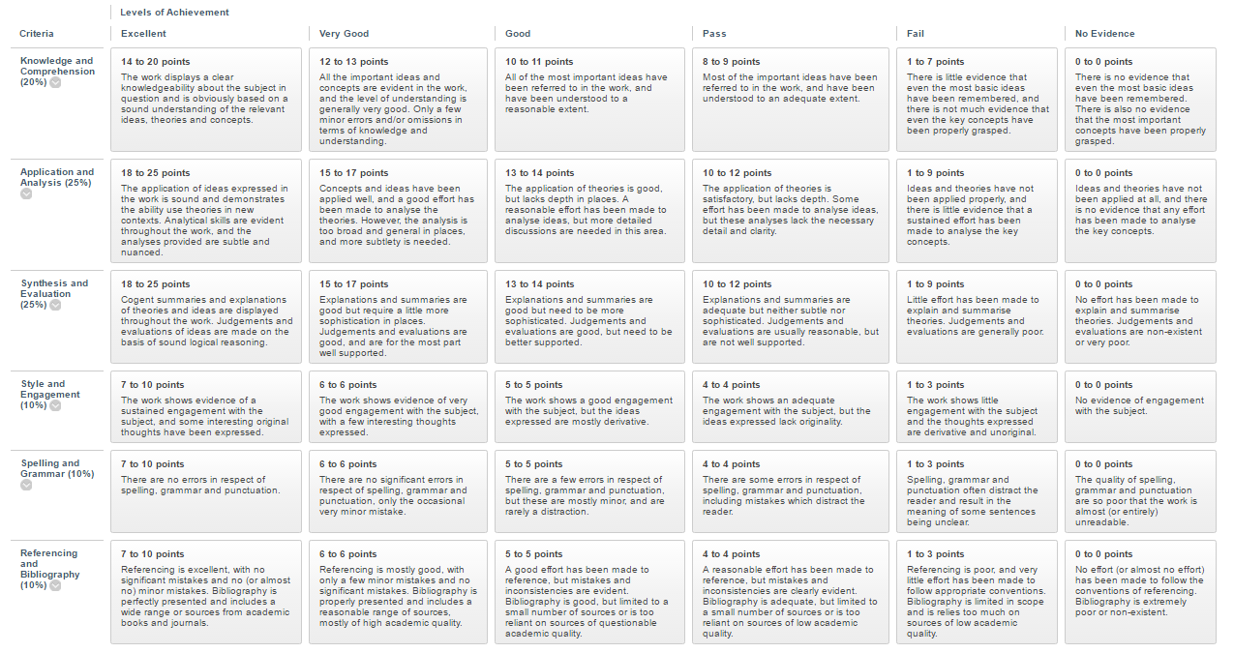
Screenshot of a NILE/Blackboard rubric

Understanding how to set-up and use rubrics in NILE to mark MSAs
The following guides have been produced in order to help staff set-up and use rubrics.
What are rubrics, why would I use one, and how do I create one?
https://nile.northampton.ac.uk/bbcswebdav/xid-1055462_1
What point ranges should I use when creating a rubric?
https://nile.northampton.ac.uk/bbcswebdav/xid-1061262_1
How do I attach a rubric to an item for assessment?
https://nile.northampton.ac.uk/bbcswebdav/xid-1061261_1

Part 2: Multiple Sub-component Assessments that are Computer Marked

Basic principles
- A maximum combined score of 100 should exist for the total of all sub-component parts. This can be broken up as appropriate, including using different weightings for some of the questions.
- Component parts should only ever receive a numerical score, not a letter grade (as detailed above).
- Unlike MSAs marked by hand, which only have one final (summative) submission date, computer marked MSAs may have a series of final (summative) submission dates.

Part 3. Managing Extensions, Resits and Mitigating Circumstances for Multiple Sub-component Assessments

Academic staff seeking to use MSAs as part of their module assessment strategy are strongly encouraged to familiarise themselves with the relevant sections of the current Assessment and Feedback Policy (sections 4.8 – 4.21), and particularly the sections governing extensions, resits and mitigating circumstances.
The following table is reproduced from section 4.21 of the Assessment and Feedback Policy for convenience. It highlights the various similarities and differences between the two types of MSA.
 | Hand Marked MSAs | Computer Marked MSAs
Nature of sub-components | Formative until final summative due date | Each sub-component functions practically as a summative assignment
Provision of feedback / feedforward | At least 1 opportunity for feedback / feedforward over the duration of the module | Supported by formative feedback / feedforward as part of learning activities, but not possible for each sub-component due to their ‘summative’ nature
Provision of grades | No score or grade available until the final summative due date has passed and the assignment has been marked | Numerical scores to be used for each sub-component part out of a combined total of 100
Letter grades | Reserved for the summative grade for the whole assignment | Reserved for the summative grade for the whole assignment
Extensions | Can only be applied to the final summative due date | Can be granted for sub-component parts if appropriate
Resits | Only available if the assignment is failed overall | Only available if the assignment is failed overall
Mitigating Circumstances | Only awarded in respect of the whole assignment where there is no engagement with any of the sub-components; cannot be applied to sub-component parts | Only awarded in respect of the whole assignment where there is no engagement with any of the sub-components; cannot be applied to sub-component parts

