Situational Analysis E-tivity
 | 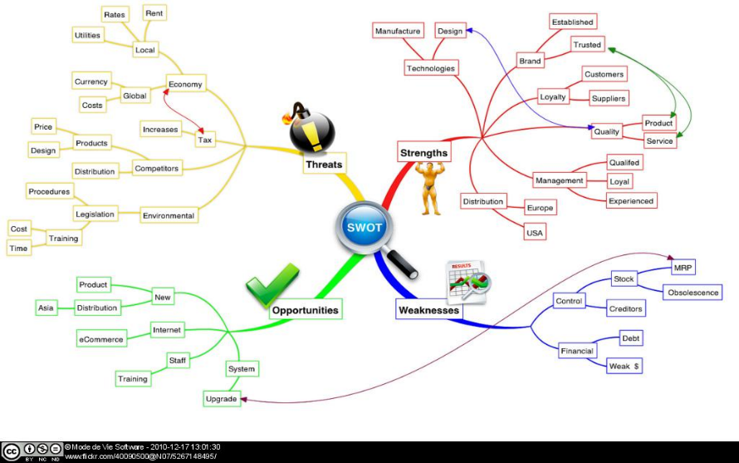
Purpose | - To explore learning, teaching and assessment strategies currently used in your areas of personal practice  - To analyse strengths, weaknesses, opportunities and threats of these practices  - To begin developing action plans for effective future educational activity
- Task | This task has three components:  - Completion of a situational analysis tool associated with identifying learning, teaching and assessment strategies used in your current practice. This will enable you to build a better understanding of the context or situation within which you are working.  - Completion of an analysis tool which will support you in identifying and analysing the strengths (S); weaknesses (W); opportunities (O); and threats (T) associated with your personal situational analysis.  - Commencing an action plan to assist you in identifying future actions needed to address any potential/actual threats and/or weaknesses identified within the SWOT analysis.  This link will take you to templates for components 1-3 above, and you will see within these templates that examples have been given for each section.  Ensure you download and save the templates onto your personal PC first in order to edit and complete them.
Response and Feedback | This activity has been timetabled for one day. The morning should be used to commence tasks 1-3 above and the afternoon should be used for online discussion with your e-moderator and other students in this cohort. This online dialogue will be via discussion board where you have opportunity to discuss your progress.
Timing | All day and approximately an additional 90 minutes to complete step 3 and make any other changes to steps 1& 2 as a consequence of online discussions.
Licence

