Programme of Learning and Resource Map E-tivity

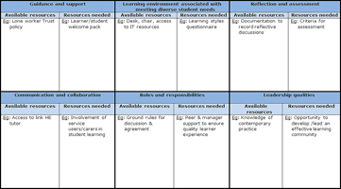
Everett and Ewing (2013)
Context & benefit | Designing a programme of learning for your students will support you in exploring and developing innovative and reflective approaches to meet the diverse learning needs of students. Completion of the resource mapping tool will further assist you in developing pro-active approaches associated with QA initiatives to support effective student progression.
Purpose | To plan the design of a 'mini-course' or focused programme of structured learning for your students, using the Resource Mapping tool.
Task | Within this activity you are required to:  - Design a student programme for a minimum of 7 days that identifies student learning activity associated with meeting individual student needs and curriculum intentions.  - Identify resources to meet your programme requirements in order to promote a quality learning environment  This link will take you to templates for the tasks identified above, and you will see within these templates that examples have been given for each section.  Ensure you download and save the templates onto your personal PC first in order to edit and complete them.
Response and Feedback | This activity has been timetabled for one day. The morning should be used to commence the tasks above and the afternoon should be used for online discussion with your e-moderator and other students in this cohort. This online dialogue will be via discussion board where you have opportunity to discuss your progress.
Timing | All day and approximately an additional 45 minutes to reflect on online discussions and complete this activity.
Licence

