How to Guide:
The Waste Land App

Two weeks before the Seminar:
Start exploring the app to ascertain possible avenues for integration into the seminar. It is important to fully investigate all the features of the app at this stage, and to verify its scholarly sources and material, before planning on using it with students.
The Waste Land app is an award-winning app that incorporates a range of scholarly material, including specially commissioned interviews with leading writers and material from the Faber archive. The aim of the seminar was to use the app to explore different aspects of the poem including the manuscript version, cultural and intertextual references, and critical perspectives, which form part of the Modernism module’s existing learning outcomes.
A few days before the seminar:
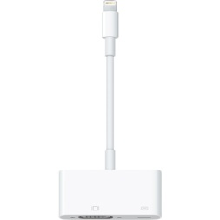
Prepare the equipment so that it is all ready to use during the seminar. It is important with iPads that they are fully charged and that any necessary cables are available.
If you wish to connect a staff iPad up to the projection system then an iPad lightning to VGA adaptor is needed (pictured)
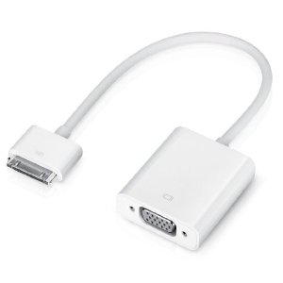
Be careful! older versions of the iPad will require a different iPad dock connector to VGA Cable Adaptor. (pictured)

It may also be useful if you familiarise yourself with the appropriate departmental IT aid before the seminar. This can come in very useful if something goes wrong!

The Seminar

As this was a session delivered to a level 5 cohort, and the students hadn’t seen the app previously, the lecturer decided to combine an open-ended exploration of the app with a more structured activity exercise. Groups of three students were provided with an iPad with the app pre-installed. They were then given 40 minutes to explore the app and its contents (10mins) and discuss the following questions (30 mins):
- Use the scholarly notes to discover more about one of Eliot’s literary allusions or intertextual references.
- Examine a section of the original manuscript version containing Pound’s edits and compare it to the final version.
- Select one of the critical perspectives to listen to and make a note of what it adds to your understanding of the poem.
After the Seminar
After the seminar session has taken place, critically reflect on what worked and what didn’t. Was there enough time for students to familiarize themselves with the app? Were the tasks appropriate to the learning outcomes of the module? Is the app sufficiently scholarly for an H. E. English class? In the case of the Waste Land app, feedback was extremely positive. The students enjoyed exploring the app, finding it easy to use and well designed. They reported learning a great deal from looking at the manuscript version and consulting the notes, and stated that watching the interviews enhanced their understanding and enjoyment of the text. However, students also felt use of the app could detract from whole group discussion and deter students from carrying out their own research.
One student said: “The app is really useful and I would definitely recommend it to other people. There is an extensive repository of information and knowledge. However, there is a danger of relying on it too much, so I would use it alongside, not instead of, my own research.”
©Sonya Andermahr and David Simmons, University of Northampton, “Opps for Apps” Project, 2015
More details available at: http://mypad.northampton.ac.uk/oppsforapps/

