Anatomy and Physiology of the Endocrine System
in relation to
Emergency and Urgent care needs

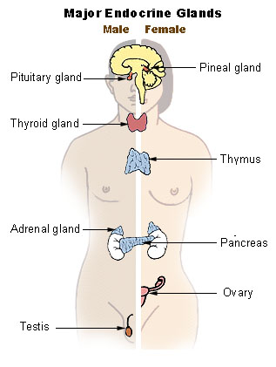

Sarah Cross
School of Health
University of Northampton
Welcome to the Anatomy and Physiology (A&P) of the endocrine system work book, which has been designed to help you understand more about the endocrine system and how this is reflected in clinical presentations you will encounter.
You can use the work book as a stand alone resource and follow the activities through to the end of session test at the end. It is suggested that three hours are allocated to complete the work book, though students are encouraged to work through at their own pace.
There are a variety of tasks and activities throughout the work book, indicated by the following symbols:
Written Discussion
Reading Thinking
Online Assessment

At the same time there are notable important pieces of information indicated by the highlighted orange boxes:
Important Information

Resources required:
Access to the internet (via a smartphone or tablet is adequate)
Core textbook: Martini, F., Bledsoe, B.E., Bartholomew, E.F. and Ober, W.C. (2008). Anatomy and physiology for emergency care. 2nd Ed. USA: Pearson
Tips for activity completion and learning are given in the highlighted yellow boxes:
Tips

Contents:
- Welcome and instructions to using work book
- Learning Objectives
- Introduction to the Endocrine System
- Glands of the Endocrine System
- Hormones of the Endocrine System
- Interaction of glands and hormones
- Negative feedback loop
- Endocrine System disorders
- Relating to practice
- Formative Assessment
- Evaluation

Learning Objectives
On completion of the work book you should be able to:
- Identify and describe the location of the glands of the endocrine system
- Explain the function of glands in relation to regulation
- Discuss the location, hormones and functions of the following endocrine glands and tissues:
  - pituitary gland
  - thyroid gland
  - parathyroid glands
  - adrenal glands
  - pancreas
  - testes & ovaries
- Explain how hormones interact to produce coordinated physiological responses
- Describe and explain the negative feedback loop in relation to hormone regulation
- Compare the similarities between the nervous and endocrine systems
- Identify common endocrine disorders that will be encountered in practice
- Explain the relationship between signs and symptoms of disorders to A&P

Please make a note of any additional learning objectives you have:
_______________________________________________________________________
_______________________________________________________________________
_______________________________________________________________________

The Endocrine System
The endocrine system works along with the nervous system to regulate the functions of the human body to maintain homeostasis. It consists of glands (that have no direct anatomical links) which secrete hormones.
HOMEOSTASIS is a term that describes a stable internal body environment
EFFECTORS cause responses that alter conditions
RECEPTORS provide information about internal stimuli

Endocrine glands help regulate metabolism, control chemical reactions, transport substances, regulate water and electrolyte balances and aid in reproduction, growth and development.
Glands secrete hormones that diffuse from the interstitial fluid into the bloodstream carrying messenger molecules throughout the body.
There are different groups of hormones and low concentrations of hormones can still stimulate target cell changes with chemical signals binding to receptor molecules.

Consider the similarities and differences between the endocrine system and the nervous system (you will be able to add to this table once you have completed some of the activities further on in the work book)
Endocrine System | Nervous System
Refer to your core text book to aide with table completion

Glands of the Endocrine System
Draw the glands of the endocrine system onto the body outline
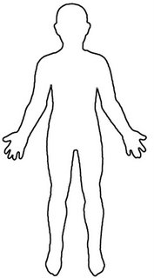
(See page 7 for answers)
There are 9 different glands to add to the diagram:
Testes (male, 2), Ovaries (female, 2), Pancreas (1), Thyroid (1), Parathyroid glands (4), Adrenal glands(2), Pituitary gland, Thymus gland, Pineal Body (1)
Function of Glands of the Endocrine system
List any endocrine disorders you know about
(Don’t worry if you can’t think of many we will add to this list by the end of the work book)

___________________________________________
___________________________________________
___________________________________________
___________________________________________
___________________________________________
___________________________________________
The main functions of glands are:
Secretion
Regulation

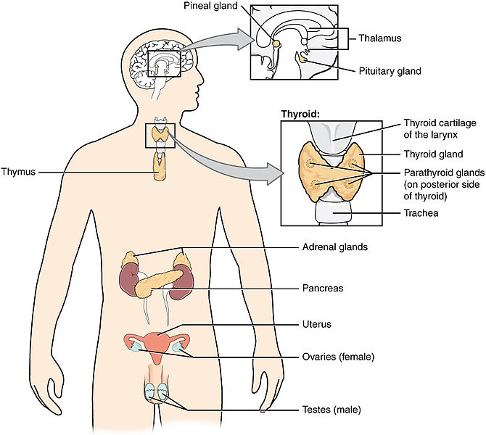
Hormones of the Endocrine system
There are more than 50 different hormones
Hormones are chemical messengers that are released in one tissue, transported in the bloodstream and reach target cells in other tissues.

Hormones can be divided into 3 groups: Amino acids, Peptide derivatives, Lipid derivatives
Type | Derived Form | Examples
Steroids | Cholesterol | Aldosterone, cortisol, oestrogen, testosterone
Amines | Amino acids | Epinephrine, norepinephrine
Glycoproteins | Carbohydrates & Proteins | Follicle-stimulating hormone (FSH), lutenizing hormone (LH), thyroid-stimulating hormone (TSH)
Peptides | Amino acids | Antidiuretic hormone (ADH), oxytocin (OT), thyrotropin-releasing hormone (TRH)
Proteins | Amino acids | Growth hormone (GH), parathyroid hormone (PTH), prolactin (PRL)

The secretion and distribution of hormones
Hormone release occurs with abundant capillaries, they quickly enter the bloodstream or distribution and circulate freely attaching to transport proteins.
Hormones are broken down by liver or kidney cells.
Endocrine activity is controlled by negative feedback mechanisms.

Access and watch the video link below. This is a 12 minute long video which explains the endocrine system and hormones in brief.
http://youtu.be/WVrlHH14q3o
Great Glands - your endocrine system

Can you complete any more of the table on page 5?

Think about the following questions, the answers of which are in the video link.

- What acts as a liaison between the endocrine and nervous systems?
- How do cells receive hormones?
- Which group of hormones are water soluble?
- What size is the pituitary gland?
- What is the function of the pancreas?
- What is the method of communication within the endocrine system called?

Watch the video link as many times as you need

Negative Feedback Loop
In systems controlled by negative feedback the effector response decreases or negates the effect of the original stimulus restoring homeostasis. We can relate this to a central heating system to aide comprehension:
The thermostat (detector) is sensitive to changes, which is connected to the
Boiler control unit (control centre) which controls the
Boiler (effector) which
Regulates temperature by raising or lowering levels

Stimulus
Detector

Control

Effector

Negative feedback regulation of secretion of hormones

Negative feedback loop for secretion of thyroxine (T4) and triiodothyronine (T3)
Stimulation
Releasing hormones
Lowered blood levels of target gland hormones
Use of hormones
Raised blood levels of target gland hormones
Inhibition
Target Gland
Pituitary Gland
Hypothalamus
Hormone levels drop / raise
Fill in the algorithm for thyroid gland secretion
Raised blood levels of T3 and T4
Use of hormones
Lowered blood levels of target gland hormones
Thyroid stimulating hormone (TSH)
Thyroid releasing hormone (THR)
Exercise, stress, malnutrition, sleep
Thyroxine (T4)
Triiodothyronine (T3)

Inhibition

Gland and hormone stimulation
The pituitary gland and the hypothalamus act as a unit regulating the activity of most of the other endocrine glands. The pituitary gland consists of 3 distinct pasts, the anterior pituitary, the posterior pituitary and the intermediate lobe (which has no known function in humans).
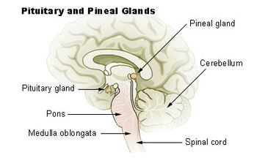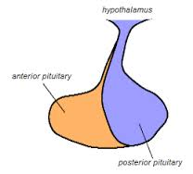

Both the anterior and posterior pituitary glands influence secretion and release of other hormones by secreting releasing and inhibiting hormones that activate target glands.
Oxytocin
Posterior Pituitary Gland

Anti-diuretic hormone (ADH)

Note the glands are highlighted in different colours to the hormones

Specific Gland Secretion
Fill in the boxes to describe hormone function

Anterior Pituitary Gland

Thyroid Stimulating Hormone (TSH)
Growth Hormone (GH) released by Growth Hormone Releasing Hormone (GHRH)
Adrenocorticotropic Hormone (ACTH)

Thyroxine
Triiodothyronine

Thyroid
Adrenal Glands

Epinephrine
Glucocorticoids eg. Cortisone, corticosterone and cortisone
Calcitonin

Aldosterone

Pancreas

Somatostatin
Glucagon
Insulin

Tells the body to absorb glucose
Gets converted to glycogen for storage

Sex Gland Secretion

Lutenising hormone releasing hormone (LHRH)
Anterior Pituitary Gland

Gonaotrophins (in response to gonadotrophon releasing hormone)
- Follicle Stimulating hormone
- Lutenising hormone

_________________

Ovaries
Testes

Androgens eg. testosterone
Oestrogens
Progestins

Refer to your core text book to aide with table completion

Diseases of the Endocrine System
Link the diseases to the hormones to the glands

Diseases Hormones Glands

Giantism
Thyroid
Ovaries

Polycystic Ovaries
Graves Disease
Growth hormone
Thyroxine
Addisons
Adrenal Insufficiency
Diabetes
Cushings Disease

Pancreas
Cortisol
Pituitary Gland
Dwarfism

Pituitary Gland Disorders

Insulin

(See answers on page 20)

Diseases of the Endocrine System
Discuss some of the diseases of the endocrine system you have encountered in practice with your peers:
- What symptoms did patients display?
- Were patients aware of their condition?
- Which gland was there an abnormality with?
- Which hormone was there too much or too little of?
- What was the cause of the malfunction?

Causes of Endocrine disorders include:
Infection
Genetics
Injury
Tumours / Growths

Contribute to the online discussion board on the integrated learning environment which has been set up to discuss cases in practice.

Please be mindful of patient anonymity and remain professional at all times.

Assessment
Answer the following questions (See answers are on page 20)

 | Questions | Answers
1 | Describe where the thyroid gland is located.
2 | Where is the pituitary gland situated?
3 | What are the primary functions of glands?
4 | What is the primary function of the pituitary gland?
5 | What are the four parts of the negative feedback loop?
6 | How does the body know to absorb glucose?
7 | Give two differences between the nervous system and the endocrine system.
8 | Give two similarities between the nervous system and the endocrine system.
9 | What are the symptoms of hyperthyroid disease?
10 | Which hormones are related to Addisons disease?

Evaluation and feedback on the educational workbook
Your opinion and comments are important to use to improve further editions of this workbook and other workbooks. Please answer the questions below in an email and send to sarah.cross3@northampton.ac.uk.
Many Thanks.

- Was the booklet easy to use?
- Did the workbook contain all the information you required?
- Were you able to access the resources suggested?
- Was the content valid?
- What was your score out of 10 on the test?
- How would you improve the workbook?
- What was your favourite part in the workbook?

Answers!
Insulin
Cortisol
Thyroid
Ovaries
Pancreas
Growth hormone
Giantism
Dwarfism
Addisons
Cushings Disease
Pituitary Gland Disorders
Pituitary Gland
Polycystic Ovaries
Graves Disease
Adrenal Insufficiency
Diabetes
Thyroxine

 | Questions | Answers
1 | Describe where the thyroid gland is located | In the neck in front of the larynx and trachea
2 | Where is the pituitary gland situated? | Below the hypothalamus in the brain
3 | What are the primary functions of glands? | Secretion and regulation
4 | What is the primary function of the pituitary gland? | To influence secretion of hormones from other glands by releasing hormones
5 | What are the four parts of the negative feedback loop? | Stimulus, Detector, Control, Effector
6 | How does the body know to absorb glucose? | A negative feedback loop communicates glucose levels are too high, so the pancreas releases insulin which informs cells in the body to absorb glucose
7 | Give two differences between the nervous system and the endocrine system. | NVS is quicker and has short acting effects  ECS uses hormones and NVS uses Neurotransmitters
8 | Give two similarities between the nervous system and the endocrine system. | Negative feedback communication system  Purpose of regulation
9 | What are the symptoms of hyperthyroid disease? | Unexplained weight loss, tachycardia, sweating, anxiety, gouter
10 | Which hormones are related to Addisons disease? | Cortisol and Aldosterone

Acknowledgement
The icons used within this work book are found from iconfinder (https://www.iconfinder.com).

Icon by Lothar Grimme, iconfinder, GNU GENERAL PUBLIC LICENSE
Icon by Design Bolts, iconfinder, free for non-commercial use
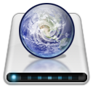 Icon by Capital18, iconfinder, free for non-commercial use
Icon by Mattrich, iconfinder, free for non-commercial use
Icon by Jojo Mendoza, iconfinder, CC BY-NC
Icon by Custom Icon Design , iconfinder, CC BY-NC
Icons by Yannick Lung, iconfinder, free for commercial use

The image is contributed by Fuelbottle, Wikipedia Commons, Public Domain
The image is contributed by greyback-squirell, http://greyback-squirell.deviantart.com/art/how-bout-deep-158236397, CC BY
Image is contributed by OpenStax College, Wikipedia Commons, CC BY
Image from Wikepedia, http://en.wikipedia.org/wiki/Posterior_pituitary
Image from Wikipedia, http://es.wikipedia.org/wiki/Hip%C3%B3fisis

