Implementing Innovative Change in Practice

E-tivity 1: Identifying issues and priorities in your practice

 |  | 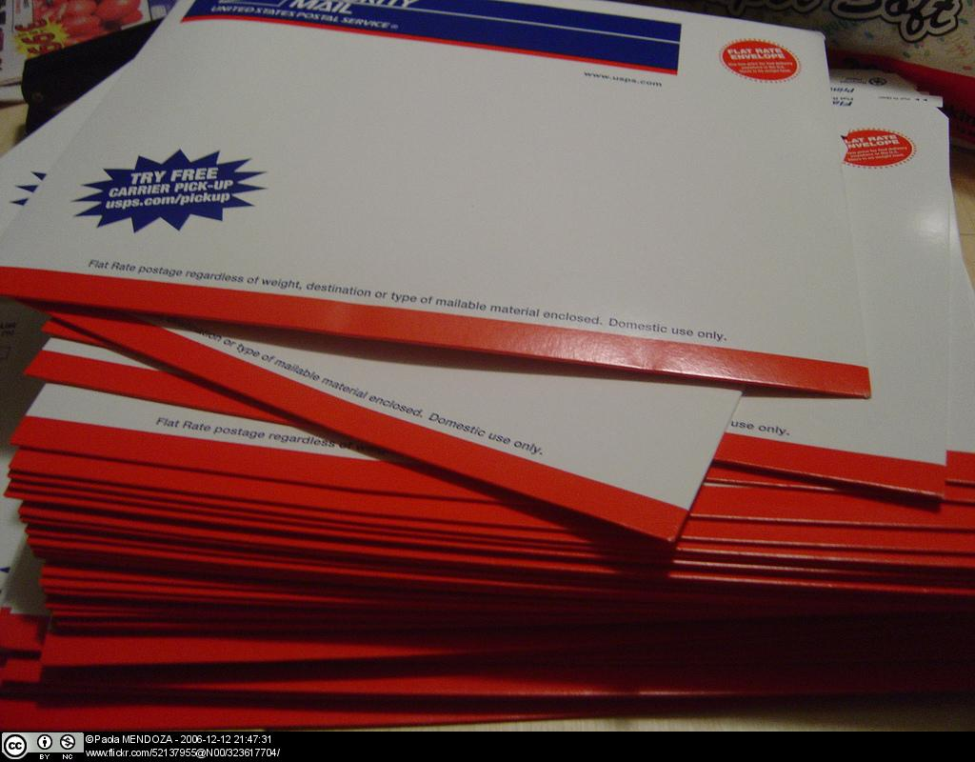
Purpose |  | To give you an opportunity to identify and discuss current issues within your practice that impact on you as a professional and,  To enable you to compose an initial action plan for change that you will develop throughout the study.
Task |  | Identify ONE issue impacting on your work as an occupational therapist. This could be political, environmental or personal.  Use this model (http://www.criticalthinking.org/CTmodel/CTModel1.cfm) to help you identify and clarify your issue. Read through the model, returning to and re-reading the segments on ‘State the Question’ and ‘Gather Information’.  Post your issue via your blog (i.e. using the blog tool on any Learning Management System (LMS)).
Feedback & Response |  | Post at least one comment to others’ issues via their blogs.

E-tivity 2: Professional thinking and responsibility

 | 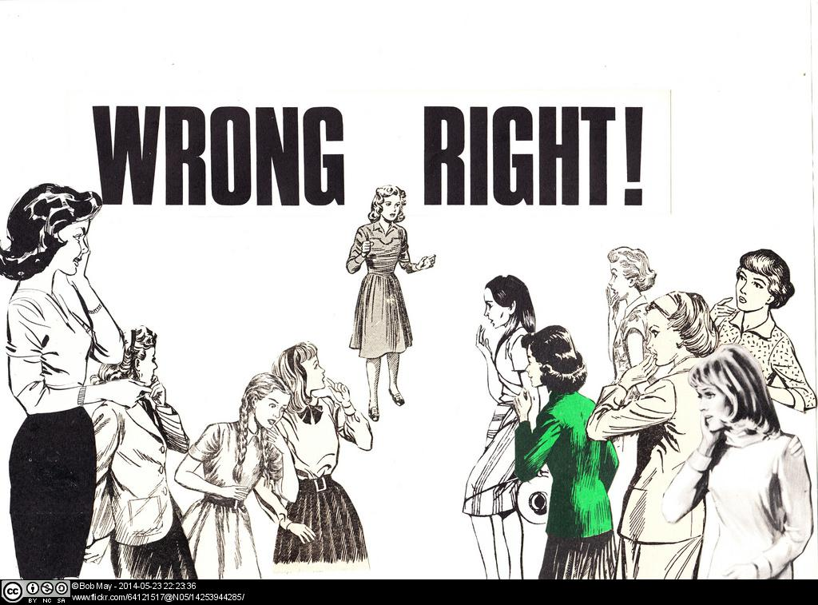
Purpose | To discuss professional empowerment and ownership when addressing current issues.
Task | Read the following article:  Clouston, T. J. and Whitcombe, S.W. (2008). The professionalisation of occupational therapy: a continuing challenge. British Journal of Occupational Therapy, 71(8): 314-320.  Highlight the key points of the paper and give a brief critical analysis using your blog.
Feedback & Response | Post at least one comment to others contributions via their blogs.

E-tivity 3: The impact of social and political issues on practice
 | Image from Pixabay, http://pixabay.com/en/social-responsibility-silhouettes-200288/, Public Domain
Purpose | To enable you to evaluate the social, political and professional influences on your practice.
Task | Use the PESTLE and SWOT analysis models to consider what the political, economic, professional and social issues influence your issue on your practice.  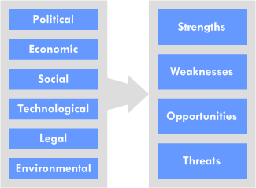  Image from Jisc infoNet, http://www.jiscinfonet.ac.uk/tools/pestle-swot, CC BY-NC-SA  Consider what research evidence might support your thinking.  Add the information you gained from answering the above question to your Business Case. (Ensure you download and save the template for the Business Case onto your personal PC first in order to edit and complete it.)
References | - Collins, R. (2010). A Graphical Method for Exploring the Business Environment. http://users.ox.ac.uk/~kell0956/docs/PESTLEWeb.pdf.  - Collins, R. Is there a better way to analyse the business environment? Master’s thesis. http://users.ox.ac.uk/~kell0956/docs/pestleweb_thesis.pdf.  - Hill, T. and Westbrook, R. (1997). SWOT analysis: it’s time for a product recall. Long Range Plan, 30: 46–52.  - Kurttila, M., Pesonen, M., Kangas, J., and Kajanus, M. (2000). Utilizing the analytic hierarchy process (AHP) in SWOT analysis—a hybrid method and its application to a forest-certification case. Forest Policy and Economics, 1(1): 41–52.  - Srdjevic, Z., Bajcetic, R., and Srdjevic, B. (2012). Identifying the Criteria Set for Multicriteria Decision Making Based on SWOT/PESTLE Analysis: A Case Study of Reconstructing A Water Intake Structure. Water Resource Management, 26: 3379–3393.  - Kolios, A. and Read, G. (2013). A Political, Economic, Social, Technology, Legal and Environmental (PESTLE) Approach for Risk Identification of the Tidal Industry in the United Kingdom. Energies, 6: 5023-5045.

E-tivity 4: Using and promoting occupation within practice
 | 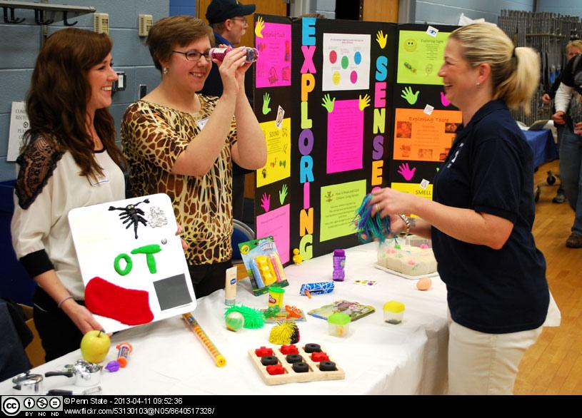
Purpose | To facilitate your understanding of how current issues impact upon the theory of occupation in practice  To enable you to formulate strategies for ensuring an occupational focus to your practice
Task | Read the following articles:  - Diamantis (2010) Defending occupation in paediatric practice  - Pollanen (2009) Craft as context in therapeutic change  - Diamant and Waterhouse (2010) Gardening and belonging: reflections on how social and therapeutic horticulture may facilitate health, wellbeing and inclusion  How do you think each author addressed the issue of occupation? Use your blog to summarise your thoughts.  Think about the occupational focus to your current practice. Return to your Business Case and add a section about the 'Occupational Focus' of your Practice. To help you complete this section use the following questions:  - What facilitates/inhibits the use of purposeful occupation in your practice?  - What is the value of enabling greater occupational content within your practice?  - Who do you need to influence to ensure an occupational focus in your practice?
Feedback & Response | Post your Business Case in your blog.  Read each others’ Business Cases and suggest ONE action that could be taken to promote occupation in their practice via their blogs.
E-tivity 5: Implementing change in your practice

Purpose | To facilitate your application and evaluation of change management strategies to the issue of your choice  To enable you to apply research evidence to inform your reasoning
Task | Use a model (i.e. Cheese model, Lewin model) to consider possible strategies for change for your chosen issue.  Consider the following:  - Revisit Stakeholders  - Think about resistance to change  - Transition management  - Adoption of change  - Balanced scorecard  - Benchmarking  Return to your Business Case and devise an action plan for implementing change within your practice, clarifying the research that will be required to justify it.

The material was developed by Roshni Khatri
School of Health
University of Northampton

The template for developing the Business Case was developed by Jisc, http://www.jiscinfonet.ac.uk/infokits/selecting-technologies/set-up/business-case/, licenced under CC BY-NC-SA.

