A Guide to the NHS Immigration Health Surcharge
From 6 April 2015 if you are applying for immigration permission for more than six months, you will be required to pay the Immigration Health Surcharge (IHS) at the point of submitting your visa application.
This surcharge will apply to all applicants and family members applying to come to the UK as dependents. This will entitle you to free health care under the National Health Service whilst you are in the UK.
The current charge is £150 for each student and £150 for each dependent for each year for the duration of your immigration permission. You can use the UKVI Calculator to work out the length of immigration permission you will be granted and calculate the fee you will be charged.
If your immigration permission includes part of a year the amount will be rounded up or down. Therefore, if it includes part of a year but less than six months, you will be required to pay an additional £75, and if your permission includes part of a year that is longer than six months you will pay an additional £150.
Examples:
- If your programme of study is 12 months or more you will be granted immigration permission for the duration of your course plus an additional one month before the course starts and four months at the end of the course. The total charge in this case would be £225.
Breakdown:
£150 – 1 Year
+ £75 – 5 months
= £225
- An undergraduate student applying for Tier 4 leave for a three year course will be required to pay a surcharge of £525.
Breakdown:
£150 X 3 years= £450
+ £75 (Additional leave)
=£525
Please note the calculation is based upon the length of leave granted and not the duration of the course.
Please visit the UKVI website to find out more information pay the Immigration Health Surcharge. Please follow the link below:
https://www.immigration-health-surcharge.service.gov.uk/checker/Type
If have any questions regarding the Immigration Health Surcharge you can contact us at iss@northampton.ac.uk
Once you have made your online payment you will receive an email confirmation with your unique reference number. You will need to write this reference number in your online Tier 4 application.

FAQ’s
Who is required to pay the NHS Immigration Health Surcharge? Student’s applying for immigration permission for more than six months and their dependents.
How much do I need to pay? The current charge is £150 for each student and £150 for each dependent for each year for the duration of your immigration permission
When do I pay? You will be prompted to pay the surcharge when you complete your online visa application.
Can a refund be issued if I do not access NHS services? No, you are not entitled to a refund even if you do not access the service during your studies.
What happens if my visa application is refused? You will be entitled to a full refund of your payment for the healthcare surcharge, but not for the visa application fee.
Do I still need Private Health Care Insurance? You can take out private health insurance in addition to the healthcare surcharge. However, you will still be required to pay the surcharge as part of your visa application.
Is anyone exempt from this IHS?
You will not have to pay the healthcare surcharge if any of the following applies:
- You are a national of a country inside the European Economic Area
- You are applying for entry clearance for less than six months
- You are applying for a Short Term Study or Visitor visa
- You are a national of Australia or New Zealand
- You have been awarded a Chevening or Commonwealth scholarship
Australian and New Zealand nationals will have their fee waived due to a reciprocal agreement between the UK and their countries, however you will still be required to complete the application process to obtain an IHS number reference number.

A Guide to paying for the NHS Immigration Health Surcharge

Please register an account with UKVI, to do so visit: www.visa4uk.fco.gov.uk/
- Click “Register an Account”

Please work your way through the visa application, you will be prompted to pay the Immigration Health Surcharge (IHS).

Please use the guide below to assist you.

1. You will be redirected to the IHS payment service, Click “Continue” to proceed.
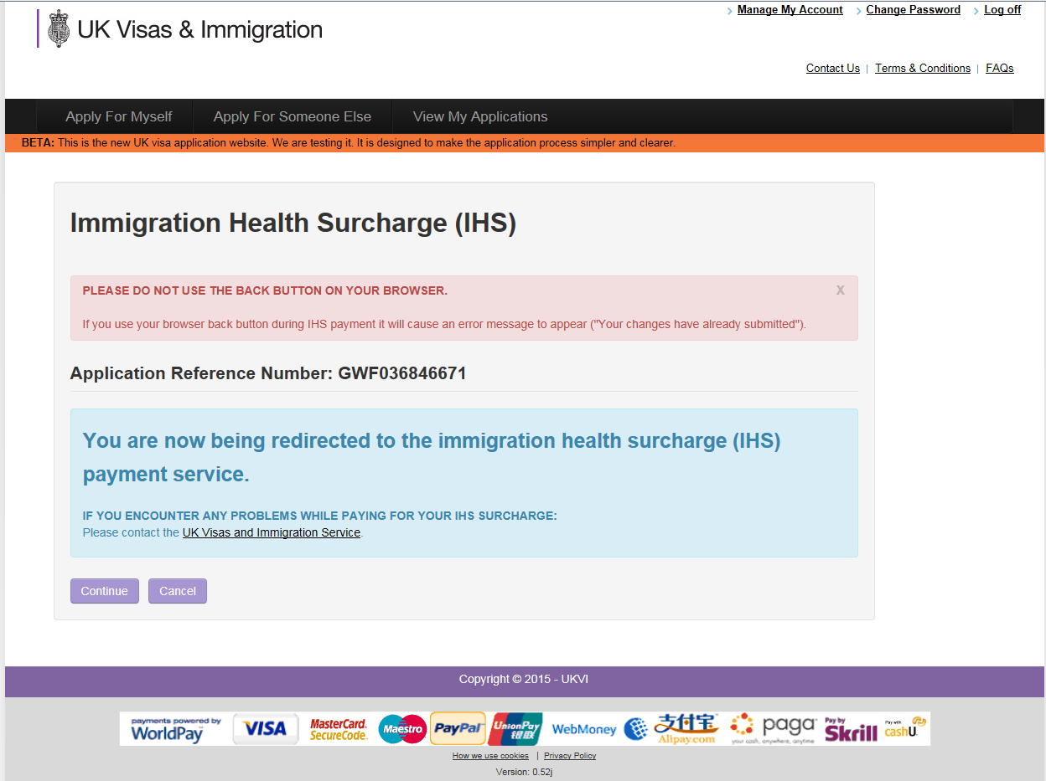

2. This page will determine if you are required to pay the Immigration Health Surcharge based on the information you have submitted in your application regarding the duration of your course.
Click “continue” to proceed.
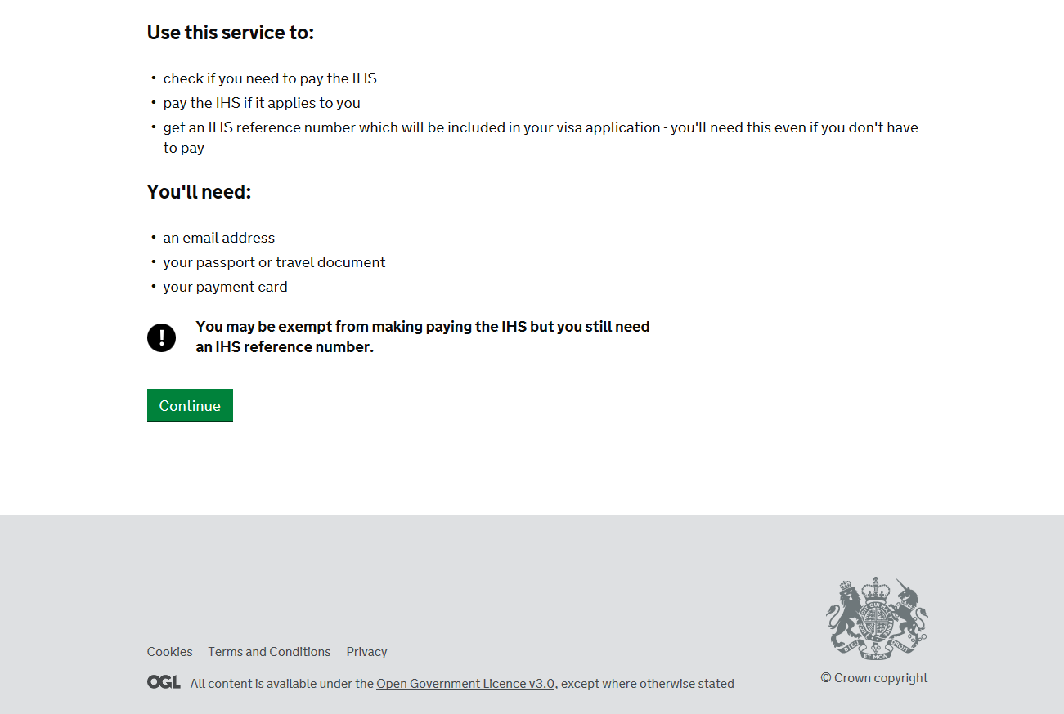

3. A summary is provided, please click “Complete this applicant” to proceed.
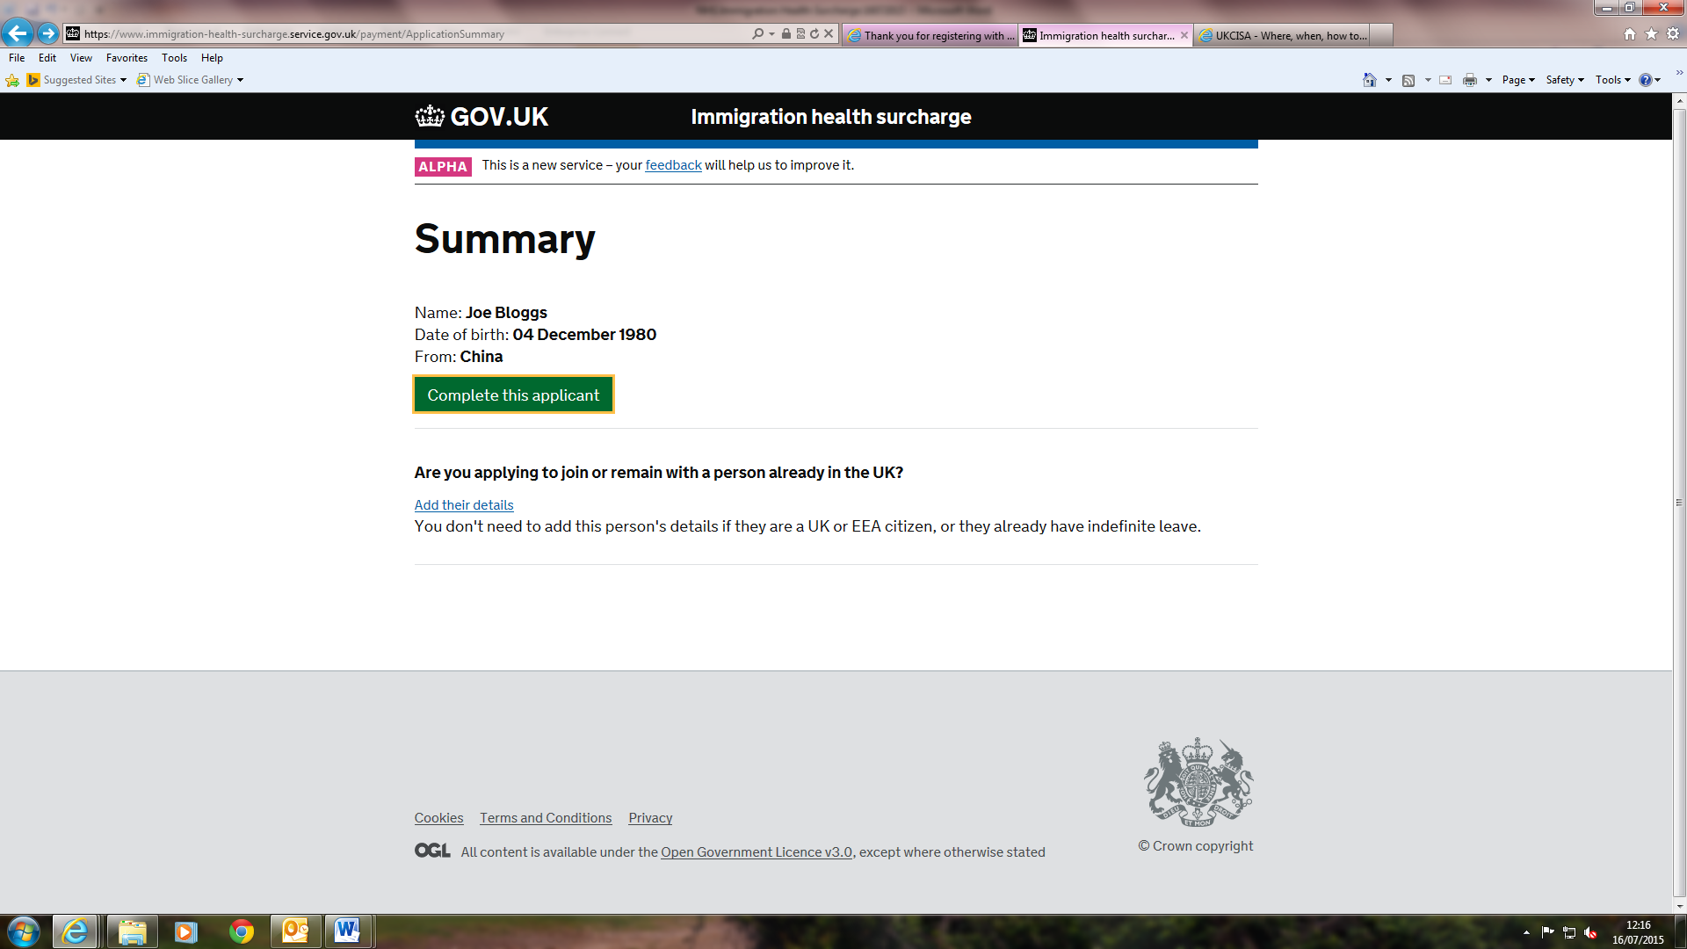

4. Please complete the following section and click “Save and continue” to proceed.

5. Please complete the next section and click “Save and continue”.

6. Please click “Continue” on the summary page to proceed.

7. Complete the Declaration page by clicking “I agree” to the terms and conditions

8. Click “Pay now” to pay the Immigration Health Surcharge, select your preferred method of payment and enter your card details to complete the IHS section of your visa application. Please continue with your visa application.
If You have any queries regarding this section of you visa application, please contact the International Student Support Team at iss@northampton.ac.uk we will be happy to assist you.

The information contained in this document was correct at the time of publication. For up to date information students should refer to the UKVI website at;
https://www.gov.uk/government/organisations/uk-visas-and-immigration

